Day 3: Convert wireframes into high-fidelity Figma mockups

1.Login Screen:

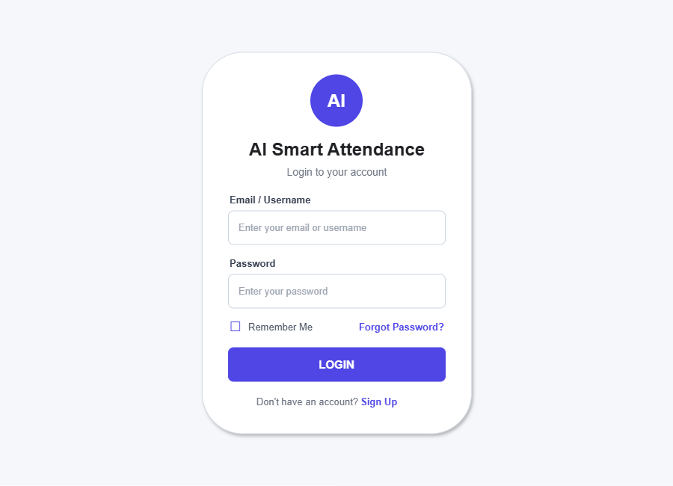

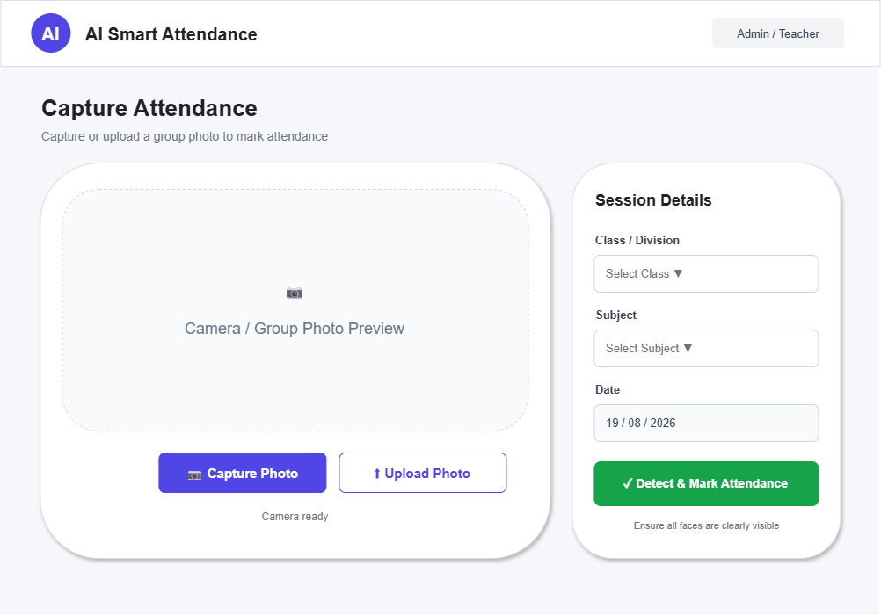
2.Capture Screen:
3.Review Screen:
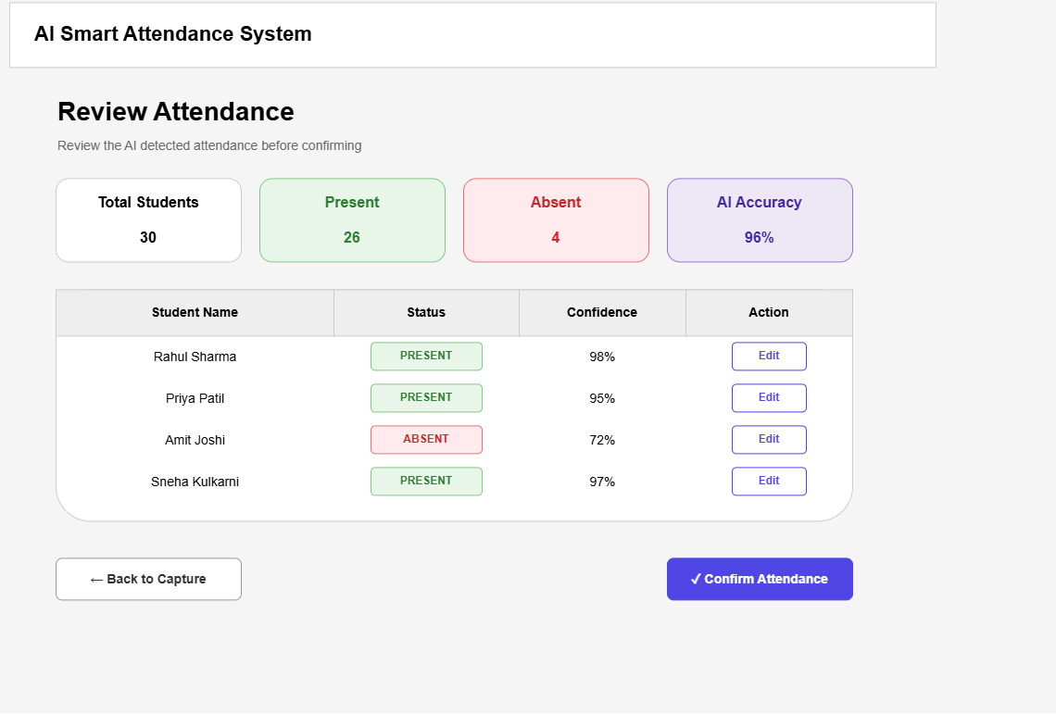

4. Report Screen:
