ASSIGNMENT 11 – DOCKER COMPOSE

Name: Aparna Kurve
Roll No.: MCA2504134

Aim

To install, configure, and use Docker Compose to define and run a multi-container application consisting of a web service, a cache/database service, and a reverse-proxy service.

Software Required

* Docker Engine
* Docker Compose (v2)
* Code Editor
* Terminal / Shell Access

Platform

Ubuntu / Windows (WSL2) / macOS

1. Introduction

Docker Compose is a tool used to define and manage multi-container Docker applications. It allows multiple services to be configured in a single YAML file and started together using simple commands.

In this assignment, the application consists of three services: 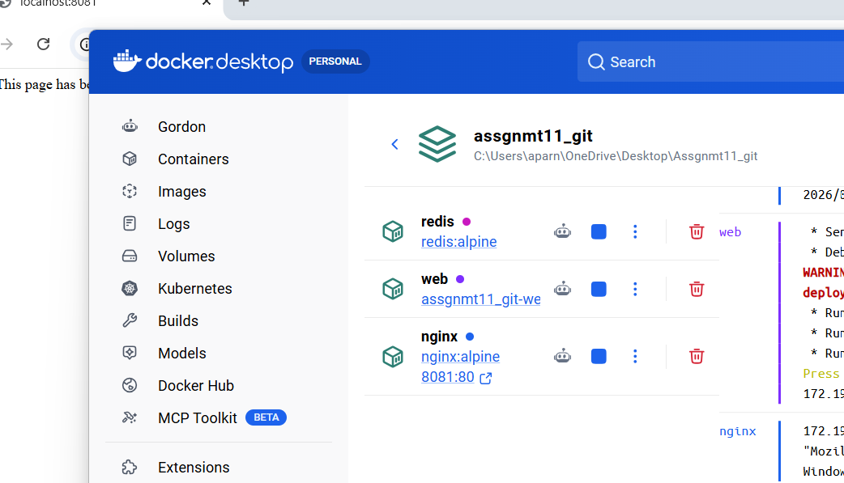
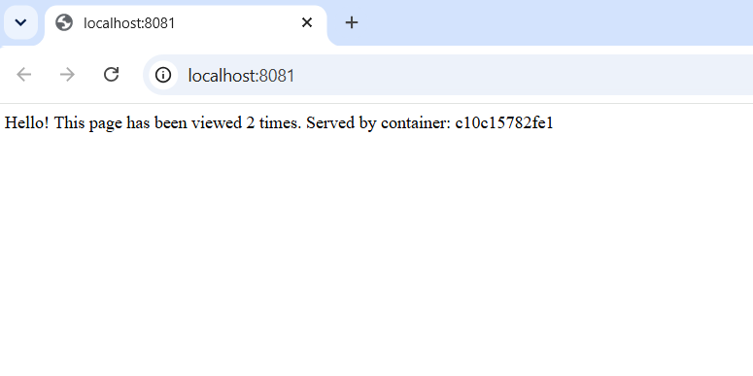
This is the final output:

