

Student Skill Portfolio Website
Project Development Report

Rohan Bhegade

ROLL NO: MCA2504136

—

Role: Project Section Development

—

Team Roles

Member | Role | Branch | Responsibilities
Pradeep | Homepage Developer | home-page | Homepage, navigation, introduction
Rohan | Projects Section Developer | projects-section | Projects section and project cards
Saujanya | Profile Section Developer | profile-section | Profile cards, skills, GitHub links
Swaraj | GitHub Manager & Contact Section Developer | contact-section | Repository, collaborators, branches, PR review, merges, deployment, contact form

Project Objectives:

The main objectives of this project were:

• Develop a responsive student portfolio website.
• Learn collaborative software development.
• Gain practical experience with Git and GitHub.
• Implement feature branching and version control.
• Practice Pull Requests and code reviews.
• Improve teamwork and communication.
• Deploy the final project using GitHub Pages.

Project Overview:

The website consists of four major sections:

• Homepage
• Student Profiles
• Projects
• Contact

Technologies Used:

Frontend

• HTML5
• CSS3
• JavaScript

Version Control

• Git
• GitHub

Deployment

• GitHub Pages

Git & GitHub Workflow

The project followed an industry-standard Git workflow.

Step 1:

Create Repository

Step 2:

Clone Repository

git clone https://github.com/Pravin-junne/student-portfolio.git

Step 3:

Create Feature Branch

Example

git checkout -b home-page
git checkout -b profile-section
git checkout -b projects-section
git checkout -b contact-section

Step 4:

Develop Feature

Each student completed their assigned module independently.

Step 5:

Commit Changes

git add .
git commit -m "Completed Homepage"

Step 6:

Push Branch

git push origin home-page

Step 7:

Create Pull Request

Each member created a Pull Request on GitHub.

Step 8:

Review Pull Request

The GitHub Manager reviewed all submitted Pull Requests.

Step 9:

Merge Pull Request

Approved Pull Requests were merged into the main branch.

Step 10:

Deploy

The final website was deployed using GitHub Pages.

Branching Strategy

main
│
├── home-page
│
├── profile-section
│
├── projects-section
│
└── contact-section

Team Roles and Responsibilities:

Student 1 – Pradeep (Homepage Developer)

Branch: home-page

Responsibilities:

• Designed the homepage.
• Created the navigation bar.
• Added website title.
• Added introduction section.
• Submitted Pull Request.

Student 2 – Saujanya(Profile Section Developer)

Branch: profile-section

Responsibilities:

• Created profile cards.
• Added student names.
• Added skills.
• Added GitHub profile links.
• Submitted Pull Request.

Student 3 – Rohan(Projects Section Developer)

Branch: projects-section

Responsibilities:

• Developed Projects section.
• Added three project cards.
• Added project descriptions.
• Mentioned technologies used.
• Submitted Pull Request.

Student 4 – Swaraj (GitHub Manager & Contact Section Developer)

Branch: contact-section

Responsibilities:

GitHub Management

• Created GitHub repository.
• Added collaborators.
• Managed branches.
• Reviewed Pull Requests.
• Merged all approved Pull Requests.
• Maintained repository.

Website Development

• Built Contact section.
• Added Email field.
• Added Message field.
• Added Submit button.

Deployment

• Published website using GitHub Pages.
• Verified live deployment.

Conclusion

The Student Skill Portfolio Website project successfully demonstrated collaborative software development using Git and GitHub. By dividing the project into separate modules and following a structured branching strategy, the team was able to work efficiently and integrate all features through Pull Requests. The project strengthened our understanding of version control, collaborative development, responsive web design, and deployment using GitHub Pages. Overall, it provided valuable practical experience that reflects real-world software development practices.

Pull Requests and Merge Process

Feature Branch
↓

Commit
↓

Push
↓

Pull Request
↓

Review
↓

Approve
↓

Merge into Main
↓

Deployment

Screenshots

Homepage:

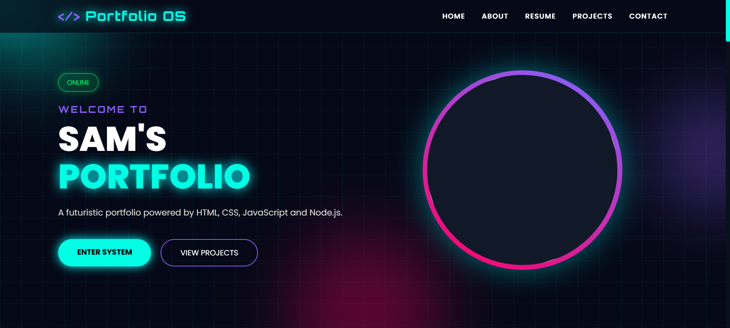

Profile Section:

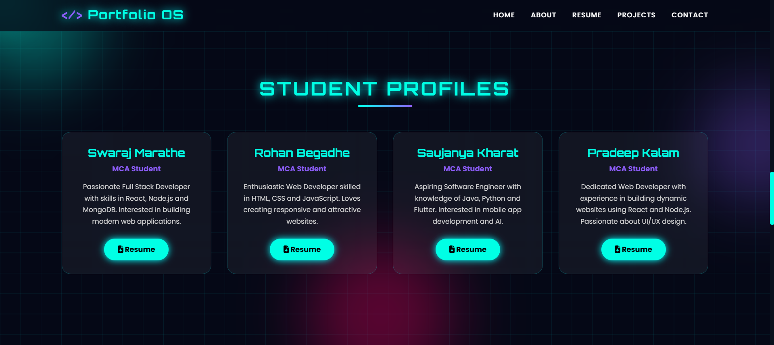

Projects Section:

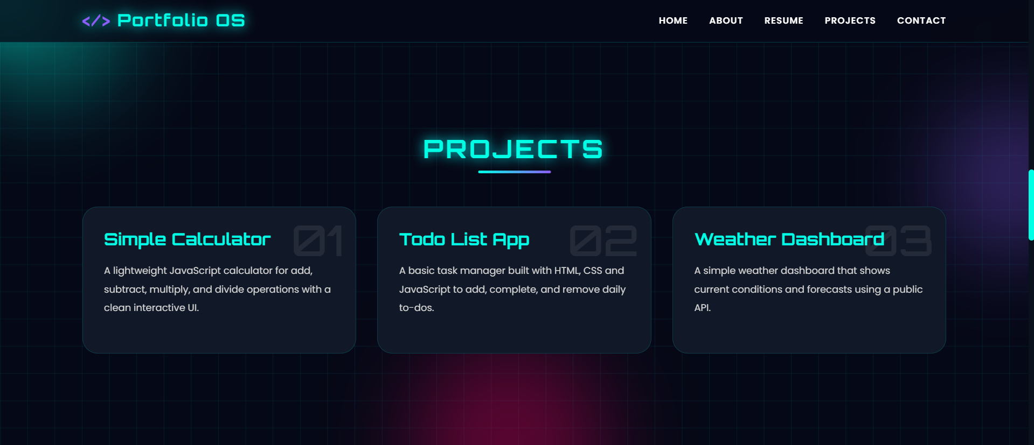

GIT Repository:

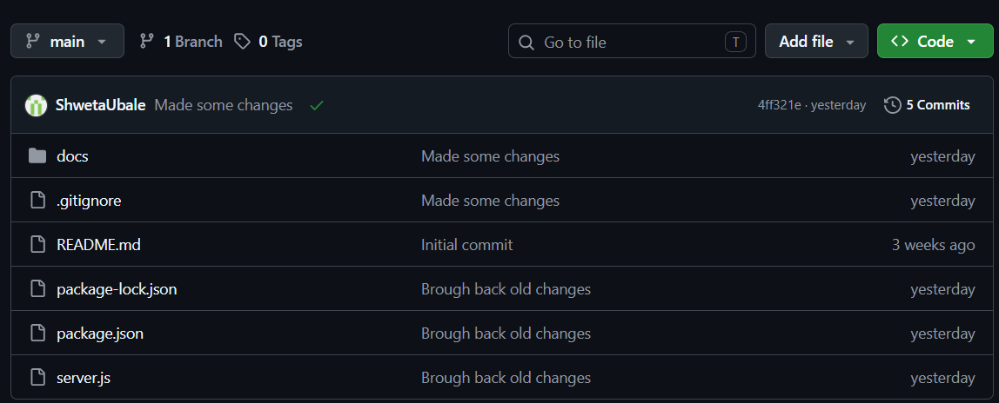

Branches:

