MCA2504134 – Aparna Kurve
Assignment 9: Dockerized College Event Registration Application with MongoDB, Volumes, and Jenkins Deployment
📌 Introduction
This assignment demonstrates how to build and deploy a Dockerized application that collects registration details for a college event. The backend uses MongoDB for data storage, with Docker volumes ensuring persistence. Deployment is automated through Jenkins, integrating Git and Jira for version control and project tracking.
🖼️ Screenshots & Explanations
Screenshot 1 – docker-compose.yml in VS Code
- Shows the Docker Compose configuration for the project.
- Defines two services: mongo (database) and app (Node.js application).
- A named volume mongo_data ensures persistence of MongoDB data.
- The terminal output confirms successful insertion of a registration record.
Screenshot 2 – Docker Desktop Containers Dashboard
- Displays multiple containers running, including:
  - jenkins/jenkins:lts → Jenkins server for CI/CD.
  - college-event_09 → The event registration app.
- Demonstrates how Docker Desktop manages multiple containers, showing CPU/memory usage and container status.
(Insert your second screenshot here)
Screenshot 3 – Docker Desktop Volumes Section
- Highlights persistent volumes:
  - college-event_09_mongo_data → Stores MongoDB data (300.6 MB).
  - jenkins_home → Stores Jenkins configuration.
- Proves that Docker volumes preserve data even if containers are deleted or restarted.

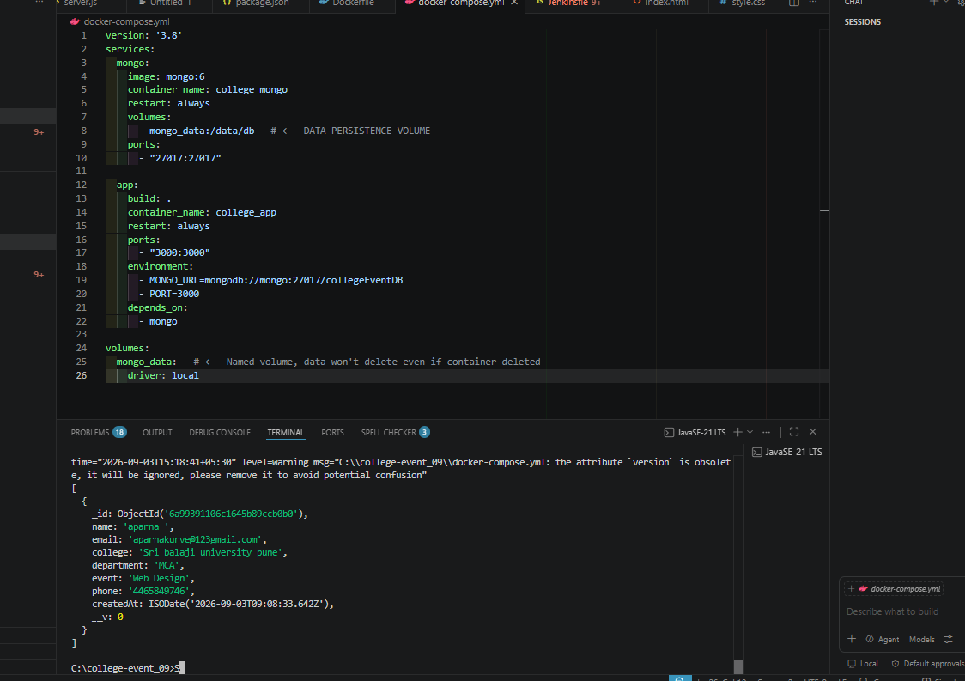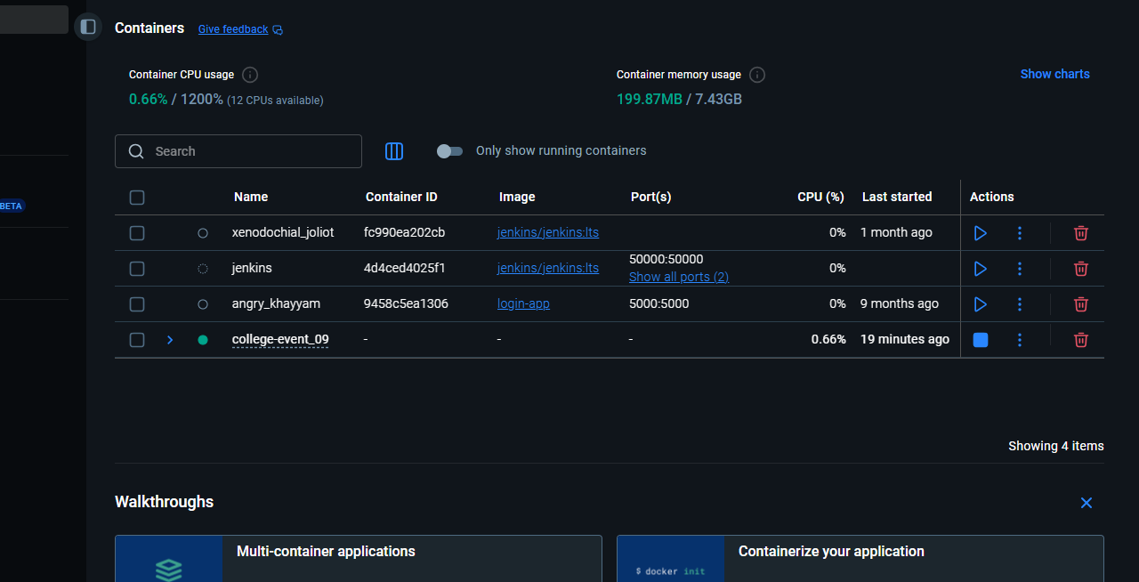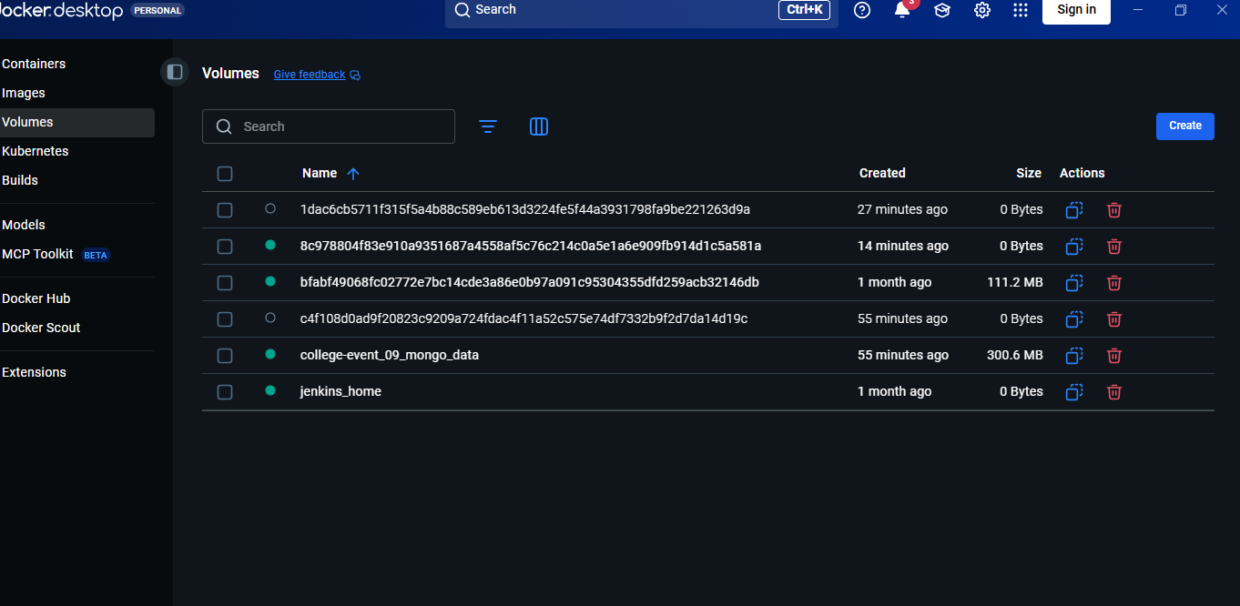 Workflow
- User Registration Form → Collects event details.
- Backend API (Node.js) → Handles requests and stores data in MongoDB.
- MongoDB with Docker Volume → Ensures data persistence (mongo_data).
- Jenkins Pipeline → Automates build and deployment from Git.
- Jira Integration → Tracks assignment progress and issues.
📂 Example docker-compose.yml
yaml
version: '3.8'
services:
mongo:
image: mongo:6
container_name: college_mongo
restart: always
volumes:
- mongo_data:/data/db
ports:
- "27017:27017"

app:
build: .
container_name: college_app
restart: always
ports:
- "3000:3000"
environment:
- MONGO_URL=mongodb://mongo:27017/collegeEventDB
- PORT=3000
depends_on:
- mongo

volumes:
mongo_data:
driver: local
📝 Assignment Explanation
- Docker: Provides isolated environments for app and DB.
- MongoDB: Stores registration details.
- Volumes: Ensure data is not lost when containers stop.

