Student Skill Portfolio Website Project Development Report
Prepared by: Parikshit Moin
Roll No: MCA2504030
Role: GitHub Manager & Contact Section Developer
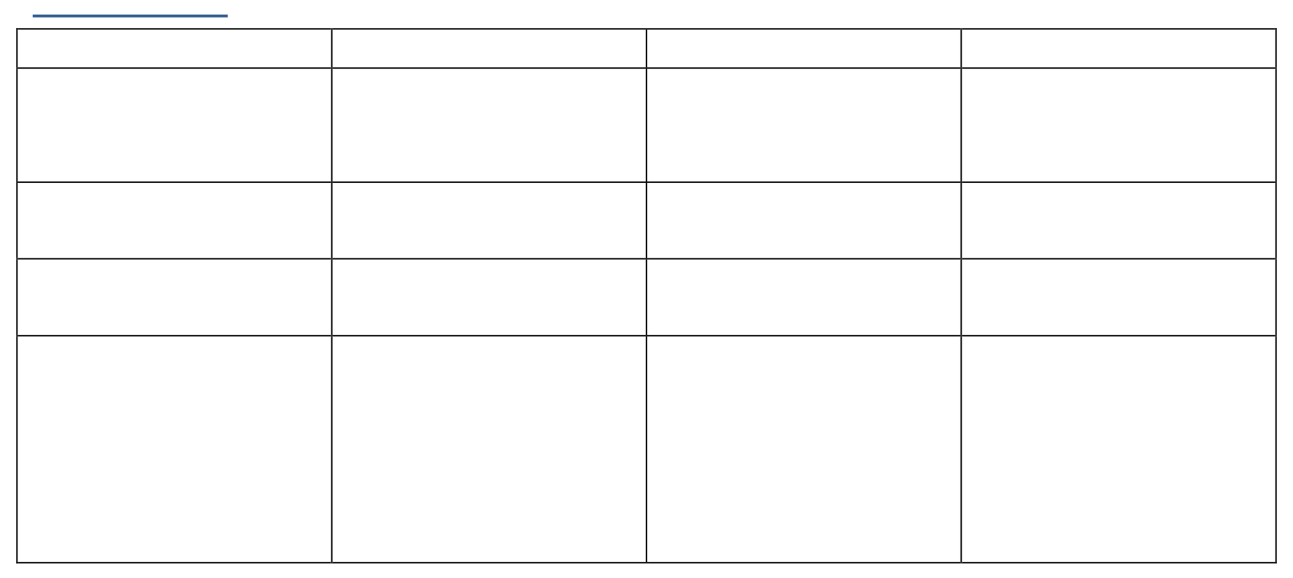

Member
Tejas Hudekar

Avinash
Samiksha

Role

Homepage
Developer

Profile Section
Developer Projects

Section

Developer

GitHub Manager &

Contact Section

Developer

Branch
home-page

profile-section
projects-section
contact-section

Responsibilities
Homepage,
navigation,
introduction

Profile
cards,
skills,
GitHub links Projects
section and

project cards

Repository,

collaborators,

branches, PR

review, merges,

deployment, contact

form

TeamRoles
SIdheshwar

Project Objectives
The main objectives of this project were:
- Develop a responsive student portfolio website.
- Learn collaborative software development.
- Gain practical experience with Git and GitHub.
- Implement feature branching and version control.
- Practice Pull Requests and code reviews.
- Improve teamwork and communication.
- Deploy the final project using GitHub Pages.

Project Overview
The website consists of four major sections:
- Homepage
- Student Profiles
- Projects
- Contact
Each section was developed independently by a team member using a separate Git branch. After development, the GitHub Manager reviewed and merged all contributions into the main branch.

Technologies Used Frontend
- HTML5
- CSS3
- JavaScript

Version Control
Git
GitHub
•
•
Deployment
• GitHub Pages

Git & GitHub Workflow
The project followed an industry-standard Git workflow.
Step 1
Create Repository
Step 2
Clone Repository git clone https://github.com/Pravin-junne/student-portfolio.git
Step 3
Create Feature Branch
Example
git checkout -b home-page
git checkout -b profile-section

git checkout -b projects-section
git checkout -b contact-section
Step 4

Develop Feature
Each student completed their assigned module independently.
Step 5

Commit Changes
git add . git commit -m "Completed Homepage"
Step 6
Push Branch git push origin home-page
Step 7

Create Pull Request
Each member created a Pull Request on GitHub.
Step 8

Review Pull Request
The GitHub Manager reviewed all submitted Pull Requests.
Step 9

Merge Pull Request
Approved Pull Requests were merged into the main branch.
Step 10

Deploy
The final website was deployed using GitHub Pages.

Branching Strategy main
│
├──home-page
│
├──profile-section
│
├──projects-section
│
└──contact-section

Team Roles and Responsibilities

Student 1 – Sidheshwar(Homepage Developer)
Branch: home-page
Responsibilities:
- Designed the homepage.
- Created the navigation bar.
- Added website title.
- Added introduction section.
- Submitted Pull Request.

Student 2 – Parikshit (Profile Section Developer)
Branch: profile-section
Responsibilities:
- Created profile cards.
- Added student names.
- Added skills.
- Added GitHub profile links.
- Submitted Pull Request.

Student 3 – Tejas (Projects Section Developer)
Branch: projects-section
Responsibilities:
- Developed Projects section.
- Added three project cards.
- Added project descriptions.
- Mentioned technologies used.
- Submitted Pull Request.
Student 4 – Avinash (GitHub Manager & Contact Section Developer)
Branch: contact-section
Responsibilities:
GitHub Management
- Created GitHub repository.
- Added collaborators.
- Managed branches.
- Reviewed Pull Requests.
- Merged all approved Pull Requests.
- Maintained repository.
Website Development
- Built Contact section.
- Added Email field.
- Added Message field.
- Added Submit button.
Deployment
- Published website using GitHub Pages.
- Verified live deployment.

Conclusion
The Student Skill Portfolio Website project successfully demonstrated collaborative software development using Git and GitHub. By dividing the project into separate modules and following a structured branching strategy, the team was able to work efficiently and integrate all features through Pull Requests. The project strengthened our understanding of version control, collaborative development, responsive web design, and deployment using GitHub Pages. Overall, it provided valuable practical experience that reflects real-world software development practices.

PullRequests and Merge Process
Feature Branch
↓
Commit ↓
Push
↓
Pull Request
↓
Review
↓
Approve
↓
Merge into Main
↓
Deployment
Screenshots Homepage:
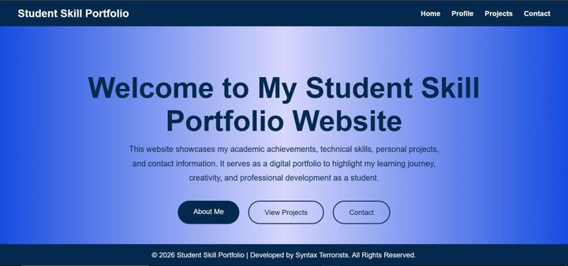
Register and Log-in
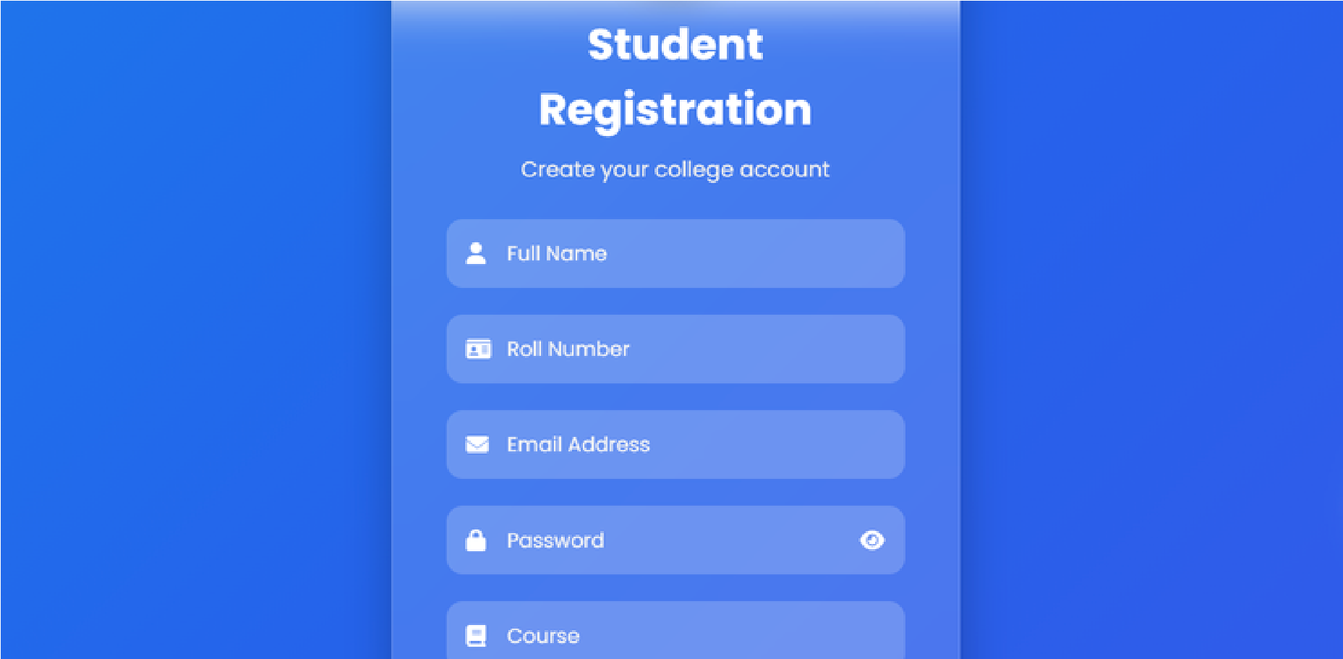
Contact Section:
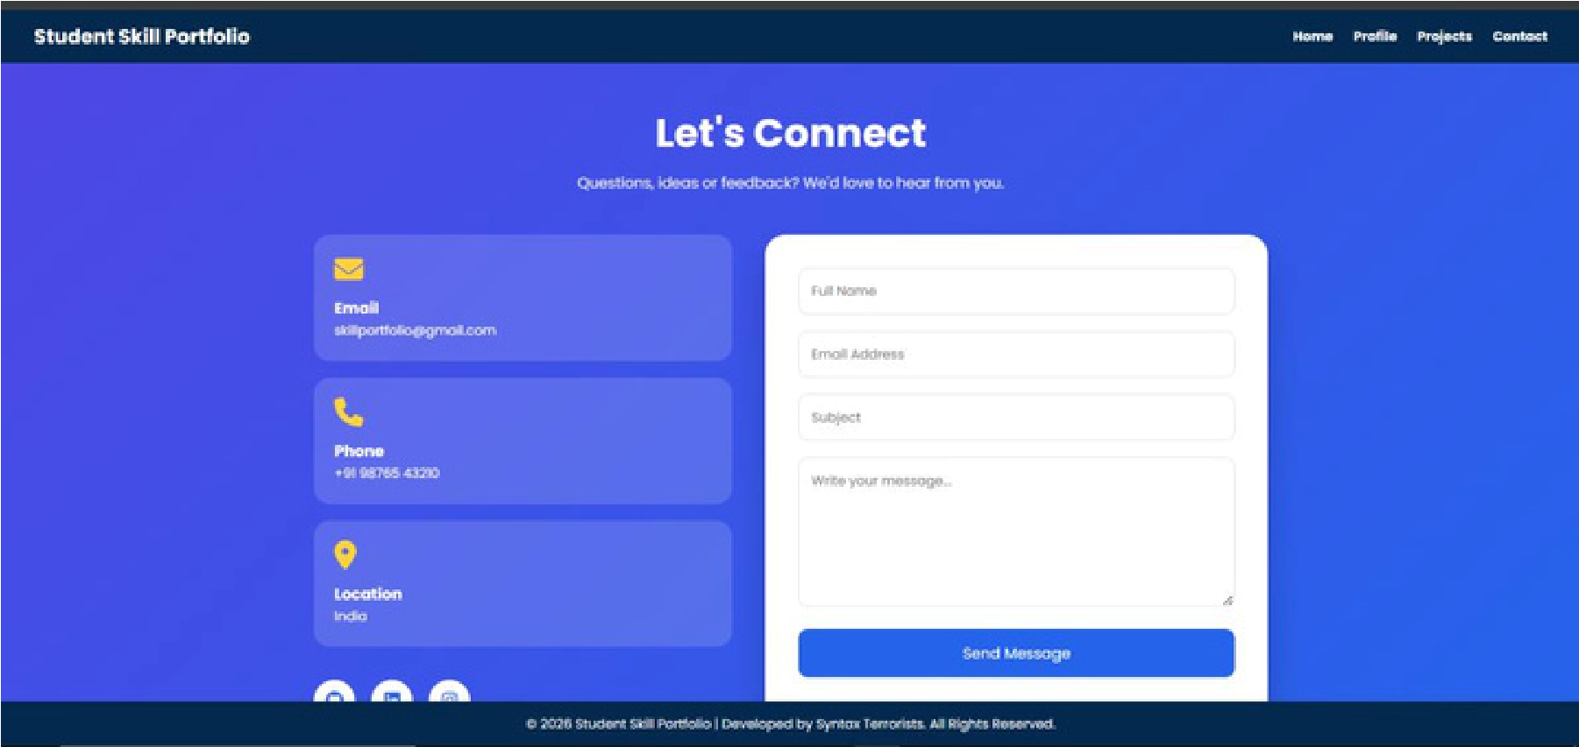
GitHub Repository:
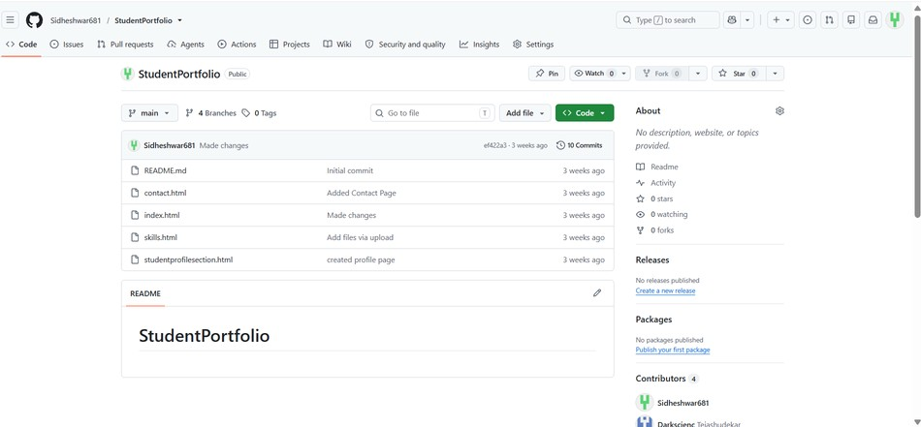
Branches:
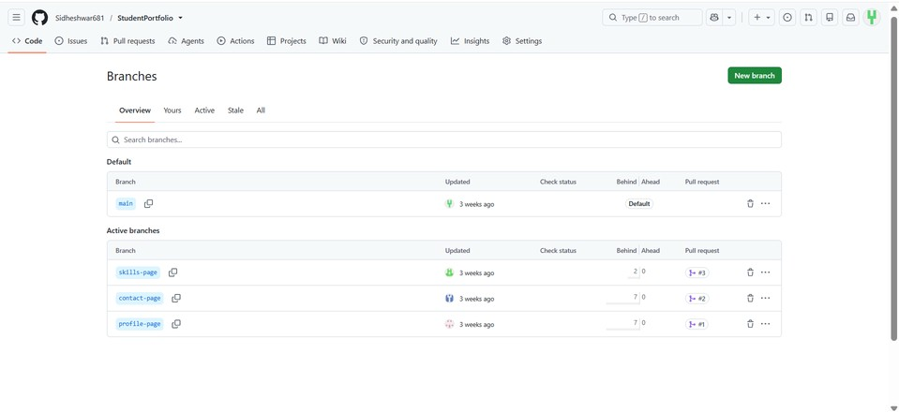
Commit History:
