Table of Contents

Summary Data: 2

Hierarchical Clustering: 2

Steps Performed: 2

K-MEANS CLUSTERING 4

Conclusion: 5

SUMMARY DATA : 6

BOXPLOT: 6

STEPS PERFORMED 7

Conclusion: 8

K-MEANS CLUSTERING 8

Scatter Plot: 9

Word CLOUD: 10

Conclusion: 10

Question no 1

Perform clustering (Both hierarchical and K means clustering) for the airlines data to obtain optimum number of clusters. Draw the inferences from the clusters obtained.

# Summary Data:



Data contains 12 columns, out of which 3 column contains factor values.

# Hierarchical Clustering:

Before going to hierarchical clustering, I build a function for normalization as well as converting dummy variable for the factor columns. I created another function to check whether which of the 8-linkage method is applicable for my hierarchical clustering.

* normalize_dummy (x) # Here x should be in data frame

No matter whether your data contains factor column or not. In this function all numeric columns will be transformed to normalize and the factor columns get their dummies respectively.

* all_hclust (dist,k) # Here dist is distance matrix, and k is no of clusters (cuttree) you want.

This function is for clustering purpose, where we can see the results of all the clusters generated by the 8 linkages "single", "complete", "average", "mcquitty", "ward.D", "ward.D2", "centroid","median". So, now I don’t have to check for each and every clusters. I can choose as my desire.

## Steps Performed:

1. Converted the type of the 3 numeric columns i.e. (cc1_miles, cc2_miles, cc3_miles) as factor using as.factor.
2. Using these two functions I normalize my data using normalize_dummy.
3. Calculate the distance matrix using dist function.
4. Calculated all the 8 possible hierarchical-clusters using function all_hclust.
5. Viewed the no of points in each cluster.



1. From the above plot we come up with the best method will be ward.D2.
2. Then we find out for the mean for numeric data and mode for categorical data as the representative of my clusters.

|  |  |  |  |  |  |  |  |  |  |
| --- | --- | --- | --- | --- | --- | --- | --- | --- | --- |
| Group.1 | Balance | Qual_ miles | Bonus_ miles | Bonus_ trans | Flight_ miles_12mo | Flight_t rans_12 | Days_since  _enroll | Award. | cc1_ miles |
| 1 | 50475.78 | 143.98 | 3913.68 | 6.68 | 462.87 | 1.39 | 3754.43 | 0.25 | 1.00 |
| 2 | 116321.43 | 162.23 | 43138.42 | 19.10 | 536.66 | 1.62 | 4763.46 | 0.57 | 4.00 |
| 3 | 83234.79 | 111.94 | 19856.30 | 16.55 | 311.24 | 0.87 | 4320.37 | 0.46 | 3.00 |

1. Here in this above table Green labeled are Higher Values, Red values are Least values, and Yellow are moderate values.
2. Then I take a subsample from the whole record and perform the same clustering Again to see the Expected values in the Grouped data.

|  |  |  |  |  |  |  |  |  |  |
| --- | --- | --- | --- | --- | --- | --- | --- | --- | --- |
| Group.1 | Balance | Qual_ miles | Bonus_ miles | Bonus_ trans | Flight_miles _12mo | Flight_trans _12 | Days_since _enroll | Award. | cc1_ miles |
| 1 | 49055.92 | 152.08 | 3740.67 | 6.59 | 449.81 | 1.35 | 3734.89 | 0.24 | 1.00 |
| 2 | 85906.15 | 90.32 | 19830.39 | 16.38 | 315.73 | 0.87 | 4403.89 | 0.48 | 4.00 |
| 3 | 118905.84 | 143.07 | 43995.69 | 19.25 | 549.26 | 1.68 | 4733.21 | 0.58 | 3.00 |

1. Looking at the 2 patterns in the above two tables here we can see cluster 2 in sampled data is similar as in cluster 3 in sampled data.

we can see that the pattern is differ only for column Qual_miles and cc1_miles.

As overall allocation is kind similar in case of both Sampled and Whole data, so we can say that we may rely in this grouping.

1. Then I plotted the Dendrogram. And saved it as a pdf file, as we can’t visualize it properly inside our RStudio.

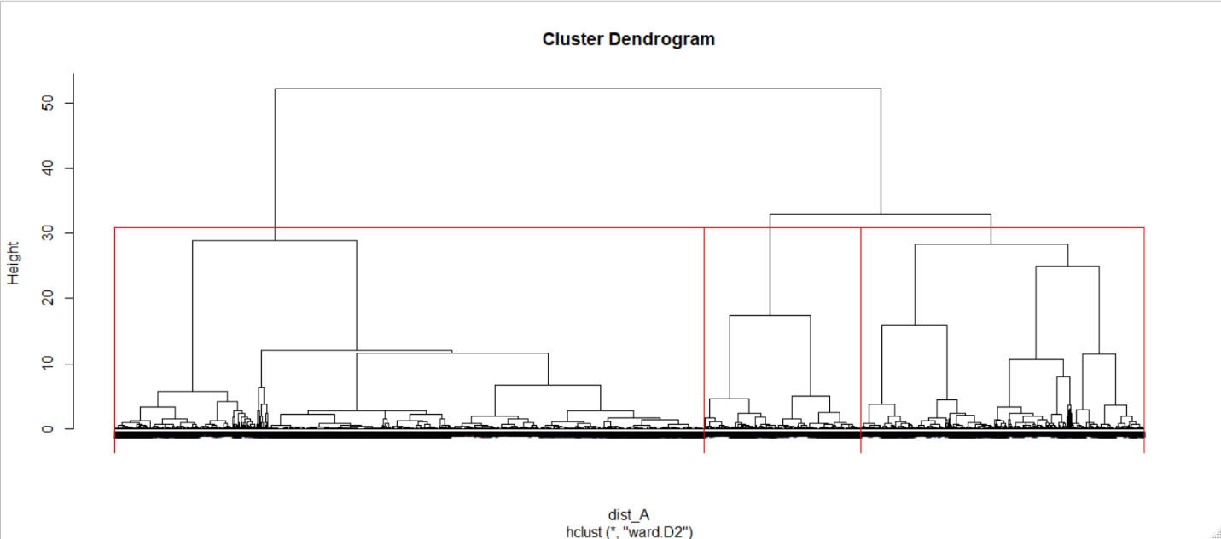

# K-MEANS CLUSTERING

For Deciding my K value, i.e. deciding my number of clusters to take, I go for my Scree plot with different values of k from 1 to 10.

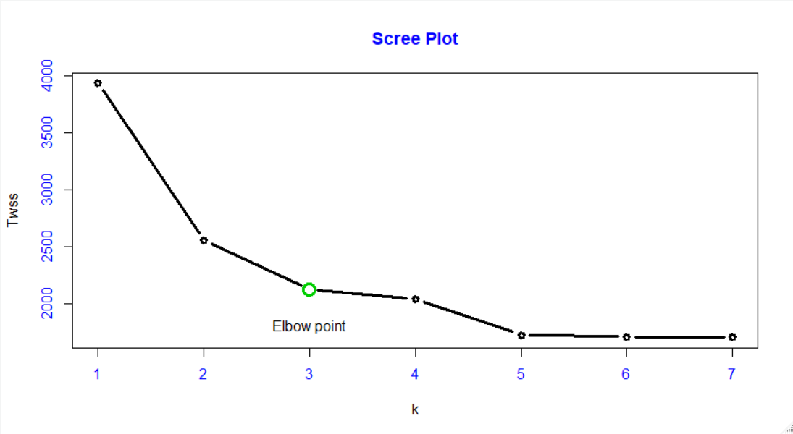

Here I got my Elbow point as 5 so I decide my k as 3.

And I perform my Clustering for k as 3

|  |  |  |  |
| --- | --- | --- | --- |
| Group no 🡪 | 1 | 2 | 3 |
| Number of Records | 568 | 1710 | 1721 |

|  |  |  |  |  |  |  |  |
| --- | --- | --- | --- | --- | --- | --- | --- |
| Group.1 | Balance | Bonus_  miles | Bonus_  trans | Flight_miles  _12mo | Flight_trans  _12 | Days_since  _enroll | Award. |
| 1 | 87144.18 | 7986.81 | 9.49 | 1137.38 | 3.48 | 4330.85 | 1.00 |
| 2 | 104895.91 | 34789.08 | 18.21 | 457.59 | 1.36 | 4606.83 | 0.53 |
| 3 | 38037.08 | 2635.91 | 5.73 | 238.96 | 0.70 | 3563.35 | 0.00 |

From Above We can say that the 3rd cluster is always having the least values for each and every column.

## Conclusion:

Group 1 represents the 14% of the travelers, which are most frequent travelers according to our data set, also all of the travelers are awarded with offers as we can see award = 1. Their Flight miles in 12 months are very much as compare to other groups. These Customers are associated with the East West Airlines since a long time.

Group 2 represents 42% of the travelers (customers) who are with once or twice travelled in the whole year as flight transition is 1.36, out of which about 53% are awarded with offers. So, we may say that this group consists of Middle-class Travelers.

Group 3 represents 43% of the travelers, who are not at all awarded as they are our non-frequent and new customers. They have flight transitions over the 12 months is nearly zero. So, we may consider them as our non-frequent travelers.

From the above we can say that, we should focus on the major part of our customers i.e. 43%, which are in our group 3. If we do some concession or offers for them, maybe we come up with profit in our business. Those who are in group 1, those are our frequent travelers, so they don’t bother about any kind of concessions.

QUESTION NO 2

Perform Clustering for the crime data and identify the number of clusters formed and draw inferences.

# SUMMARY DATA :

|  |  |  |  |
| --- | --- | --- | --- |
| Murder | Assault | Urban Pop | Rape |
| Min. : 0.800 | Min. : 45.0 | Min. :32.00 | Min. : 7.30 |
| 1st Qu.: 4.075 | 1st Qu.:109.0 | 1st Qu.:54.50 | 1st Qu.:15.07 |
| Median : 7.250 | Median :159.0 | Median :66.00 | Median :20.10 |
| Mean : 7.788 | Mean :170.8 | Mean :65.54 | Mean :21.23 |
| 3rd Qu.:11.250 | 3rd Qu.:249.0 | 3rd Qu.:77.75 | 3rd Qu.:26.18 |
| Max. :17.400 | Max. :337.0 | Max. :91.00 | Max. :46.00 |

Mean and median of every column seems like approximately same, so we can say there may be no outliers, if than in very less numbers.

# BOXPLOT:

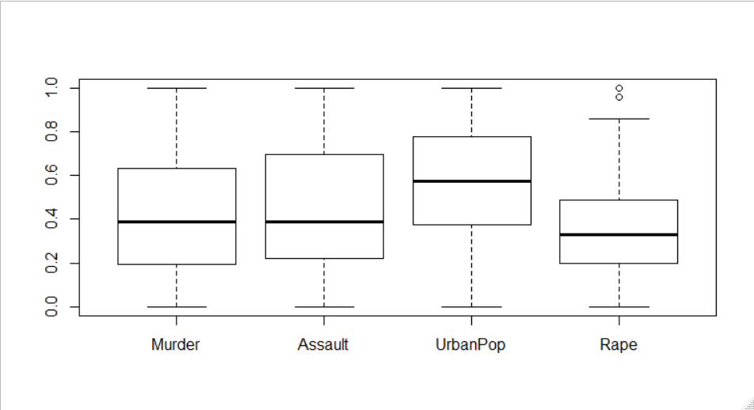From the boxplot for normalized data, we can see only 2 outliers in the column “Rape”. So we may proceed with this Data for my clustering.

# STEPS PERFORMED

1. Normalized the using the function I defined prior i.e. normalize_dummy,.
2. Calculated distance among each and every records in my data, using the Euclidian distance and the function dist.
3. Calculated all possible clusters for my crime data using my function all_hclust. With number of cluster as 3.
4. The Table of linkage methods and the number of records in each cluster can be seen by this table.

|  |  |  |  |  |
| --- | --- | --- | --- | --- |
|  | method | Group 1 | Group 2 | Group 3 |
| 1 | single | 48 | 1 | 1 |
| 2 | complete | 20 | 20 | 10 |
| 3 | average | 19 | 1 | 30 |
| 4 | mcquitty | 22 | 21 | 7 |
| 5 | ward.D | 20 | 18 | 12 |
| 6 | ward.D2 | 20 | 18 | 12 |
| 7 | centroid | 48 | 1 | 1 |
| 8 | median | 37 | 1 | 12 |

1. From this I may consider “complete”, or “ward.D2”, so I proceed with the ward.D2 clustering method calculated expected values for each column with respect to each groups.

|  |  |  |  |  |
| --- | --- | --- | --- | --- |
| Group.1 | Murder | Assault | UrbanPop | Rape |
| 1.00 | 12.17 | 255.25 | 68.40 | 29.17 |
| 2.00 | 6.06 | 140.06 | 71.33 | 18.68 |
| 3.00 | 3.09 | 76.00 | 52.08 | 11.83 |

1. Dendrogram:
2. From the Dendrogram we can classify the Place names and their Crime Rate.
3. Then we performed the same Experiment to check the stability of clustering with respect to a new sample from the Crime data.

|  |  |  |  |  |
| --- | --- | --- | --- | --- |
| Population | Murder | Assault | UrbanPop | Rape |
| 1.00 | 12.17 | 255.25 | 68.40 | 29.17 |
| 2.00 | 6.06 | 140.06 | 71.33 | 18.68 |
| 3.00 | 3.09 | 76.00 | 52.08 | 11.83 |

|  |  |  |  |  |
| --- | --- | --- | --- | --- |
| Sample | Murder | Assault | UrbanPop | Rape |
| 1 | 12.18182 | 260.6364 | 69.45455 | 29.85455 |
| 2 | 3.136364 | 74.63636 | 55.63636 | 12.87273 |
| 3 | 6.35 | 152.8333 | 70.94444 | 20.45 |

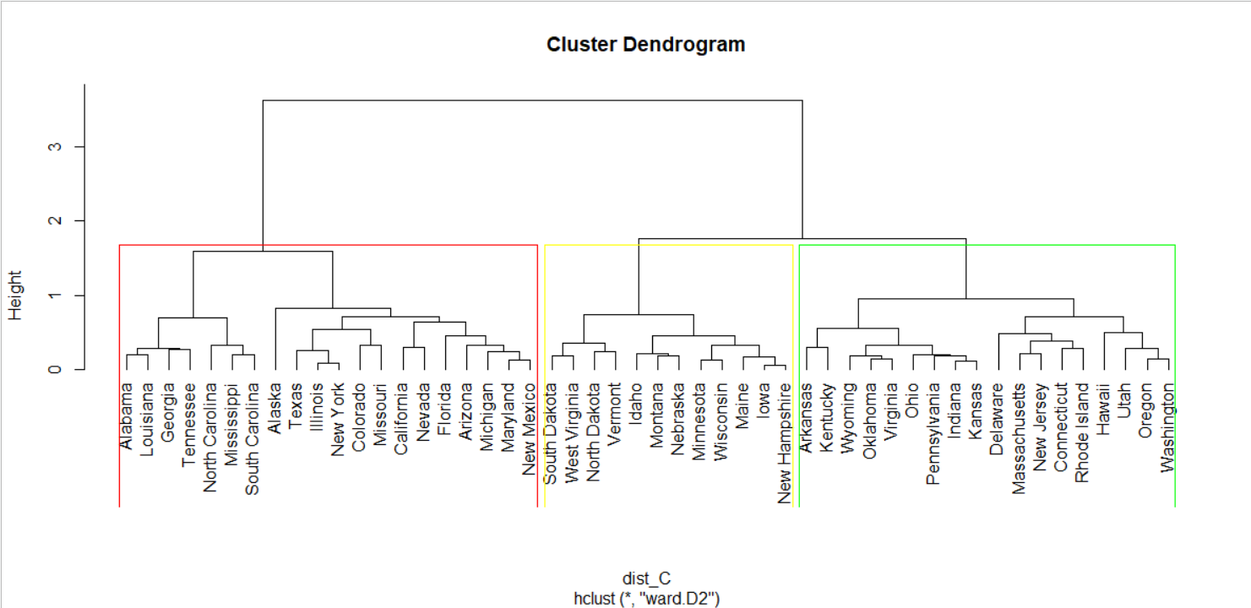

## Conclusion:

If we look at the clusters here, group 1 from population is similar as group 1 in sample 1, mean difference is very little. Group 2 from population is similar as group 3 in sample.

So we may say that those places which belongs to group 1 are at high risk, and places which belongs to group 2 is also considered as a Risky place for visitors, but little bit less compare to group 1, among these 3 groups , the places belongs to group 3 may be considered as least risk for the tourists.

# K-MEANS CLUSTERING

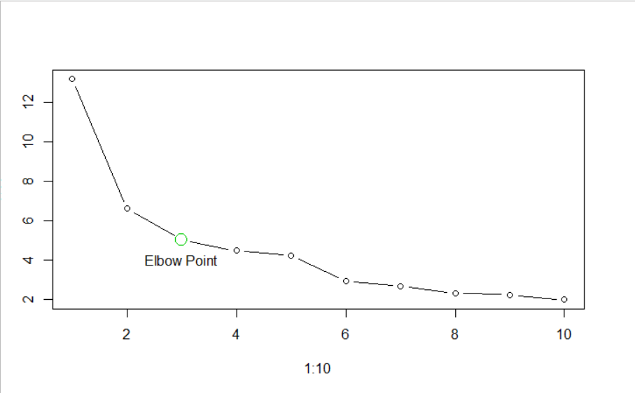To choose my best k value for performing K-Means clustering, I do my Scree Plot

Here I got my elbow point for k as 3, so I perform my K-Means Clustering with k (number of cluster as 3).

I come up with the Result in the Tabular format.

|  |  |  |  |  |
| --- | --- | --- | --- | --- |
| Group.1 | Murder | Assault | UrbanPop | Rape |
| 1 | 2.981818 | 73.63636 | 51.18182 | 11.40909 |
| 2 | 12.33158 | 259.3158 | 68.31579 | 29.21579 |
| 3 | 6.115 | 140.05 | 70.8 | 19.05 |

The Expected values in each of our ariables with respect to the groups of clusters matches to the output of the Hierarchical Clustering.

## Scatter Plot:

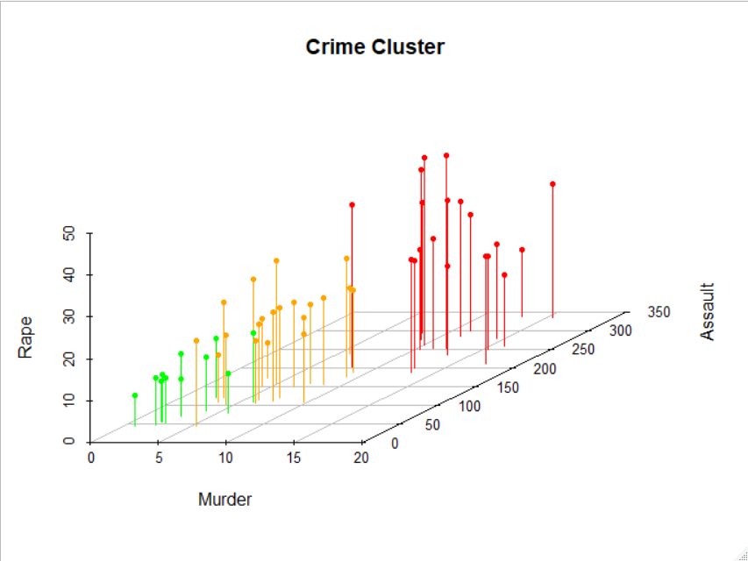

## Word CLOUD:

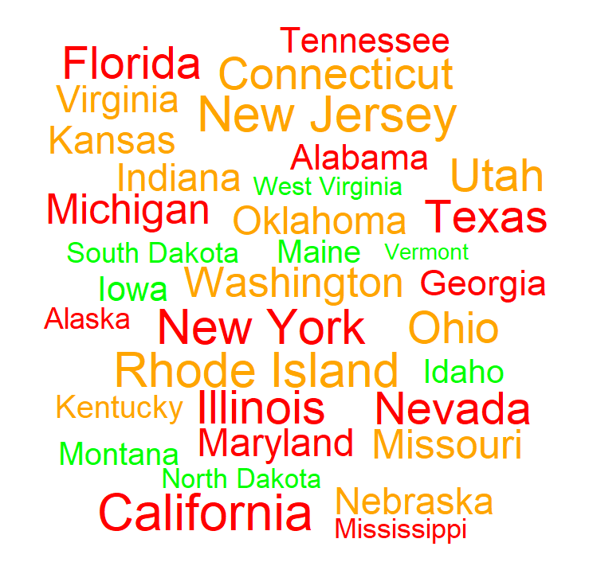

This word cloud TEXT SIZE is based on the population of the locations and TEXT COLOUR based on the crime rate.

Red represents higher crime rate compare to all, yellow represents moderate and green represents least crime rate areas.

## Conclusion:

Here each dot is representing each location, based on color green colored dots have low chances of crime in the location, whereas yellow for moderate crime and red for High rate in crime.

We may Focus on our group 2 i.e. red areas where crime rate is very high, we may deploy more Interceptors for those areas which locations are in group 2 with exotic series of vehicles with armed force for night duty.

Based on group 3 where we can find moderate crime, there we may create Awareness for the safety of people and make the Police department quick responsive introducing some sports series vehicles for them.

Sorry for the funny conclusion.