NAIVE BAYES

# Question No 1 (Spam and Ham Message Classification)

After Data import, I am curious that which kind of messages are of spam category. So, I call the library “textcat “ then run the code

**table(textcat(x = message$type),message$type)**

ham spam

latvian 0 747

norwegian 4812 0

From here itself I am able to classify whether the message is Spam or Ham, we can say that the messages are categories as Latvian can be classified as Spam. This was a try hit method, not applicable each and every time.

But here our major focus is to go for our Naïve Bayes method,

* Converted the message to a Carpus using the library tm
* Cleaning of data as performed in Text mining i.e. data pre processing
* Convert the corpus to Document Term Matrix
* Perform train test split in the original data, corpus data and as well as the Document Term Matrix data.
* Perform WordCloud with the Original train data to see the frequent words used in spam message (in **Red** colour) as well as the frequently used words in Ham messages (in **Blue** Colour)
* Reduce the dimension of Document_Term_Matrix data, using the findFrequentTerms function.
* Finally fit our model using the naiveBayes function in library e1071 and come up with the confusion matrix

Actual

Predicted ham spam

ham 1422 37

spam 7 202

* Here my efficiency of my model is 0.9736, and I am happy with it.

# Question No 2 (Classification with the salary data )

Lets see the structure of our data:

'data.frame': 30161 obs. of 14 variables:

$ age : int 39 50 38 53 28 37 49 52 31 42 ...

$ workclass : Factor w/ 7 levels " Federal-gov",..: 6 5 3 3 3 3 3 5 3 3 ...

$ education : Factor w/ 16 levels " 10th"," 11th",..: 10 10 12 2 10 13 7 12 13 10 ...

$ educationno : int 13 13 9 7 13 14 5 9 14 13 ...

$ maritalstatus: Factor w/ 7 levels " Divorced"," Married-AF-spouse",..: 5 3 1 3 3 3 4 3 5 3 ...

$ occupation : Factor w/ 14 levels " Adm-clerical",..: 1 4 6 6 10 4 8 4 10 4 ...

$ relationship : Factor w/ 6 levels " Husband"," Not-in-family",..: 2 1 2 1 6 6 2 1 2 1 ...

$ race : Factor w/ 5 levels " Amer-Indian-Eskimo",..: 5 5 5 3 3 5 3 5 5 5 ...

$ sex : Factor w/ 2 levels " Female"," Male": 2 2 2 2 1 1 1 2 1 2 ...

$ capitalgain : int 2174 0 0 0 0 0 0 0 14084 5178 ...

$ capitalloss : int 0 0 0 0 0 0 0 0 0 0 ...

$ hoursperweek : int 40 13 40 40 40 40 16 45 50 40 ...

$ native : Factor w/ 40 levels " Cambodia"," Canada",..: 38 38 38 38 5 38 22 38 38 38 ...

$ Salary : Factor w/ 2 levels " <=50K"," >50K": 1 1 1 1 1 1 1 2 2 2 ...

Here my data contains 9 factor columns and 5 numeric variables. So, here I am going to pass my function normalized dummy to normalize the whole data as well as create dummy variables for all the factor data.

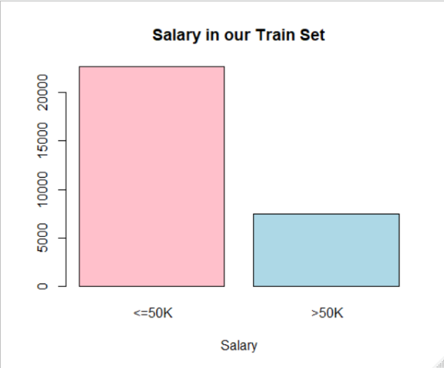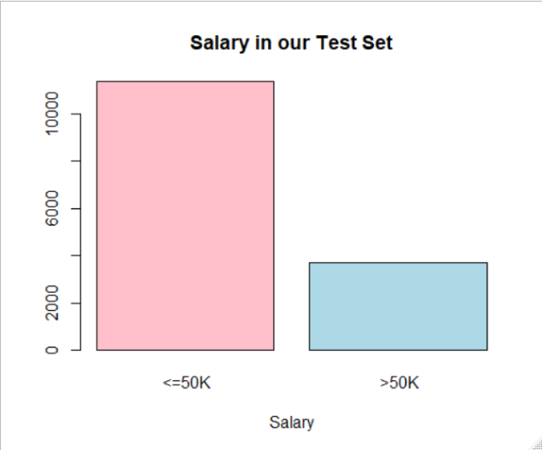Let’s have a look on our Salary (categorical) variable:

Although it’s imbalanced. I may balance the data if I find something specious in my results.

## Boxplot of Numerical Variables in test data set after the normalization :

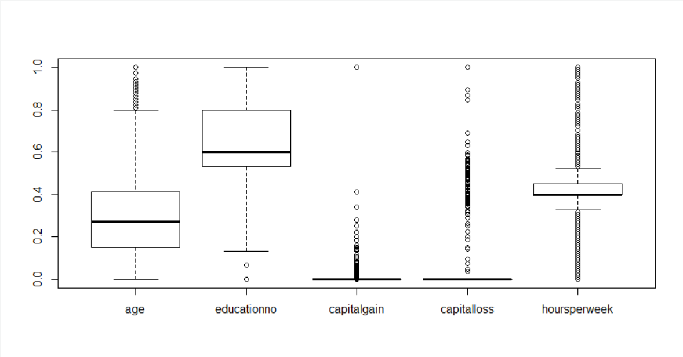Here we can see lots of outlier in my data, so in such scanerio I may not consider to remove them as I may face loss of lots of informations.

So I consider to move for my model fitting with the normalised dummy data.

## Model 1 Without Laplace Smoothing:

Summary of my model is

Length Class Mode

apriori 2 table numeric

tables 102 -none- list

levels 2 -none- character

isnumeric 102 -none- logical

call 3 -none- call

Here I got my efficiency as 0.78373.

With the confusion matrix as given below

Predicted

Actual <=50K >50K

<=50K 10753 607

>50K 2650 1050

With Laplace smoothing also I come up with the same result

So here my conclusion is with my efficiency as 0.78373