**AZURE MULESOFT MAIN ASSIGNMENT**

1. **GET -** /getKey  
   **Description:** This endpoint will get azure keyvault secrets.  
     
   **Flow:**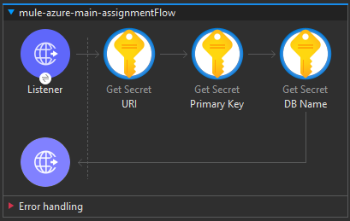
2. **POST -** /createDoc

**Description:** Used to create a new item in Student Container within Azure Cosmos DB.  
  
**Flow:**

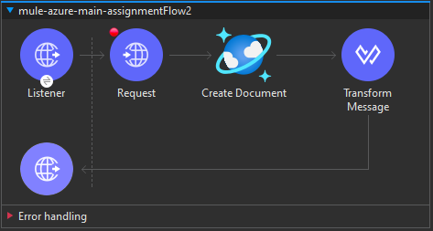  
  
**Response Screenshot:**  
  
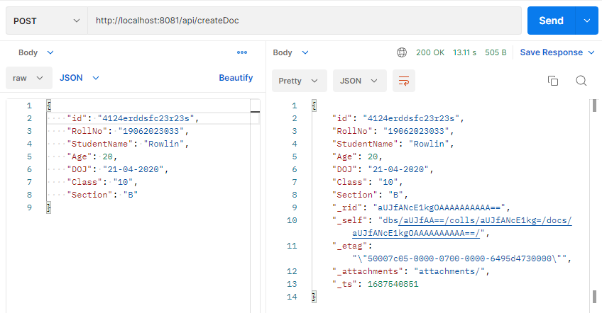

1. **GET -** /getAndLoadData

**Description:** To list all items in container and load that data in azure file storage.

**Flow:  
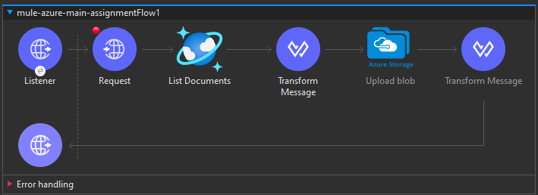**

**Response Screenshot:**  
  
