**JAVA MULESOFT MAIN ASSIGNMENT**

1. Postman response

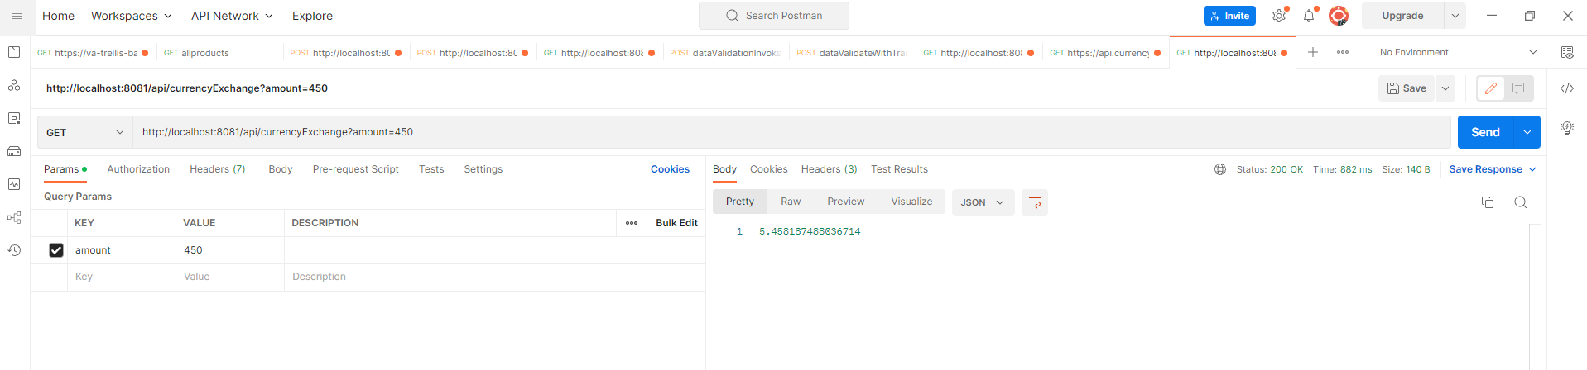

1. Mule Flow

