**MINI ASSIGNMENT**

**(JAVA SPRING MODULE)**

**Problem Statement-1**

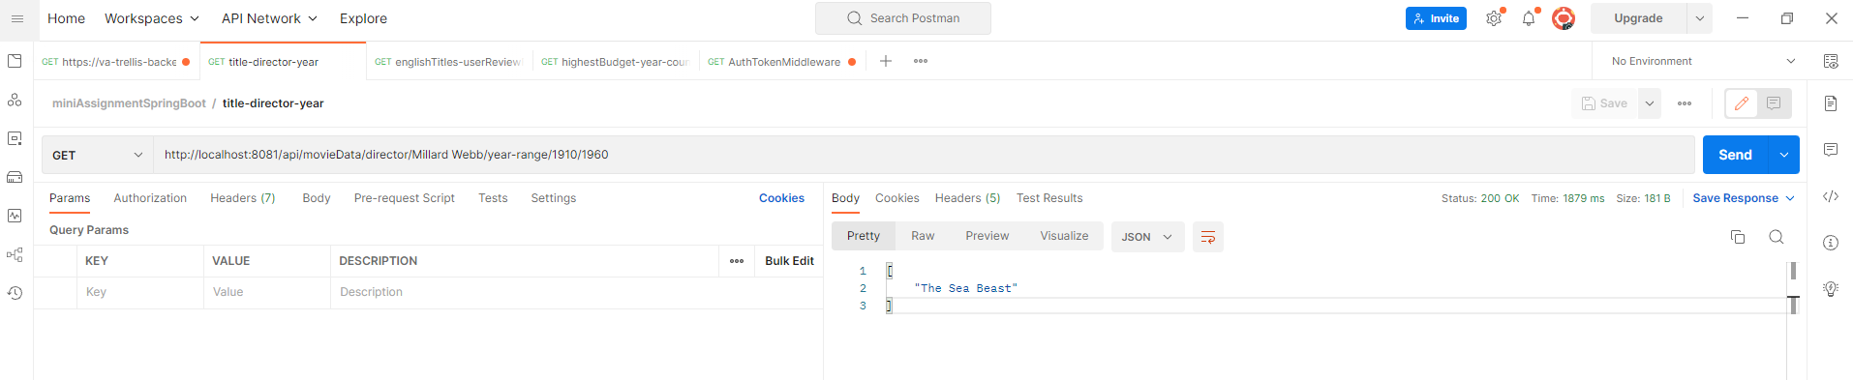

**Problem Statement-2**

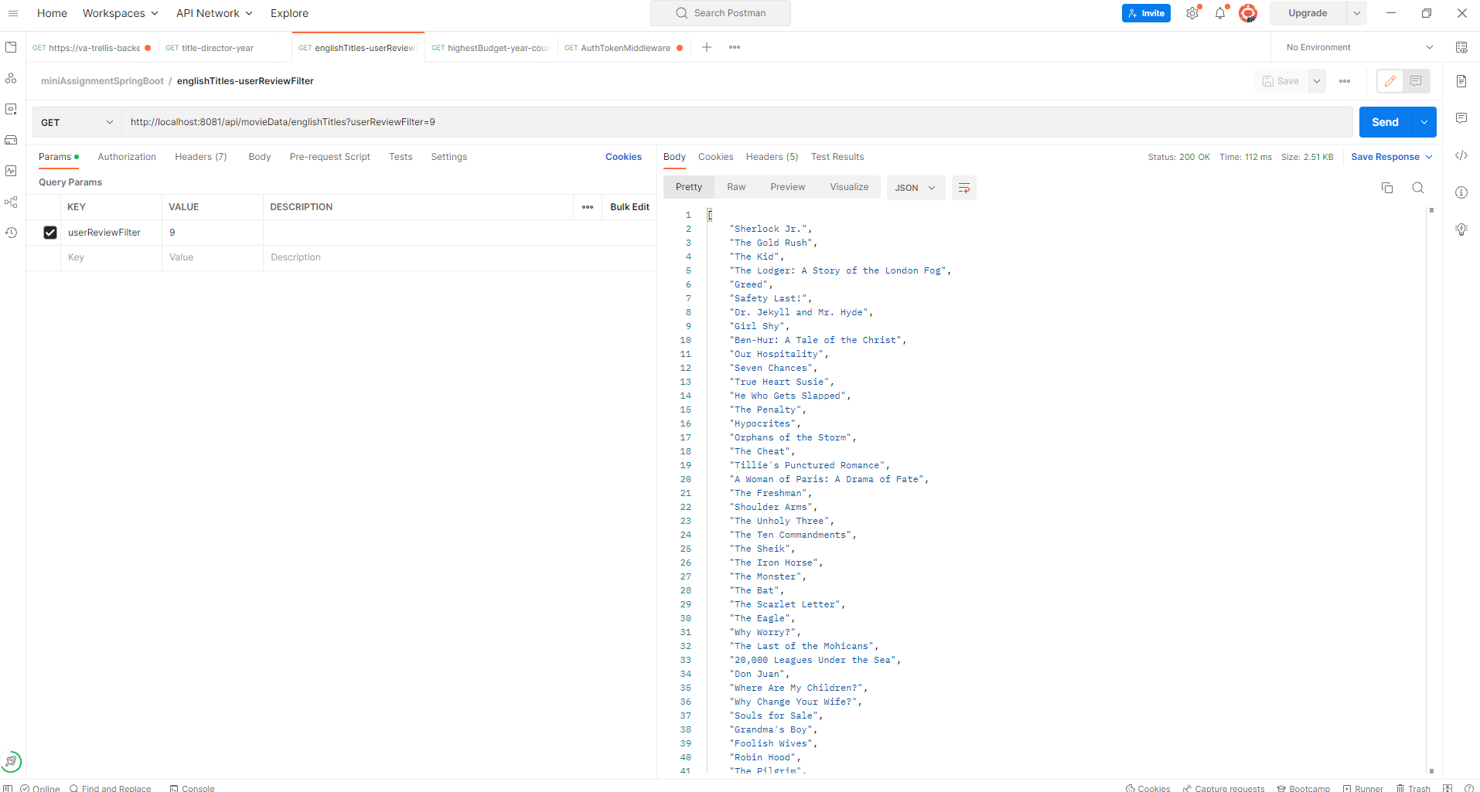

**Problem Statement-3**

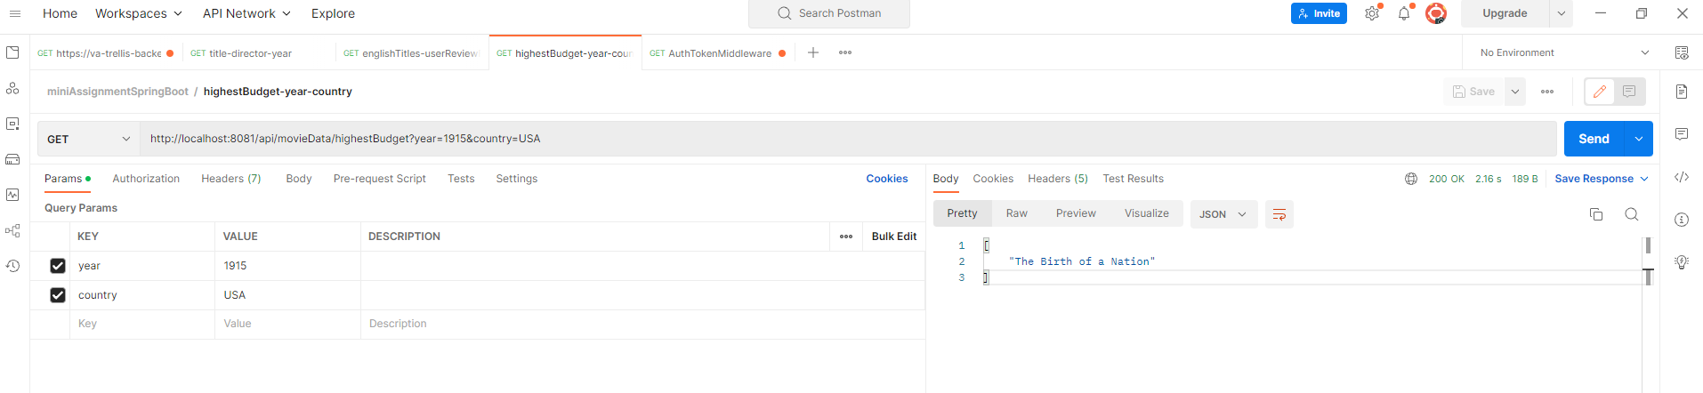

**Problem Statement-5**



