Learn to Program with Minecraft

**MORE SMART BOOKS FOR CURIOUS KIDS!** 

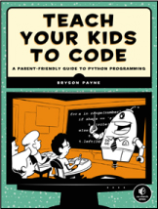

**TEACH YOUR KIDS TO CODE**

**A Parent-Friendly Guide to Python Programming**

*by* BRYSON PAYNE

APRIL 2015, 336 PP., $29.95

ISBN 978-1-59327-614-0

*full color*

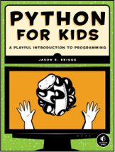

**PYTHON FOR KIDS**

**A Playful Introduction to Programming**

*by* JASON R. BRIGGS

DEC 2012, 344 PP., $34.95

ISBN 978-1-59327-407-8

*full color*

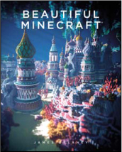

**BEAUTIFUL MINECRAFT**

*by* JAMES DELANEY

FALL 2016, 112 PP., $19.95

ISBN 978-1-59327-765-9

*full color*, *hardcover*

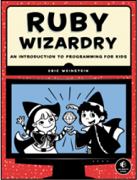

**RUBY WIZARDRY**

**An Introduction to Programming for Kids**

*by* ERIC WEINSTEIN

DEC 2014, 352 PP., $29.95

ISBN 978-1-59327-566-2

*two color*

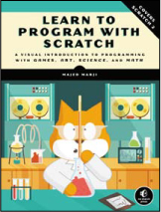

**LEARN TO PROGRAM WITH SCRATCH**

**A Visual Introduction to Programming with Games, Art, Science, and Math**

*by* MAJED MARJI

FEB 2014, 288 PP., $34.95

ISBN 978-1-59327-543-3

*full color*

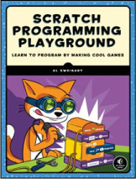

**SCRATCH PROGRAMMING PLAYGROUND**

**Learn to Program By Making Cool Games**

*by* AL SWEIGART

FALL 2016, 288 PP., $24.95

ISBN 978-1-59327-762-8

*full color*

**1.800.420.7240 or 1.415.863.9900 |** [**sales@nostarch.com**](mailto:sales@nostarch.com) **|** [**www.nostarch.com**](http://www.nostarch.com)