Unknown

# **PYTHON FOR KIDS**

# **2ND EDITION**

**A PLAYFUL INTRODUCTION TO PROGRAMMING**

**by Jason R. Briggs**

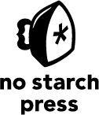

**San Francisco**