**LAB EXERCISE 1**

**By Dino Alfred T. Timbol**

**Link to Github Repository**: <https://github.com/neoboi76/timbol-IT128>

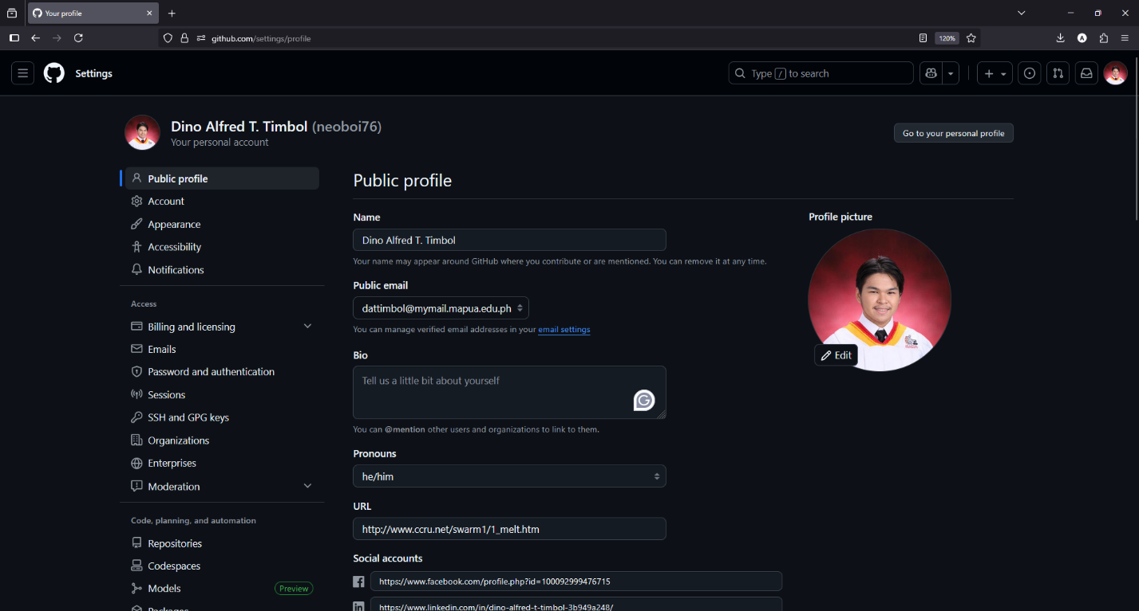**Getting Started (Screenshots)**

**Check whether git was successfully installed (Screenshots)**

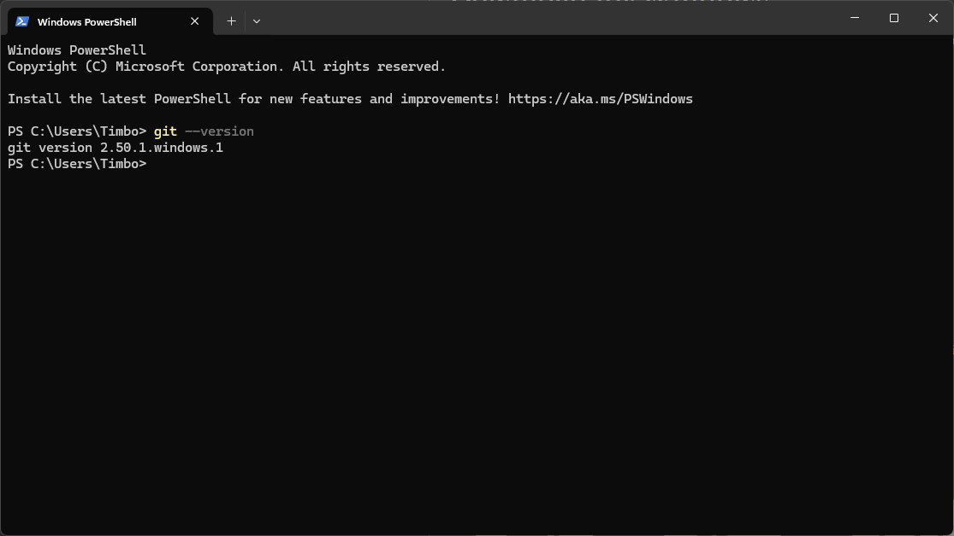

**Create a Github Repository (Screenshots)**

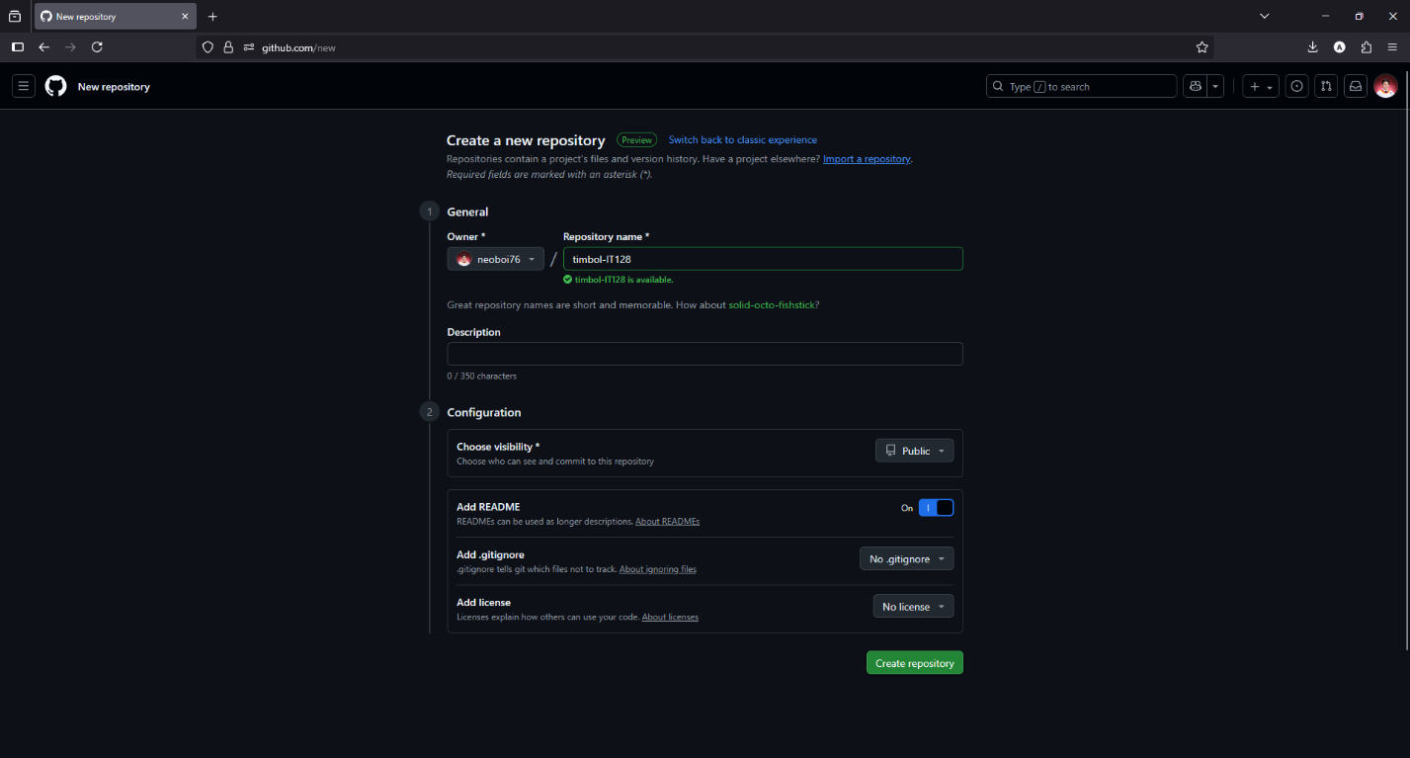

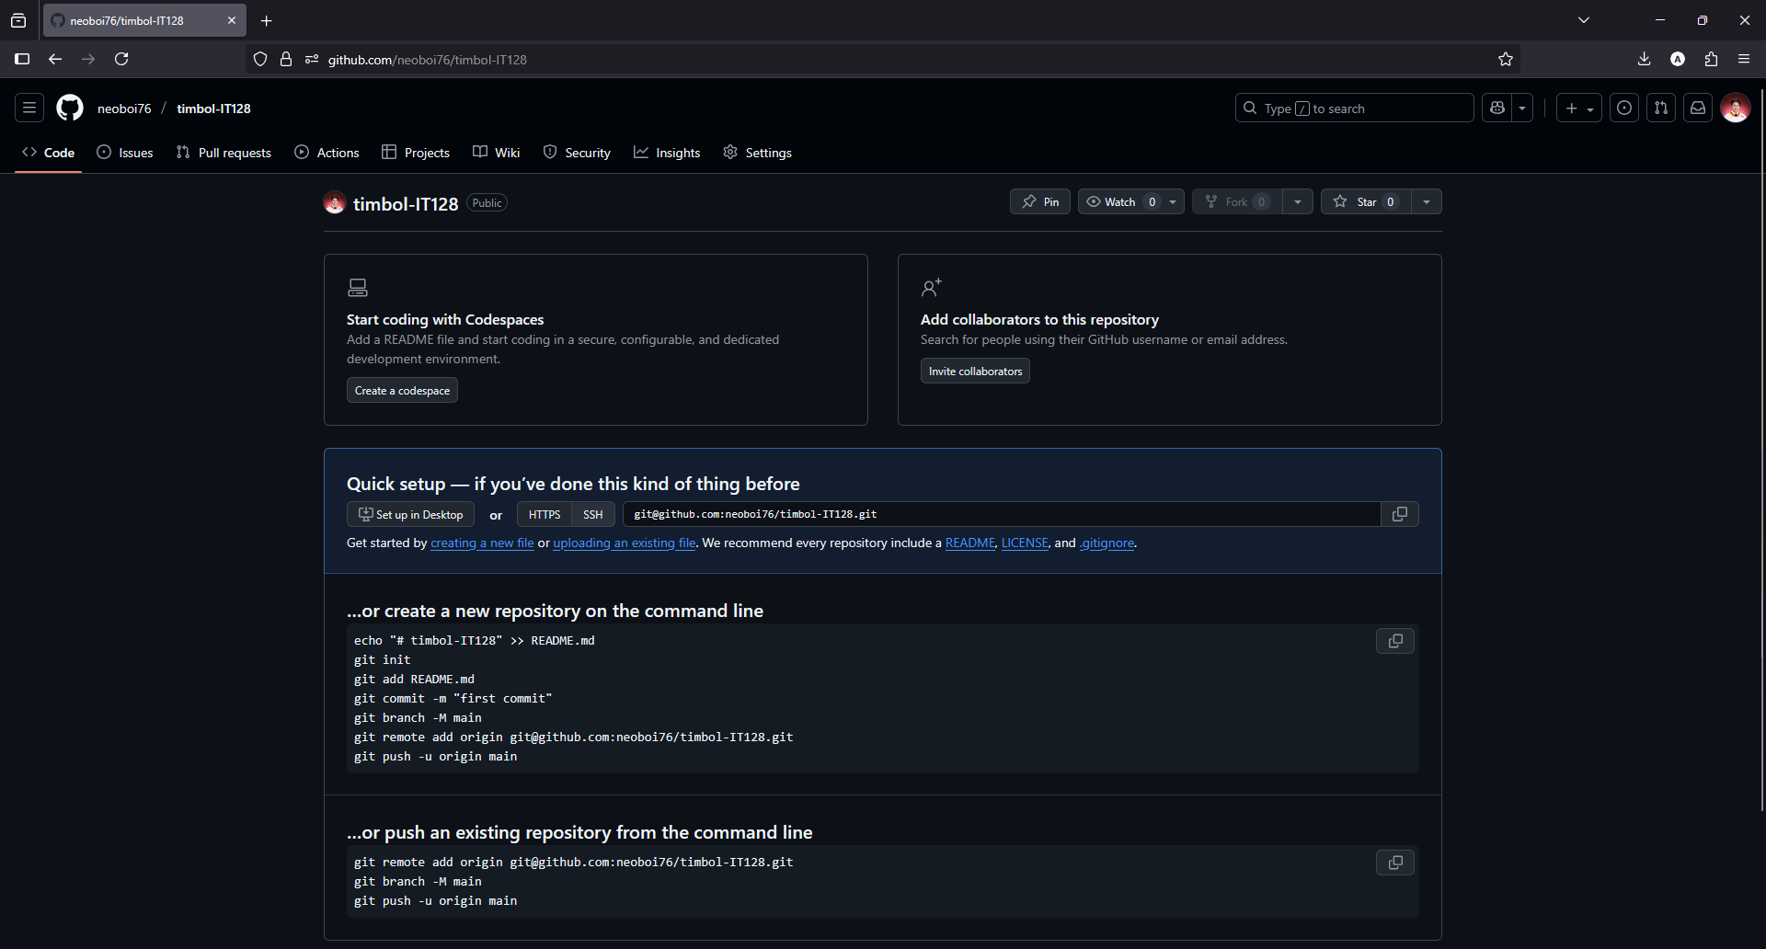

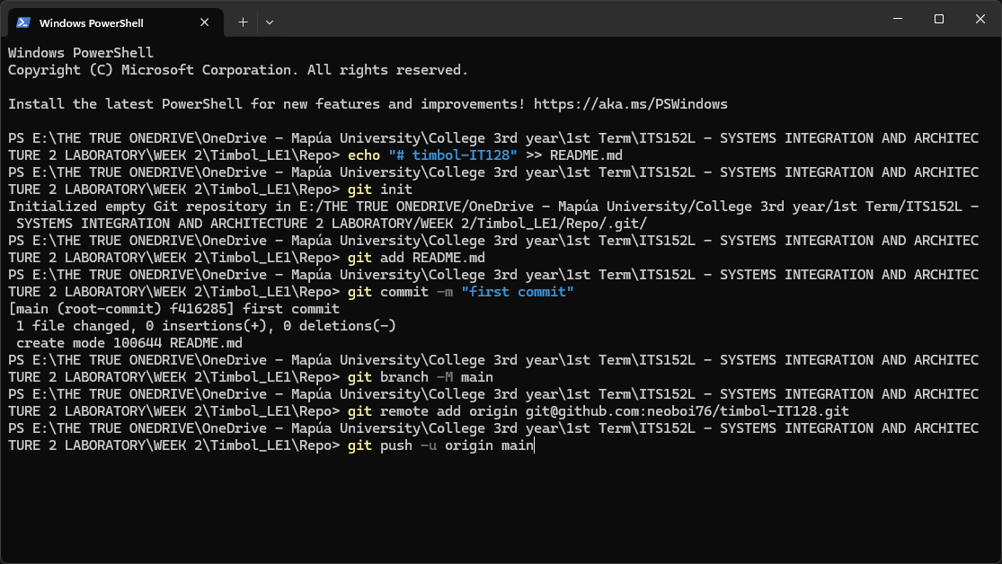

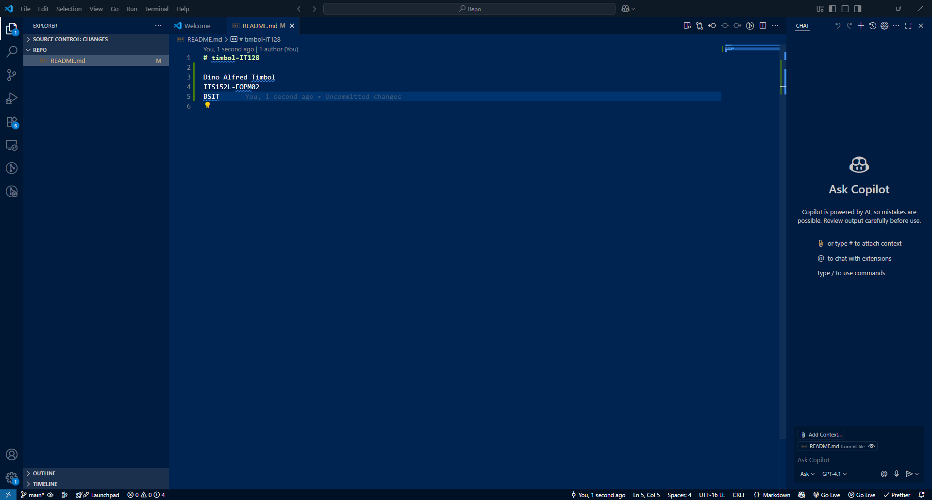

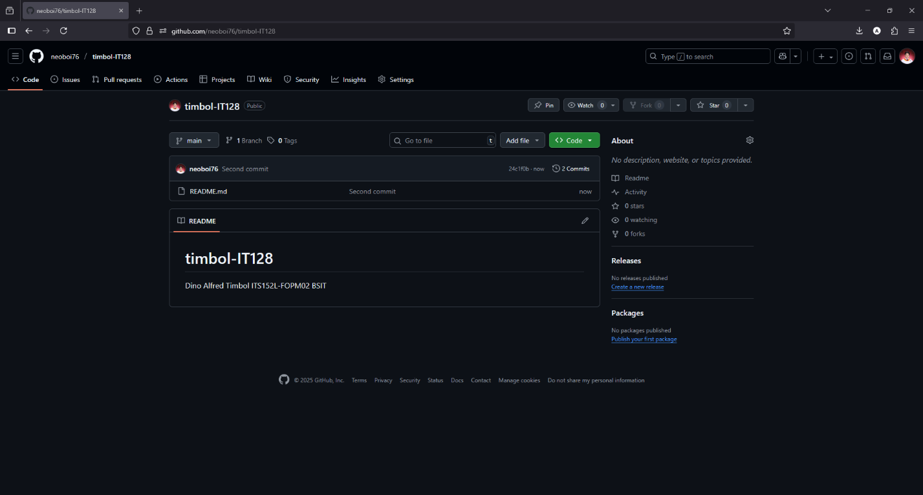

**Define the following commands.**

*git init -* Creates or "initializes" a new local Git repository in the directory in which the command is run. This will be the basis for the remote repository that may be created through further commands.

*git add <file>* - Adds a particular file (or set of files) to the staging area.

*git add . -* Adds all modified and newly created files in the staging area

*git remote add origin <url> -* Facilitates the connection between the local and remote repository through a URL.

*git commit -* Commits or saves all changes from the staging area into the local repository. Usually accompanied by a message set in the imperative mood (e.g., "Fix system bug").

*git push -* Uploads the changes in the local repository to the remote repository.

**What is the difference between remote and local repositories?**

Local repositories are repositories hosted on one's local machine, in which a user is able to track the changes they have made in their code locally over time. These changes are local, which means that other users cannot remotely check or modify the user's code on which the local repository is situated.

On the other hand, remote repository is a version of the local repository that is hosted on a server, such as GitHub. This enables collaboration among developers, who are able to collectively track changes, comment on them, make changes of their own, and these changes can be reviewed and approved (or denied) by each of the collaborators.

**Create more commits (Screenshots)**

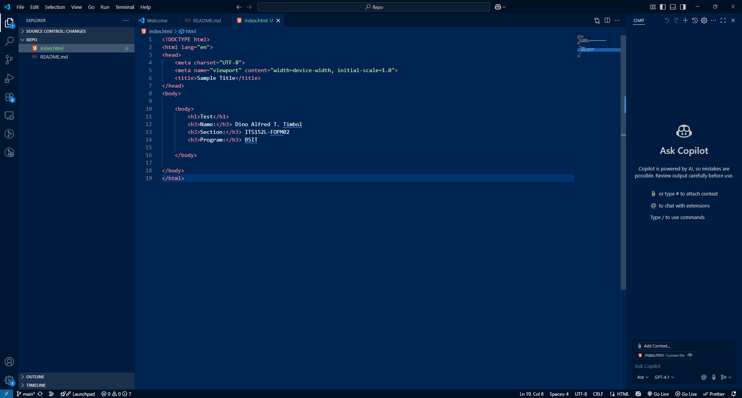

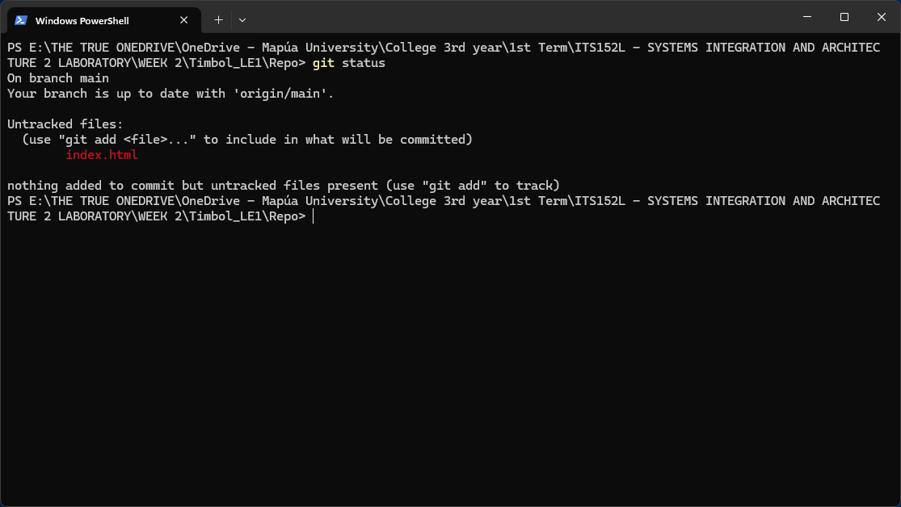

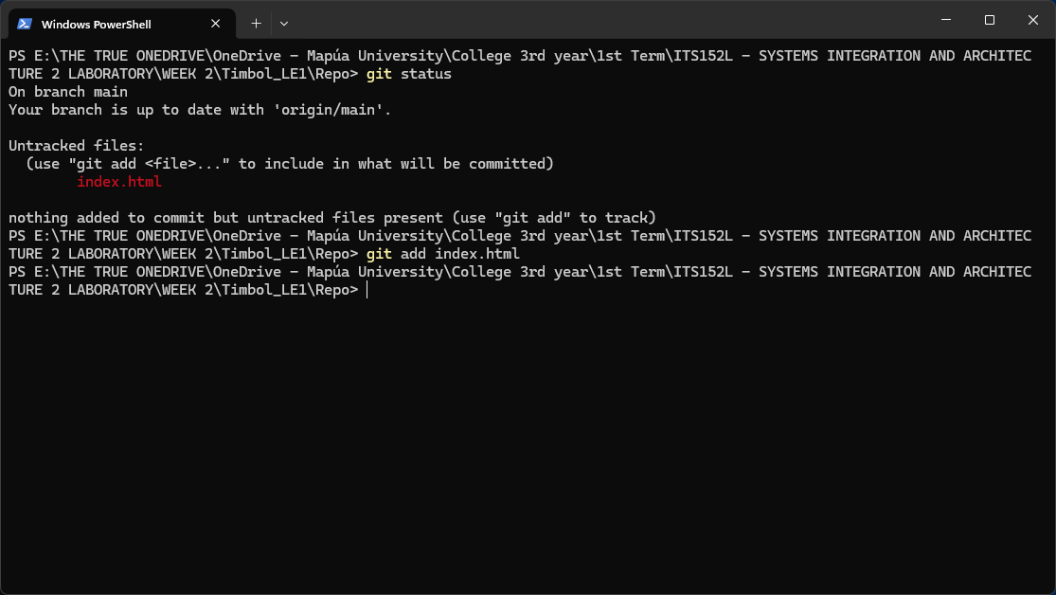

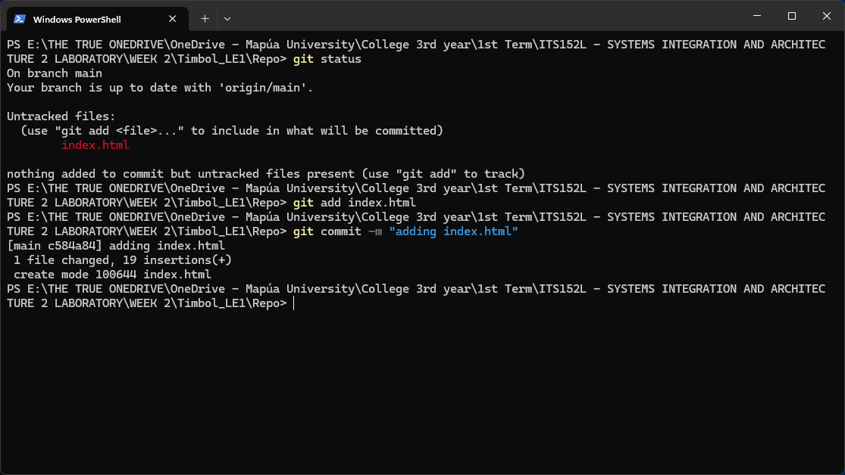

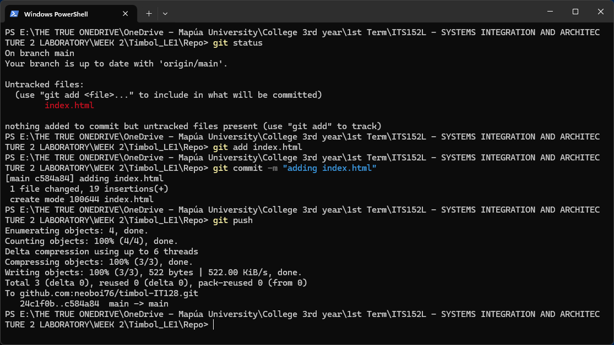

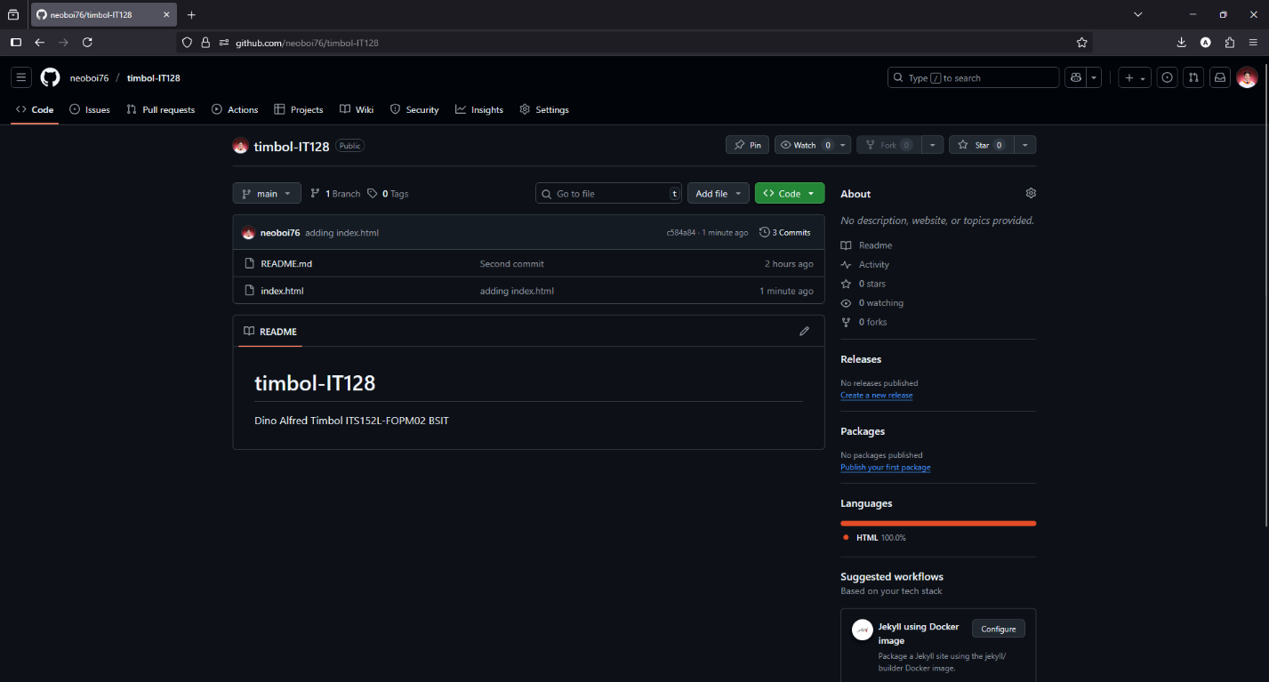

**Creating branches (Screenshots)**

