LAB EXERCISE 3
By Dino Alfred T. Timbol
Link to Github Repository: https://github.com/neoboi76/timbol-IT128
Setting up the UI
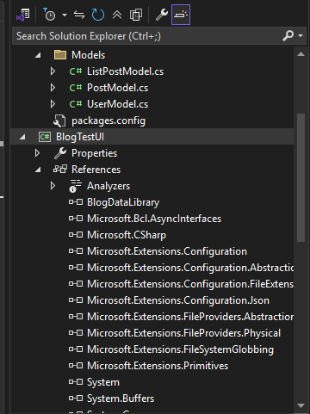
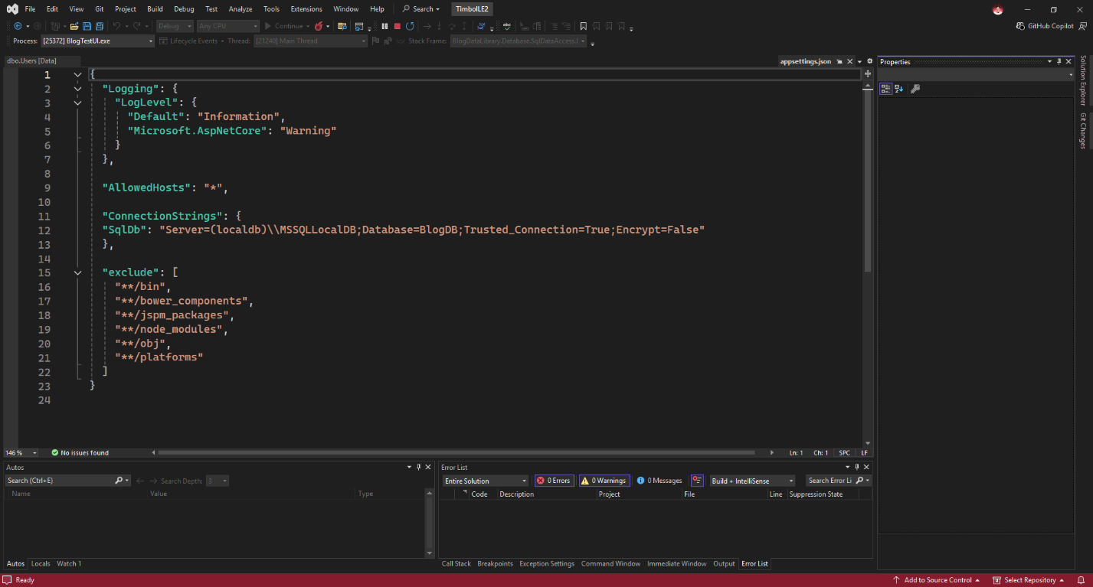
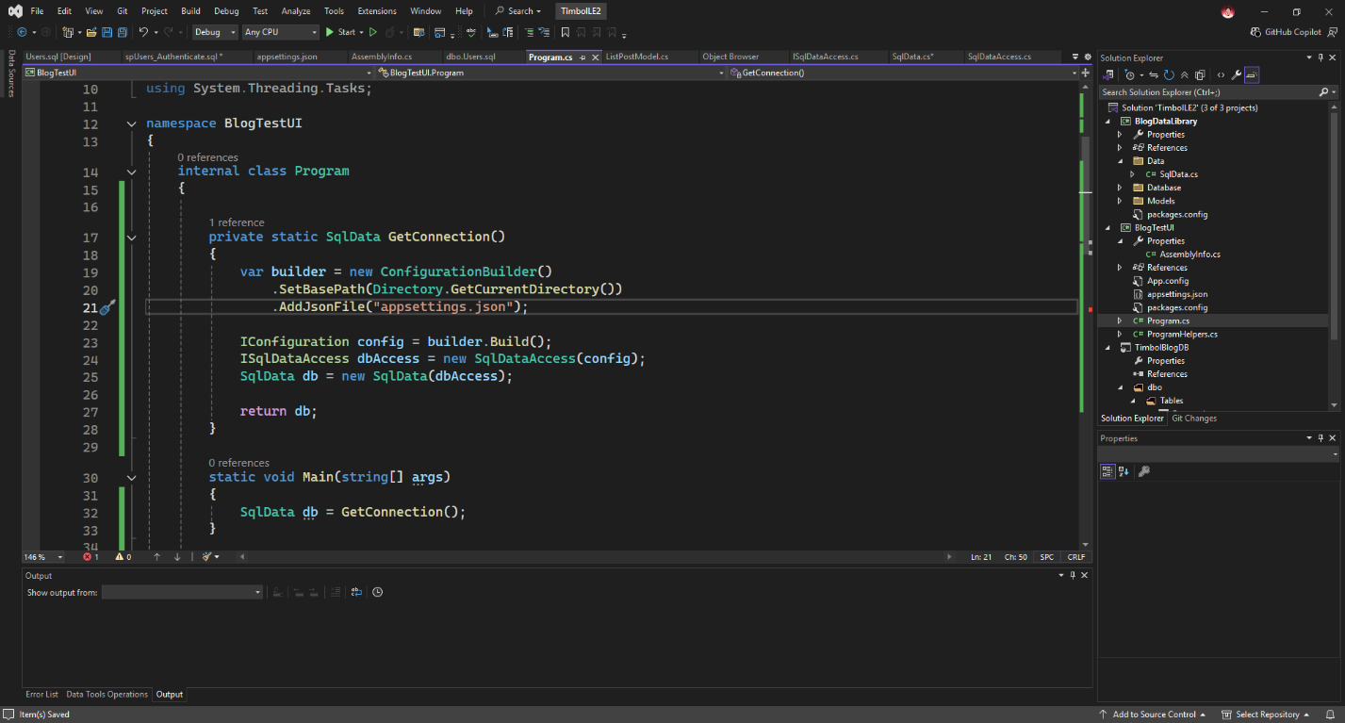

App functionality: Login
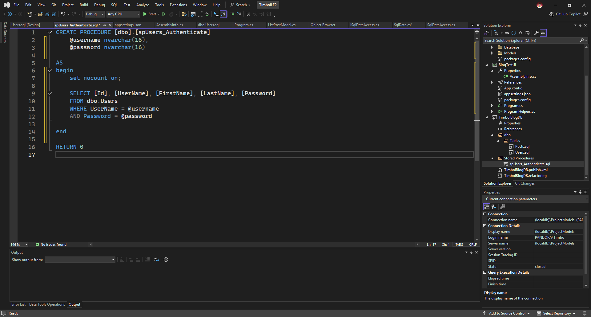
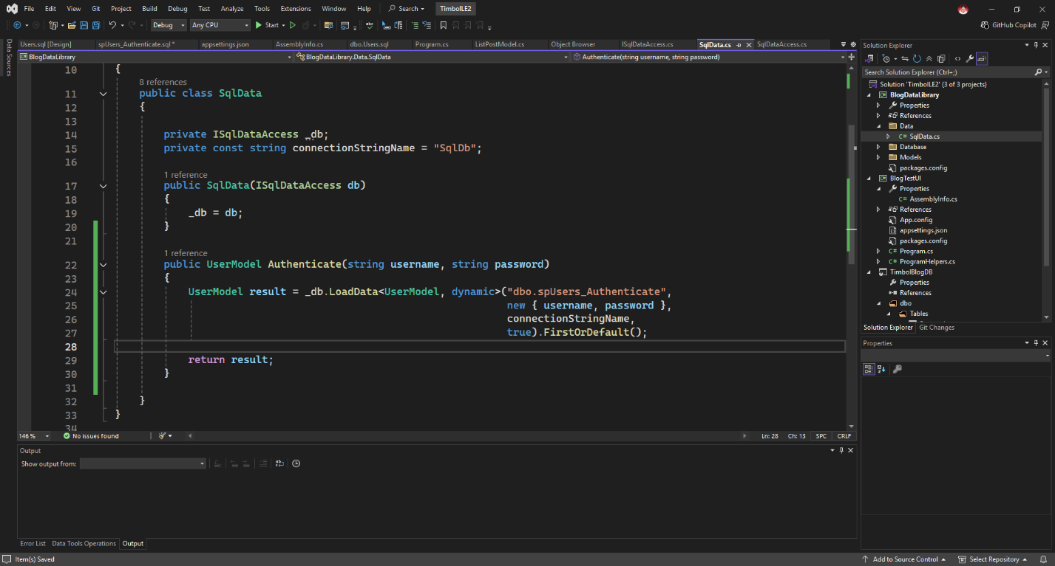
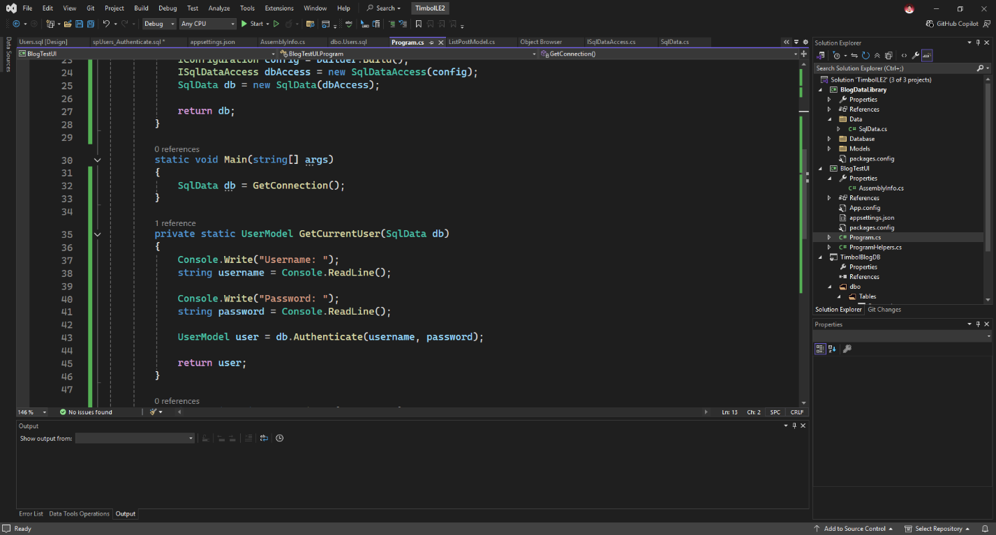
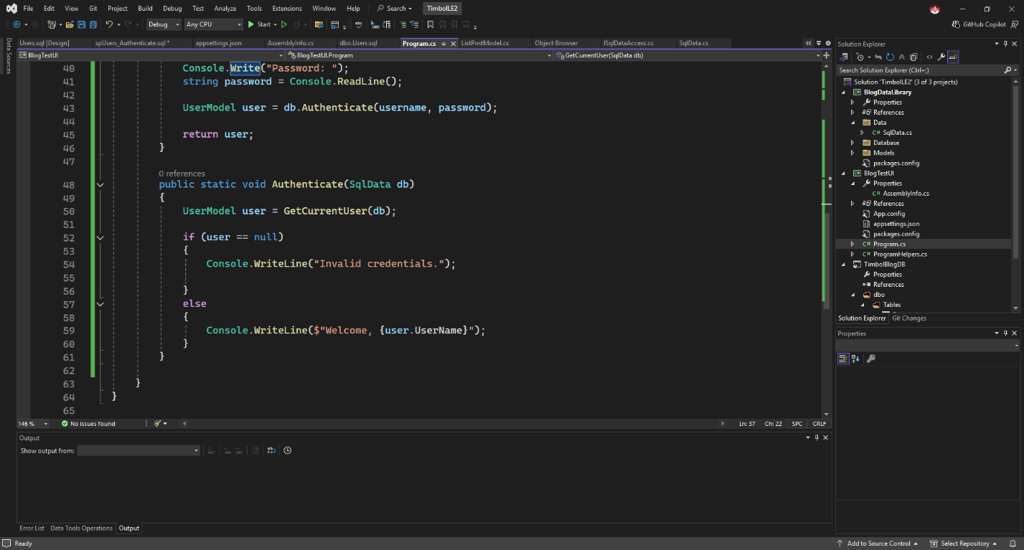

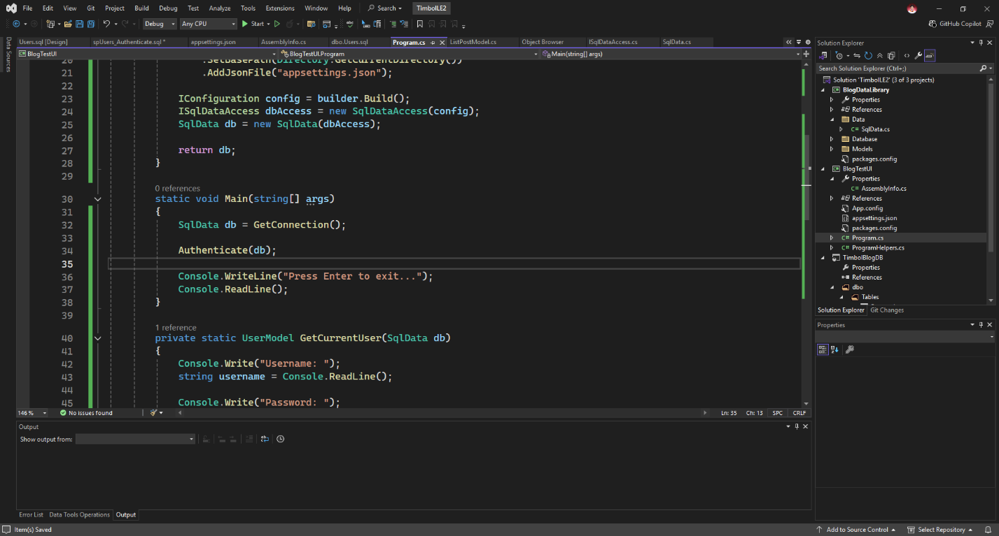

Publishing changes in DB
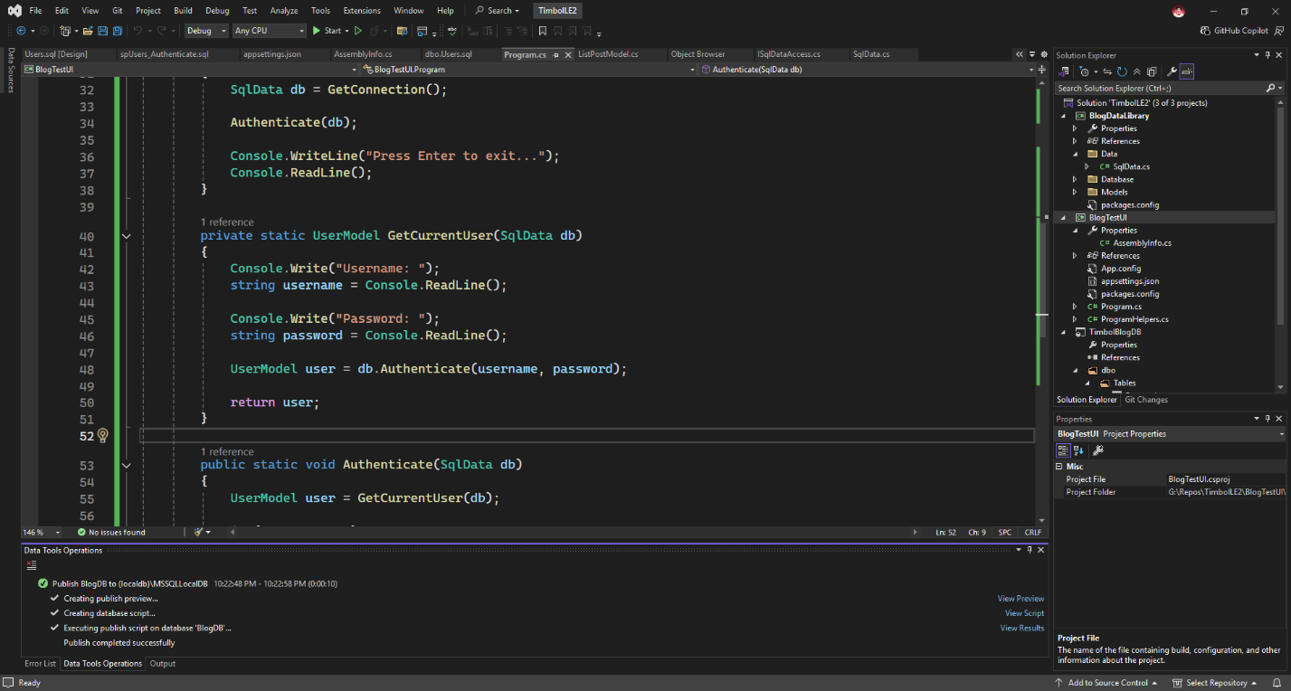

App functionality: Login Test
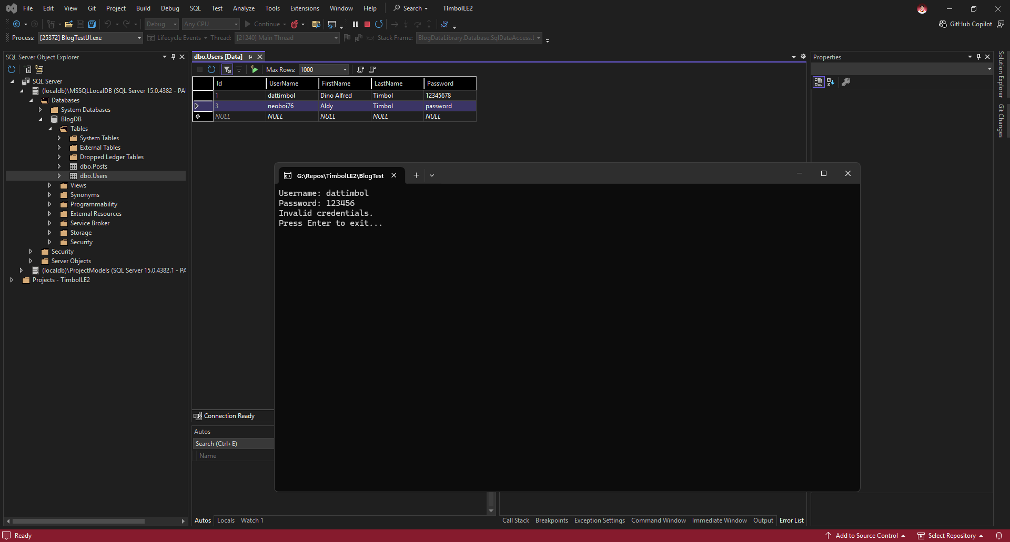
App functionality: Register
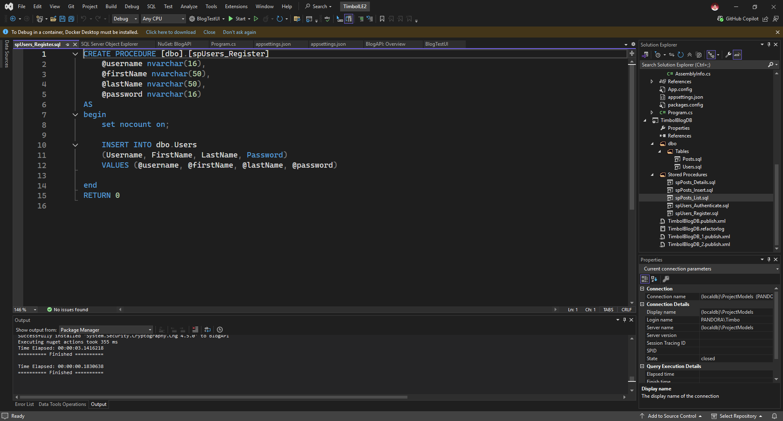
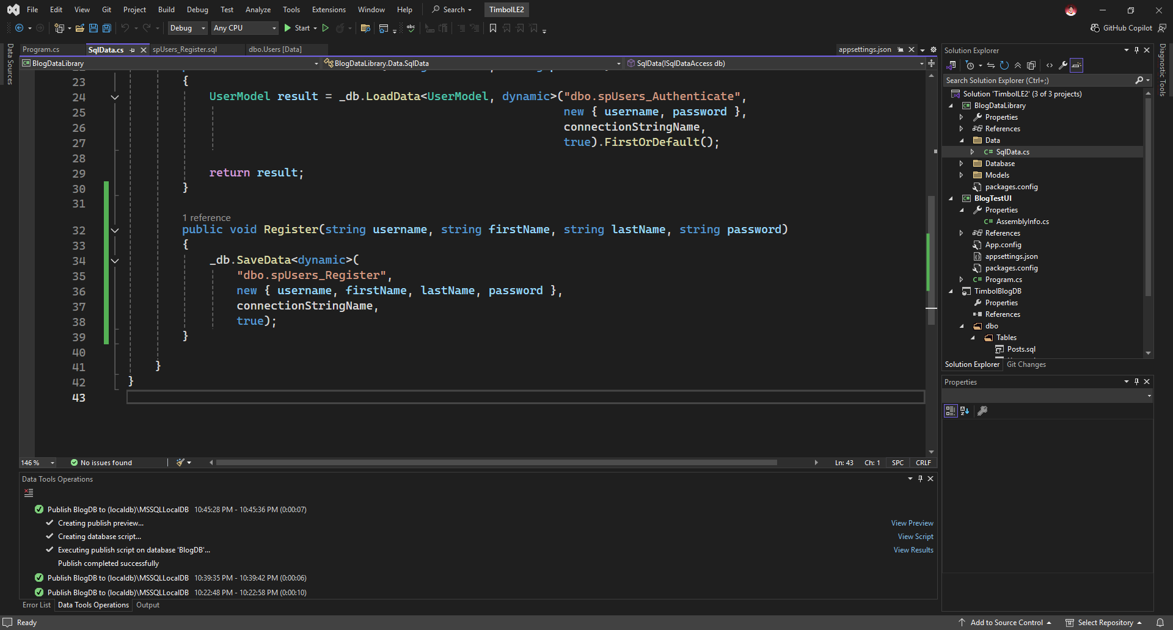
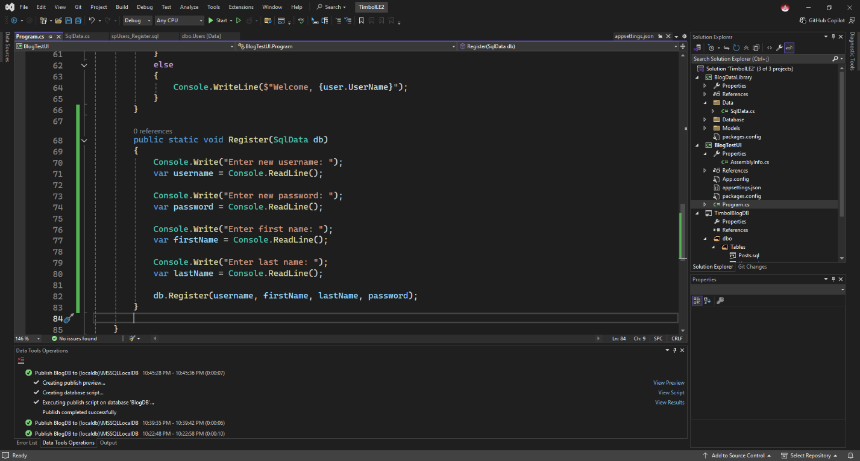
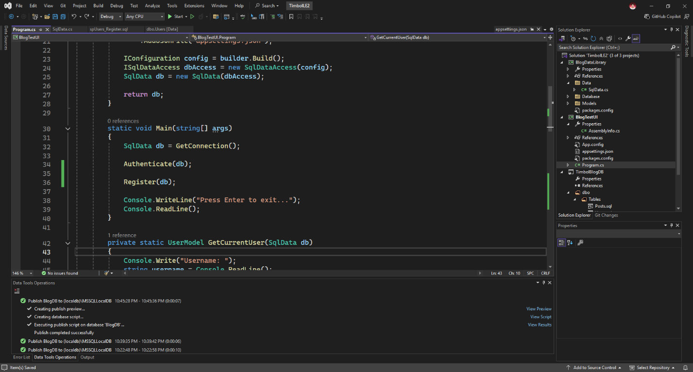
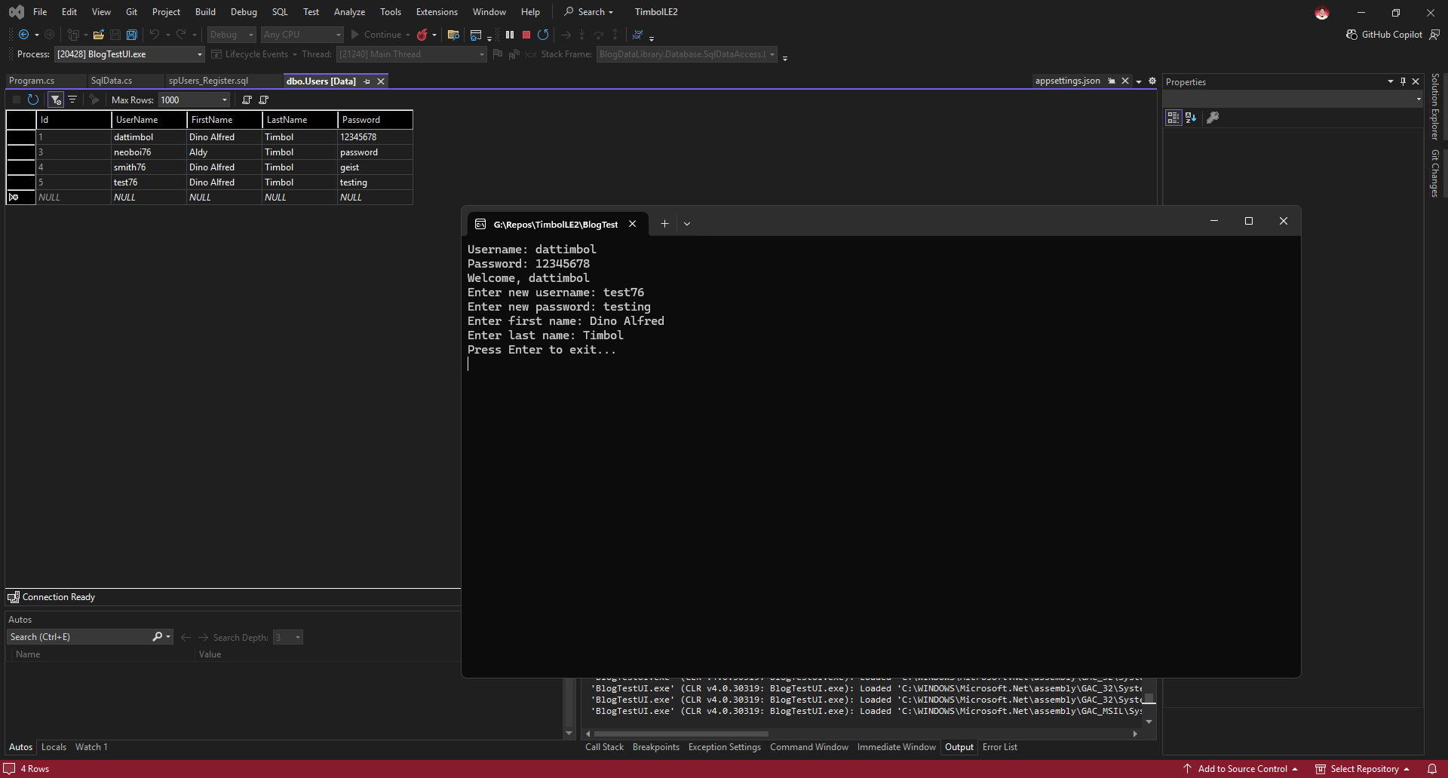

App functionality: Adding posts
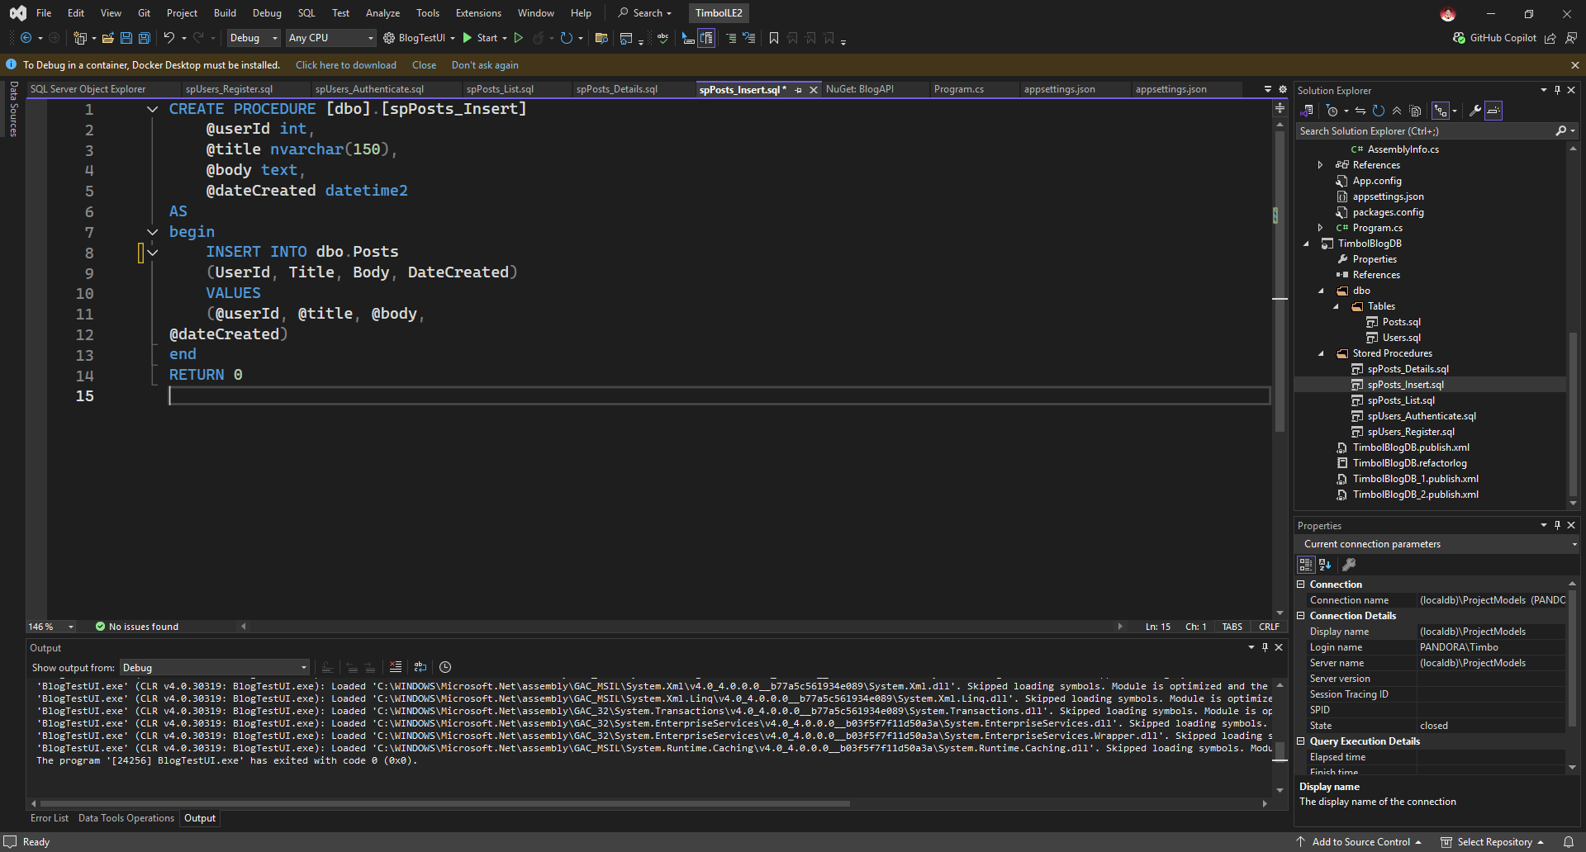
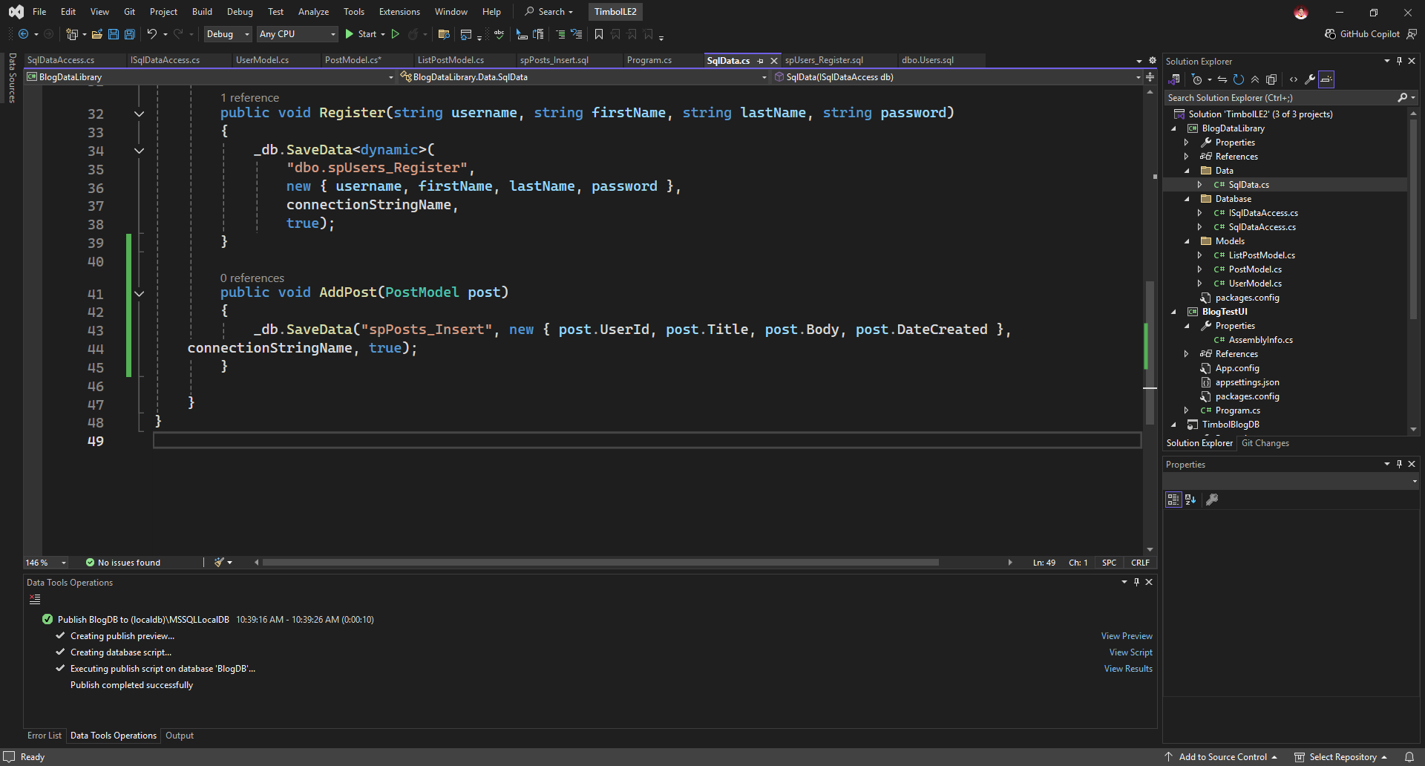
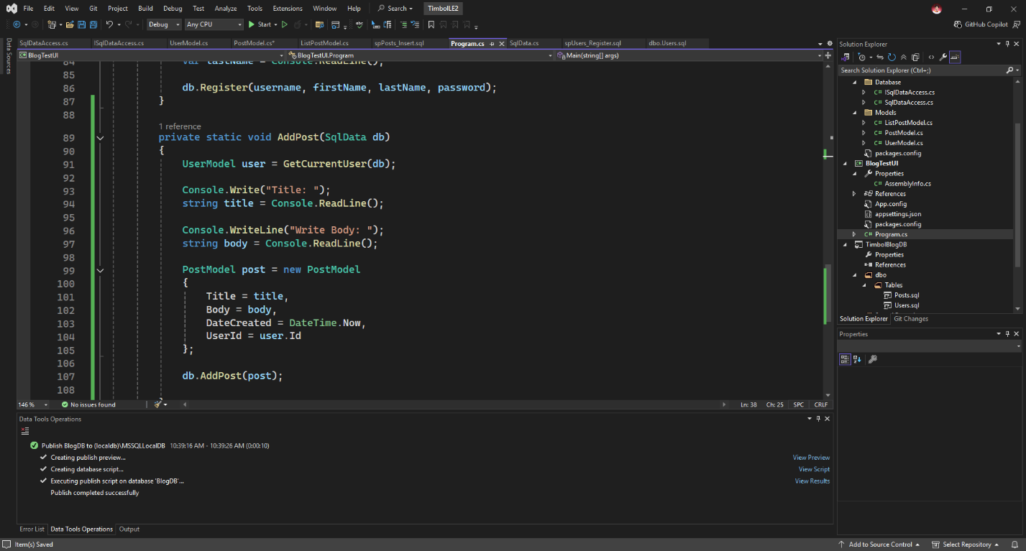
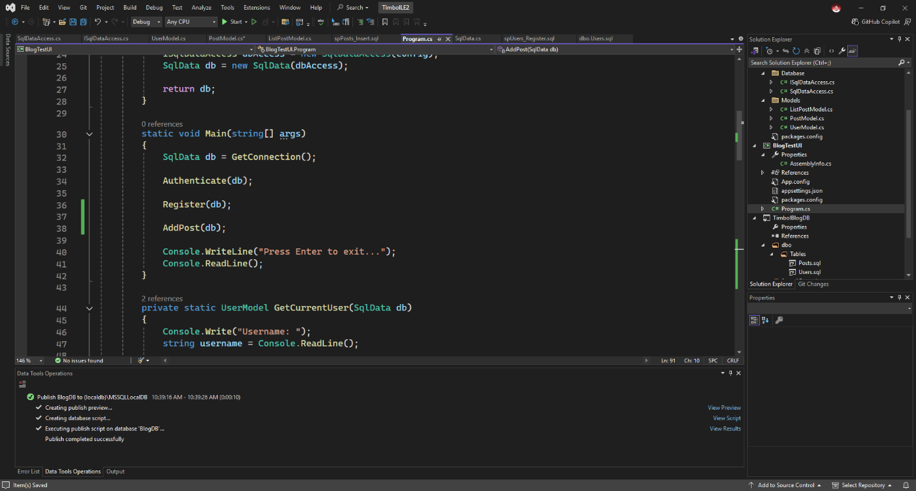
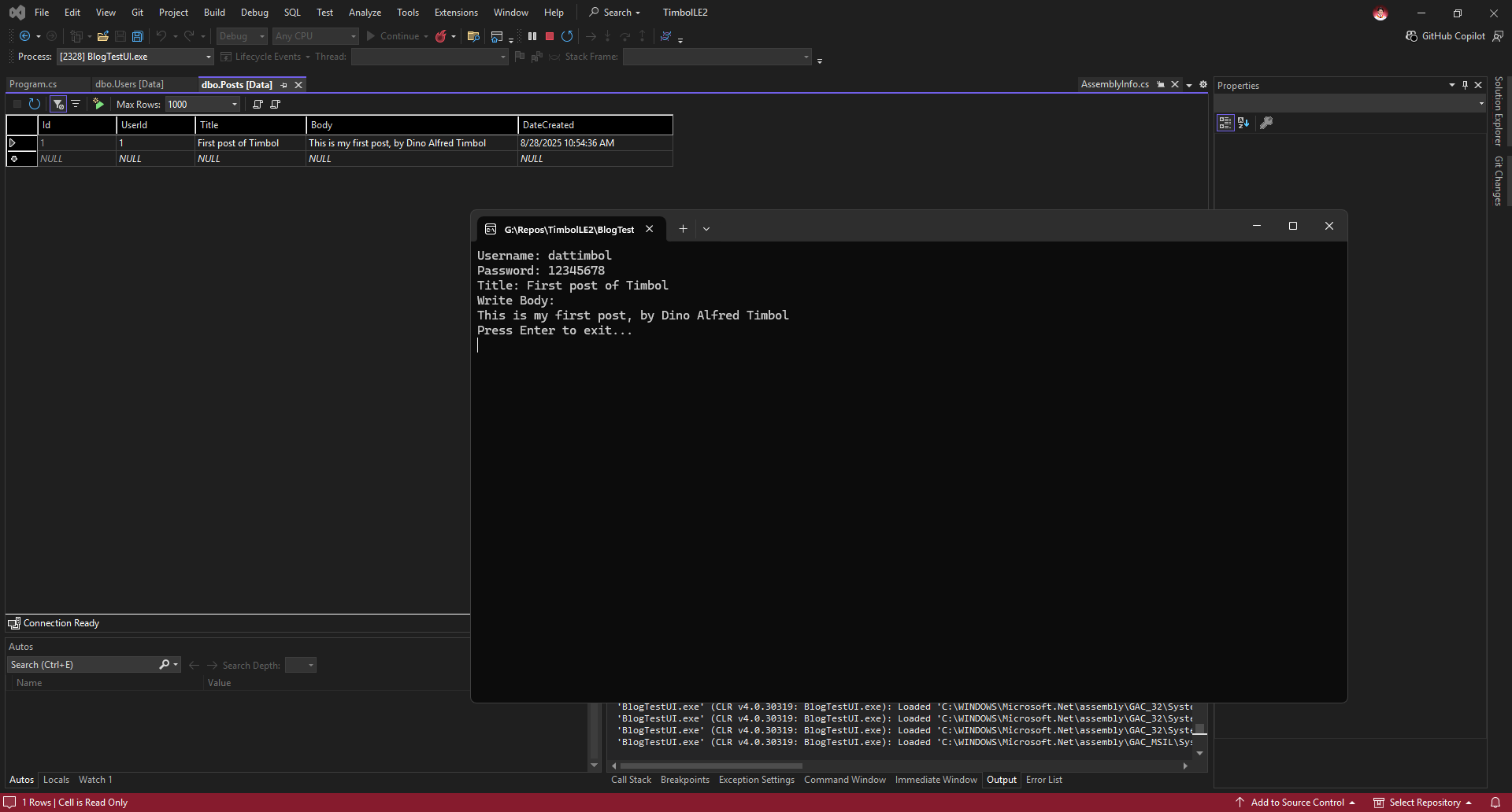
App functionality: List of posts
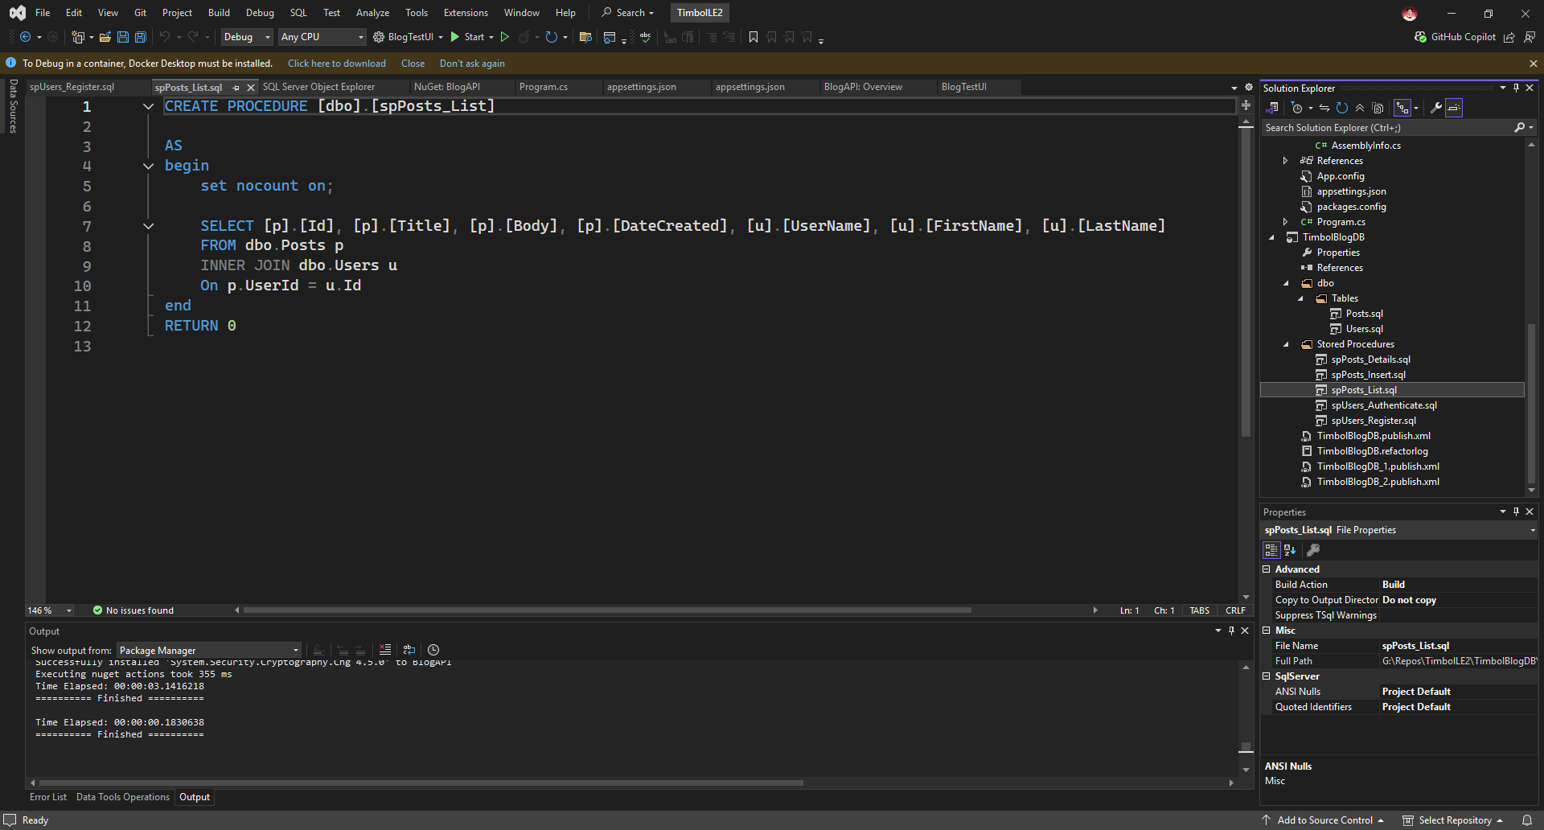
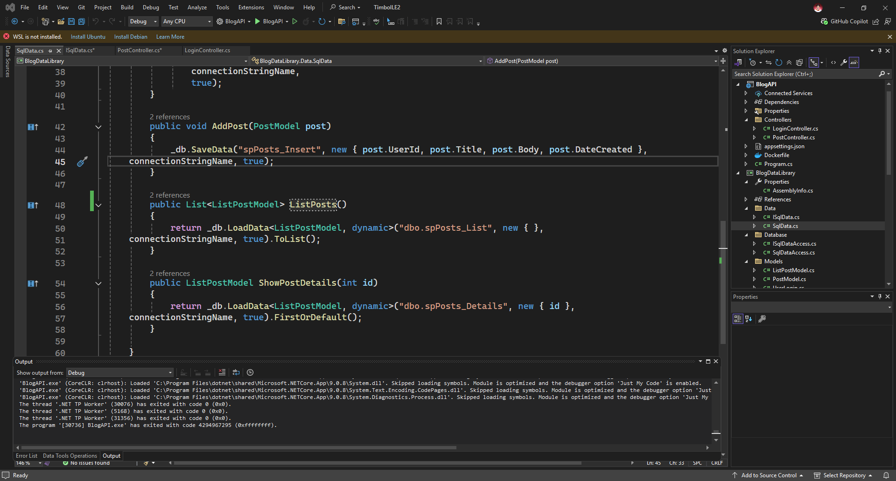
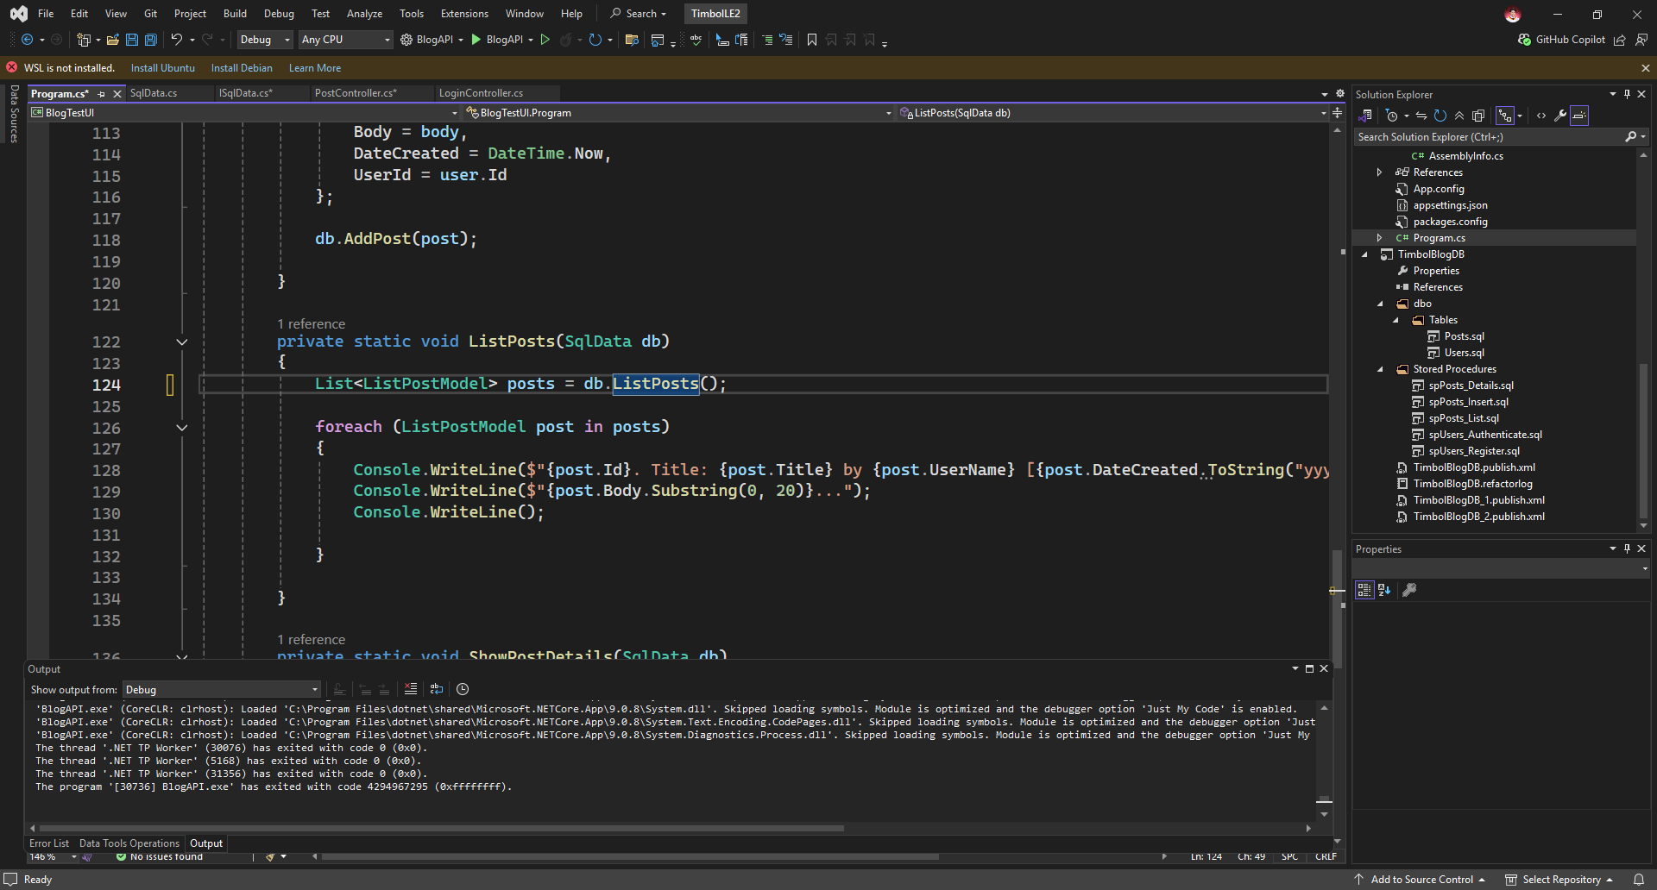
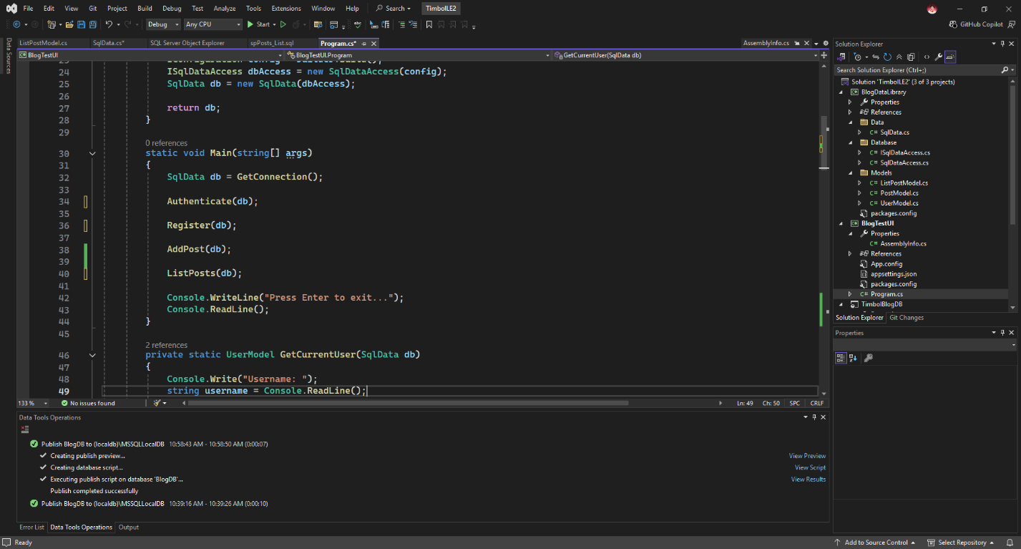
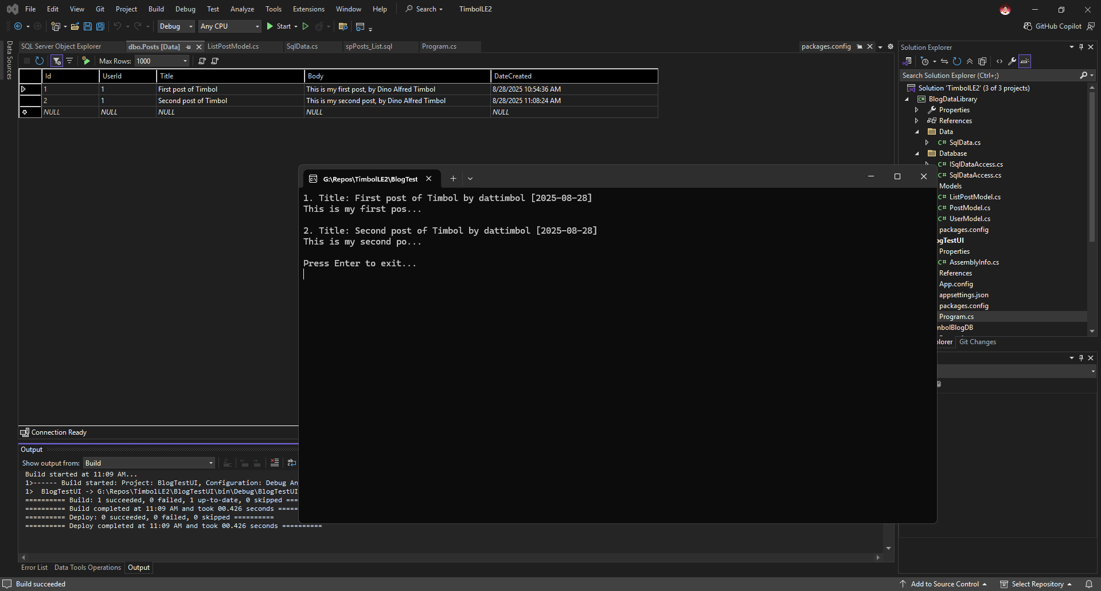

App functionality: Showing post details
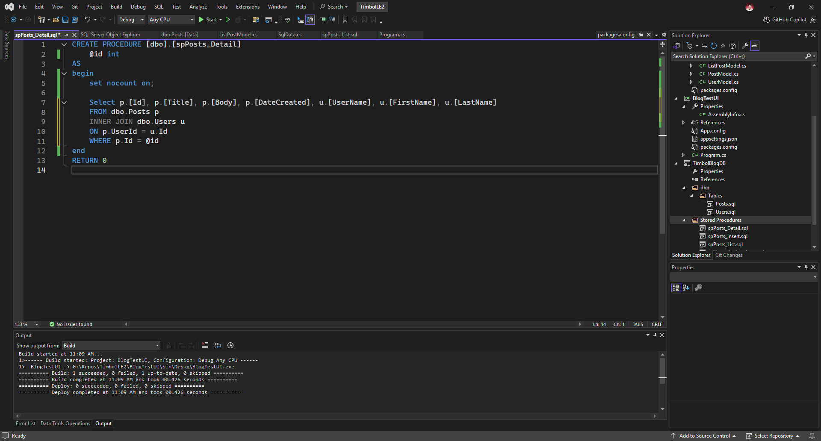
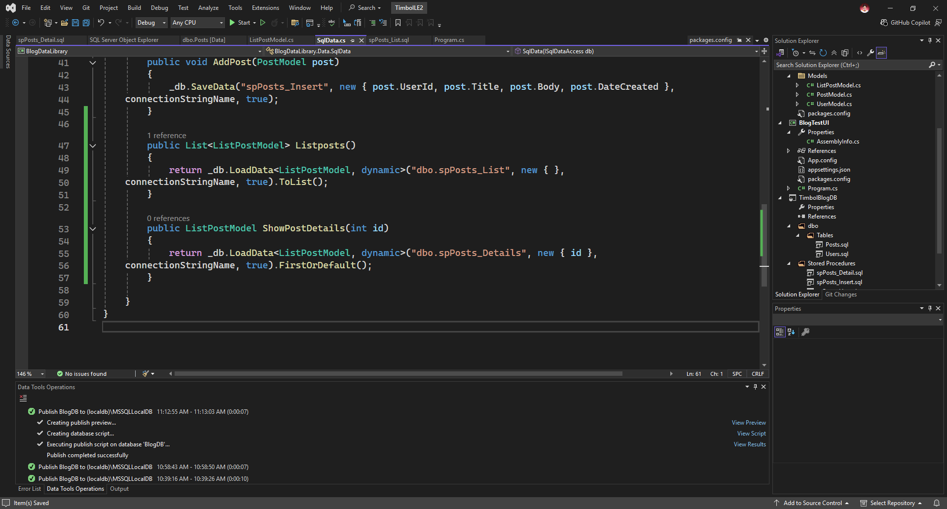
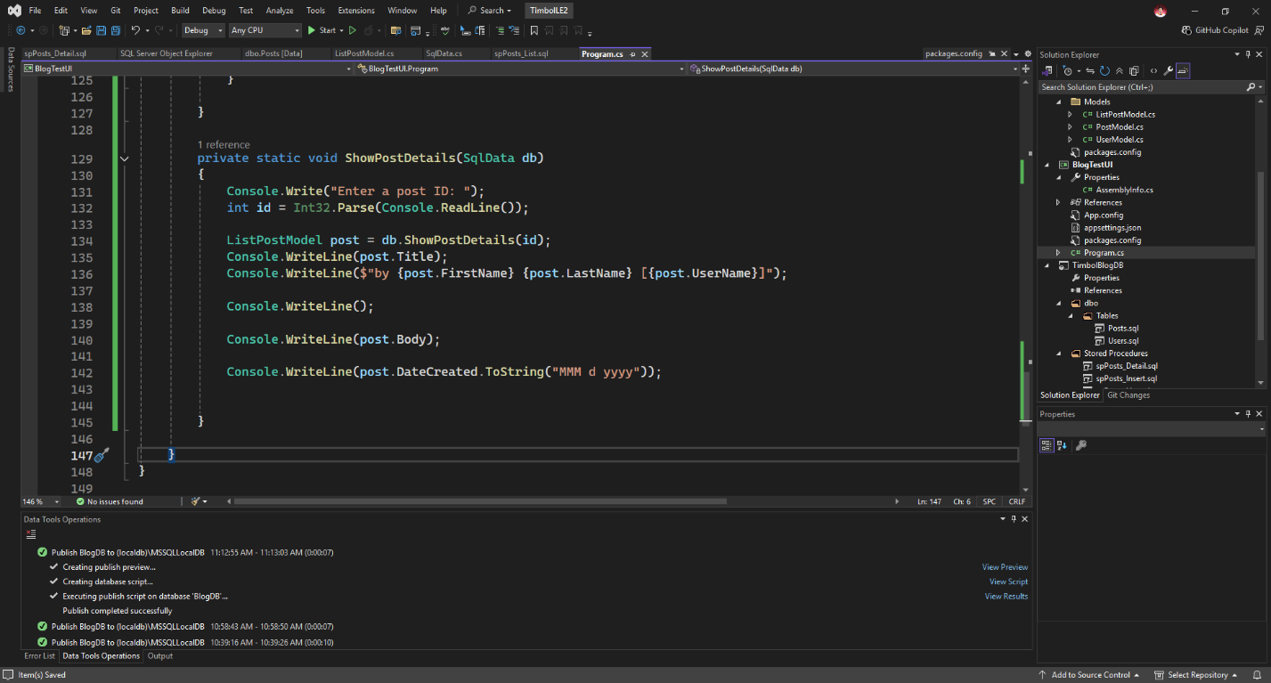
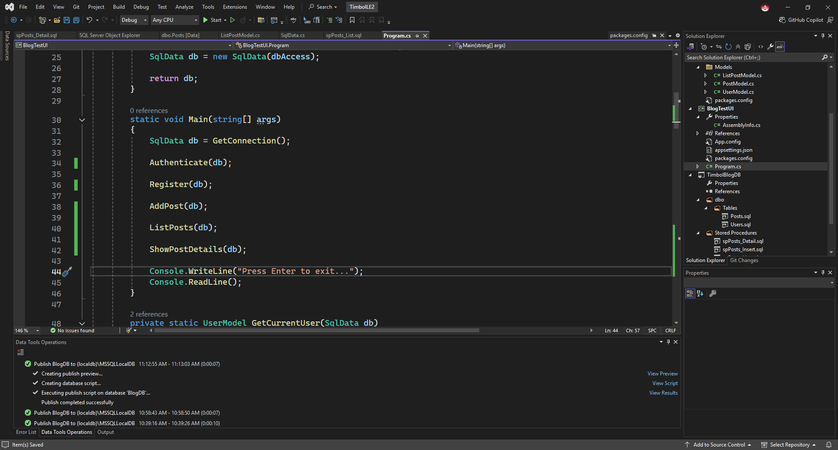
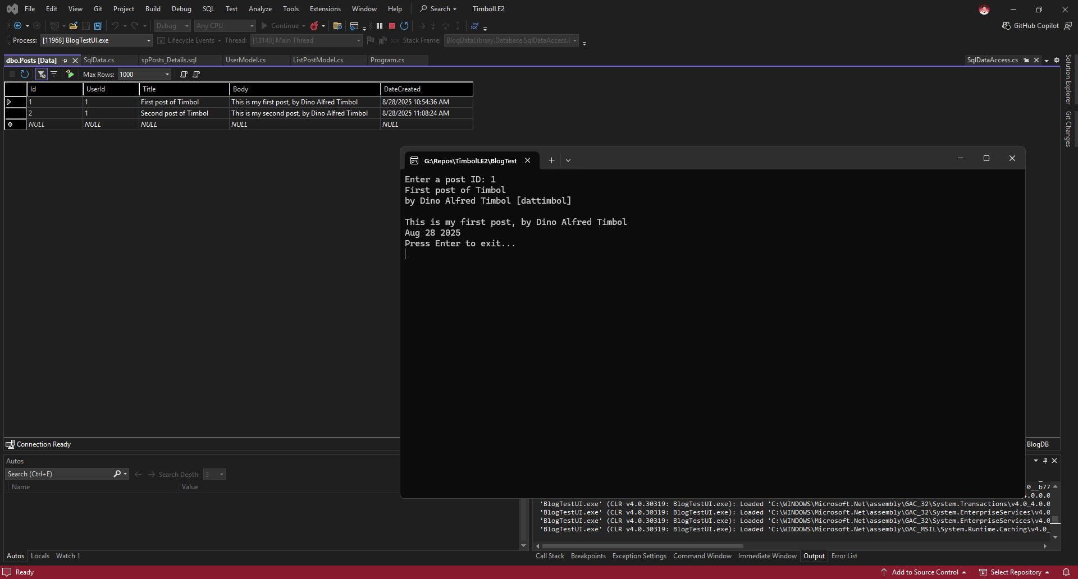
Post-program requirements
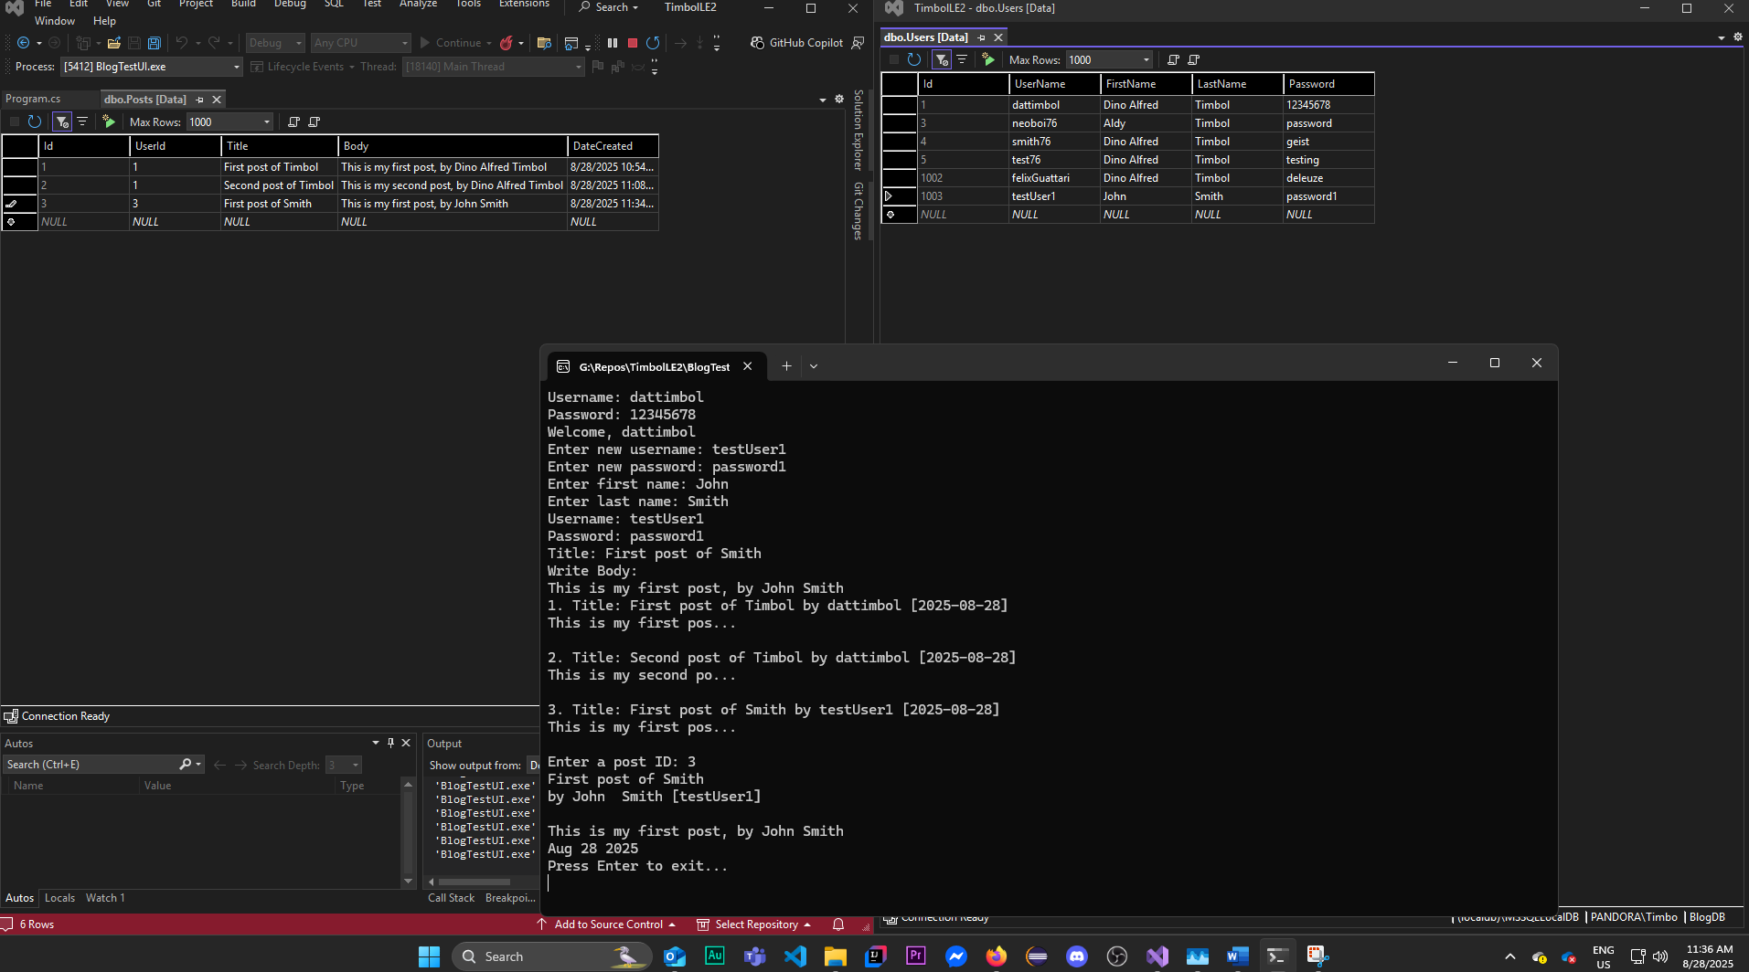
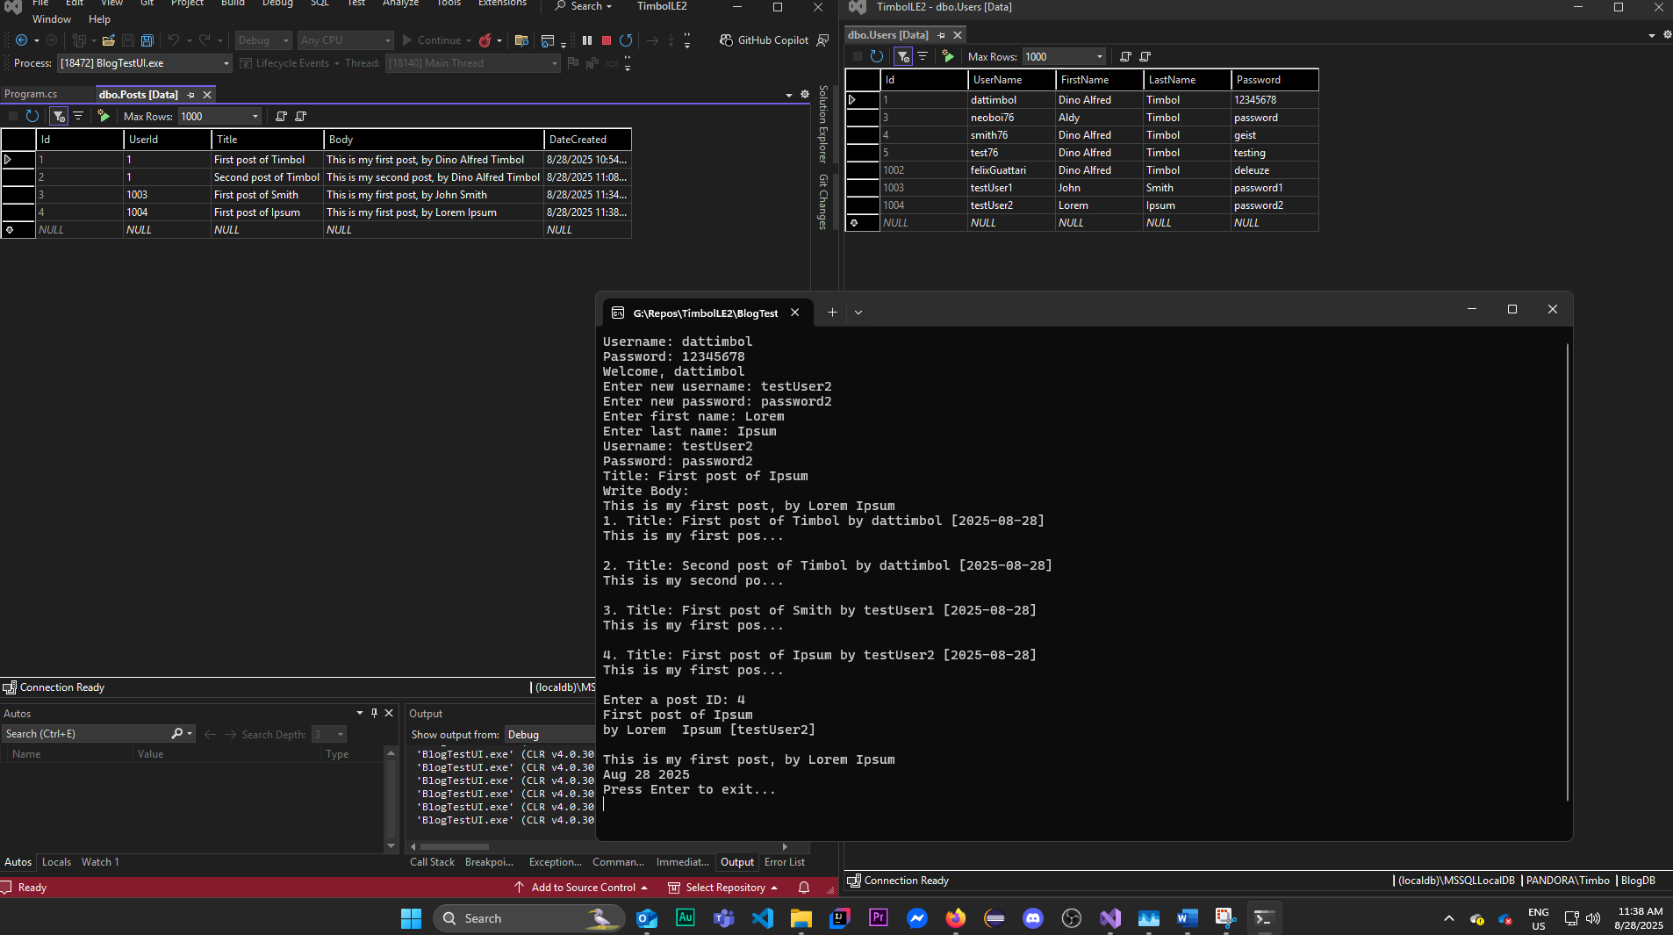
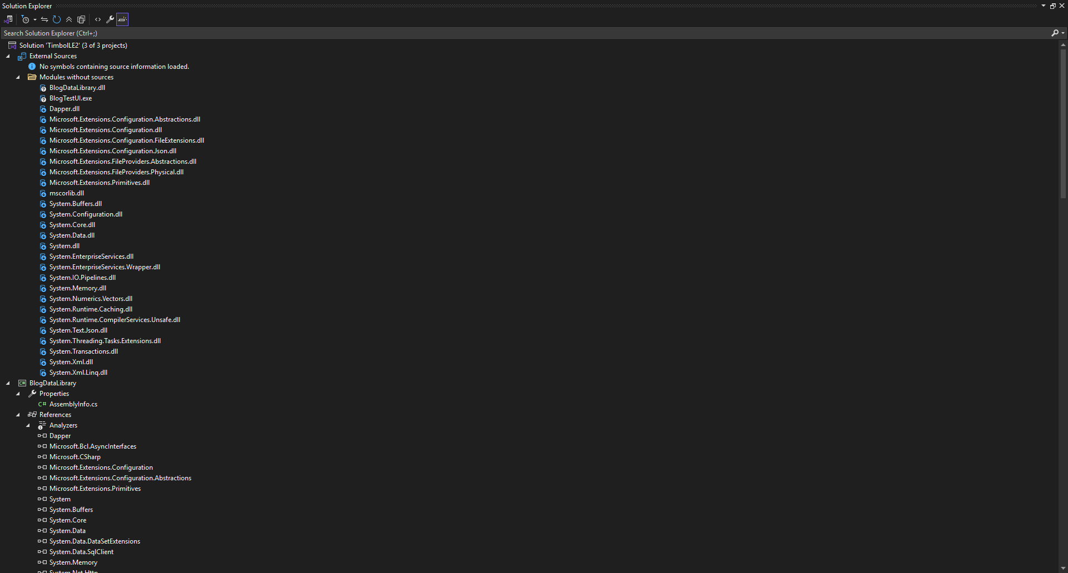
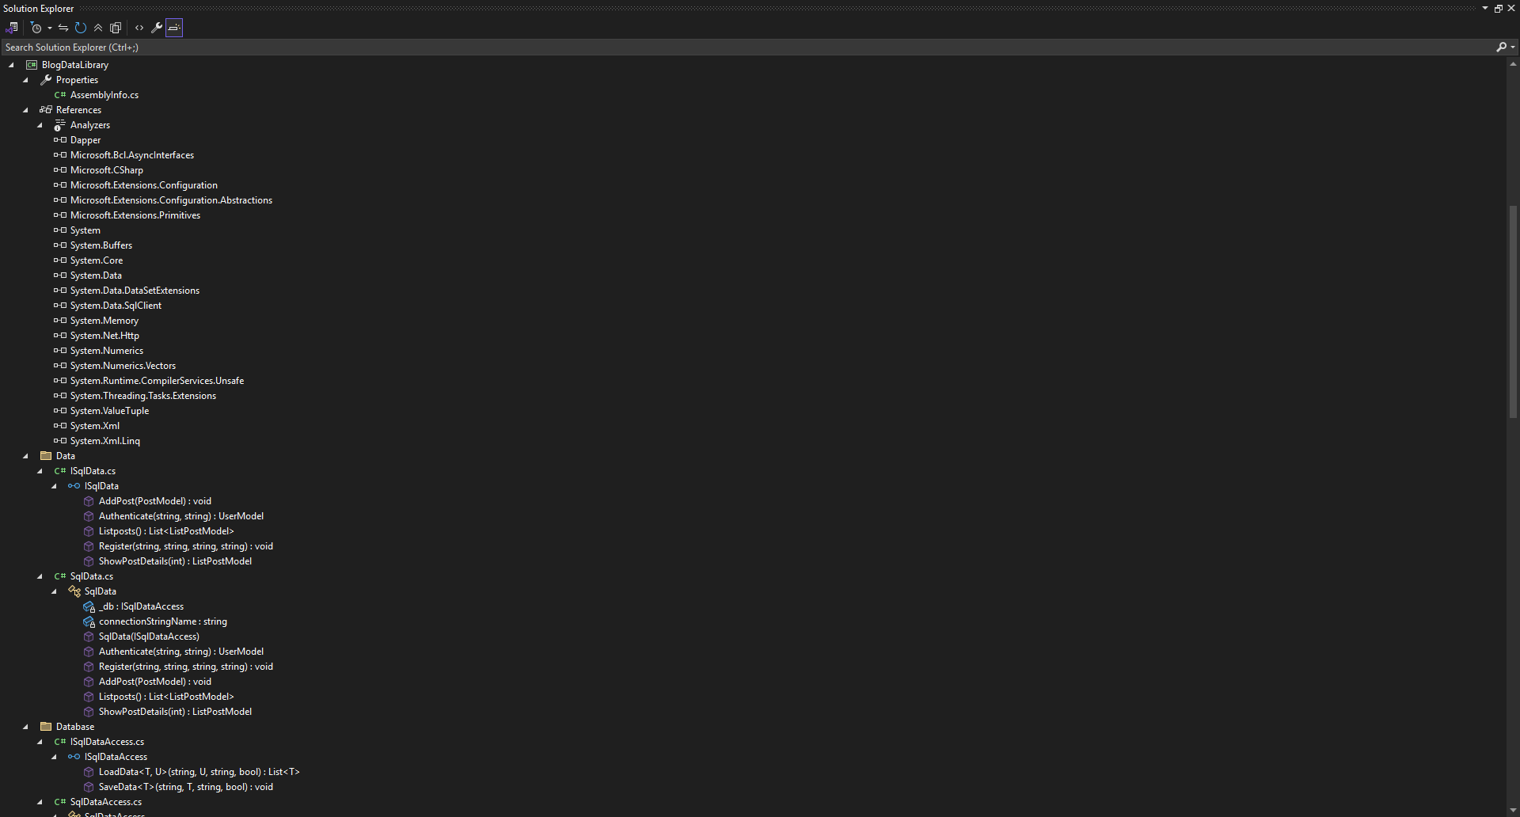
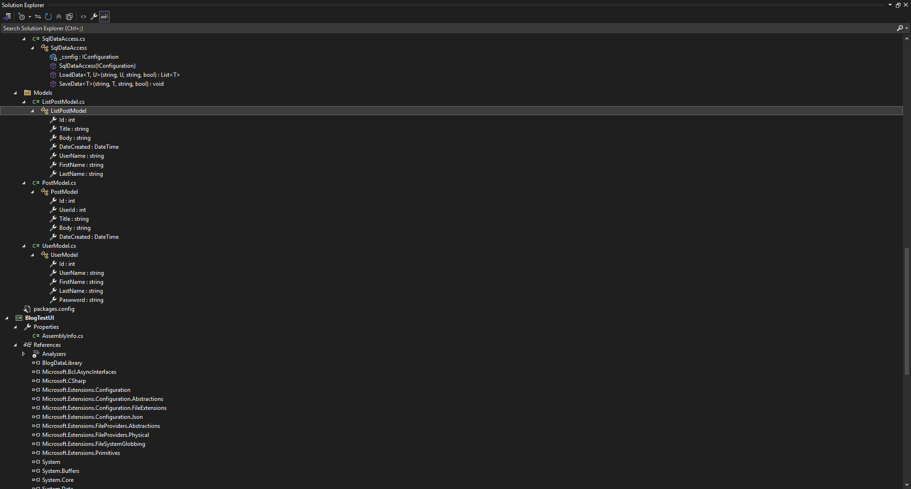
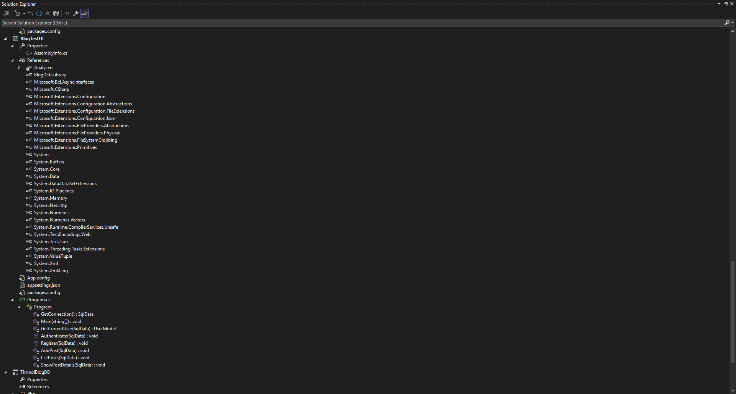
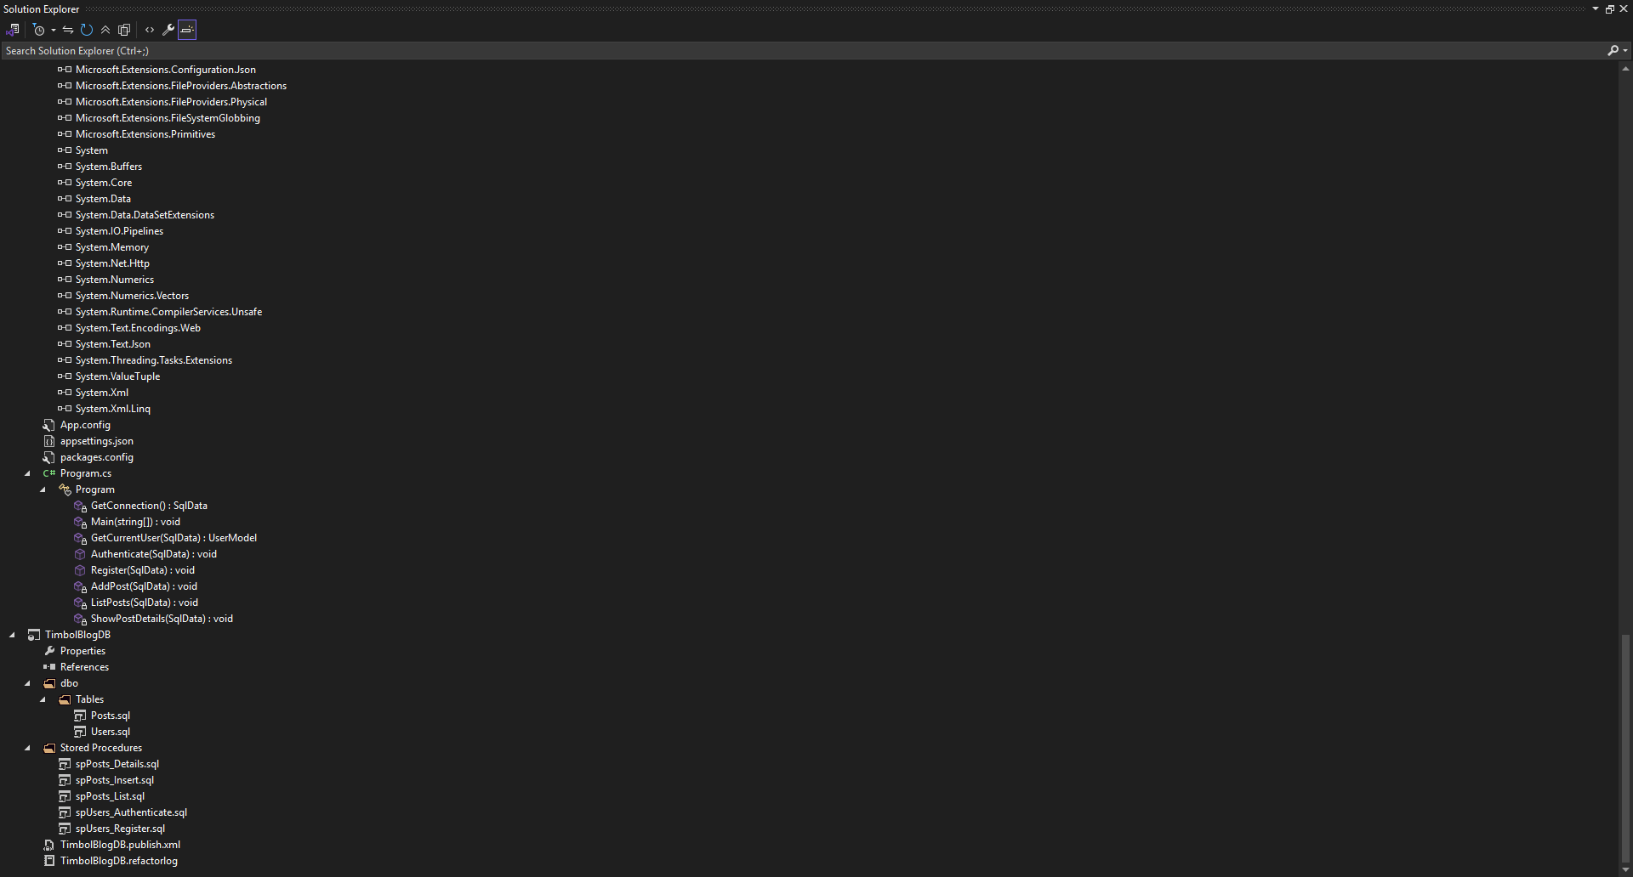

Codes from BlogDataLibrary/SqlData.cs
using BlogDataLibrary.Database;
using BlogDataLibrary.Models;
using System;
using System.Collections.Generic;
using System.Linq;
using System.Text;
using System.Threading.Tasks;
using System.Data.SqlClient;

namespace BlogDataLibrary.Data
{
public class SqlData : ISqlData
{

private ISqlDataAccess _db;
private const string connectionStringName = "SqlDb";

public SqlData(ISqlDataAccess db)
{
_db = db;
}

public UserModel Authenticate(string username, string password)
{
UserModel result = _db.LoadData<UserModel, dynamic>("dbo.spUsers_Authenticate",
new { username, password },
connectionStringName,
true).FirstOrDefault();

return result;
}

public void Register(string username, string firstName, string lastName, string password)
{
_db.SaveData<dynamic>(
"dbo.spUsers_Register",
new { username, firstName, lastName, password },
connectionStringName,
true);
}

public void AddPost(PostModel post)
{
_db.SaveData("spPosts_Insert", new { post.UserId, post.Title, post.Body, post.DateCreated },
connectionStringName, true);
}

public List<ListPostModel> ListPosts()
{
return _db.LoadData<ListPostModel, dynamic>("dbo.spPosts_List", new { },
connectionStringName, true).ToList();
}

public ListPostModel ShowPostDetails(int id)
{
return _db.LoadData<ListPostModel, dynamic>("dbo.spPosts_Details", new { id },
connectionStringName, true).FirstOrDefault();
}

}
}

Codes from BlogTestUI/Program.cs
using BlogDataLibrary.Data;
using BlogDataLibrary.Database;
using BlogDataLibrary.Models;
using Microsoft.Extensions.Configuration;
using System;
using System.Collections.Generic;
using System.IO;
using System.Linq;
using System.Security.AccessControl;
using System.Text;
using System.Threading.Tasks;

namespace BlogTestUI
{
internal class Program
{
private static bool control = false;

private static SqlData GetConnection()
{
var builder = new ConfigurationBuilder()
.SetBasePath(Directory.GetCurrentDirectory())
.AddJsonFile("appsettings.json");

IConfiguration config = builder.Build();
ISqlDataAccess dbAccess = new SqlDataAccess(config);
SqlData db = new SqlData(dbAccess);

return db;
}

static void Main(string[] args)
{
SqlData db = GetConnection();

Authenticate(db);

if (control)
{

Register(db);

AddPost(db);

ListPosts(db);

ShowPostDetails(db);
}

Console.WriteLine("Press Enter to exit...");
Console.ReadLine();
}

private static UserModel GetCurrentUser(SqlData db)
{
Console.Write("Username: ");
string username = Console.ReadLine();

Console.Write("Password: ");
string password = Console.ReadLine();

UserModel user = db.Authenticate(username, password);

return user;
}

public static void Authenticate(SqlData db)
{
UserModel user = GetCurrentUser(db);

if (user == null)
{
Console.WriteLine("Invalid credentials.");

}
else
{
Console.WriteLine($"Welcome, {user.UserName}");
control = true;
}
}

public static void Register(SqlData db)
{
Console.Write("Enter new username: ");
var username = Console.ReadLine();

Console.Write("Enter new password: ");
var password = Console.ReadLine();

Console.Write("Enter first name: ");
var firstName = Console.ReadLine();

Console.Write("Enter last name: ");
var lastName = Console.ReadLine();

db.Register(username, firstName, lastName, password);
}

private static void AddPost(SqlData db)
{
UserModel user = GetCurrentUser(db);

Console.Write("Title: ");
string title = Console.ReadLine();

Console.WriteLine("Write Body: ");
string body = Console.ReadLine();

PostModel post = new PostModel
{
Title = title,
Body = body,
DateCreated = DateTime.Now,
UserId = user.Id
};

db.AddPost(post);

}

private static void ListPosts(SqlData db)
{
List<ListPostModel> posts = db.ListPosts();

foreach (ListPostModel post in posts)
{
Console.WriteLine($"{post.Id}. Title: {post.Title} by {post.UserName} [{post.DateCreated.ToString("yyyy-MM-dd")}]");
Console.WriteLine($"{post.Body.Substring(0, 20)}...");
Console.WriteLine();

}

}

private static void ShowPostDetails(SqlData db)
{
Console.Write("Enter a post ID: ");
int id = Int32.Parse(Console.ReadLine());

ListPostModel post = db.ShowPostDetails(id);
Console.WriteLine(post.Title);
Console.WriteLine($"by {post.FirstName} {post.LastName} [{post.UserName}]");

Console.WriteLine();

Console.WriteLine(post.Body);

Console.WriteLine(post.DateCreated.ToString("MMM d yyyy"));

}

}
}

