LAB EXERCISE 4
By Dino Alfred T. Timbol
Link to Github Repository: https://github.com/neoboi76/timbol-IT128
Setting up the project
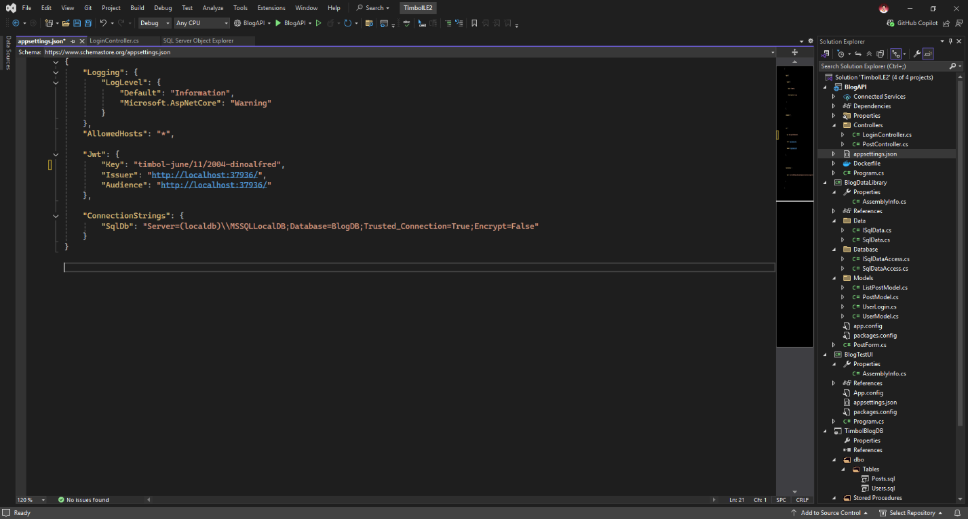
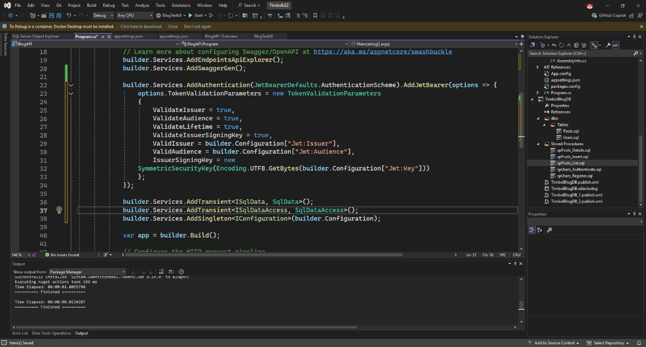
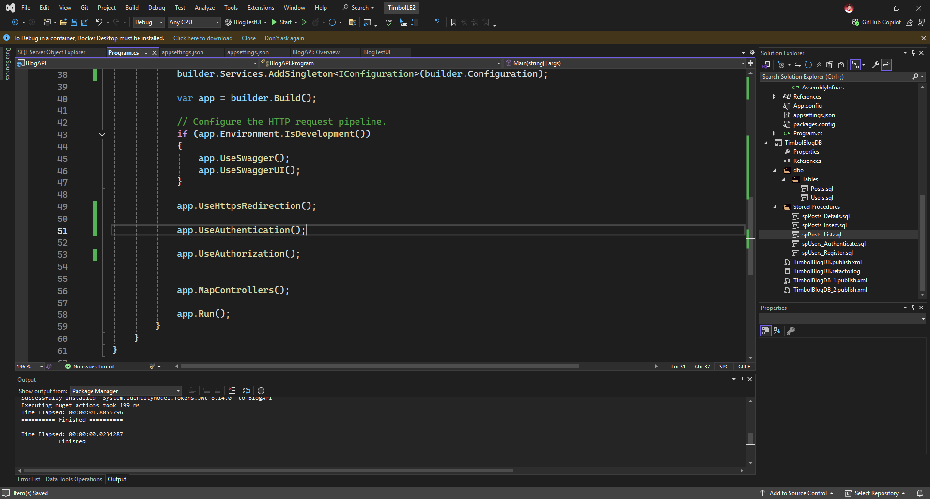

App feature: Login
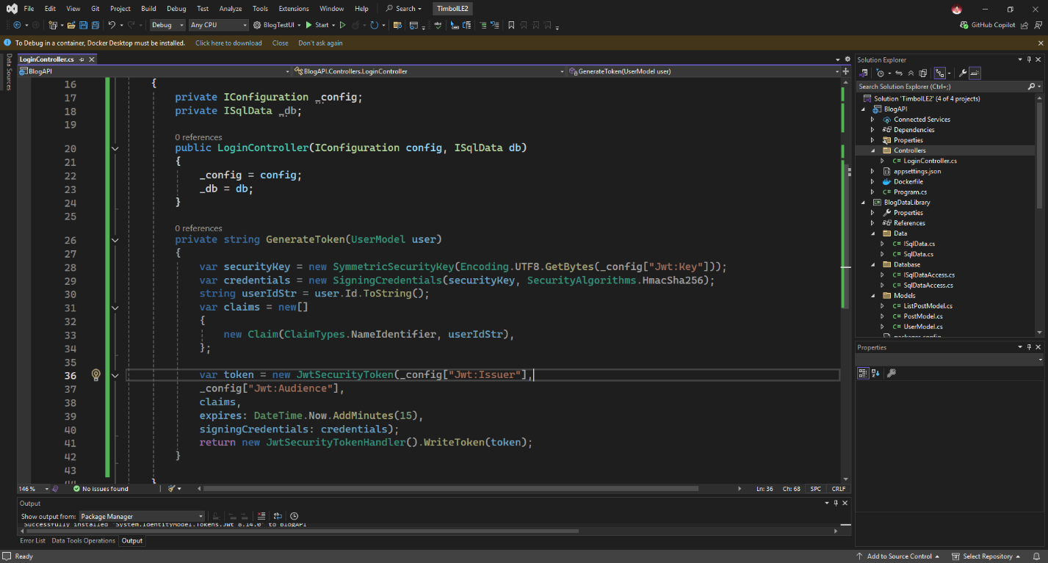
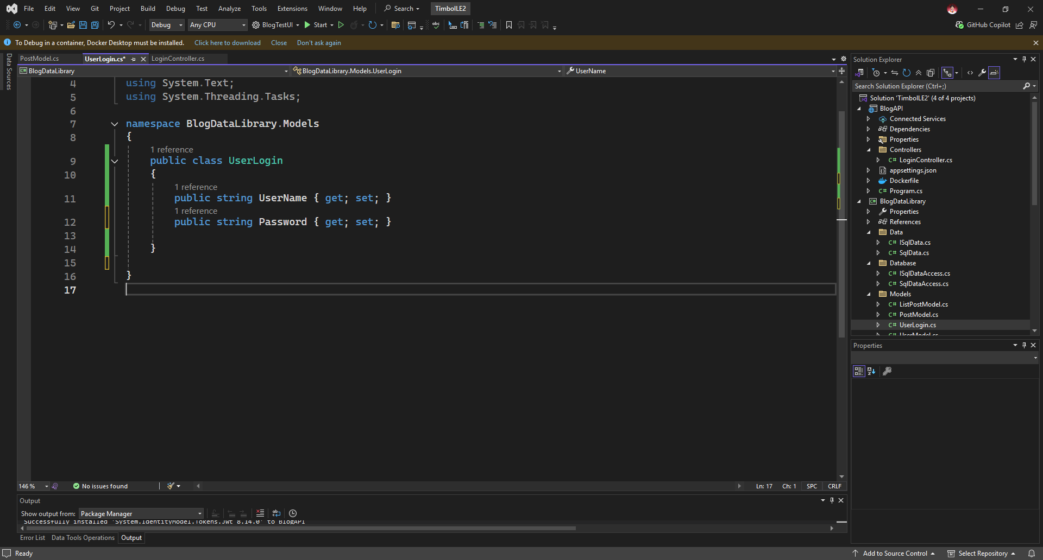
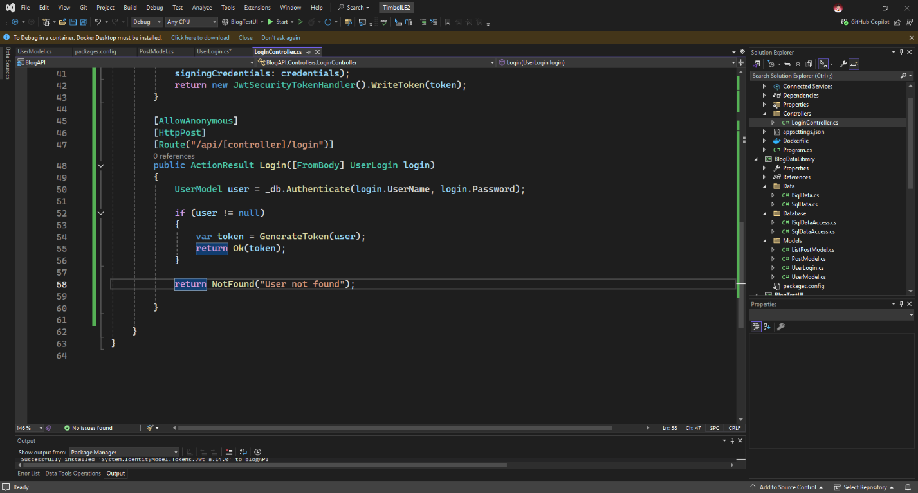
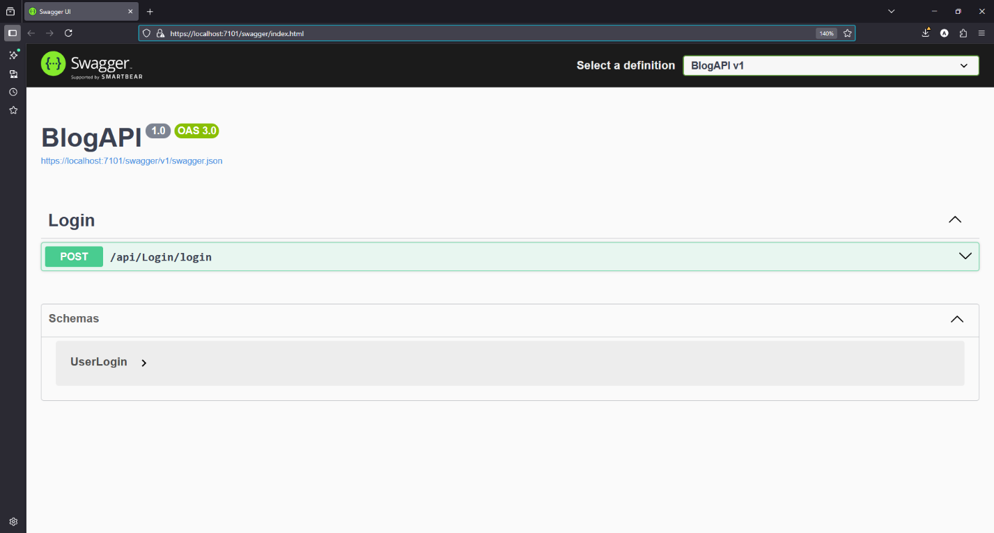
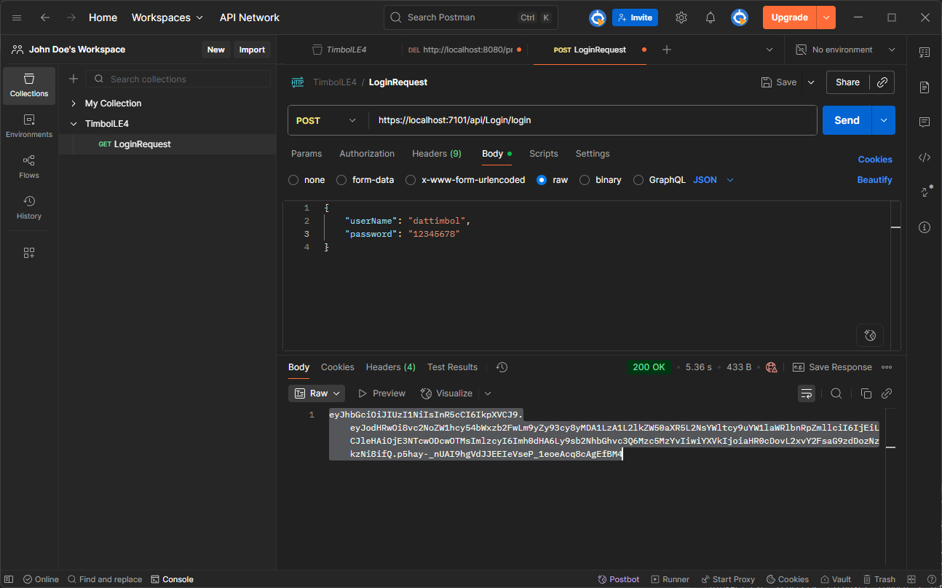
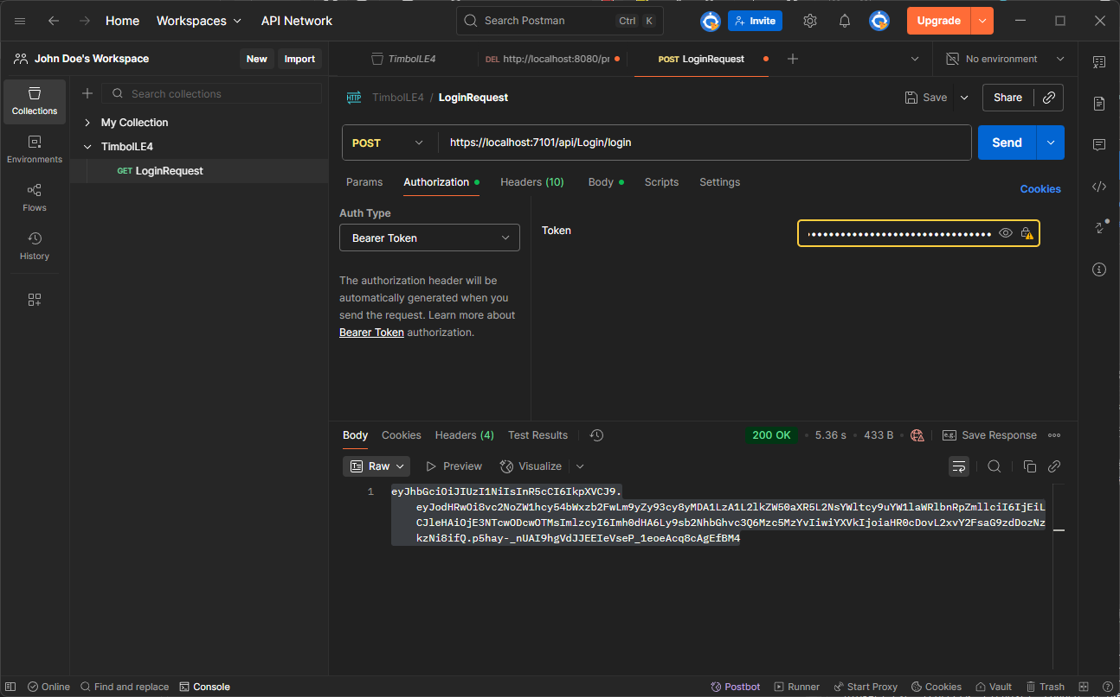

App feature: Register
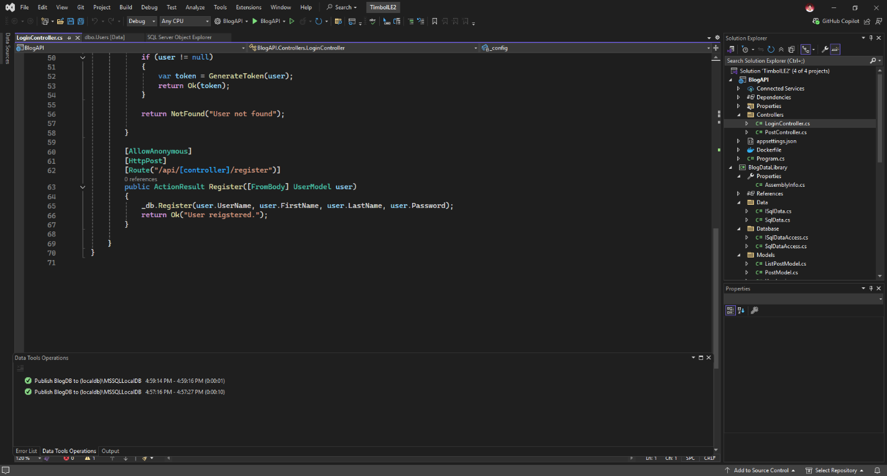
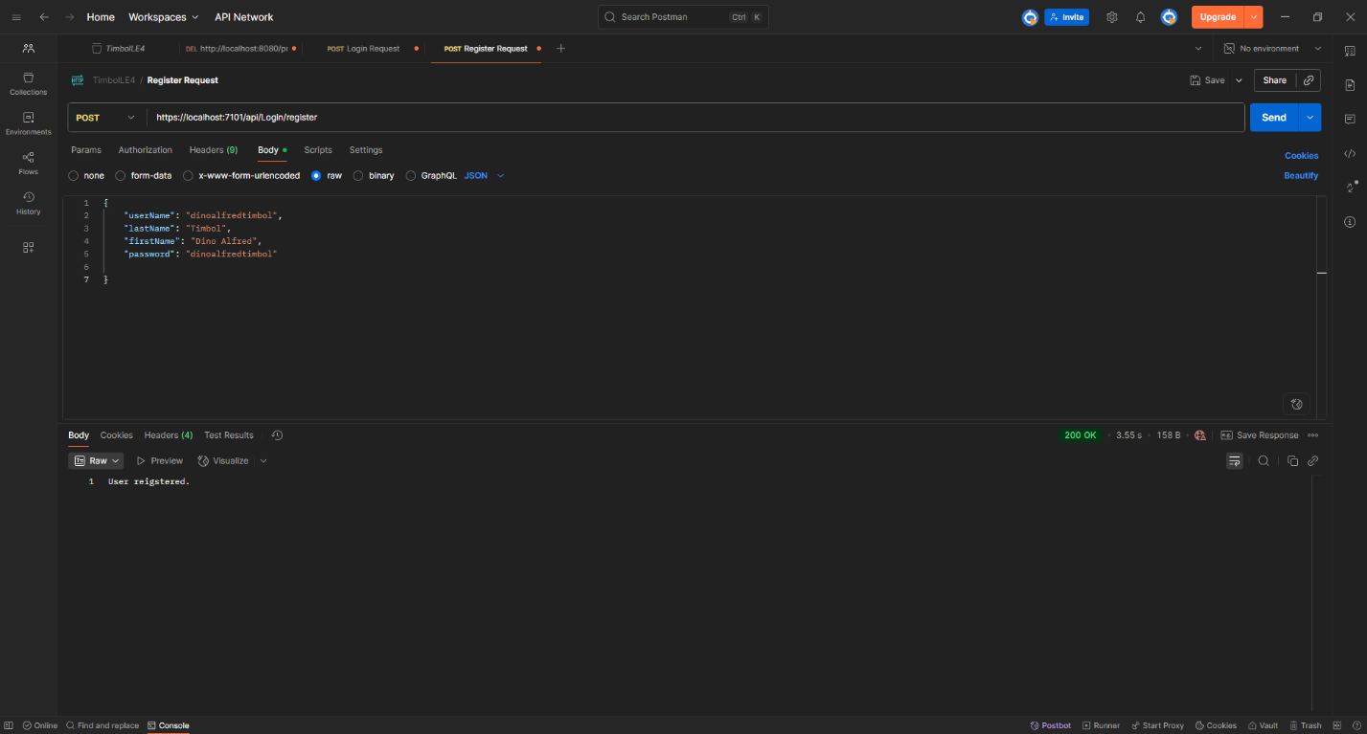

App functionality: List Posts
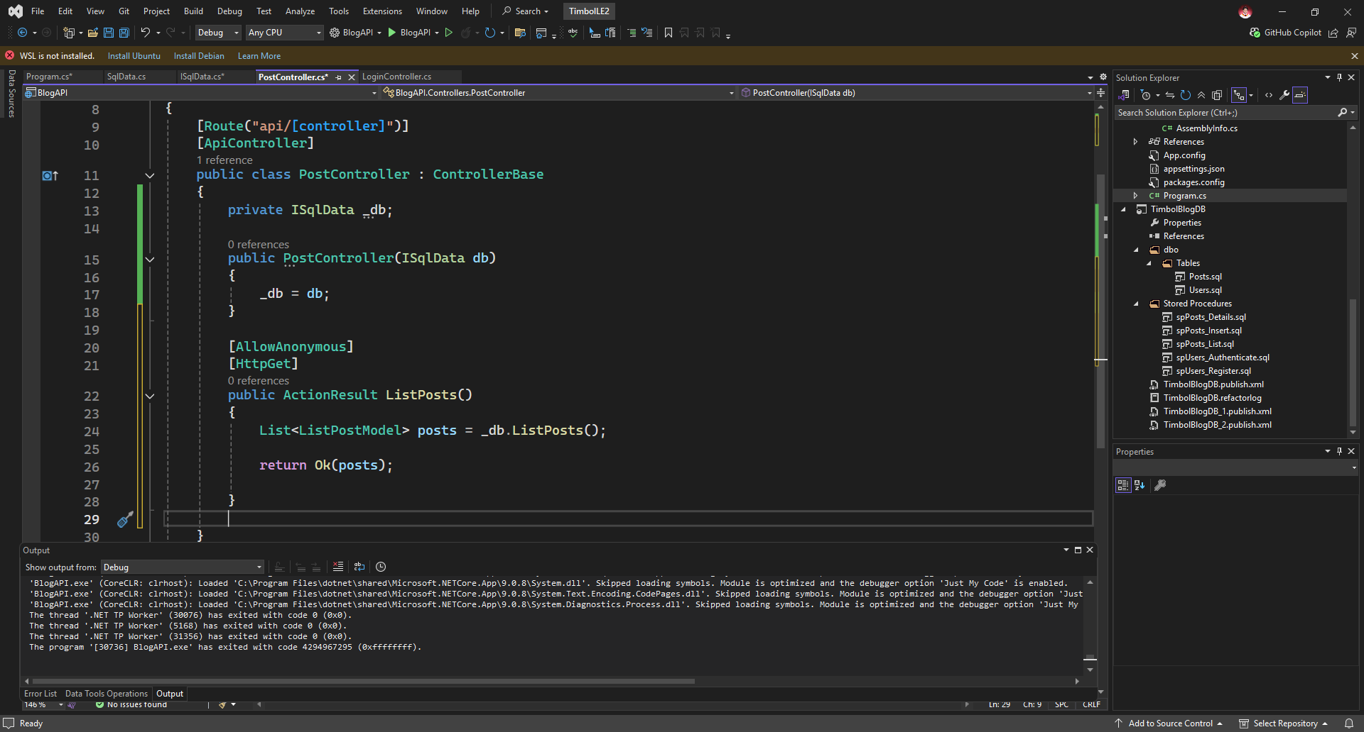
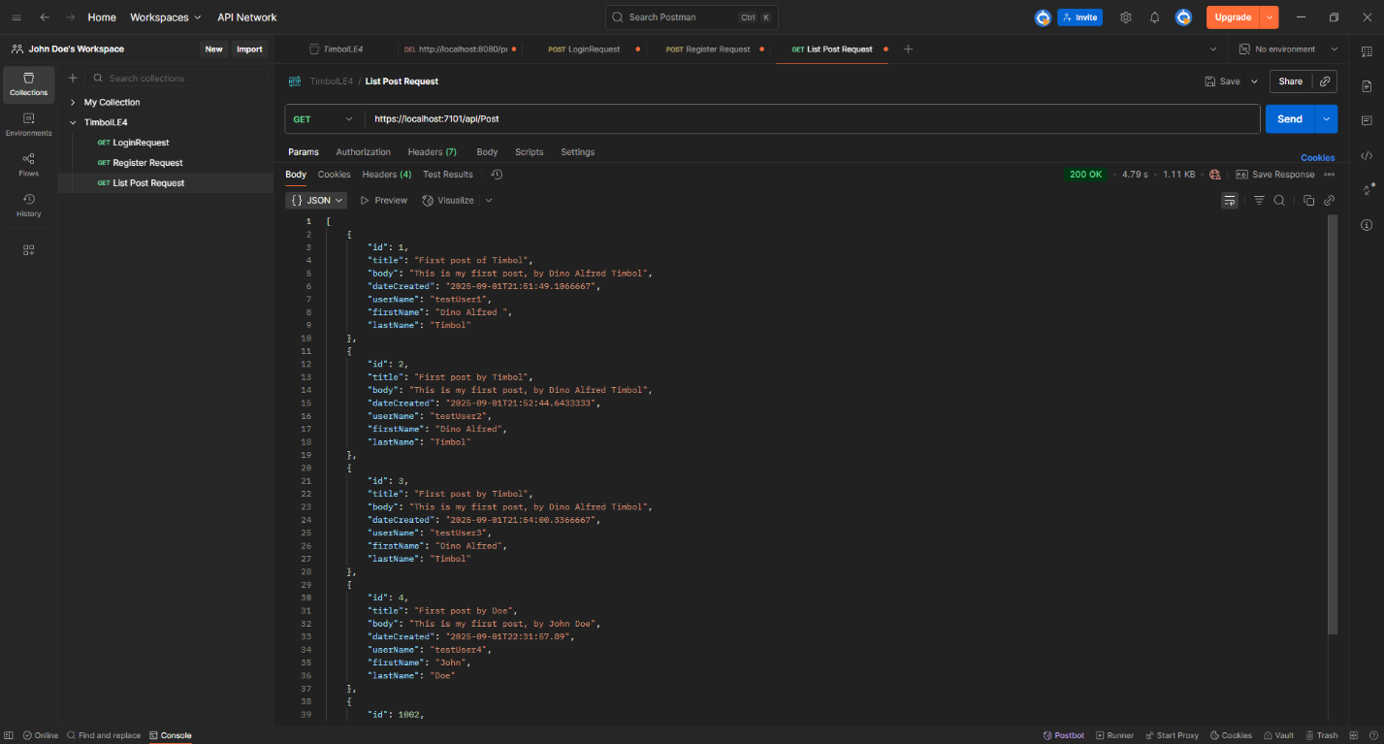

App functionality: Show Post Details
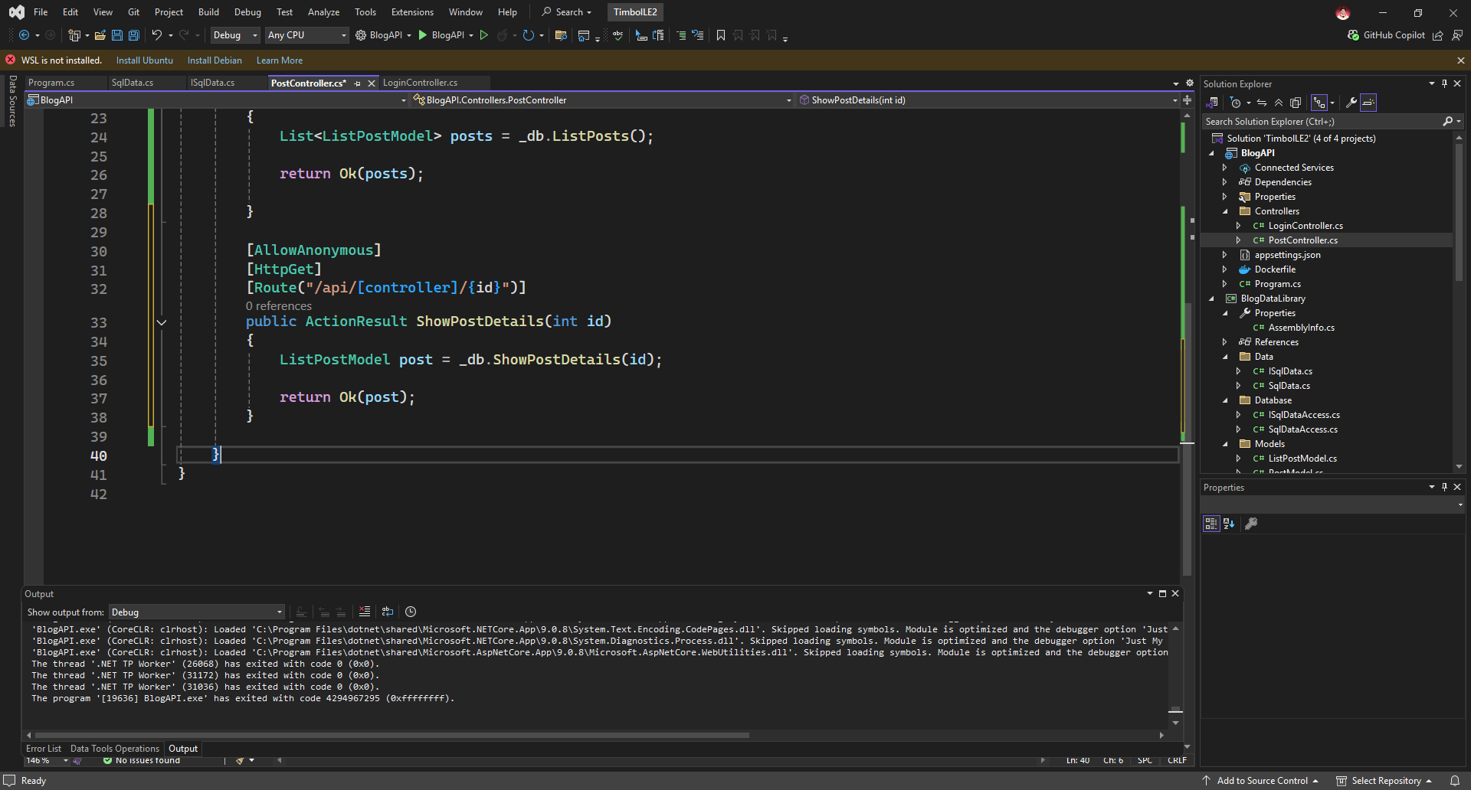
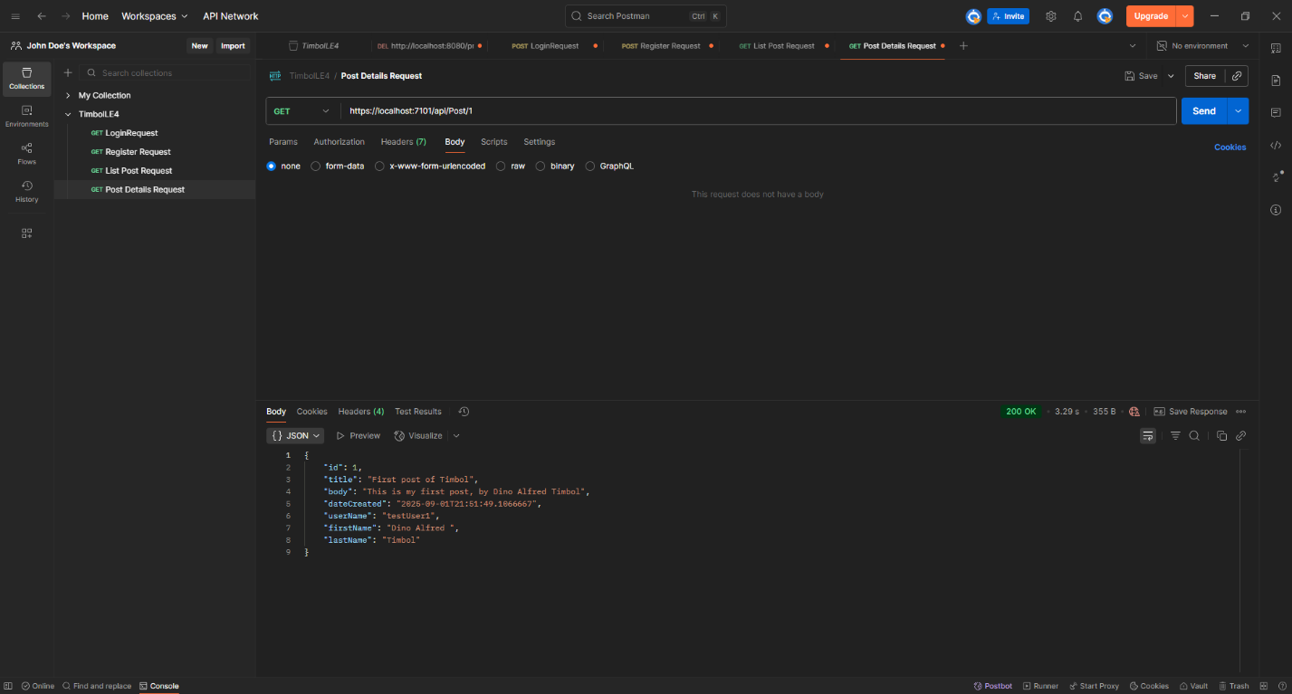

App functionality: Add post
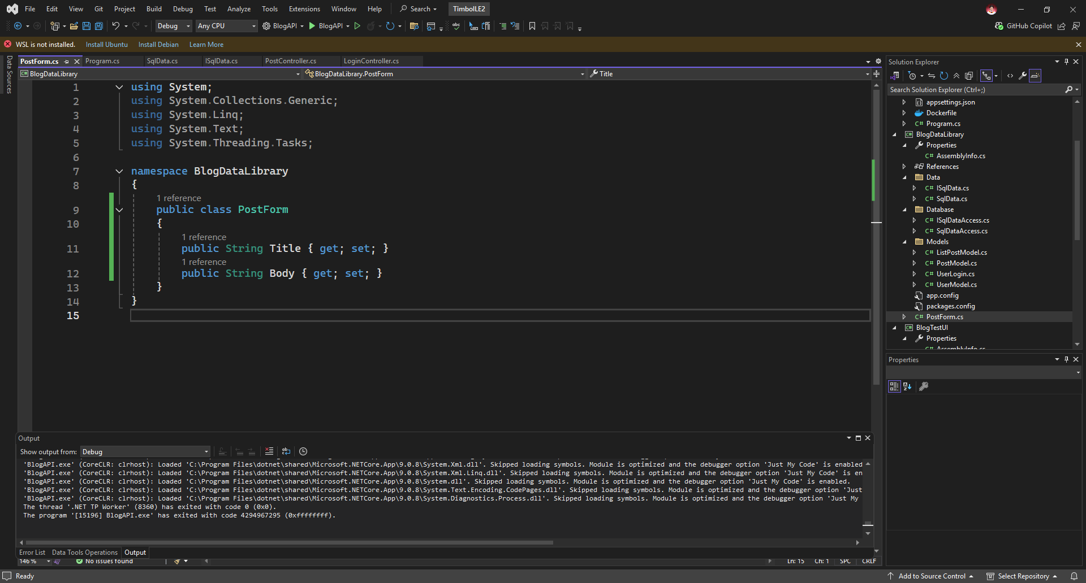
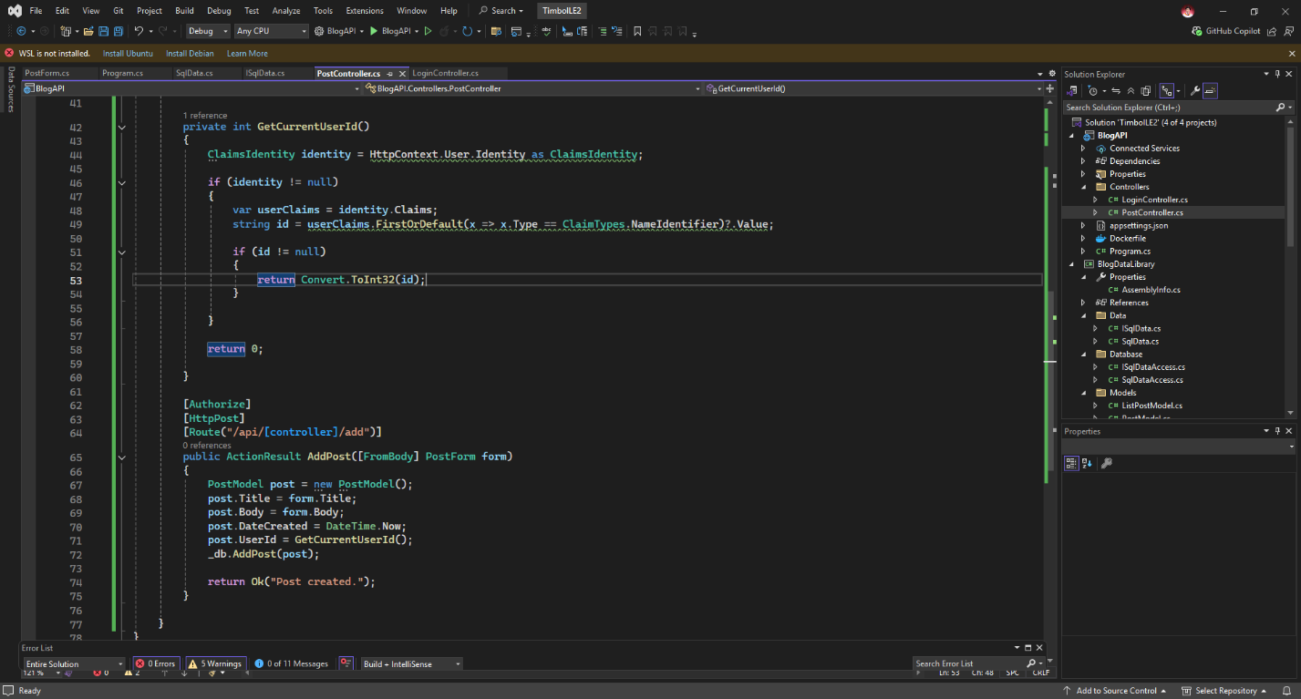
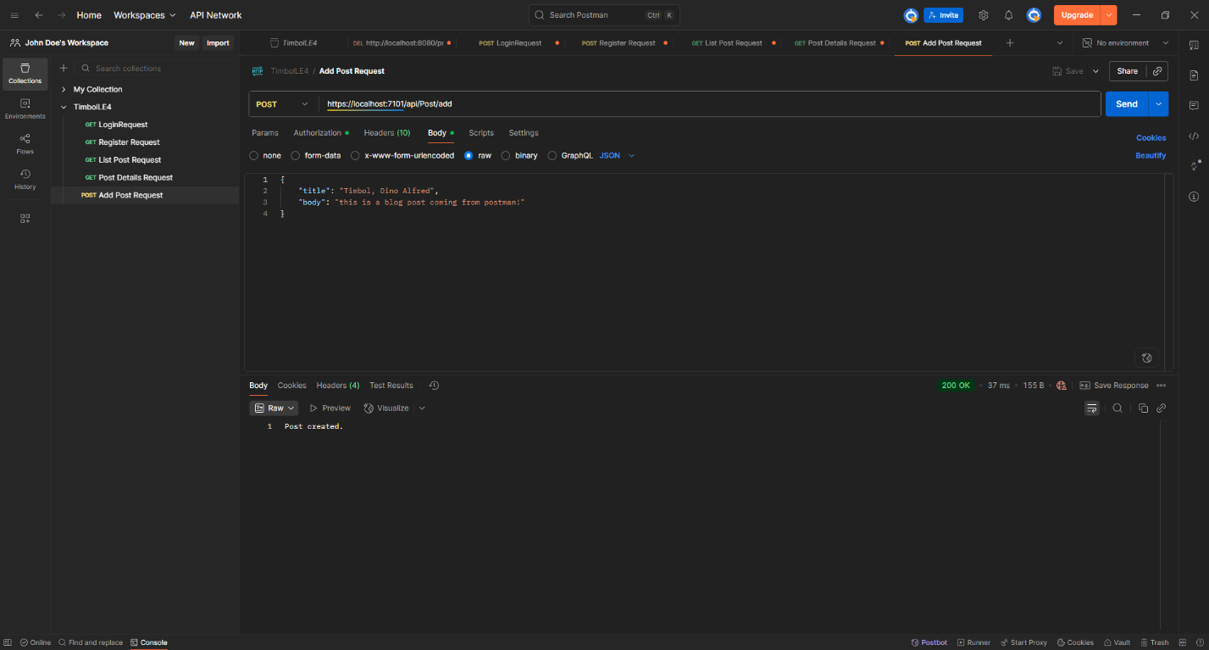

Post-program requirements
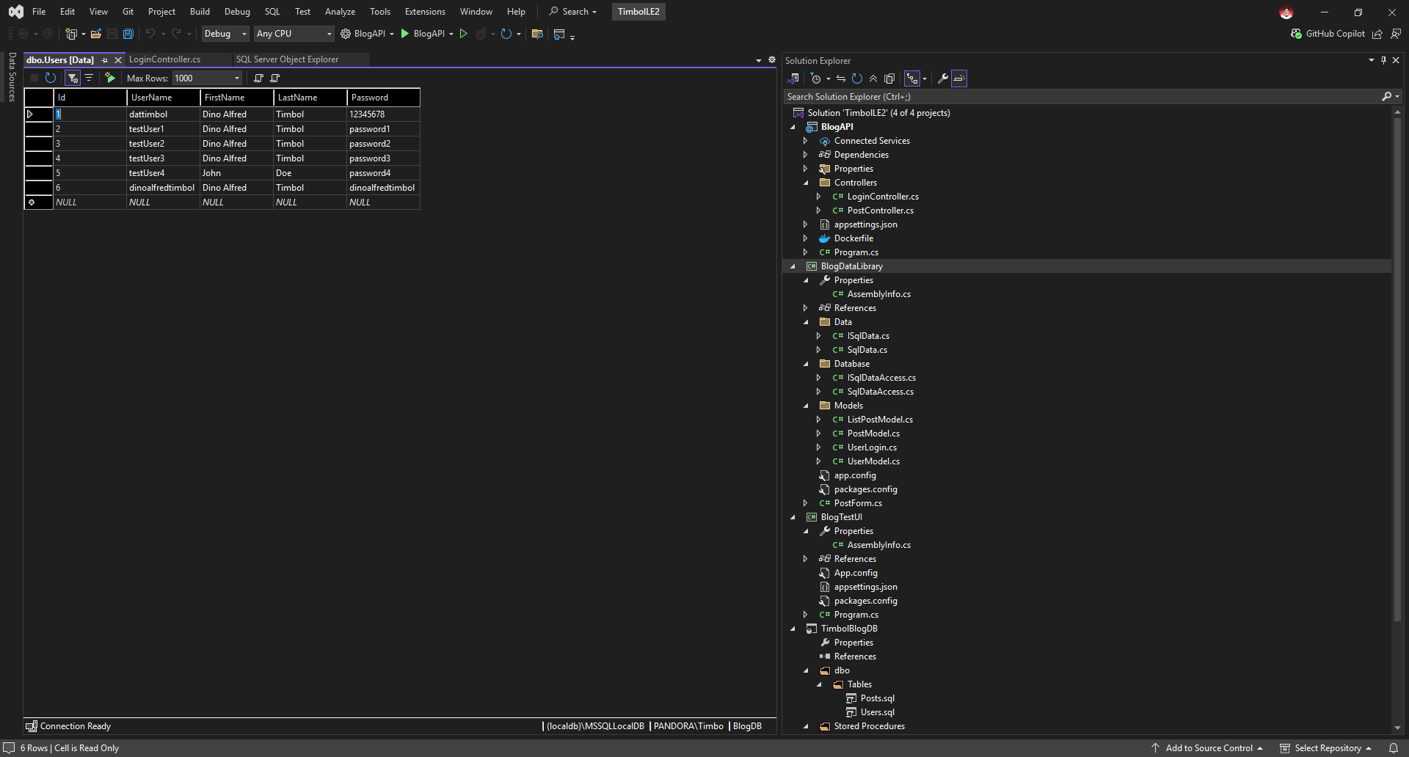
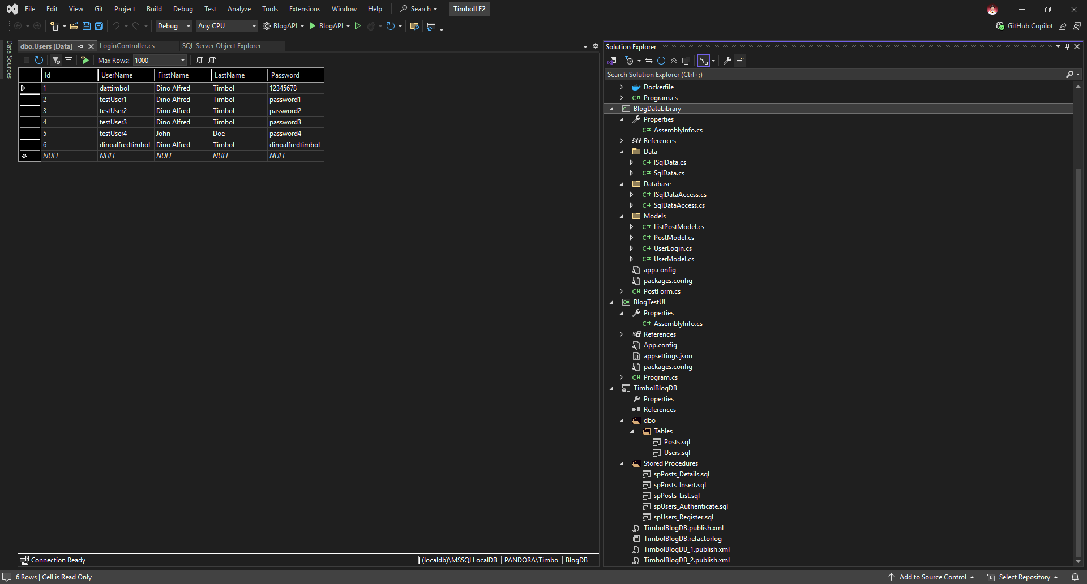
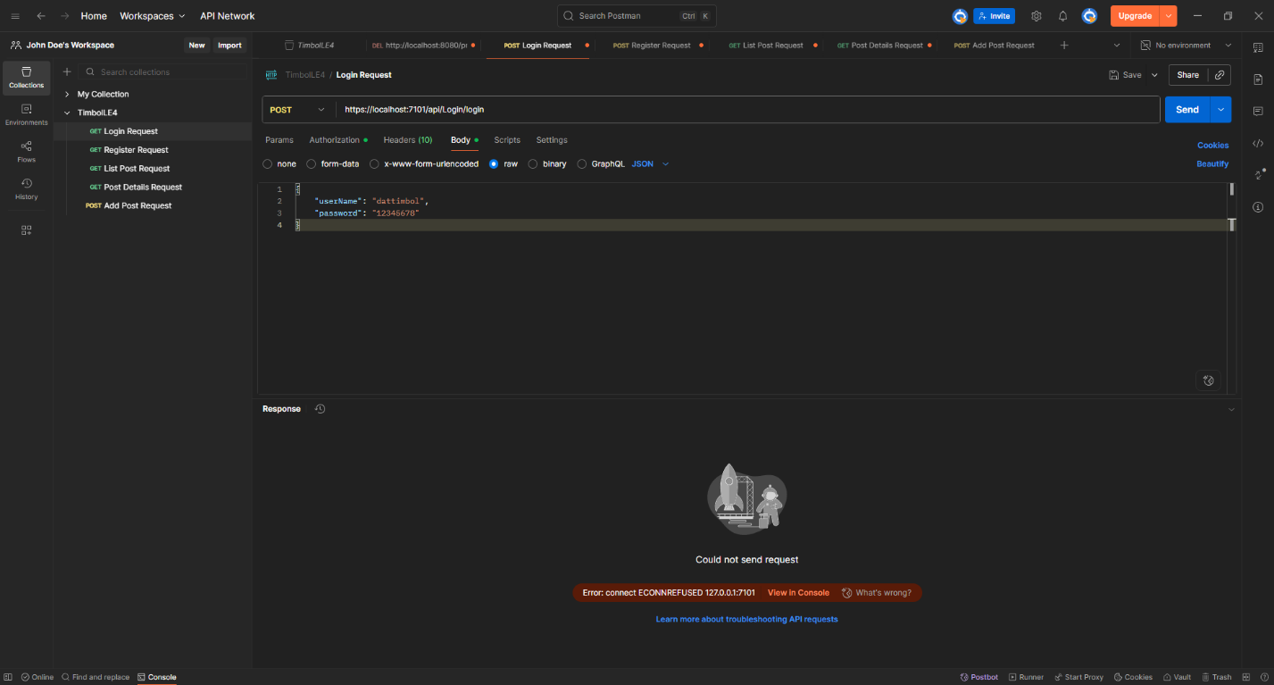

Codes from LoginController
using BlogDataLibrary.Data;
using BlogDataLibrary.Models;
using Microsoft.AspNetCore.Authorization;
using Microsoft.AspNetCore.Http;
using Microsoft.AspNetCore.Mvc;
using Microsoft.IdentityModel.Tokens;
using System.IdentityModel.Tokens.Jwt;
using System.Security.Claims;
using System.Text;

namespace BlogAPI.Controllers
{

public class LoginController : ControllerBase
{
private IConfiguration _config;
private ISqlData _db;

public LoginController(IConfiguration config, ISqlData db)
{
_config = config;
_db = db;
}

private string GenerateToken(UserModel user)
{
var securityKey = new SymmetricSecurityKey(Encoding.UTF8.GetBytes(_config["Jwt:Key"]));
var credentials = new SigningCredentials(securityKey, SecurityAlgorithms.HmacSha256);
string userIdStr = user.Id.ToString();
var claims = new[]
{
new Claim(ClaimTypes.NameIdentifier, userIdStr),
};

var token = new JwtSecurityToken(_config["Jwt:Issuer"],
_config["Jwt:Audience"],
claims,
expires: DateTime.Now.AddMinutes(15),
signingCredentials: credentials);
return new JwtSecurityTokenHandler().WriteToken(token);
}

[AllowAnonymous]
[HttpPost]
[Route("/api/[controller]/login")]
public ActionResult Login([FromBody] UserLogin login)
{
UserModel user = _db.Authenticate(login.UserName, login.Password);

if (user != null)
{
var token = GenerateToken(user);
return Ok(token);
}

return NotFound("User not found");

}

[AllowAnonymous]
[HttpPost]
[Route("/api/[controller]/register")]
public ActionResult Register([FromBody] UserModel user)
{
_db.Register(user.UserName, user.FirstName, user.LastName, user.Password);
return Ok("User reigstered.");
}

}
}

Codes from PostController
using BlogDataLibrary;
using BlogDataLibrary.Data;
using BlogDataLibrary.Models;
using Microsoft.AspNetCore.Authorization;
using Microsoft.AspNetCore.Http;
using Microsoft.AspNetCore.Mvc;
using System.Security.Claims;

namespace BlogAPI.Controllers
{
[Route("api/[controller]")]
[ApiController]
public class PostController : ControllerBase
{
private ISqlData _db;

public PostController(ISqlData db)
{
_db = db;
}

[AllowAnonymous]
[HttpGet]
public ActionResult ListPosts()
{
List<ListPostModel> posts = _db.ListPosts();

return Ok(posts);

}

[AllowAnonymous]
[HttpGet]
[Route("/api/[controller]/{id}")]
public ActionResult ShowPostDetails(int id)
{
ListPostModel post = _db.ShowPostDetails(id);

return Ok(post);
}

private int GetCurrentUserId()
{
ClaimsIdentity identity = HttpContext.User.Identity as ClaimsIdentity;

if (identity != null)
{
var userClaims = identity.Claims;
string id = userClaims.FirstOrDefault(x => x.Type == ClaimTypes.NameIdentifier)?.Value;

if (id != null)
{
return Convert.ToInt32(id);
}

}

return 0;

}

[Authorize]
[HttpPost]
[Route("/api/[controller]/add")]
public ActionResult AddPost([FromBody] PostForm form)
{
PostModel post = new PostModel();
post.Title = form.Title;
post.Body = form.Body;
post.DateCreated = DateTime.Now;
post.UserId = GetCurrentUserId();
_db.AddPost(post);

return Ok("Post created.");
}

}
}

