LAB EXERCISE 6
By Dino Alfred T. Timbol
Link to Github Repository: https://github.com/neoboi76/timbol-IT128

Screenshots
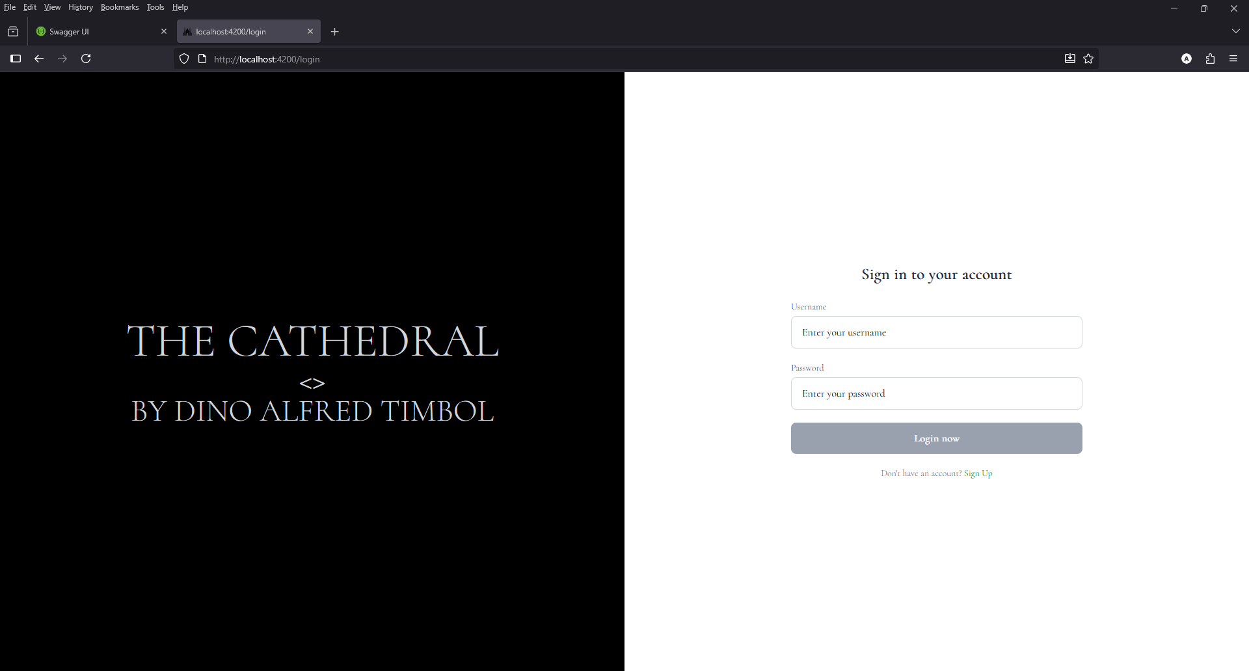
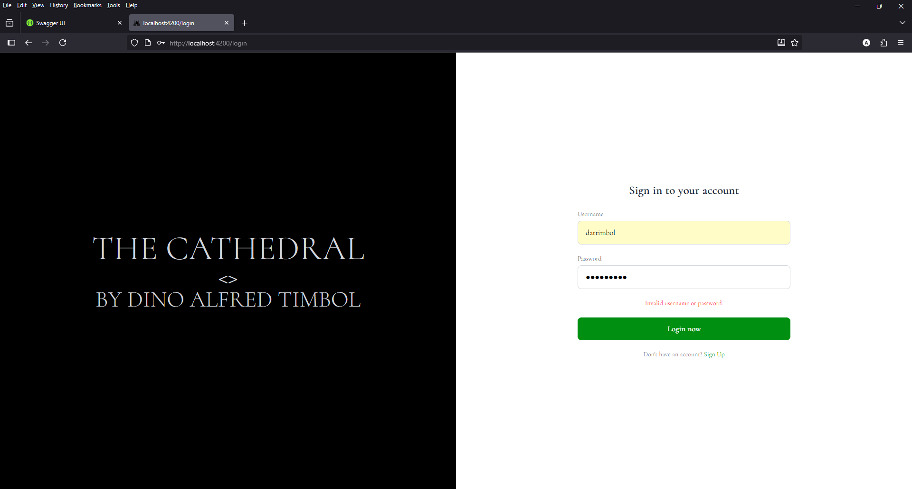
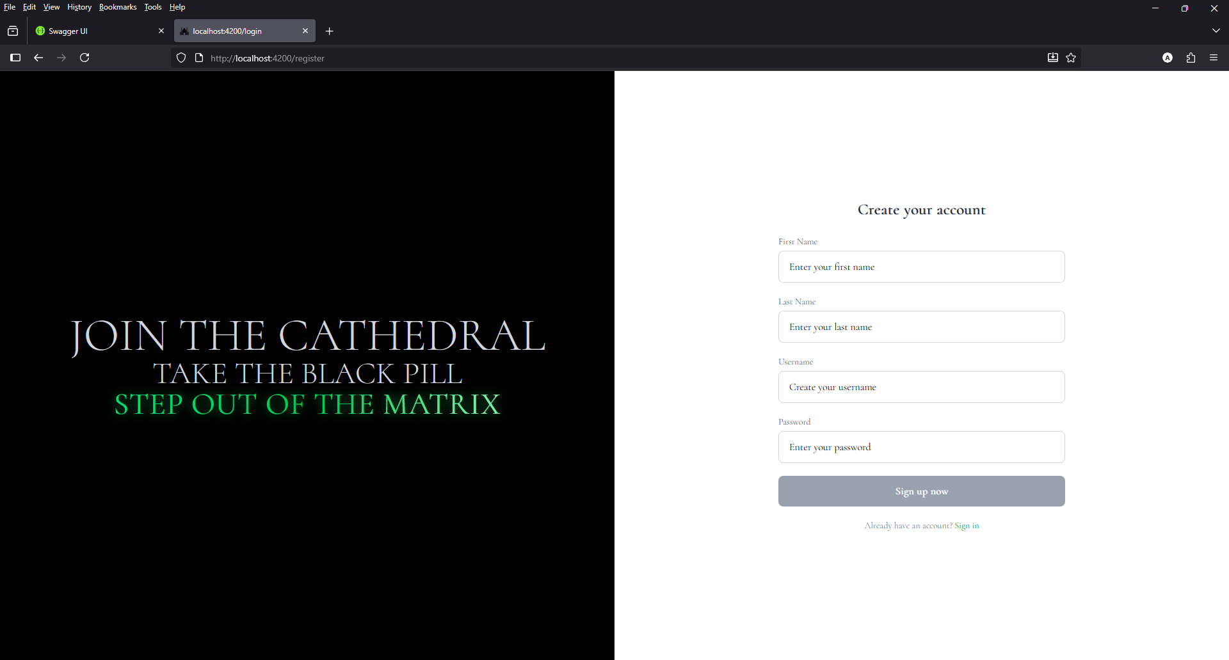
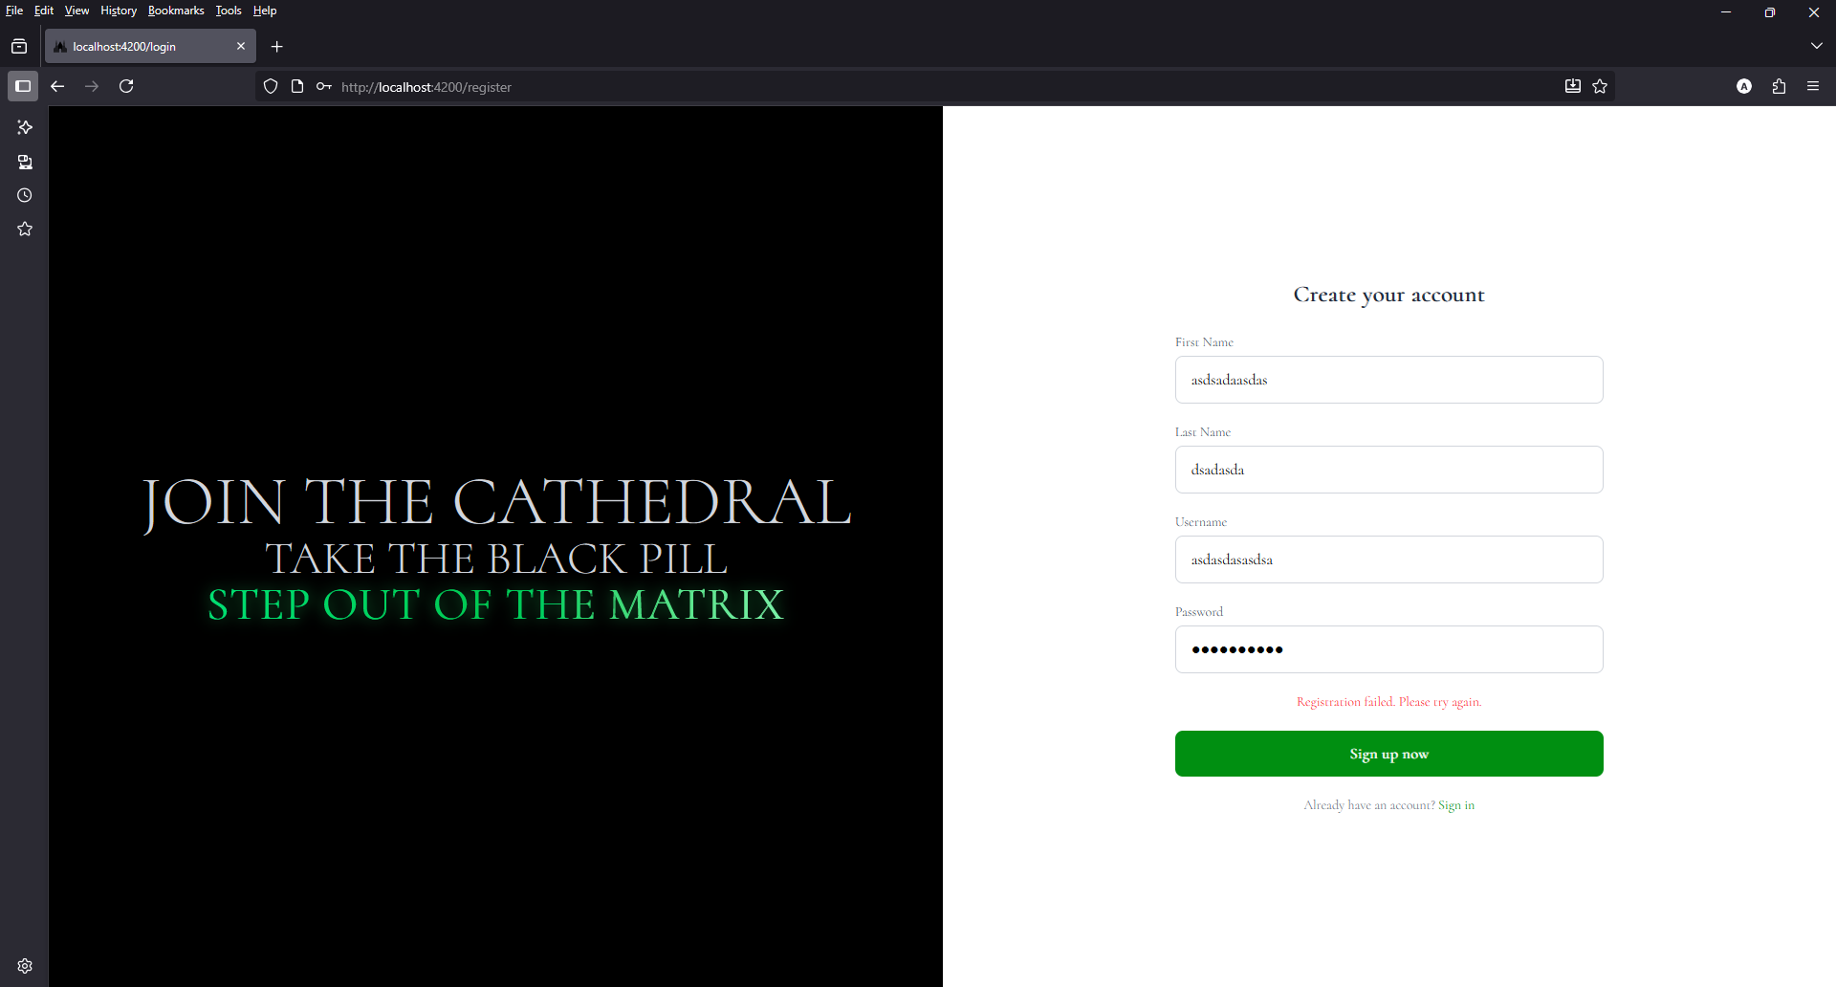
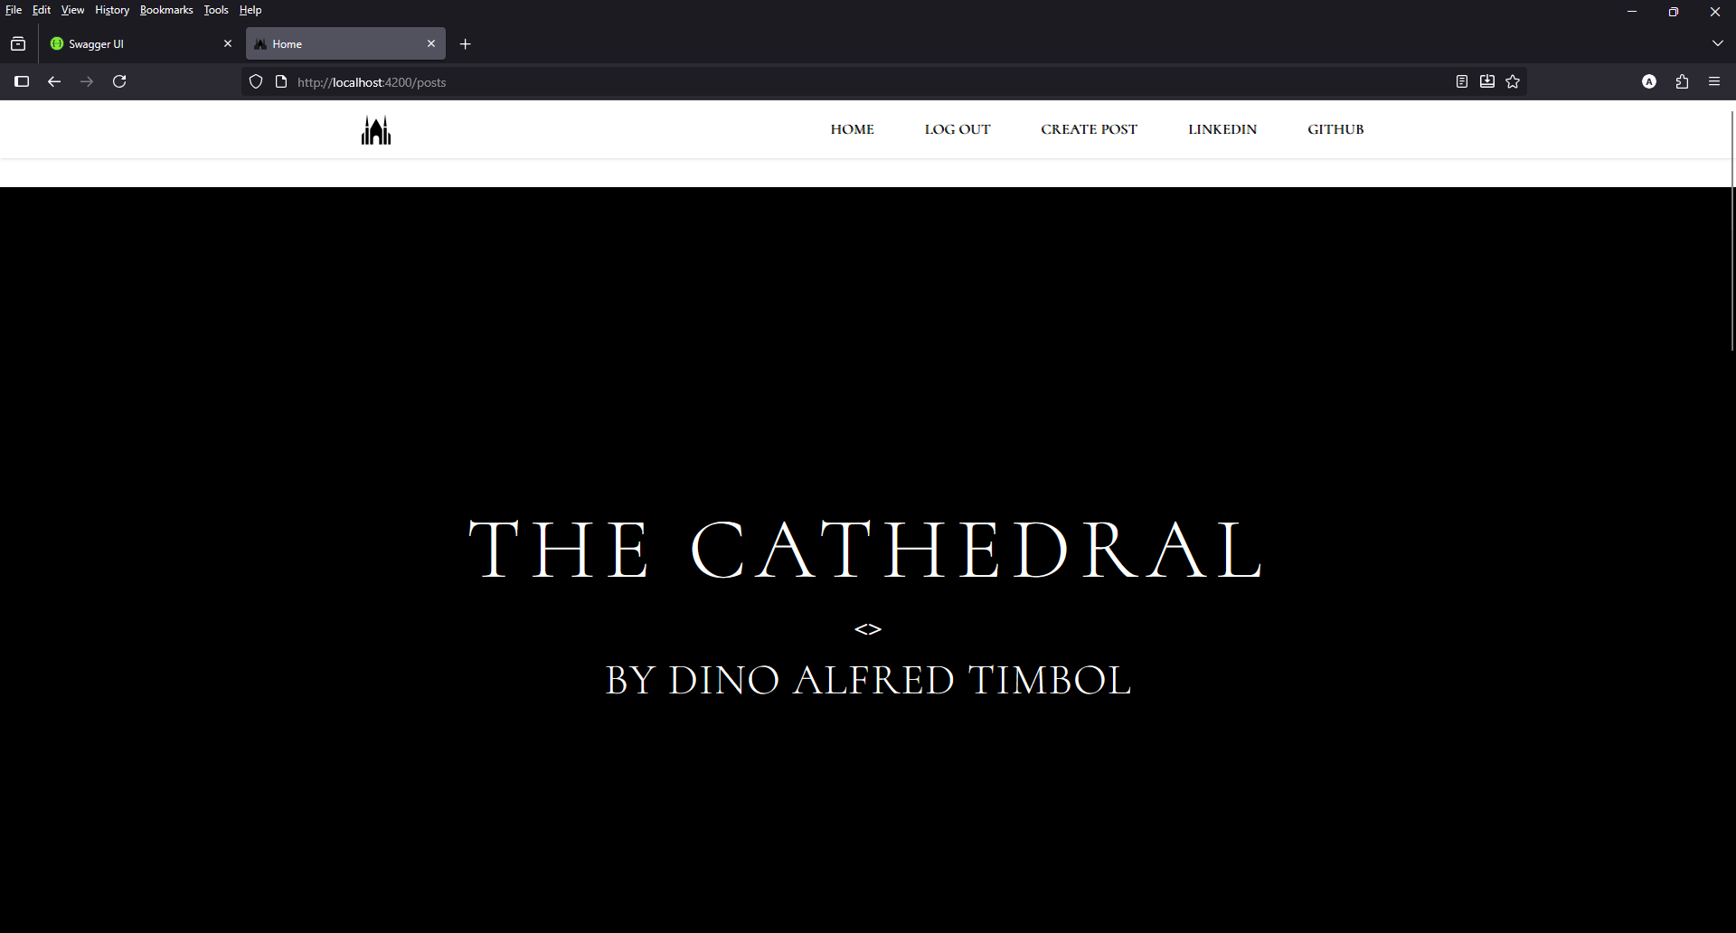
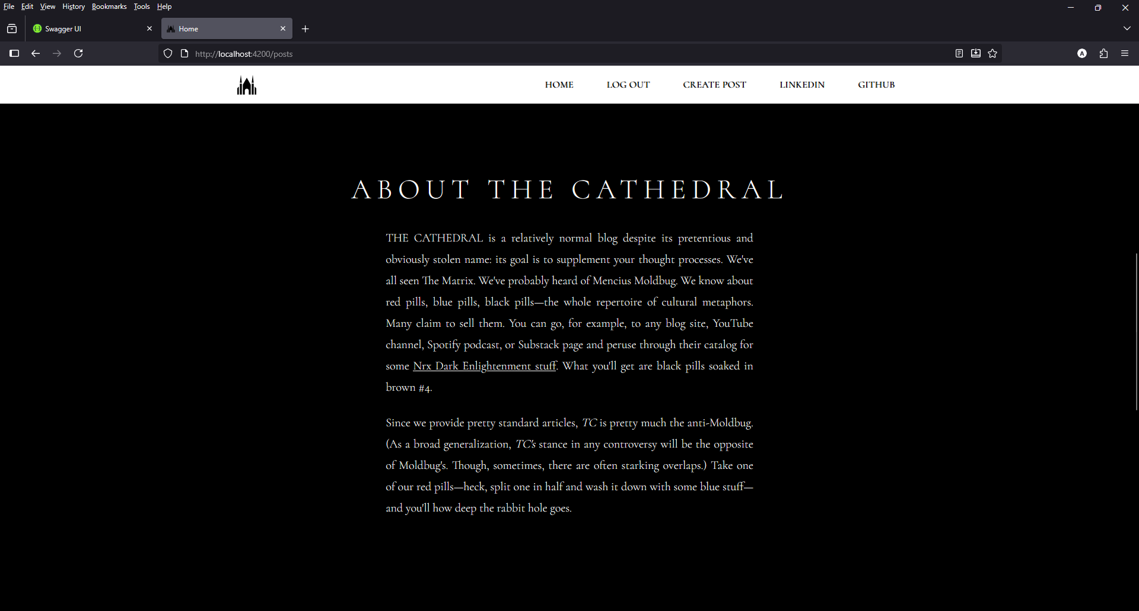
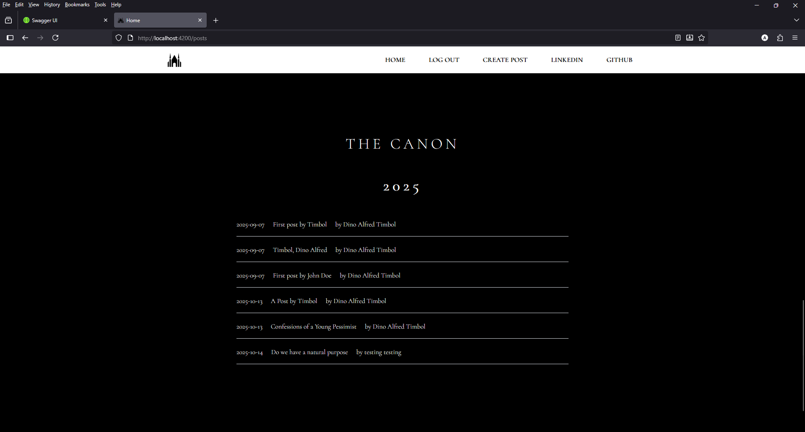
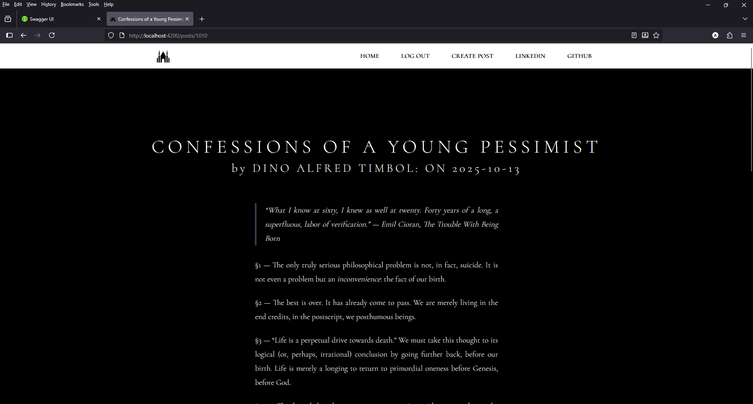
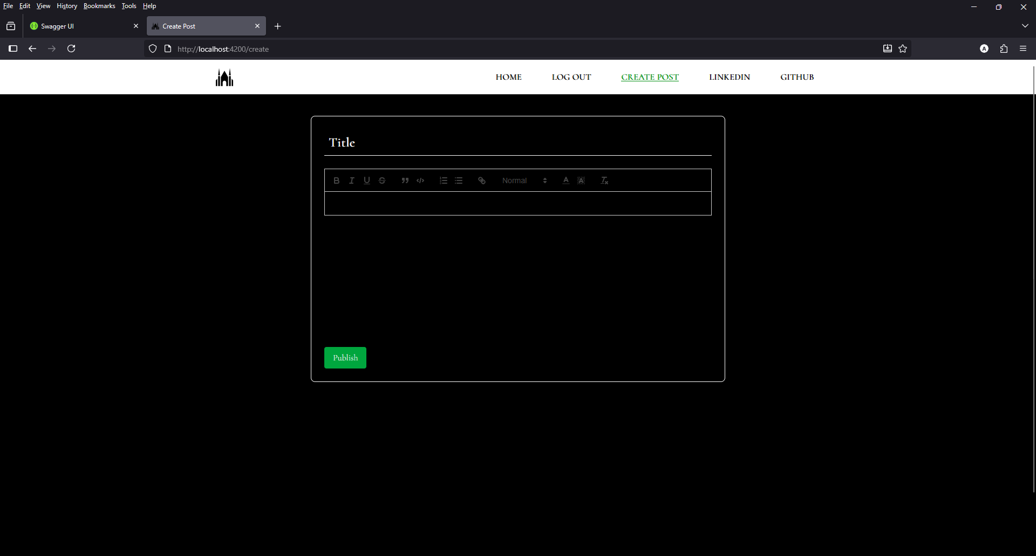

Code
add-post.html
<title>Create Post</title>

<app-nav></app-nav>

<div class="bg-black text-white min-h-screen p-6 mt-10 font-[Cormorant]">
<div class="max-w-3xl mx-auto bg-black p-6 rounded-lg shadow-lg border mt-10 border-white">
<input
type="text"
[(ngModel)]="addPost.title"
placeholder="Title"
class="w-full bg-black text-white border-b border-white p-2 mb-6 text-2xl font-semibold focus:outline-none focus:border-[#008F11] placeholder-white"
/>

<quill-editor
[(ngModel)]="addPost.body"
[modules]="quillConfig"
theme="snow"
class="bg-black text-white w-full overflow-hidden
[&_.ql-container]:max-w-full
[&_.ql-container]:overflow-visible
[&_.ql-editor]:whitespace-pre-wrap
[&_.ql-editor]:break-words
[&_.ql-editor]:overflow-wrap-break-word
[&_.ql-editor]:overflow-x-hidden
[&_.ql-editor]:text-wrap
[&_.ql-code-block]:whitespace-pre-wrap
[&_.ql-code-block]:break-words
[&_.ql-code-block]:overflow-wrap-break-word
min-h-[300px]"
></quill-editor>

<button
(click)="submitPost()"
class="cursor-pointer mt-6 bg-green-600 text-white px-4 py-2 rounded hover:bg-green-700 transition"
>
Publish
</button>
</div>
</div>

<footer class="bg-white text-black text-center font-bold text-base md:text-lg py-6">
<div><em>THE CATHEDRAL</em> Copyright &copy; 2025 by DINO ALFRED TIMBOL.</div>
</footer>

add-post.ts
import { HttpClient } from '@angular/common/http';
import { Component } from '@angular/core';
import { FormsModule } from '@angular/forms';
import { Router } from '@angular/router';
import { QuillModule } from 'ngx-quill';
import { TokenStorageService } from '../../services/token-storage.service';
import { CommonModule } from '@angular/common';
import { AuthServiceService } from '../../services/auth.service';
import { AddPostModel } from '../../models/add.model';
import { NavComponent } from "../nav.component/nav.component";

@Component({
selector: 'app-add-post',
imports: [FormsModule, QuillModule, CommonModule, NavComponent],
templateUrl: './add-post.html',
styleUrl: './add-post.css'
})
export class AddPostComponent {
isMenuOpen = false;
addPost: any;

constructor(
private http: HttpClient,
private route: Router,
private tokenStorage: TokenStorageService,
private auth: AuthServiceService
) {
this.addPost = {
userId: Number(this.tokenStorage.getUser()),
title: '',
body: '',
dateCreated: new Date()
};
}

quillConfig = {
toolbar: [
['bold', 'italic', 'underline', 'strike'],
['blockquote', 'code-block'],
[{ list: 'ordered' }, { list: 'bullet' }],
['link'],
[{ header: [1, 2, 3, false] }],
[{ color: [] }, { background: [] }],
['clean']
]
};

submitPost() {
const token = this.tokenStorage.getToken();
const { userId, title, body, dateCreated } = this.addPost;

this.auth.addPost(userId, title, body, dateCreated, token).subscribe({
next: (data) => {
console.log(data);
setTimeout(() => this.route.navigate([this.auth.redirectUrl]), 1000);
},
error: (err) => {
console.error(err);
}
});
}

}

list-posts.html
<title>Home</title>
<div class="bg-black text-white text-center box-border m-0 p-0 font-[Cormorant]">

<app-nav></app-nav>

<main class="relative mt-24 mb-16">
<section id="entry-1" class="flex flex-col justify-center items-center min-h-screen px-4">
<h1 class="text-3xl sm:text-5xl md:text-6xl lg:text-8xl tracking-widest">THE CATHEDRAL</h1>
<b class="text-3xl sm:text-3xl md:text-4xl mt-4">&lt;&gt;</b>
<p class="text-3xl sm:text-3xl md:text-5xl tracking-wide mt-4">BY DINO ALFRED TIMBOL</p>
</section>

<section id="about" class="flex flex-col justify-center items-center min-h-screen w-full text-white px-6 lg:px-25 text-justify">
<h2 class="text-3xl md:text-5xl tracking-[0.2em] text-center mb-10">ABOUT THE CATHEDRAL</h2>

<article class="prose xl:prose-xl text-white prose-blockquote:text-white">
<p>
THE CATHEDRAL is a relatively normal blog despite its pretentious and obviously stolen name: its goal is to supplement your thought processes.
We've all seen The Matrix. We've probably heard of Mencius Moldbug. We know about red pills, blue pills, black pills—the whole repertoire of cultural metaphors.
Many claim to sell them. You can go, for example, to any blog site, YouTube channel, Spotify podcast, or Substack page and peruse through their catalog for some
<a href="https://en.wikipedia.org/wiki/Dark_Enlightenment" class="underline text-white">Nrx Dark Enlightenment stuff</a>.
What you'll get are black pills soaked in brown #4.
</p>

<p>
Since we provide pretty standard articles, <em>TC</em> is pretty much the anti-Moldbug.
(As a broad generalization, <em>TC's</em> stance in any controversy will be the opposite of Moldbug's.
Though, sometimes, there are often starking overlaps.)
Take one of our red pills—heck, split one in half and wash it down with some blue stuff—and you'll how deep the rabbit hole goes.
</p>
</article>
</section>

<section id="canon" class="flex flex-col justify-center items-center min-h-screen w-full px-6 lg:px-20 text-justify">
<h2 class="text-3xl md:text-4xl tracking-[0.2em] text-center mb-15 mt-20">THE CANON</h2>
<h3 class="text-3xl font-bold md:text-4xl tracking-[0.2em] text-center mb-10">2025</h3>

<a routerLink="/posts/{{ post.id }}" *ngFor="let post of posts" class="flex [@media(max-width:370px)]:flex-col sm:flex-row space-x-5 justify-left sm:w-[75%] md:w-[70%] xl:w-[45%] w-[100%] mx-auto px-0 py-5 items-center text-justify border-b border-gray-300 pb-4 hover:bg-[#008F11] transition-colors duration-300 cursor-pointer">
<span class="text-[0.6rem] sm:text-base text-white">{{ post.dateCreated | date:'yyyy-MM-dd' }} </span>
<span class="text-[0.6rem] sm:text-base text-white">{{ post.title }}</span>
<span class="text-[0.6rem] sm:text-base text-white"> by {{ post.firstName }} {{ post.lastName }}</span>
</a>
</section>
</main>

<footer class="bg-white text-black font-bold text-base md:text-lg py-6">
<div><em>THE CATHEDRAL</em> Copyright &copy; 2025 by DINO ALFRED TIMBOL.</div>
</footer>
</div>

list-posts.ts
import { Component } from '@angular/core';
import { Post } from '../../models/post.model';
import { HttpClient } from '@angular/common/http';
import { CommonModule } from '@angular/common';
import { TokenStorageService } from '../../services/token-storage.service';
import { Router, RouterLink } from '@angular/router';
import { AuthServiceService } from '../../services/auth.service';
import { NavComponent } from '../nav.component/nav.component';

@Component({
selector: 'app-list-posts',
imports: [CommonModule, RouterLink, NavComponent],
templateUrl: './list-posts.html',
styleUrl: './list-posts.css'
})
export class ListPostsComponent {
isMenuOpen = false;
posts?: Post[] = [];

constructor(
private http: HttpClient,
private tokenStorageService: TokenStorageService,
private auth: AuthServiceService,
private route: Router
) {}

ngOnInit() : void {
this.initData();
}

initData(): void {
this.http.get<Post[]>('https://Localhost:7101/api/post')
.subscribe({
next: (data: Post[]) => {
this.posts = data;
console.log(this.posts);
},
error: err => {
console.error(err);
}
})
}

}
login-page.html
<div class="min-h-screen flex bg-white">
<div class="hidden lg:flex w-1/2 bg-black text-white flex-col justify-center items-center">
<div class="flex flex-col items-center px-8 text-center">
<p class="text-7xl text-gray-300">THE CATHEDRAL</p>
<p class="text-5xl text-gray-300"><b>&lt;&gt;</b></p>
<p class="text-5xl text-gray-300">BY DINO ALFRED TIMBOL</p>
</div>
</div>

<div class="fixed lg:hidden top-0 left-0 w-full bg-black p-4 text-white">
<div class="flex flex-col items-center text-center">
<p class="text-5xl text-gray-300">THE CATHEDRAL</p>
</div>
</div>

<div class="flex w-full lg:w-1/2 justify-center items-center bg-white">
<div class="w-full max-w-lg px-8">
<h1 class="text-2xl font-semibold text-gray-800 mb-6 text-center">Sign in to your account</h1>

<form [formGroup]="loginForm" (ngSubmit)="onSubmit()" novalidate class="space-y-5">
<div>
<label for="username" class="block text-sm font-medium text-gray-600 mb-1">Username</label>
<input
type="text"
id="username"
formControlName="username"
class="w-full px-4 py-3 border border-gray-300 rounded-lg focus:ring-2 focus:ring-[#008F11] focus:outline-none"
placeholder="Enter your username"
/>
<div *ngIf="submitted && f['username'].errors" class="text-red-500 text-sm mt-1">
<span *ngIf="f['username'].errors['required']">Username is required.</span>
<span *ngIf="f['username'].errors['minlength']">Username is must be at least 4 characters</span>
</div>
</div>

<div>
<label for="password" class="block text-sm font-medium text-gray-600 mb-1">Password</label>
<input
type="password"
id="password"
formControlName="password"
class="w-full px-4 py-3 border border-gray-300 rounded-lg focus:ring-2 focus:ring-[#008F11] focus:outline-none"
placeholder="Enter your password"
/>
<div *ngIf="submitted && f['password'].errors" class="text-red-500 text-sm mt-1">
<span *ngIf="f['password'].errors['required']">Password is required.</span>
<span *ngIf="f['password'].errors['minlength']">Must be at least 6 characters.</span>
</div>
</div>

<div *ngIf="errorMessage" class="text-red-500 text-center text-sm">
{{ errorMessage }}
</div>

<button
type="submit"
[disabled]="loginForm.invalid"
class="cursor-pointer w-full py-3 bg-[#008F11] text-white rounded-lg hover:bg-green-700 transition disabled:bg-gray-400 disabled:cursor-not-allowed font-semibold"
>
Login now
</button>

<p class="text-sm text-center text-gray-500">
Don't have an account?
<a routerLink="/register" class="text-[#008F11] hover:underline">Sign Up</a>
</p>
</form>
</div>
</div>
</div>
login-page.ts
import { CommonModule } from '@angular/common';
import { Component, OnInit } from '@angular/core';
import { FormBuilder, FormGroup, FormsModule, ReactiveFormsModule, Validators } from '@angular/forms';
import { TokenStorageService } from '../../services/token-storage.service';
import { HttpClient } from '@angular/common/http';
import { Router, RouterLink } from '@angular/router';
import { AuthServiceService } from '../../services/auth.service';
import { LoginPostData } from '../post-detail/post-detail';

@Component({
selector: 'app-login-page',
standalone: true,
imports: [CommonModule, ReactiveFormsModule, RouterLink],
templateUrl: './login-page.html',
styleUrls: ['./login-page.css']
})
export class LoginPageComponent implements OnInit {
loginForm!: FormGroup;
submitted = false;
errorMessage = '';

constructor(
private authService: AuthServiceService,
private tokenStorage: TokenStorageService,
private router: Router,
private fb: FormBuilder
) {}

ngOnInit(): void {
if (this.tokenStorage.getToken()) {
this.authService.isLoggedIn = true;
this.router.navigate([this.authService.redirectUrl]);
}

this.loginForm = this.fb.group({
username: ['', [Validators.required, Validators.minLength(4)]],
password: ['', [Validators.required, Validators.minLength(6)]],
});
}

get f() {
return this.loginForm.controls;
}

onSubmit(): void {
this.submitted = true;
this.errorMessage = '';

if (this.loginForm.invalid) return;

const { username, password } = this.loginForm.value;

this.authService.login(username, password).subscribe({
next: (data: LoginPostData) => {
this.tokenStorage.saveToken(data.id_token);
this.tokenStorage.saveUser(data.id);
this.authService.isLoggedIn = true;
setTimeout(() => this.router.navigate([this.authService.redirectUrl]), 1000);
},
error: err => {
console.error(err);
this.errorMessage = 'Invalid username or password.';
}
});
}
}

nav.component.html
<nav class="bg-white border-gray-200 text-center fixed top-0 w-full z-50 shadow-sm">
<div class="max-w-6xl flex flex-wrap items-center justify-between mx-auto px-4 py-3">
<a routerLink="/home" class="flex items-center space-x-3 rtl:space-x-reverse">
<img src="assets/logo.svg" alt="logo" class="object-cover [@media(max-width:640px)]:ml-0 ml-7 h-10 w-8 xl:ml-0 sm:w-8 sm:h-10" />
</a>

<button
type="button"
class="inline-flex items-center p-2 w-10 h-10 justify-center text-sm text-white-800 bg-white md:hidden hover:bg-gray-300 dark:text-black dark:hover:bg-white-900 focus:outline-none focus:ring-2 focus:ring-gray-300"
aria-controls="navbar-default"
(click)="toggleMenu()"
[attr.aria-expanded]="isMenuOpen">
<span class="sr-only">Open main menu</span>
<svg class="w-5 h-5" aria-hidden="true" xmlns="http://www.w3.org/2000/svg" fill="none" viewBox="0 0 17 14">
<path stroke="currentColor" stroke-linecap="round" stroke-linejoin="round" stroke-width="2" d="M1 1h15M1 7h15M1 13h15"/>
</svg>
</button>

<div
id="navbar-default"
class="w-full md:block md:w-auto overflow-hidden transition-all duration-300 ease-in-out md:!max-h-none md:!opacity-100"
[class.max-h-0]="!isMenuOpen"
[class.max-h-96]="isMenuOpen"
[class.opacity-0]="!isMenuOpen"
[class.opacity-100]="isMenuOpen">
<ul class="font-bold flex flex-col p-4 md:p-0 mt-4 border border-gray-100 rounded-lg bg-gray-50 md:flex-row md:space-x-8 rtl:space-x-reverse md:mt-0 md:border-0 md:bg-white dark:border-gray-700">
<li><a (click)="goHome()" class="cursor-pointer block py-2 px-3 text-black hover:text-[#008F11] hover:underline rounded-md transition md:hover:bg-transparent">HOME</a></li>
<li><a (click)="logOut()" class="block py-2 px-3 text-black hover:text-[#008F11] hover:underline rounded-md transition md:hover:bg-transparent cursor-pointer">LOG OUT</a></li>
<li><a (click)="createPost()" class="cursor-pointer block py-2 px-3 text-black hover:text-[#008F11] hover:underline rounded-md transition md:hover:bg-transparent">CREATE POST</a></li>
<li><a href="https://linkedin.com/in/dino-alfred-timbol-3b949a248" target="_blank" class="block py-2 px-3 text-black hover:text-[#008F11] hover:underline rounded-md transition md:hover:bg-transparent">LINKEDIN</a></li>
<li><a href="https://github.com/neoboi76" target="_blank" class="block py-2 px-3 text-black hover:text-[#008F11] hover:underline rounded-md transition md:hover:bg-transparent">GITHUB</a></li>
</ul>
</div>
</div>
</nav>

nav.component.ts
import { Component } from '@angular/core';
import { TokenStorageService } from '../../services/token-storage.service';
import { Router } from '@angular/router';
import { AuthServiceService } from '../../services/auth.service';

@Component({
selector: 'app-nav',
imports: [],
templateUrl: './nav.component.html',
styleUrl: './nav.component.css'
})
export class NavComponent {

constructor(
private tokenStorageService: TokenStorageService,
private auth: AuthServiceService,
private route: Router
) {}

isMenuOpen = false;

createPost() {
this.route.navigate(['/create']);
}

goHome() {
this.route.navigate(['/posts'], { fragment: 'canon' });
}

logOut() {
this.tokenStorageService.signout();
this.auth.isLoggedIn = false;
setTimeout(() => this.route.navigate(['/login']), 1000);
}

toggleMenu() {
this.isMenuOpen = !this.isMenuOpen;
}

}

post-detail.html
<title>{{ post?.title }}</title>
<div class="bg-black text-white text-center box-border m-0 p-0 font-[Cormorant]">
<app-nav></app-nav>

<section class="flex flex-col justify-center items-center min-h-screen w-full px-6 lg:px-25 mb-30 text-justify">
<h2 id="title" class="text-3xl md:text-5xl tracking-[0.2em] text-center mb-3 mt-[15rem]">
<a routerLink="/posts/{{ post?.id}}"> {{ post?.title | uppercase }}</a>
</h2>
<span class="text-2xl md:text-3xl tracking-[0.2em] text-center">by {{ post?.firstName | uppercase }} {{ post?.lastName | uppercase }}: ON {{ post?.dateCreated | date:'yyyy-MM-dd' }}</span>

<div class="flex flex-col items-center min-h-screen w-full text-white align-top text-justify">
<div class="prose prose-invert mt-10 xl:prose-xl break-words text-white prose-blockquote:text-white">
<div [innerHTML]="sanitizeQuill(post?.body)"></div>
</div>
</div>
</section>

<footer class="bg-white text-black font-bold text-base md:text-lg py-6">
<div><em>THE CATHEDRAL</em> Copyright &copy; 2025 by DINO ALFRED TIMBOL.</div>
</footer>
</div>

post-detail.ts
import { Component, Pipe } from '@angular/core';
import { Subscription } from 'rxjs/internal/Subscription';
import { Post } from '../../models/post.model';
import { HttpClient } from '@angular/common/http';
import { ActivatedRoute, Router, RouterLink } from '@angular/router';
import { CommonModule, UpperCasePipe } from '@angular/common';
import { FormsModule } from '@angular/forms';
import { TokenStorageService } from '../../services/token-storage.service';
import { AuthServiceService } from '../../services/auth.service';
import { DomSanitizer, SafeHtml } from '@angular/platform-browser';
import DOMPurify from 'dompurify';
import { PostService } from '../../services/post.service';
import { NavComponent } from "../nav.component/nav.component";

@Component({
selector: 'app-post-detail',
imports: [UpperCasePipe, CommonModule, FormsModule, RouterLink, NavComponent],
templateUrl: './post-detail.html',
styleUrl: './post-detail.css'
})
export class PostDetailComponent {
isMenuOpen = false;
private routeSub: Subscription = new Subscription();
private id: number = 0;
post?: Post;

constructor(
private route: ActivatedRoute,
private router: Router,
private http: HttpClient,
private tokenStorage: TokenStorageService,
private auth: AuthServiceService,
private sanitizer: DomSanitizer,
private postService: PostService
) {}

sanitizeQuill(html?: string): SafeHtml {
const clean = html ? DOMPurify.sanitize(html.replace(/&nbsp;/g, ' ').replace(/style="[^"]*"/g, '')) : '';
return this.sanitizer.bypassSecurityTrustHtml(clean);
}

ngOnInit(): void {
this.routeSub = this.route.params.subscribe(params => {
this.id = params['id'];
this.initData();
})
}

initData(): void {
this.http.get<Post>('https://localhost:7101/api/post/' + this.id).subscribe({
next: (data: Post) => {
this.post = data;
console.log(this.post);
},
error: err => {
console.error(err);
}
})
}
}

export interface LoginPostData {
id_token: string;
id: number;
}

register-page.html
<div class="min-h-screen flex bg-white">
<div class="hidden lg:flex w-1/2 bg-black text-white flex-col justify-center items-center">
<div class="flex flex-col items-center px-8 text-center">
<p class="text-7xl text-gray-300">JOIN THE CATHEDRAL</p>
<p class="text-5xl text-gray-300">TAKE THE BLACK PILL</p>
<p class="text-5xl font-semibold bg-gradient-to-r from-green-400 via-green-500 to-green-300 bg-clip-text text-transparent drop-shadow-[0_0_8px_rgba(34,197,94,0.7)]">
STEP OUT OF THE MATRIX
</p>
</div>
</div>

<div class="fixed lg:hidden top-0 left-0 w-full bg-black p-4 text-white">
<div class="flex flex-col items-center text-center">
<p class="text-5xl text-gray-300">JOIN THE CATHEDRAL</p>
</div>
</div>

<div class="flex w-full lg:w-1/2 justify-center items-center bg-white py-10">
<div class="w-full max-w-lg px-8">
<h1 class="text-2xl font-semibold text-gray-800 mb-6 text-center">Create your account</h1>

<form [formGroup]="registerForm" (ngSubmit)="onSubmit()" novalidate class="space-y-5">
<div>
<label for="firstName" class="block text-sm font-medium text-gray-600 mb-1">First Name</label>
<input
id="firstName"
type="text"
placeholder="Enter your first name"
formControlName="firstName"
class="w-full px-4 py-3 border border-gray-300 rounded-lg focus:ring-2 focus:ring-[#008F11] focus:outline-none"
/>
<div *ngIf="submitted && f['firstName'].errors" class="text-red-500 text-sm mt-1">
<span *ngIf="f['firstName'].errors['required']">First name is required.</span>
</div>
</div>

<div>
<label for="lastName" class="block text-sm font-medium text-gray-600 mb-1">Last Name</label>
<input
id="lastName"
type="text"
placeholder="Enter your last name"
formControlName="lastName"
class="w-full px-4 py-3 border border-gray-300 rounded-lg focus:ring-2 focus:ring-[#008F11] focus:outline-none"
/>
<div *ngIf="submitted && f['lastName'].errors" class="text-red-500 text-sm mt-1">
<span *ngIf="f['lastName'].errors['required']">Last name is required.</span>
</div>
</div>

<div>
<label for="username" class="block text-sm font-medium text-gray-600 mb-1">Username</label>
<input
id="username"
placeholder="Create your username"
type="text"
formControlName="username"
class="w-full px-4 py-3 border border-gray-300 rounded-lg focus:ring-2 focus:ring-[#008F11] focus:outline-none"
/>
<div *ngIf="submitted && f['username'].errors" class="text-red-500 text-sm mt-1">
<span *ngIf="f['username'].errors['required']">Username is required.</span>
<span *ngIf="f['username'].errors['minlength']">Username must be at least 4 characters.</span>
</div>
</div>

<div>
<label for="password" class="block text-sm font-medium text-gray-600 mb-1">Password</label>
<input
id="password"
type="password"
placeholder="Enter your password"
formControlName="password"
class="w-full px-4 py-3 border border-gray-300 rounded-lg focus:ring-2 focus:ring-[#008F11] focus:outline-none"
/>
<div *ngIf="submitted && f['password'].errors" class="text-red-500 text-sm mt-1">
<span *ngIf="f['password'].errors['required']">Password is required.</span>
<span *ngIf="f['password'].errors['minlength']">Must be at least 6 characters.</span>
</div>
</div>

<div *ngIf="errorMessage" class="text-red-500 text-center text-sm">{{ errorMessage }}</div>
<div *ngIf="successMessage" class="text-green-600 text-center text-sm">{{ successMessage }}</div>

<button
type="submit"
[disabled]="registerForm.invalid"
class="cursor-pointer w-full py-3 bg-[#008F11] text-white rounded-lg hover:bg-green-700 transition disabled:bg-gray-400 disabled:cursor-not-allowed font-semibold"
>
Sign up now
</button>

<p class="text-sm text-center text-gray-500">
Already have an account?
<a routerLink="/login" class="text-[#008F11] hover:underline">Sign in</a>
</p>
</form>
</div>
</div>
</div>

register-page.ts
import { CommonModule } from '@angular/common';
import { Component, OnInit } from '@angular/core';
import { FormBuilder, FormGroup, ReactiveFormsModule, Validators } from '@angular/forms';
import { Router, RouterLink } from '@angular/router';
import { HttpClient } from '@angular/common/http';
import { AuthServiceService } from '../../services/auth.service';
import { RegisterModel } from '../../models/register.model';

@Component({
selector: 'app-register-page',
standalone: true,
imports: [CommonModule, ReactiveFormsModule, RouterLink],
templateUrl: './register-page.html',
styleUrls: ['./register-page.css']
})
export class RegisterPageComponent implements OnInit {

registerForm!: FormGroup;
submitted = false;
errorMessage = '';
successMessage = '';

constructor(
private fb: FormBuilder,
private http: HttpClient,
private router: Router,
private auth: AuthServiceService
) {}

ngOnInit(): void {
this.registerForm = this.fb.group({
firstName: ['', [Validators.required, Validators.minLength(2)]],
lastName: ['', [Validators.required, Validators.minLength(2)]],
username: ['', [Validators.required, Validators.minLength(4)]],
password: ['', [Validators.required, Validators.minLength(6)]],
});
}

get f() {
return this.registerForm.controls;
}

onSubmit(): void {
this.submitted = true;
this.errorMessage = '';
this.successMessage = '';

if (this.registerForm.invalid) return;

const formData = this.registerForm.value;

this.http.post("https://localhost:7101/api/Login/register", formData, { responseType: 'text' })
.subscribe({
next: () => {
this.successMessage = 'Account created successfully!';
setTimeout(() => this.router.navigate(['/login']), 1000);
},
error: (err) => {
console.error(err);
this.errorMessage = 'Registration failed. Please try again.';
}
});

}
}

/* const {firstName, lastName, userName, password} = this.registerForm.value;

this.auth.register(firstName, lastName, userName, password).subscribe({
next: () => {
this.successMessage = 'Account created successfully!';
setTimeout(() => this.router.navigate(['/login']), 1000);
},
error: (err) => {
console.error(err);
this.errorMessage = 'Registration failed. Please try again.';
}
});
}
} */

add.model.ts
export type AddPostModel = {
userId: number;
title: string;
body: string;
dateCreated: Date;
}

post.model.ts
export type Post = {
id: number;
title: string;
body: string;
dateCreated: Date;
userName: string;
firstName: string;
lastName: string;
}

register.model.ts
export type RegisterModel = {
firstName: string;
lastName: string;
userName: string;
password: string;
}

auth-guard.ts
import { Injectable } from '@angular/core';
import { CanActivate, Router } from '@angular/router';
import { AuthServiceService } from './auth.service';
import { TokenStorageService } from './token-storage.service';

@Injectable({
providedIn: 'root'
})
export class AuthGuard implements CanActivate {
constructor(
private auth: AuthServiceService,
private router: Router,
private tokenStorageService: TokenStorageService
) {}

canActivate(): boolean {
if (this.tokenStorageService.getToken()) {
return true;
} else {
this.router.navigate(['/login']);
return false;
}
}
}

auth.service.ts
import { HttpClient } from '@angular/common/http';
import { Injectable } from '@angular/core';
import { LoginPostData } from '../components/post-detail/post-detail';
import { RegisterModel } from '../models/register.model';
import { AddPostModel } from '../models/add.model';

@Injectable({
providedIn: 'root'
})
export class AuthServiceService {
isLoggedIn: boolean = false;
public redirectUrl: string = "/posts";

constructor(private http: HttpClient) {}

login(username: string, password: string) {
return this.http.post<LoginPostData>(
"https://localhost:7101/api/Login/login",
{username, password}
);
}

/* register(registerData: any) {
return this.http.post<RegisterModel>(
"https://localhost:7101/api/Login/register",
{registerData},
);
}
*/
addPost(userId: number, title: string, body: string, dateCreated: Date, token: any) {
return this.http.post<AddPostModel>(
"https://localhost:7101/api/Post/add",
{userId, title, body, dateCreated},
{
headers: {Authorization: `Bearer ${token}`},
responseType: 'text' as 'json'
}
);
}
}

post.service.ts
import { Injectable } from '@angular/core';
import { HttpClient } from '@angular/common/http';
import { Observable, BehaviorSubject } from 'rxjs';
import { Post } from '../models/post.model';

@Injectable({
providedIn: 'root'
})
export class PostService {
private postsSource = new BehaviorSubject<Post[]>([]);
posts$ = this.postsSource.asObservable();

constructor(private http: HttpClient) {}

loadPosts(): void {
this.http.get<Post[]>('https://localhost:7101/api/post').subscribe({
next: (data) => this.postsSource.next(data),
error: (err) => console.error(err),
});
}

getPostsSnapshot(): Post[] {
return this.postsSource.getValue();
}
}

token-storage.service.ts
import { Injectable } from '@angular/core';

const TOKEN_KEY = 'auth-token';
const USER_KEY = 'auth-user';

@Injectable({
providedIn: 'root'
})
export class TokenStorageService {
constructor() {}

signout(): void {
window.sessionStorage.clear();
sessionStorage.clear();
}

public saveToken(token: string): void {
window.sessionStorage.removeItem(TOKEN_KEY);
window.sessionStorage.setItem(TOKEN_KEY, token);
}

public getToken(): string | null {
console.log(TOKEN_KEY);
return window.sessionStorage.getItem(TOKEN_KEY);
}

public saveUser(id: number): void {
let strId = id.toString();
window.sessionStorage.removeItem(USER_KEY);
window.sessionStorage.setItem(USER_KEY, strId);
}

public getUser(): number | null {
const user = window.sessionStorage.getItem(USER_KEY);
return user ? parseInt(user, 10) : null;
}
}

app.routes.ts
import { Routes } from '@angular/router';
import { ListPostsComponent } from './components/list-posts/list-posts';
import { PostDetailComponent } from './components/post-detail/post-detail';
import { LoginPageComponent } from './components/login-page/login-page';
import { RegisterPageComponent } from './components/register-page/register-page';
import { AddPostComponent } from './components/add-post/add-post';
import { AuthGuard } from './services/auth-gaurd';

export const routes: Routes = [
{ path: '', component: LoginPageComponent, canActivate: [AuthGuard]},
{ path: 'posts', component: ListPostsComponent},
{ path: 'posts/:id', component: PostDetailComponent },
{ path: 'login', component: LoginPageComponent},
{ path: 'register', component: RegisterPageComponent},
{ path: 'create', component: AddPostComponent }
];
styles.css
@import url('https://fonts.googleapis.com/css2?family=Cinzel:wght@500&family=Cormorant:wght@300&family=Roboto&display=swap');
@import "tailwindcss";
@plugin "@tailwindcss/typography";

body {
font-family: 'Cormorant', sans-serif;
}

.postcssrc.json
{
"plugins": {
"@tailwindcss/postcss": {}
}
}

