HW8

*Date: 2021. 11. 16*

*Student ID: 21600635*

*Name: Bomoon JUNG*

1. **Homework 8**

1) Develop a program which performs background substraction.

* Read ‘background.mp4’ as gray scale
* Set background image as the average of the first 10 frames.
* Generate a binary image by using the following equation.
* Result(x, y) = $\left\{\begin{aligned}255 \left| Current frame\left(x, y\right)-Background\left(x, y\right)\right|>20 \\ 0 otherwise \end{aligned}\right.$
* Draw bounding rectangle on the original input video each moving object whose size is bigger than 400 pixels.
* Print out the number of moving objects on the image whose size is bigger than 400 pixels.
* Display three windows.
* A window showing the background image
* A window showing the Result (x, y) video
* A window showing the final result video (with rectangles and text)

2) explanation

1. function description

* background_img: This is a function that takes an image as an argument and extracts the average over the entire gray scale image time as a background.
* draw_rect: It takes 1 frame of the image and the extracted object as arguments, and if the size of the object detected through ‘boundingRect’ exceeds 400 pixels, a box is drawn using a rectangle.
* main: After reading the ‘background.mp4’ video, the background is obtained through the background_img function. Then, after obtaining a 'foregroundMask' for each frame, it makes image processing easier by using a threshold. Finally, after using the draw_rect function to draw a box on objects of a certain size, the foregroundMask and the resulting value are output.

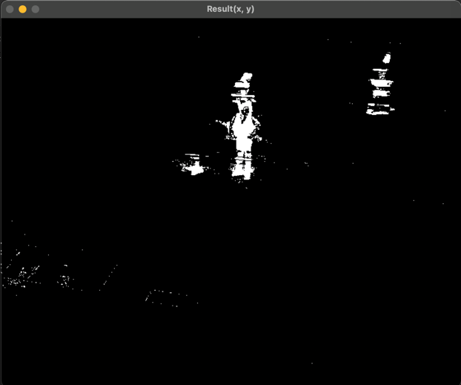

3) Source code

*// g++ $(pkg-config --cflags --libs opencv) HW8_21600635.cpp -o ./a*

*#include* <opencv2/opencv.hpp>

*#include* <iostream>

*#include* <string>

using *namespace* cv ;

using *namespace* std ;

Mat

background_img ( VideoCapture src ) {

Mat background ;

Mat image ;

Mat gray ;

Mat avg ;

src >> avg ;

cvtColor( avg, avg, CV_RGB2GRAY ) ;

*int* cnt = 2 ;

*while* ( true ) {

*if* ( !src.read( image ) )

*break* ;

cvtColor( image, gray, CV_BGR2GRAY ) ;

add(gray / cnt, avg * (cnt - 1) / cnt, avg) ;

cnt++ ;

*int* current_frame = src.get( CAP_PROP_POS_FRAMES ) ;

}

*return* avg ;

}

Mat

draw_rect ( Mat src, Mat foregroundMask ) {

vector<vector<Point> > contours ;

vector<Vec4i>hierarchy ;

findContours( foregroundMask, contours, hierarchy, CV_RETR_EXTERNAL, CV_CHAIN_APPROX_SIMPLE ) ;

*// defining bounding rectangle*

vector<Rect> boundRect(contours.size()) ;

*for* ( *int* i = 0 ; i < contours.size() ; i++ ) {

boundRect[i] = boundingRect(Mat(contours[i])) ;

}

*// draw rectangles on the contours*

*int* count = 0 ;

*for* ( *int* i = 0 ; i < contours.size() ; i++ ) {

*if* (boundRect[i].width * boundRect[i].height > 400) {

count++ ;

rectangle( src, boundRect[i].tl(), boundRect[i].br(), Scalar(255, 0, 0), 2, 8 ,0) ;

}

}

putText(src, format("object: %d", count), Point(5, 20), 1, 0.8, Scalar(255, 255, 255), 1, 8) ;

*return* src ;

}

*int*

main () {

VideoCapture capture ;

VideoCapture capture_for_background ;

*// open mp4 file*

*if* ( capture.open( "background.mp4") == 0 || capture_for_background.open("background.mp4") == 0 ) {

cout << "no such file" << endl ;

*return* 0 ;

}

Mat background = background_img( capture_for_background ) ;

Mat gray ;

Mat image ;

Mat foregroundMask ;

imshow( "background", background ) ;

cout << "pass" << endl ;

*while* ( true ) {

*if* ( capture.grab() == 0 )

*break* ;

capture.retrieve( image ) ;

cvtColor( image, gray, CV_BGR2GRAY ) ;

absdiff( background, gray, foregroundMask ) ;

threshold( foregroundMask, foregroundMask, 20, 255, CV_THRESH_BINARY ) ;

gray = draw_rect ( gray, foregroundMask ) ;

imshow( "Result(x, y)", foregroundMask ) ;

imshow( "result", gray) ;

waitKey( 33 ) ;

}

*return* 0 ;

}