Git commands
- clean all untracked file including build products (-x switch) directories (-d switch), forcefully (-f),
git clean -dfx

- discard all changed and return to last commit changes
git checkout -- .
git checkout -- path/to/file (resets specific file)
git checkout -b <new-branch-name> <commit-id-sha> [This will create a branch from the specific commit id provided]
git checkout <commit-id-sha> will simply checkout specific commit id version. It will be a detached head.

- git add --all (adds all modified file into stage)
- git fetch origin && git reset --hard origin/main && git clean -f -d (updates local main branch from the remote main branch)
- git branch (lists all the available branch)
- git branch -D ‘branchname’ (force delete branch named as ‘branchname’)

Parallel job submission with torque (PBS) script
- “qsub submission_script.sh” submits the job
- “qstat -u user_id” lists submitted job by user id.
- “qstat -x job_id” lists details of the job
- “qdel job_id” kills the specific job
- “qselect -u user_id | xargs qdel” deletes all job by user id.

Debug segfault
- first ensure ulimit is set to a non-zero value with command ‘ulimit -a’
- set ulimit value to a specific value or unlimited using ‘ulimit -c 1000’ or ‘ulimit -c unlimited’. This needs to be on the same directory the program is located.
- Build the program with debug mode on.
- this can be done by toggling the Cmake:[Release]:Ready or Cmake:[Debug]: Ready from the bottom of the VSCode.
- Alternately, running “cmake -DCMAKE_BUILD_TYPE=Release ..” then “make” command can be used to make the release version or “cmake -DCMAKE_BUILD_TYPE=Release ..” then “make” command for the debug version.
- Running the program in debug mode will alert if there is a segfault.
- the default location for core dump file when ‘ulimit -c unlimited’ is set is at /var/lib/apport/coredump/ directory. The generated core file can be copied from the location to a suitable location
- the core file dump location can be changed to current directory by echo “core.%e.%p”>/proc/sys/kernel/core_pattern. “sudo su” might be required if the default user is not root
- Running the program with “gdb program_name core” will use the ‘core’ file that is dumped initially to point out at what line the program code failed due to segmentation fault.
- Generation of core file might take a while. Untill the file generation is complete, access/copying the file is restricted.

Ref:
1. https://askubuntu.com/questions/1349047/where-do-i-find-core-dump-files-and-how-do-i-view-and-analyze-the-backtrace-st
2. https://medium.com/@sourabhedake/core-dumps-how-to-enable-them-73856a437711

List Directory by space
- “du -hs *|sort -hr” will list directory by space taken.
- “quota” to check the disc space of quota, limit, grace, files etc
- “quota -v -s -f /dev/sdb1” to check quota, limit and files. Use “man quota” to use additional switches.
- “quota -u aaa6979 -p -v -s” is the most useful command.

Connecting to Paraveiw Remotely
Steps
1. After connecting to ARES use ‘printenv’ and look for SSH_CONNECTION=10.120.224.111 41862 129.105.61.168 22

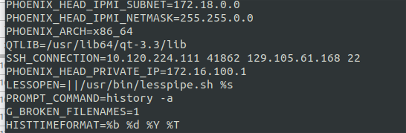
2. Use this ip when connected over vpn.
3. Setup Client/Server (reverse connection) on the local computer from the paraview by clicking on the ‘connect’ and then choosing the following settings
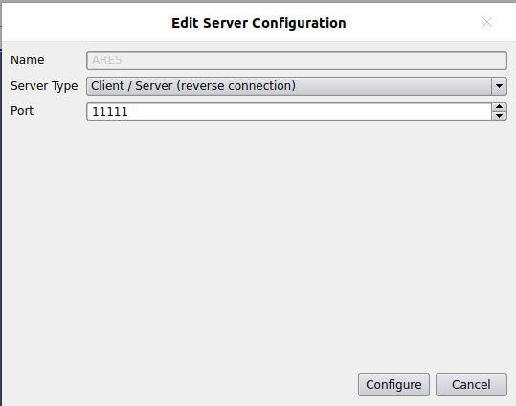
4. Use the ‘Manual’ startup type and click ‘save.’
5. On the ARES cluster terminal use the command “pvserver -rc -ch=10.120.224.111:11111” The following message should appear on the window
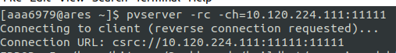

6. It is possible that error should also appear. But if everything [ip address, port, paraview version] is correctly matching, it should work when trying to connect from the client paraview window.
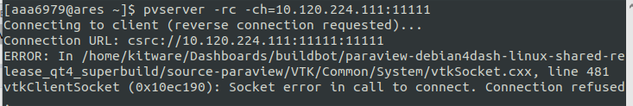
7. On the paraview window(Make sure appropriate version is run), click connect→ choose the configuration and click ‘connect’ on the window
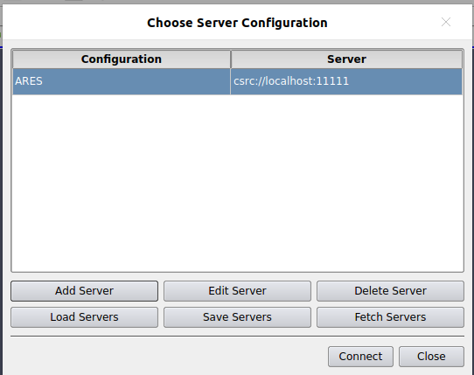
8. It should successfully establish connection and files can be open remotely on the paraview program.

