Book Reimagined | Book Legacy
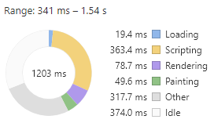 | 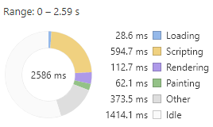
Google Chrome Performance tab

Book Reimagined | Book Legacy
99 requests  2.3 MB transferred | 82 requests  2.4 MB transferred
Google Chrome Network tab

Book Reimagined | Book Legacy
Score  60  First Meaningful Paint 950 ms  First Interactive 11290 ms | Score  22  First Meaningful Paint 12850 ms  First Interactive 16280 ms
Google Chrome Lighthouse Audit: Performance

