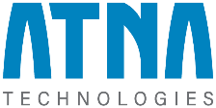
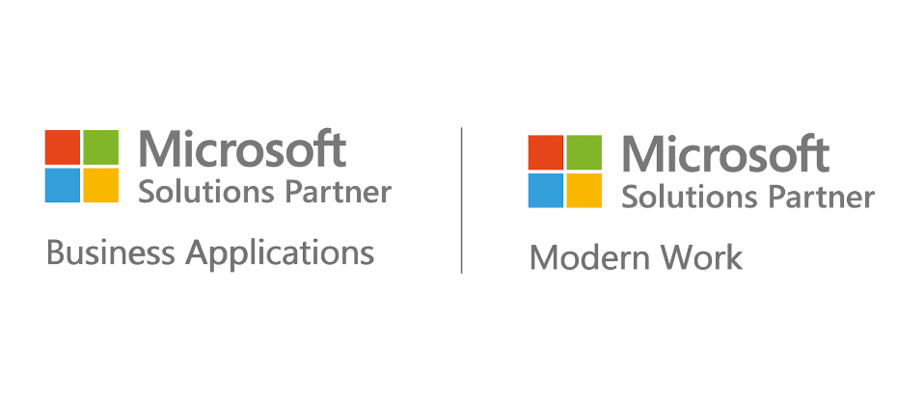
MICROSOFT DESIGNATIONS
At ATNA Technologies, we specialize in a comprehensive range of Microsoft solutions, including Business Applications, Modern Workspace, Infrastructure (Azure), Data and AI, Digital and App Innovation, and Security. As a certified Microsoft Solution Partner in Business Applications and Modern Work, we leverage our expertise to deliver transformative solutions across Dynamics 365 BC, CRM, F&O, Power BI, Power Apps, Power Automate, Data and AI, ML, Azure DevOps, Azure Cloud, M365 solutions, and Microsoft Security (Endpoint, Defender).
By August 10, 2024, we aim to expand our Microsoft partnership to include Infrastructure (Azure), Data and AI, and Digital and App Innovation. Additionally, we offer robust services in AWS, GCP, and ODC setups, ensuring that our clients receive versatile and scalable solutions tailored to their unique business needs.

