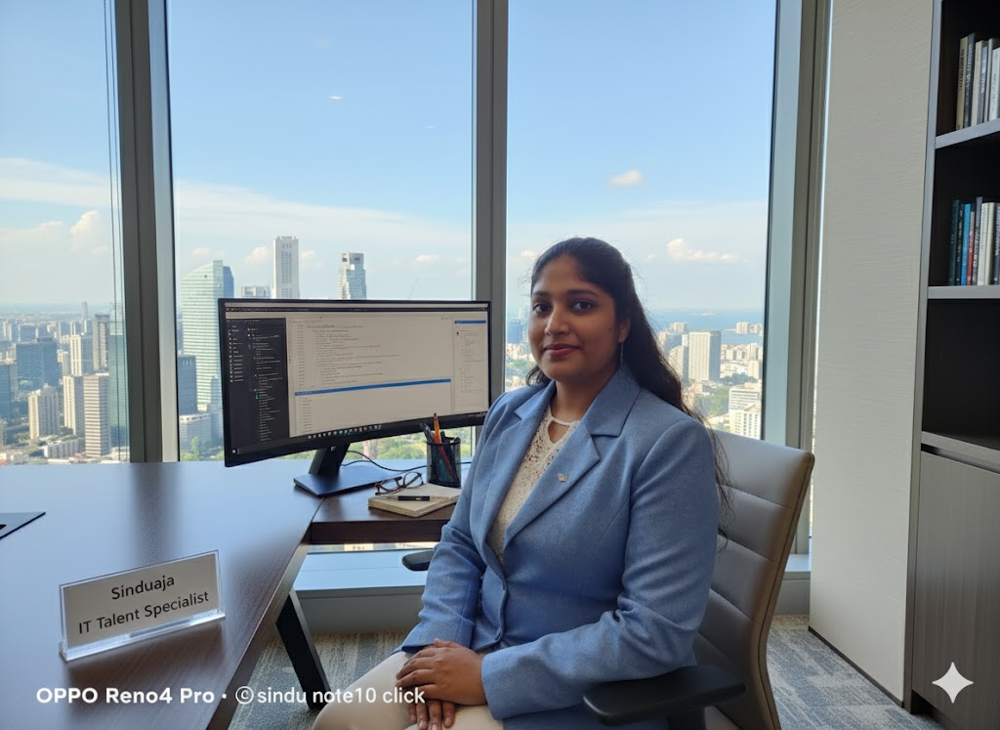
Talent Acquisition specialist- IT / healthcare recruitment.
Video link for my presentations at Microsoft  Adelaide
https://www.linkedin.com/in/sinduja-manokaran-6b946485/recent-activity/articles/

Cindy

Sinduja Manokaran (Cindy) 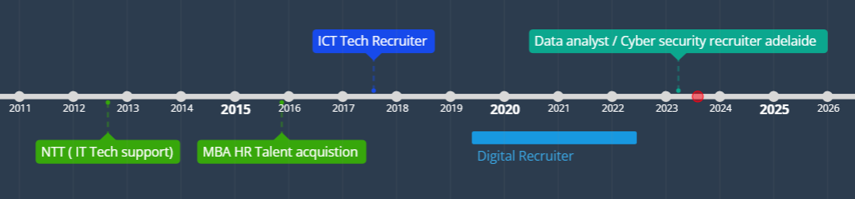
Phone:
+61422 217 137
+91-9095543029
E-Mail:
sinduja.manokaran@outlook.com
Linkedin:
www.linkedin.com/in/sinduja-manokaran

Skill Highlights
- Applicant Tracking Systems (ATS)
- Sourcing and Recruiting Techniques.
- Candidate Assessment and Evaluation.
- Diversity and Inclusion Strategies.
- Talent Pipeline Development.
- HR Compliance and Regulations.
Software Used
- Workday/ Monday.com
- Oracle HCM Cloud
- SAP SuccessFactors
- BambooHR
- Zenefits
- PeopleSoft
- Namely
- Kronos Workforce Ready Rippling.

Summary

Experience across recruitment and sales, I am passionate about connecting talented individuals with innovative companies that are transforming industries and empowering developers. As an IT Recruiter I leverage my skills in CRM and problem solving to source, screen, and place candidates for various IT roles across multiple sectors.( Have lived in Australia more than 3plus years travelled Sydney / Brisbane / Adelaide & Melbourne )

Working across all the phases of Recruitment cycle starting from Sourcing, Screening, Scheduling, Conducting Interviews, Following up with the Candidates, Negotiation, Offer, Pre-joining formalities, Documentation and Closing the positions.

Experience

My focus for the past 5 years has been ICT recruitment. I started off work as desktop analyst at NTT providing technical support to top niche corporate customers, studied post graduate and moved into HR role supporting & recruiting TOP ICT talents, mentoring start-up companies, travelled overseas from India to Adelaide, Sydney, Brisbane and lived there for some time and more recently dedicated my time to becoming a Talent Acquisition specialist to Roles that help individuals grow into their full potential.

What skills am good at?
Using Microsoft office 365 tech skills against recruitment needs / Keyword search etc/ workday / digital marketing skills in recruitment
Below are some of my recent activities
https://www.linkedin.com/in/sinduja-manokaran-6b946485/recent-activity/posts/

My candidate DB :
Network event connections / LinkedIn groups/ Indian community fb/whtzapp group admin

Australia experience Living (3 years syd/bris/Adelaide)

My Strong tech recruitment skills can significantly reduce the chances of making a bad hire for a technical role. The applicant may have the ideal experience and skill set, but the introductory meeting with the technical recruiter can show if there are any red flags.
- Adelaide clients - Lutheran , council ( port adelaide, city of adelaide etc), Haigs chocolate ( finance role/ blue collar) , India IT ( Kannini, Deepsense,Cavincare )

What Talent I bring to my employer / Partner?

Cindy is a highly skilled and adaptable recruiter with a strong technical background in information technology. She excels in various domains, including software development, network engineering, cybersecurity, and data analysis. Demonstrating industry awareness, she stays updated on trends and emerging technologies to identify top talent. With expertise in the recruitment process, she employs diverse strategies, effective communication, and networking to match candidates with suitable positions. Cindy conducts insightful technical interviews, assesses resumes, and navigates applicant tracking systems proficiently. Her problem-solving abilities, negotiation skills, and commitment to ethical practices make her a standout recruiter. She manages time efficiently, builds strong client relationships, and ensures a positive candidate experience. Cindy's continuous learning approach and documentation precision further contribute to her success in the dynamic ICT field.

Education

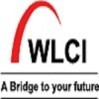 Wigan and Leigh College (WLC) India Postgraduate Degree, Human Resources Management and Services
 Sri Krishna College of Arts and Science
Bachelor of Science - BS, Computer Technology/Computer Systems Technology

Employment Experience

BLACKMAN RECRUITMENT - MAY 2024 – JULY 2024
IT RECRUITMENT SPECIALIST
- Collaborating with the Recruitment Manager to deeply understand hiring needs, driving successful placements, and achieving competitive recruitment goals.

- Leading the entire recruitment process for multiple roles, working closely with managers to source, interview, and secure top-tier talent.

- Maintaining a high-touch approach with a database of skilled candidates, ensuring we’re ready for future hiring needs.

- Developing and executing innovative recruitment strategies alongside senior management, ensuring we stay ahead in attracting the best talent.

- Proactively engaging on job boards, social media, and professional networks to source high-quality candidates and strategically post job announcements.

- Expanding and managing a client portfolio by providing expert recruitment consultation, ensuring repeat business and building strong client relationships.

- Generating new business by leveraging my network, identifying leads, and converting them into long-term clients.

- Developing close relationships with department managers, fully understanding their needs and offering tailored recruitment solutions.

- Attending Adelaide’s IT and professional networking events to connect with industry professionals and uncover new business opportunities.

- Staying informed on the latest technological and industry trends, allowing for meaningful conversations with clients about their future talent needs.

- Actively networking both online and offline, promoting our employer brand and attracting Adelaide’s top professionals.

- Actively connecting with new hires in Adelaide’s Indian community across blue-collar, IT, and aged care sectors.
- Partner eager to explore opportunities with SA Water as a vendor connection.
Established strong relationships with key Adelaide clients including Lutheran, Port Adelaide, and City of Adelaide Councils.
Trusted recruitment partner for Haigh's Chocolates in finance and blue-collar roles.
Collaborating with IT firms Kannini and Deepsense to meet their talent needs.

Recruitment Consultant – Medical/ Digital Analytics
Health care / Power staff
April 2023 – August 2023
- will be assisting General Practitioner's to find their perfect next position and Practices to staff as needed. This is a 360-degree recruitment role where I work with both the candidate and the client and manage the process from first contact to commencement including AHPRA registration, Medicare Provider Number applications and much more, so there is more to this than your normal recruiter role.
- Maintaining and utilising internal recruitment databases and social media accounts i.e. LinkedIn, SEEK and Facebook.
- Write and place job ads on multiple job sites
- Attract and reach out to talent via Linkedin & networking groups
- Screen candidates over the phone
- Set up interviews for the relevant managers
- Reference check candidates
- Developing, reviewing, and maintaining the library of corporate job descriptions
- Driving experience driven onboarding practices including new employee onboarding system support
- Proactive head hunting and utilising LinkedIn Recruiter for hard to fill roles
- Write and place job ads on multiple job sites
- Attract and reach out to talent via Linkedin & networking groups
- Screen candidates over the phone
- Set up interviews for the relevant managers
- Reference check candidates

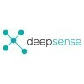 Talent Acquisition Specialist
DEEPSENSE DIGITAL
Nov 2020 - Jul 2022 (1 year 10 months)
- Deepsense Digital Solutions is start-up company engaged in providing the best digital solutions to all businesses
- Partner with site leadership teams to understand challenges and opportunities, and create a road map that delivers solutions which will drive a high-performance culture
- Manage the talent attraction, employee retention, Contracts of Employment and REM/benefits
- Ensure learning and development is in line with business/client requirements
- Manage all IR/ER matters including case/performance management, grievances, resolution of workplace issues
- Organisational culture and employee engagement
- Assist the Board of Directors and Management Team with various projects and tasks
- Partnering with leadership teams on the Performance and Development planning cycle
- Work with lead teams to identify talent and assist in creating targeted development plans
- Partner with Managers on the planning, design, change management and implementation of projects and programs, such as capability programs or restructuring activities
- Advise Managers on internal queries regarding HR policies/practices/procedures/legislation
- Drive continuous improvement of HR practises, provided coaching, insight and strategic advice to the leadership team and line managers on workforce management, workforce planning, performance enhancement and innovative HR solutions to deliver on business objectives within legislative and policy requirements
- Involved in leading the design of a contemporary approach to recruitment with the candidate journey and experience at the centre
- Mentored my organization to identify opportunities for enhanced employee engagement and retention across the whole employee lifecycle
- Acted as brand ambassador to educate candidates on culture, career growth, benefits, and advantages of working for company.
- Evaluated resumes, interviewed, and presented qualified candidates to hiring managers and solicited feedback to refine recruiting strategy.
- Worked alongside global business leader to deploy new training strategies.
- Developed and maintained strong working relationships with executives, HR team, and hiring managers to foster partnerships that produced consistent results.
- Created and distributed job postings on job boards, corporate career sites and social media networks to increase reach.
- Built relationships with external recruiters and staffing agencies to access quality talent.
- Implemented innovative recruitment strategies to increase number of high-quality job applicants.
- Administered employee benefits programs and assisted with open enrollment.
- Advocated for staff members, helping to identify and resolve conflicts.
- Utilized social media platforms to source potential candidates and build pipeline of qualified talent.
- Improved office efficiency by effectively managing internal communications and correspondence.
- Partnered with departmental managers to ascertain hiring needs and subsequently provide candidate recommendations.
- Created and delivered HR training sessions to staff, managers and executives.
- Developed disaster and recovery strategy to prepare company for hazardous weather conditions, nuclear accidents and terrorist attacks.

 Recruitment Consultant
PHOENIX IT CONSULTANTS PVT LTD., (FORMERLY KNOWN AS PHOENIX HUMAN CAPITAL PVT LTD)
Jan 2019 - Nov 2020 (1 year 11 months)
- Screen resumes on seek, indeed , LinkedIn, reference check and conduct telephone and face to face interviews
- Take job briefs in consultants’ absence
- Brief candidates for both temporary and permanent positions
- Fill both temporary and permanent vacancies
- Develop a network of potential candidates and industry professionals
- Use social media platforms and professional networks to connect with potential candidates
- Devise candidate sourcing strategies
- Advise on rates, salaries, and relevant awards
- Provide career advice, counselling, and performance management
- Write job advertising copy
- Update and maintain talent pools
- Forecast future employer hiring needs and perform regular analysis
- Run candidate workshops
- Implement strategies for continually improving the candidate's experience
- Ad-hoc project work in relation to enhancing the candidate experience
- Partnered with departmental managers to ascertain hiring needs and subsequently provide candidate recommendations.
- Screened and interviewed candidates to evaluate potential employees' qualifications.
- Coordinated implementation of people-related services, policies and programs through departmental staff.
- Reduced expenses by analyzing compensation policies and implementing competitive programs while ensuring adherence to legal requirements.
- Networked and built relationships with potential candidates and industry professionals to identify potential candidates, stay informed about industry trends and gain insight into skills and qualifications in demand.
- Conducted background checks, reference checks and other pre-employment screenings, identifying candidates to meet hiring criteria.
- Pre-screened resumes prior to sending to corporate hiring managers for consideration.
- Utilized recruitment technology tools and platforms to streamline recruitment processes.
- Identified and sourced qualified candidates for open positions to meet organizational needs.
 HR Trainee Recruiter
CROWN SOLUTIONS INDIA PVT LTD
Jan 2014 - May 2014 (5 months)
- Created effective talent acquisition training materials that supported culture and performance objectives.
- Compiled reports on recruiting activity to illustrate time-to-fill, cost-per-hire, and source of hire.
- Developed and maintained applicant tracking system, tracking all job openings, applicants and interviewing activity.
- Conducted performance reviews and provided feedback to managers on employee performance.
- Provided regular updates to hiring managers and HR staff on recruitment activities and progress.
- Improved organizational filing systems for confidential employee records, resulting in improved accessibility and efficiency.
- Generated and analyzed reports to monitor employee engagement and attrition trends.
- Worked alongside global business leader to deploy new training strategies.
- Created and distributed job postings on job boards, corporate career sites and social media networks to increase reach.
- Developed and implemented onboarding and orientation programs for new employees.

 Desktop Support Specialist
NTT DATA SERVICES
Jun 2012 - Jan 2013 (8 months)
- Service desk employee
- Handling request through calls/web/mail
- Providing best of the solution based on urgency and worked prioritizing
- Prepare and maintain volumetric reports of work done
- Worked in shift and update shift details.
- Created user accounts and assigned permissions.
- Collaborated with vendors to locate replacement components and resolve advanced problems.
- Researched and identified solutions to technical problems.
- Monitored system performance to identify potential issues.
- Enhanced helpdesk ticketing system, resulting in [Number]% reduction in support call turnaround time.
- Authored detailed documentation on service call resolutions, providing valuable data on both personnel performance and effective remediation techniques.
- Diagnosed and troubleshot hardware, software and network issues.
- Patched software and installed new versions to eliminate security problems and protect data.
- Installed, configured and maintained computer systems and network connections.
- Helped streamline repair processes and update procedures for support action consistency.

