|  |
| --- |
| **D:\fcuc-logo.png** |
| FACULTY OF ENGINEERING & COMPUTING |

|  |  |  |
| --- | --- | --- |
| **Programme** | : | Bachelor of Computer Science in Intelligent System (Hons) |
| **Academic Year** | : | 2019 |
| **Module** | : | Business Intelligence |
| **Module Code** | : | CIS2016 |
| **Module Leader** | : | Kwan Lee |
| **Assignment Type** | : | Report |
| **Intake/Group** | : | Intake/Group |
| **Distribution Date** | : | Monday, 14 October 2019 |
| **Submission Date** | : | Tuesday, 3 December 2019 4:55 PM |

|  |  |  |
| --- | --- | --- |
| **Student Name** | **Student ID** | **Class Code** |
| Neoh Kim Seng | B1472 |  |

|  |
| --- |
| Assignment Feedback Form |
| Business Intelligence |

|  |  |  |
| --- | --- | --- |
| Criteria | Marks | Comments |
| Analysis the Problem faced by the Company | /5 |  |
| Discussion | /10 |  |
| Format Report | /5 |  |
|  | Total |  |

Marks:

|  |  |
| --- | --- |
| **General Comments:** | |
|  | |
| **Assessor’s Signature**: | **Date:** |
| **Name: Kwan Lee** | |

|  |  |  |  |  |  |  |  |
| --- | --- | --- | --- | --- | --- | --- | --- |
| **Section: Documentation**  **/20** | | **Excellent** | **Good** | **Satisfactory** | **Marginal** | **Poor** | **Comments** |
| **(Out of 5)** | Analysis the Problem faced by the Company |  |  |  |  |  |  |
| **(Out of 10)** | Discussion |  |  |  |  |  |  |
| **(Out of 5)** | Format Report |  |  |  |  |  |  |

1. **Assignment**

This is an individual assignment and it contributes **20%** of the assessment.

In this assignment, you are required to prepare case study report based on the given case study: Domino Pizza Case Study

This assignment consists of **TWO (2)** tasks as listed below:

***Task 1 –*** ***Analyse the Problem faced by the Company***

From the case study given, analyses what are the problems faced by the Domino Pizza.

***Task 2 – Discussion***

If you were the Business Intelligence (BI) analysis, in your own opinions:

1. Discuss how you can/should re-identify the cycle of BI analysis.
2. Discuss what type of analysis techniques (descriptive, predictive, and prescriptive) you will propose to address the problem?

S***ubmission Requirements***

1. Submit a soft copy and a hard copy of your report, following the general instructions described above.
2. Submit a copy of TurnItIn report.

Details of TurnItIn

Class Id : 22690225

Enrollment Key: 1234

1. Submit a copy of your report into GitHub repository.
2. Minimum number of report pages is 3, and maximum number of report pages is 10 pages (excluding the front cover, table of content pages and appendix).

# Case Study

Domino’s n Hot Soup After Filling Police Report Against It’s Own Customers

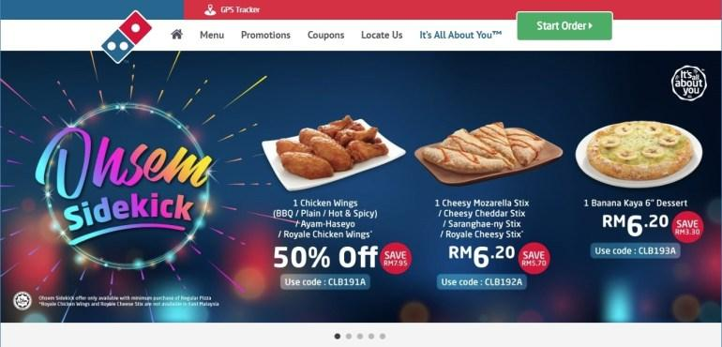

Popular pizza chain Domino’s has found itself embroiled in a social media storm this week after several of its online customers were called up by the Commercial Crimes Department of the Royal Malaysia Police (PDRM) for questioning after ordering their meals online.

Domino’s has since claimed that these customers were reported as they had ‘abused’ ‘unauthorized’ vouchers in their purchase. In what we can only call a ‘hastily’ released media statement earlier today, Domino’s made the following claim.

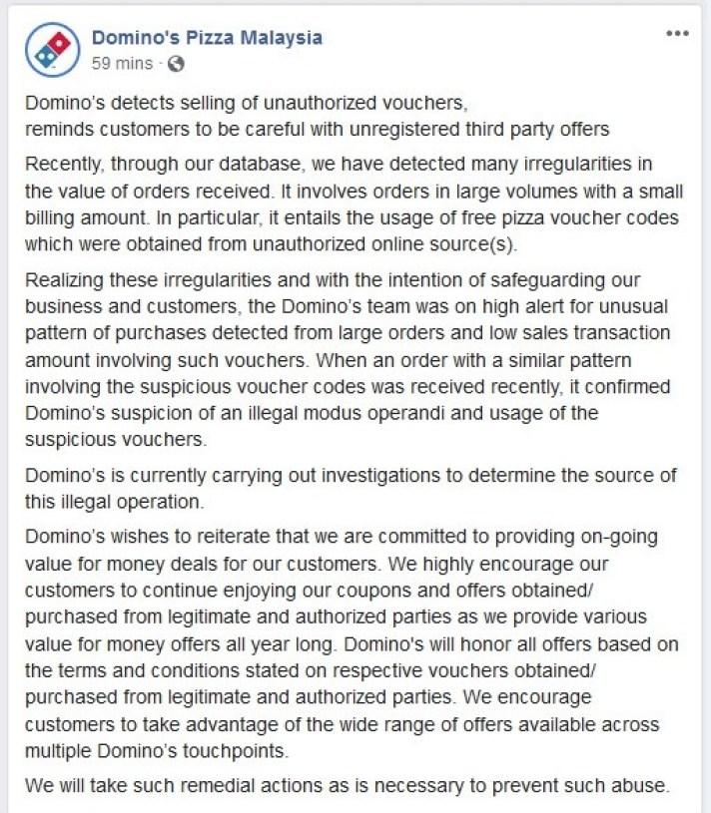*screengrab of Domino’s original Media Statement that was subsequently removed*

The above statement, which was published on their Facebook page, and sent out to local media outlets, was quickly taken down after it received severe backlash from their own followers. Sadly enough, for Domino’s – the Customers in this case actually had every right to feel aggrieved by their actions.

According to comments from one of the Customers who was questioned by the PDRM, as well as a copy of a counter police report that we have sighted – Domino’s are claiming that the customer had illegally ‘hacked’ the Domino’s online platform, and had utilized illegal voucher codes to purchase meals at a heavily discounted price.

While we’re not entirely sure how [legitimate coupon codes ended up on online shopping sites like Shopee](https://shopee.com.my/Kupon-Dominos-i.10719448.1896690295), it is complete and utterly unfair to blame any customer for using these codes as the codes still remain valid on Domino’s site. If the coupon codes were illegally obtained, Domino’s should be filing a report against the seller of the codes, and disabling these ‘unauthorized’ codes on their system. At time of writing, the above coupon codes are still listed for sale on the Shopee platform.

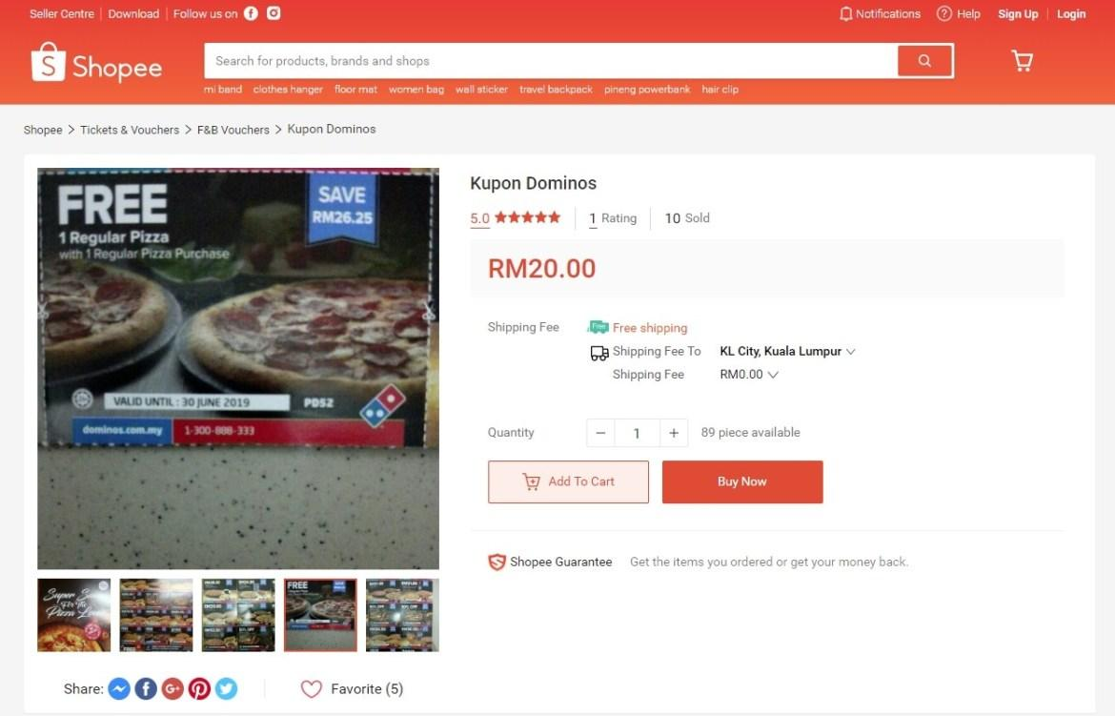

Domino’s via their original statement had put the blame of the irregularities on the order amounts solely on the coupon and free pizza codes. What they have failed to admit (or maybe even realize) is that there are fundamental logic flaws in their online ordering system that has been exploited long before they went on ‘high alert for unusual pattern of purchases’.

These known ‘flaws’ or ‘glitches’ in their system was never fixed (and still hasn’t been fixed at time of writing), and oddly enough worked both ways. Unsuspecting customers who were not aware of the glitches might end up paying more for their orders through odd combinations made during their order process, while other customers who noticed the flaws would have been able to easily exploit the glitch to gain a huge discount on their order.

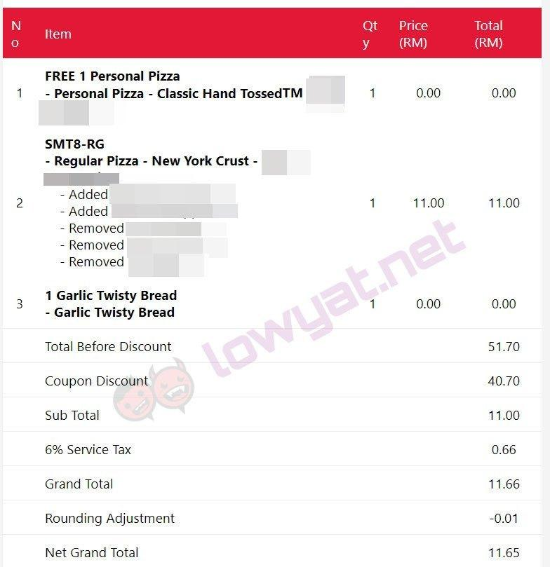*screenshot of checkout page after hefty discount – via Lowyat Forums*

Are you as an online consumer liable if you exploit these glitches in an online ordering system to your advantage? The short answer is probably no. During Amazon Prime Day Sale in July this year, [Amazon accidentally discounted high end camera gear – some costing close to USD13,000+ for a measly USD100](https://www.engadget.com/2019/07/18/amazon-prime-day-pricing-error-camera-gear/). Amazon acknowledged their mistake and honored all the purchases.  Domino’s did not (and still have not) corrected the obvious flaws in their system that is allowing this to happen. While some have cited the simple analogy of if a door is left open, stealing is still a crime – the difference here is that these customers have entered into a legitimate contract with Domino’s and paid the advertised price for their meal that has been agreed and accepted by Domino’s via their flawed system.

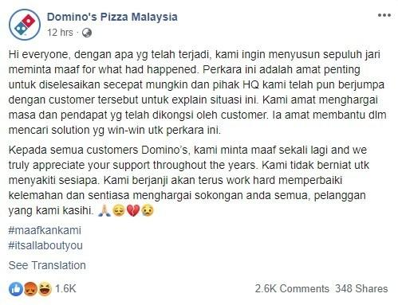

*updated ‘apology’ from the Domino’s team*

While Domino’s has every right to refuse service to these customers, and refund their money – there was absolutely no need for them to file a police report that caused their customers to be interrogated by police in a public place for their own incompetence and negligence in managing their online ordering system.

*Taken from https://www.lowyat.net/2019/195025/dominos-in-hot-soup-after-filing-police-report-against-its-own-customers/*

# Learning Outcomes

|  |  |
| --- | --- |
| **Learning Outcomes** | **Assessment Question** |
| 1. Explain the concepts and components of Business Intelligence; | Task 2 |
| 1. Evaluate the technologies that make up Business Intelligence; | - |
| 1. Describe the technological structure that makes up Business Intelligence systems | - |
| 1. Plan the implementation of Business Intelligence system. | - |

Table of Contents

FACULTY OF ENGINEERING & COMPUTING 1

Assignment Feedback Form 2

II. Case Study 5

III. Learning Outcomes 10

1. Introduction 12

2. Analyze the Problems 12

3. Discussions 13

a. Re-identify Cycle of Business Intelligence 13

b. Predictive Analysis Techniques 14

4. Conclusion 17

5. References 18

# Introduction

Domino’s Pizza is a well-known fast food restaurant that mainly sells pizza. Most of the loyal customers uses its service to order pizza whether it’s in online delivery or take away. However, in around the end of September 2019 in Malaysia, there was a case where Domino’s allegedly accused his customers for “hacking” their system to purchase high amounts of pizzas with low amount of price.

# Analyze the Problems

After study the Domino’s Pizza Malaysia case study, there should have two problems identify in this incident. Firstly, there where been reported from the customers stating that unauthorized coupon codes were sold by third parties on online shopping platform such as Shopee. Those coupons able to bypass the system and allow the customers to have huge number of discounts when ordering the pizza or at counter. From the customers perspective, these coupons may look like a legitimate coupon and therefore, the customer does not suspect any issue and use it as like a normal coupon.

The second issue that Domino’s Pizza Malaysia faced is that the online ordering system is exploited or perhaps not well maintained. After the IT department had noticed the abnormal data of the purchase order in the database, they post a status and stating that they found some of the customer had purchase high number of items and pay much lesser compare to the original prices. Thus, the Domino’s Pizza Malaysia suspect some of the customers had “hacked” the system rather than do a validation on to the online ordering system algorithms. However, more knowledgeable customers will use this “flaw” and buy large number of pizzas and pay less amount price of the order. This is not a “hacking” process as they mentioned, it is obvious that the online ordering system did not maintain appropriately.

# Discussions

## Re-identify Cycle of Business Intelligence

Most of the companies uses Business Intelligence (BI) tools to manage their decision-making process based on data that has been gathered into a data warehouse or a data mart and occasionally working from operational data [1]. It is also a continuous cycle of analysis, insight, decision and evaluation.

The initial phase of cycle would be the analysis, which is to identify the problems that potentially may occur. In this case, the online ordering system had been exploited by the customers and yet the Domino’s Pizza Malaysia does not realize until the customers pinpoint the flaw. The BI would carry out the analysis by checking the pattern of purchases for each of the customers. For instance, if there is large number of pizzas ordered but small amount of price cost to that customer, The BI should look more into that customer purchase behavior to analyze it. Therefore, we can find out the factor that causes this issue and take proper measurement.

Moreover, another problem that Domino’s Pizza Malaysia faced would be the unauthorized vouchers and coupon codes were sold on online shopping sites such as Shopee. For this scenario, it would be hard to detect which codes that were being sold online since it is from a third-party platform. However, the BI could check the purchase order from each of the affected customers’ purchase history, whether the customer uses particular codes to purchase their meal to cheat the system. Some of the voucher codes are re-useable and repeatable even after purchase, therefore, we could identify which code was being used frequently for ordering free pizza through the database.

After done analyzing, it would be the Insight phase which is to understand the problems. First, the BI would take a deeper look into the Domino’s online ordering system to check whether the code logic flow appropriately. If is not faulty code, then check whether the database was breached with the security team. For this scenario, customers are able to abuse the system to deduct the total cost of order as they remove and add back certain items. Therefore, it will be necessary to check each individual purchase history to find out what is the pattern or behavior was made. After that, compare with other customers’ behavior or purchase history to check whether they have similarities. Thus, this can have more understanding towards the matter of system’s flaw.

For the unauthorized voucher codes and coupons, the BI should be able to identify which voucher codes or coupons are being used to have the huge amount of discount. For instance, maybe in previous promotion had enabled some new codes for free pizza, but after certain period of time, the code should be invalid. However, some codes may and may not be disabled. Therefore, the BI would validate and identify each of the codes that customers used to order free pizza.

After have a deeper knowledge regarding the issues, it would be the decision phase. The BI would predict the order purchase price by comparing the historical data from the database. By applying the 0-1 logic, if the similarities gap of the order purchase price from the customer and the database price which is less than 0.5, the BI should not allow the customers to proceed his/hers purchase when ordering. Next for the unauthorized coupon validation, the BI should also use the historical data set and compare with the customers’ codes to check whether it is authorizable by predicting and classifying the coupons or voucher codes. Thus, this will avoid the company from business loss.

Last but not least, the evaluation phase. After detected the “flaw” of the system, definitely should fix the issue as soon as possible. Besides that, after restricting and banning those unauthorized codes, the customers eventually will acknowledge and understand those third-party sellers is fraud and will stop buying those codes from them. In conclusion, there is no needed to call the police and interrogate the innocent customers allegedly as it will hurt the reputation of the company.

## Predictive Analysis Techniques

It will use predictive analysis technique to address these two issues. Predictive analytic is to compare with historical data set with the incoming data or new data to predict the similarities. It also can improve the pattern detection and prevent criminal behavior [3]. Logically, not all the customers are good, so it is better to classify which customers are good and try to have connection with them so that the business sales will be consistent.

For both of the problems that Domino’s Pizza Malaysia faced, it is suitable to use a supervised machine learning algorithm to solve those issues. A supervised learning is where there is an input variable (x) and output variable (y) that uses an algorithm to learn the mapping function from the input to the output [4]. There are two types of supervised machine learning algorithm which are classification and regression.

For the first issue which is the unauthorized voucher or coupons codes, a supervised machine learning can use data classification to label a data item that belongs to a class or category [2]. For example, for this case study, there might be hundreds or thousands of obsolete voucher codes available previously and stored in the database, a classifier is able to determine whether the new incoming code is valid or not by comparing those old coupon codes in the data sets or database. After running its algorithm, the classifier can label and decide the new code to fit a category such as “Valid”, “Invalid” or “Unknown” assuming that these categories are being used in the database. Therefore, it can predict whether the incoming code is authorized or not and then ban or restrict the customers to use that code. Therefore, classification would be the suitable solution for it.

Next, the “flaw” of online ordering system is being exploited. It would better to use a supervised machine learning with regression algorithm. A linear regression is a type of regression analysis where the number of independent variables is one and there is a linear relationship between the independent (x) and dependent (y) variable [6]. For the case study, the figures below will assist the explanation of why using linear regression algorithm can predict the outcome and solve the issue [5].

Total order Price

Number of item purchase

Figure 1.0

In the figure 1.0, it shows a positive relationship between the number of item purchase (x) and the total order price (y). Thus, the system should validate this as a valid price since as the number of item purchase increases, the order price should also increase.

Total order Price

Number of item purchase

Figure 1.1

However, just like the problem faced from the Domino’s Pizza Malaysia, as the number of purchase (x) increases, the total order price decrease (y). This indicate that it has a negative relationship between the x-axis and y-axis. Therefore, the system should reject the price and warn the developer of unusual purchase behavior occurs.

# Conclusion

In conclusion, if the Domino’s Pizza Malaysia apply or invest more onto a Business Intelligent system to help on managing the sales and online ordering system. All of these possible problems may not be occurred. This should also satisfy the customers how consistency and reliability for them to purchase pizza in peace.

Github link:

<https://github.com/neohks/Business-Intelligent-Assignment>

# References

[1] L. Andre, "What Is the Purpose of Business Intelligence in a Business? - Financesonline.com", Financesonline.com. Accessed on: 26- Nov- 2019. [Online]. Available: <https://financesonline.com/purpose-business-intelligence-business/#bi>.

[2] D. Bari, M. Chaouchi and T. Jung, "Understanding Data Classification and Its Role in Predictive Analytics - dummies", dummies. Accessed on: 01- Dec- 2019 [Online]. Available: https://www.dummies.com/programming/big-data/data-science/understanding-data-classification-role-predictive-analytics/

[3] S. Seng, "How Organizations are Using Predictive Analytics", 3Pillar Global. Accessed on: 01- Dec- 2019 [Online]. Available: <https://www.3pillarglobal.com/insights/how-organizations-are-using-predictive-analytics>.

[4] J. Brownlee, "Supervised and Unsupervised Machine Learning Algorithms", Machine Learning Mastery, 2016. Accessed on: 01- Dec- 2019 [Online]. Available: <https://machinelearningmastery.com/supervised-and-unsupervised-machine-learning-algorithms/>.

[5] statisticsfun (2012, Feb 5). “An Introduction to Linear Regression Analysis”, Youtube. Accessed on: 01- Dec- 2019 [Video file]. Available: <https://www.youtube.com/watch?v=zPG4NjIkCjc>

[6] R. Gandhi, "Introduction to Machine Learning Algorithms: Linear Regression", Medium, 2018. [Online]. Available: https://towardsdatascience.com/introduction-to-machine-learning-algorithms-linear-regression-14c4e325882a. [Accessed: 01- Dec- 2019].