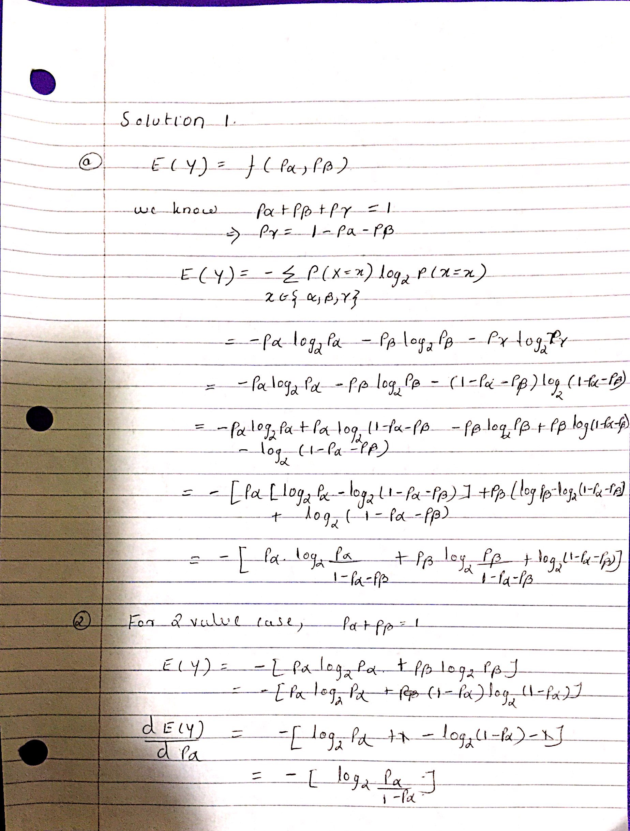
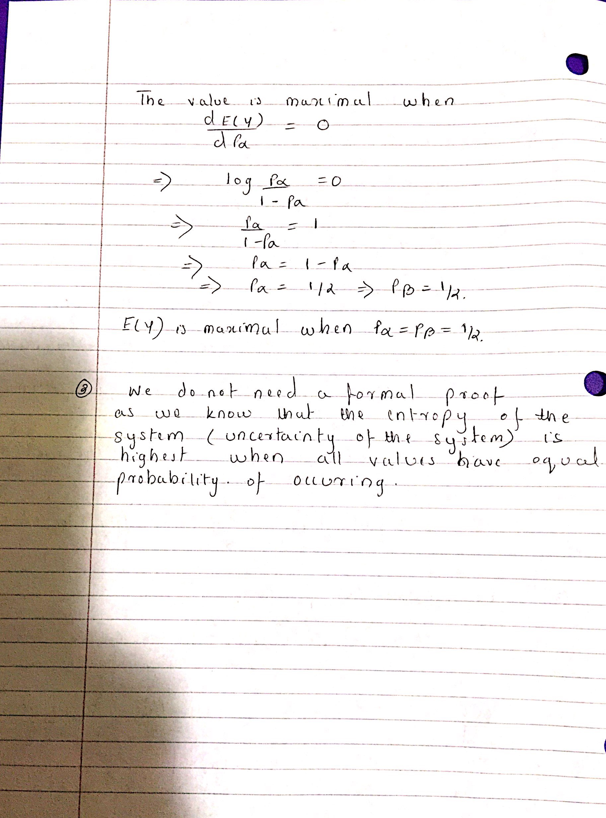

Problem 2

function calculateEyAndPlot()
[x,y]=meshgrid(0.001:0.01:1);
size=length(x);
for(i=1:size)
for(j=1:size)
if(x(i,j)+y(i,j)>1)
y(i,j)=1-x(i,j);
end
if(x(i,j)+y(i,j)<=1)
z(i,j)=1-x(i,j)-y(i,j);
end
end
end
for(i=1:size)
for(j=1:size)
alpha=x(i,j);
beta=y(i,j);
gamma=z(i,j);
if(~alpha) alpha=1; end
if (~beta) beta=1; end
if(~gamma) gamma=1; end

c(i,j)=-(alpha*log2(alpha)+beta*log2(beta)+gamma*log2(gamma));

end
end
surf(x,y,real(c));
title('Entropy Plot For 3 Variable Entropy in Alpha,Beta and Gamma')
xlabel('alpha')
ylabel('beta')
zlabel('gamma')

end
calculateEyAndPlot()

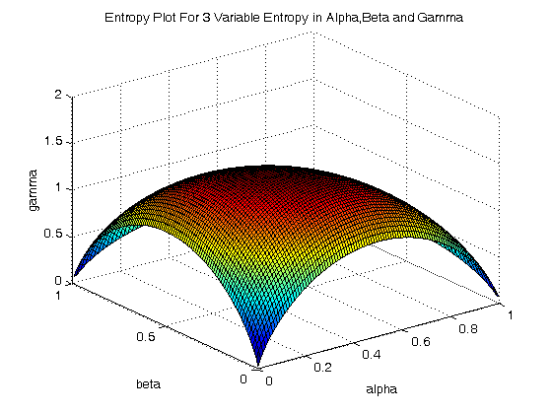

Problem 3
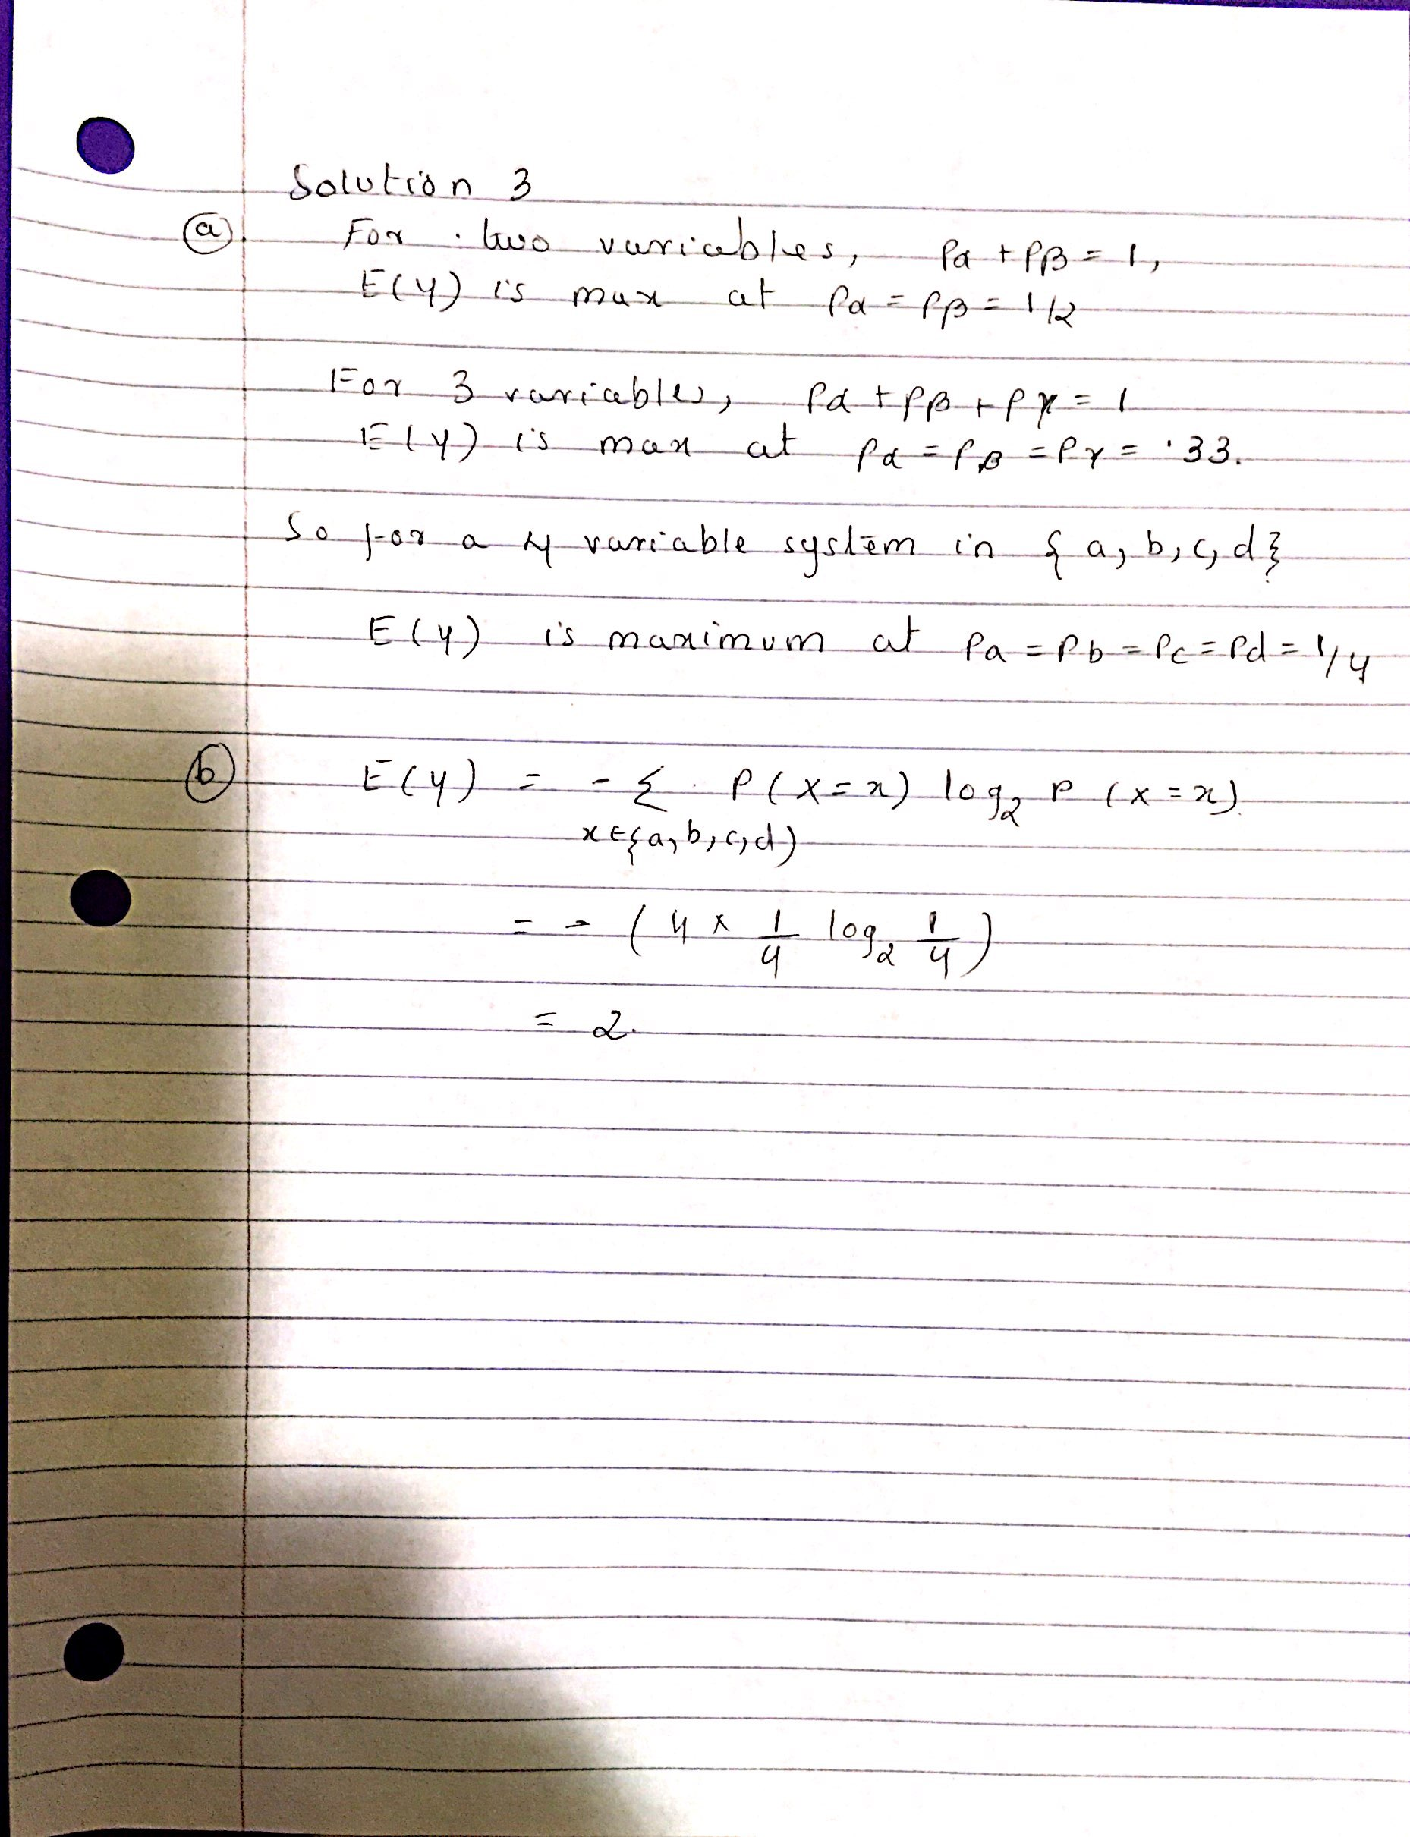

Problem 4

From the data set we calculate the overall entropy of the data set

Overall Entropy

Number of positive data samples = 6 .
Number of negative data samples = 6
Total Samples = 12

Entropy = -6/12*log6/12 – 6/12log6/12
= -1/2log1/2 – 1/2log1/2
=1/2log2 +1/2log2
=log 2
= 1

Gain From Age as the attribute

Age
1 year
2 year

4 year

[3Y,2N] [2Y,3N] [1Y,1N]

E[Age = 1] = - [ 3/5log3/5 +2/5log2/5]
= 3/5log5/3 +2/5log5/2
= 0.9710

E[Age=2]= -2/5log2/5 – 3/5log3/5
= 2/5log5/2+ 3/5log5/3
= 0.9710

E[Age=3] = -1/2log1/2 -1/2log1/2
= log 2 = 1

Gain(Data,Age) = 1 - ( 5/12*(.9710) + 5/12*(9710) + 2/12*(1))
=0.0242

Gain From Selecting Attribute as Sex

Sex

Male
Female

[3Y,3N] [3Y,3N]

E(Sex = Male) = -3/6log3/6 -3/6log3/6 = log2 = 1

E(Sex = Female) = -3/6log3/6 -3/6log3/6 = log2 = 1

Gain(Data,Sex) = 1 – (6/12*1 + 6/12*1) = 0

Gain From Selecting Breed as attribute

Breed
Pomerian

Chihuahua

American Shepherd

Pit Bull

[1Y,2N] [3Y,0N] [2Y,2N] [0Y,2N]

Entropy(Breed = Pmerian) = -1/3log1/3 – 2/3log2/3
= 1/3log3 +2/3log3/2
=0.9183

Entropy(Breed = Chihuahua) = -3/3log3/3 – 0log0
= 1log1 = 0

Entropy(Breed = American Shepherd = -1/2log2/4 -1/2log2/4
= -1/2log1/2 -12/log1/2
=1

Entropy(Breed=Pitbull) = 0 – 2/2log2/2 = 0

Gain(Data,Breed) = 1 – (3/12 *0.9183 + 3/12* 0 + 4/12 * 1 + 2/12 * 0)
= 1 – (3/12 * 0.9183 + 1/3) = 0.4371
So we select the attribute Breed as the overall gain from using this highest among all the attributes.

Solution 5

The ID3 tree derived from the data set is as below.

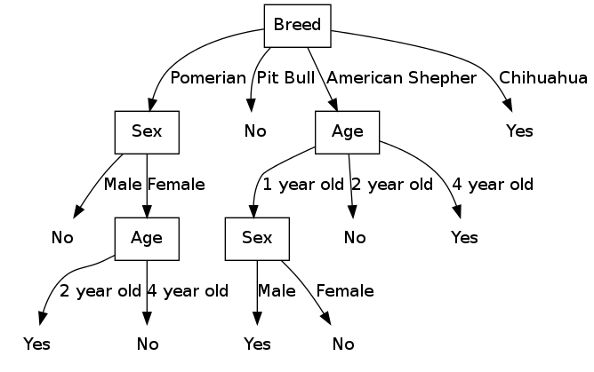

ID3.H

#ifndef __ID3_LEARNING_H__
#define __ID3_LEARNING_H__

#include<iostream>
#include<stdio.h>
#include<math.h>
#include<string>
#include<list>
#include<vector>
#include<stdlib.h>
#include<fstream>
#include<sstream>
using namespace std;
enum Sex
{
M,
F
};

enum Breed
{
P,
PB ,
AS ,
C
};
enum Decision
{
N,
Y
};

enum Attribute
{
Age,
Sex,
Breed
};

enum NodeType
{
NotLeaf,
Leaf
};

class ID3
{
public:
int at_;
int numOfChildNodes_;
NodeType nt_;
vector<int> attrList_;
string nodeLabel_;
ID3 * parent_;
ID3 * childNodes_[4];
string childLabels_[4];
ID3()
{
numOfChildNodes_=0;
for(int i=0;i<4;i++)
{
childNodes_[i]=NULL;
childLabels_[i]="";
}
}
};

double calculateOverAllEntropy(int data[][4],int size);
double calculateEntropy(int numY,int numN);
double calculateGain(Attribute at,double ent,int data[][4],int size,int &leafType);
void findDistribution(Attribute at,int val,int & numY,int &numN,int data[][4],int size);

void calculatePerAttributeGain(Attribute at,int Values[],double ent,int data[][4],int datasize,int atSize,double & gain,int & leafType);

ID3 * createID3TreeNode(int at,NodeType ndt,string nodelabel,string parentLabel,ID3 * parent);
void createID3R(ID3 * parent,int at, int data[][4],int size,vector<Attribute> attributeList,string parentLabel);

void printNode(ID3 * node,bool nodeCreated,string nodeStr);
void attrToName(int at,string & atName);
void calculateLeafDecision(int data[][4],int datasize,int &leafType);
void mapParentAttrChildAttr(int atV, int childAtv,string & name);
void flushToFile(const string fileName);

#endif

ID3.cpp
#include "ID3.H"
int datag[][4]= {
{1, M, C , Y },
{1 ,F, C, Y } ,
{2 ,M, C, Y } ,
{4, F, AS , Y },
{1, M, AS , Y },
{1, F, AS, N },
{2 ,F, AS, N},
{2, M, PB, N },
{1, M, PB , N },
{4 ,F, P, N } ,
{2, M, P, N },
{2 ,F, P, Y }
};

static int attributeCount1 = 0, leafCount=1;
static string globalGraphVizString = "digraph G { \n";
ID3 * root=NULL;
int main(int argc,char * argv[])
{
vector<Attribute> attributeList;

attributeList.push_back(Age);
attributeList.push_back(Sex);
attributeList.push_back(Breed);
double overallEnt=calculateOverAllEntropy(datag,12);
vector<Attribute>::iterator it=attributeList.begin();
Attribute attributeWithMaxGain;
double maxGain=0;
int leafType;
while(it!=attributeList.end())
{
double cGain = calculateGain(*(it),overallEnt,datag,12,leafType);
if(cGain >= maxGain)
{
attributeWithMaxGain = *(it);
maxGain=cGain;
}
it++;
}
//cout<<" XXXX Attribute Gain " << maxGain<<"Attribute " <<attributeWithMaxGain<<endl;
it=attributeList.begin();
while(it!=attributeList.end())
{
if(*(it) == attributeWithMaxGain)
{
it=attributeList.erase(it);
}
else
it++;
}
int atV=attributeWithMaxGain;
string atName;
attrToName(atV,atName);
createID3TreeNode(atV,NotLeaf,atName,"",NULL);
//The internal labels like P,PB,AS,C
vector<int>::iterator itAttr = root->attrList_.begin();
while(itAttr!=root->attrList_.end())
{
int dataTmp[12][4]={0};
int size=0;
for (int i =0;i<12;i++)
{
if(datag[i][atV]==*(itAttr))
{
dataTmp[size][0]=datag[i][0];
dataTmp[size][1]=datag[i][1];
dataTmp[size][2]=datag[i][2];
dataTmp[size][3]=datag[i][3];
cout<<"Match at posn "<<i+1<<"for attr "<<*(itAttr)<<endl;
size++;
}
}
//string atName;
attrToName(atV,atName);
cout<<"Creating tree for sub-attribute of type" << *(itAttr) <<" for attribute "<<atName<<endl ;

mapParentAttrChildAttr(atV,*(itAttr),atName);
createID3R(root,*(itAttr),dataTmp,size,attributeList,atName);
itAttr++;

}

printNode(root,false,"");
globalGraphVizString+="\n}\n";
string fileName="dt.dot";
flushToFile(fileName);
string cmdstr="dot -Tpng -o dt.png "+ fileName;
system(cmdstr.c_str());
cout<<endl<<globalGraphVizString<<endl;

return 0;
}

double calculateOverAllEntropy(int data[][4],int size)
{
int yVal =0;
int nVal = 0;
for(int i =0;i<size;i++)
{
if(data[i][3] == Y)
yVal++;
else if (data[i][3] == N)
nVal++;
}
double x = size;
double entropy = (-(yVal/x) *log2 (yVal/x) )
+ (-(nVal/x) *log2 (nVal/x));
//cout<<"Num of Y " << yVal <<" number of N "<< nVal<< " Entropy "<<entropy<<endl;

return entropy;

}

double calculateGain(Attribute at,double ent,int data[][4],int size,int &leafType)
{

double gain=ent;
bool allVals=Y;
switch(at)
{
case Age:
{
int ageValues[3]={1,2,4};
calculatePerAttributeGain(at,ageValues,ent,data,size,3,gain,leafType);
}

break;
case Sex:
{
int sexValues[2]={M,F};
calculatePerAttributeGain(at,sexValues,ent,data,size,2,gain,leafType);
}
break;
case Breed:
{
int breedValues[4]={P,PB,AS,C};
calculatePerAttributeGain(at,breedValues,ent,data,size,4,gain,leafType);
}
break;
default:
break;
}
//cout<<"Attribute Gain " << gain<<endl;
return gain;
}
void calculatePerAttributeGain(Attribute at,int Values[],double ent,int data[][4],int datasize,int atSize,double & gain,int & leafType)
{
int YNDistribution[4][2]={{0,0},
{0,0},
{0,0},
{0,0}};
double entropies [4]={0,0,0,0};
int sumY=0,sumN=0;
for(int i=0;i<atSize;i++)
{
int numY=0;
int numN=0;
findDistribution(at,Values[i],numY,numN,data,datasize);
sumY+=numY;
sumN+=numN;
YNDistribution[i][0]=numY;
YNDistribution[i][1]=numN;
}
int x = datasize;
double sumEnt=0;
for (int i=0;i<atSize;i++)
{
entropies[i]=calculateEntropy(YNDistribution[i][0],YNDistribution[i][1]);
sumEnt +=((YNDistribution[i][0]+YNDistribution[i][1])/(double)x) * entropies[i];
if(entropies[i] ==-0) entropies[i]=0;
cout<<"ent" << entropies[i] << "sumEnt"<<sumEnt<<endl;
}
gain = gain-sumEnt;
cout<<"Overall entropy "<<sumEnt<<"Gain is "<<gain<<endl;
if(sumY==datasize)
{
cout<<"Leaf type is YES"<<endl;
leafType=Y;
}
else if(sumN==datasize)
{
cout<<"Leaf type is NO"<<endl;
leafType=N;
}
else
{
cout<<" NOT Leaf type"<<endl;
leafType=-1;
}

}

double calculateEntropy(int yVal,int nVal)
{
double x = yVal+nVal;
double entropy =0;
if((nVal==0) && (yVal==0))
entropy = 0;
else if(yVal==0)
entropy = (-(nVal/x) *log2 (nVal/x));
else if (nVal ==0)
entropy = (-(yVal/x) *log2 (yVal/x));
else
entropy = (-(yVal/x) *log2 (yVal/x) )
+ (-(nVal/x) *log2 (nVal/x));
return entropy;
}
void findDistribution(Attribute at,int val,int & numY,int &numN,int data[][4],int size)
{
int attributeToCheck=at;
for(int i =0;i<size;i++)
{
if((data[i][attributeToCheck] == val ) &&
(data[i][3] == Y ) )
numY++;
else if((data[i][attributeToCheck] == val ) &&
(data[i][3] == N ) )
numN++;
}

}
ID3 * createID3TreeNode(int at,NodeType ndt,string label,string parentLabel,ID3 * parent)
{

if(root==NULL)
{
root= new ID3[1];
root->at_ =at;
root->nt_ =ndt;
root->nodeLabel_=label;
root->parent_=parent;
switch(at)
{
case Age:
break;
case Sex:
break;
case Breed:
root->attrList_.push_back(P);
root->attrList_.push_back(PB);
root->attrList_.push_back(AS);
root->attrList_.push_back(C);
break;
default:
break;

}
return root;
}
else
{
ID3 * node = new ID3[1];
node->at_ =at;
node->nt_ =ndt;
node->nodeLabel_=label;
node->parent_=parent;
node->parent_->childNodes_[node->parent_->numOfChildNodes_]=node;
node->parent_->childLabels_[node->parent_->numOfChildNodes_]=parentLabel;
node->parent_->numOfChildNodes_++;
switch(at)
{
case Age:
node->attrList_.push_back(1);
node->attrList_.push_back(2);
node->attrList_.push_back(4);
break;
case Sex:
node->attrList_.push_back(M);
node->attrList_.push_back(F);
break;
case Breed:
node->attrList_.push_back(P);
node->attrList_.push_back(PB);
node->attrList_.push_back(AS);
node->attrList_.push_back(C);

break;
default:
break;
}
return node;
}
}
void createID3R(ID3 * parent,int at, int data[][4],int datasize,vector<Attribute> attributeList,string parentLabel)
{
cout<<"Data size is "<<datasize<<endl;
if(datasize ==0)
{
cout<<"0 size "<<endl;
return;
}
double overallEnt=calculateOverAllEntropy(data,datasize);
Attribute attributeWithMaxGain;
double maxGain=0;
int leafDecisionType=0;
ID3 * node=NULL;

vector<Attribute>::iterator it=attributeList.begin();
if(!attributeList.empty())
{
while(it!=attributeList.end())
{
double cGain = calculateGain(*(it),overallEnt,data,datasize,leafDecisionType);
if((leafDecisionType==Y) || (leafDecisionType==N)) break;
if(cGain >= maxGain)
{
attributeWithMaxGain = *(it);
maxGain=cGain;
}
it++;
}
}
else
{
calculateLeafDecision(data,datasize,leafDecisionType);
}
string atName;
attrToName(attributeWithMaxGain,atName);
cout<<"Max gain attribute is "<<atName<<endl;
//No reduction in entropy so this has to be the leaf node.
if(((overallEnt-maxGain) ==1) || (leafDecisionType!=-1))
{
//Create the leaf node if any elements
string leafLabel="";
if(leafDecisionType==Y) leafLabel ="Yes";
if(leafDecisionType==N) leafLabel ="No";
cout<<"Create a leaf node of type "<<leafLabel<<endl;
node=createID3TreeNode(attributeWithMaxGain,Leaf,leafLabel,parentLabel,parent);
return;
}
else
{
cout<<"Creating a node for type"<<atName<<endl;
node=createID3TreeNode(attributeWithMaxGain,NotLeaf,atName,parentLabel,parent);
}
//Remove the attribute from subsequent iteration
it=attributeList.begin();
while(it!=attributeList.end())
{
if(*(it) == attributeWithMaxGain)
{
it=attributeList.erase(it);
}
else
it++;
}
int atV = attributeWithMaxGain;
vector<int>::iterator itAttr = node->attrList_.begin();
while(itAttr!=node->attrList_.end())
{
int dataTmp[12][4]={0};
int size=0;
for (int i =0;i<datasize;i++)
{
if(data[i][atV]==*(itAttr))
{
dataTmp[size][0]=data[i][0];
dataTmp[size][1]=data[i][1];
dataTmp[size][2]=data[i][2];
dataTmp[size][3]=data[i][3];
size++;
}
}

string atName;
attrToName(atV,atName);
cout<<"Creating tree for sub-attribute of type" << *(itAttr) <<" for attribute "<<atName<<endl ;

mapParentAttrChildAttr(atV,*(itAttr),atName);
createID3R(node,*(itAttr),dataTmp,size,attributeList,atName);
itAttr++;
}
}

void printNode(ID3 * node,bool nodeCreated,string nodeStr)
{
cout<<"Node Details"<<endl;
string nodeType;
cout<<"Attribute node::"<<node->nodeLabel_<<endl;
string parentNode=nodeStr;
if((node->nt_==NotLeaf) && !nodeCreated)
{
ostringstream convert;
convert << attributeCount1;
globalGraphVizString += "attr"+convert.str();
globalGraphVizString+=" [shape=\"rectangle\", label="+node->nodeLabel_+"]\n";
parentNode +="attr"+convert.str();
attributeCount1++;
}
else if((node->nt_==Leaf) && !nodeCreated)
{
ostringstream convert;
convert << leafCount;
globalGraphVizString += "leaf"+convert.str();
globalGraphVizString+=" [shape=\"plaintext\", label="+node->nodeLabel_+"]\n";
parentNode +="leaf"+convert.str();
leafCount++;
}

for(int i=0;i<node->numOfChildNodes_;i++)
{
cout<<"Child label "<<node->childLabels_[i]<<endl;
string nodeNext="";
if(node->childNodes_[i]->nt_==NotLeaf)
{
ostringstream convert;
convert << attributeCount1;
globalGraphVizString += "attr"+convert.str();
globalGraphVizString+=" [shape=\"rectangle\", label="+node->childNodes_[i]->nodeLabel_+"]\n";
nodeNext +="attr"+convert.str();
attributeCount1++;
}
else if (node->childNodes_[i]->nt_==Leaf)
{
ostringstream convert;
convert << leafCount;
globalGraphVizString += "leaf"+convert.str();
globalGraphVizString +=" [shape=\"plaintext\", label="+node->childNodes_[i]->nodeLabel_+"]\n";
nodeNext +="leaf"+convert.str();
leafCount++;
}

globalGraphVizString += parentNode + " -> "+ nodeNext+" [label =\""+node->childLabels_[i]+"\"]\n";
printNode(node->childNodes_[i],true,nodeNext);
}

}
void attrToName(int at,string & atName)
{
if(at==Age) atName="Age";
if(at==Sex) atName="Sex";
if(at==Breed) atName="Breed";

}
void calculateLeafDecision(int data[][4],int datasize,int &leafType)
{
int numY=0,numN=0;
for(int i =0;i<datasize;i++)
{
if(data[i][3] == Y)
numY++;
else if(data[i][3] == N )
numN++;
}
if(numY==datasize)
{
cout<<"Leaf type is YES"<<endl;
leafType=Y;
}
else if(numN==datasize)
{
cout<<"Leaf type is NO"<<endl;
leafType=N;
}
else
{
cout<<" NOT Leaf type"<<endl;
leafType=-1;
}

}
void mapParentAttrChildAttr(int atV, int childAtv,string & name)
{
switch(atV)
{
case Age:
if(childAtv==1) name = "1 year old";
if(childAtv==2) name = "2 year old";
if(childAtv==4) name = "4 year old";
break;
case Sex:
if(childAtv==M) name = "Male";
if(childAtv==F) name = "Female";
break;
case Breed:
if(childAtv==P) name = "Pomerian";
if(childAtv==PB) name = "Pit Bull";
if(childAtv==AS) name = "American Shepher";
if(childAtv==C) name = "Chihuahua";
break;
}
cout<<"Mapped name "<<name<<endl;
}
void flushToFile(const string fileName)
{
ofstream myfile;
myfile.open (fileName.c_str());
myfile << globalGraphVizString;
myfile.close();
}

