Date: 23/9/2019

Time: 3.30pm to pm

Venue: SOE/SOSS GSR 3-15

Attendees: All

Agenda:

1. Update database to follow wiki’s format
2. Filter out whitespace
3. Updating the index.php (with bid button)
4. Display bid( with specific conditions)

The meeting was adjourned at 6.30 pm. These minutes will be circulated and adopted if there are no amendments reported in the next three days.

As of 4.09pm

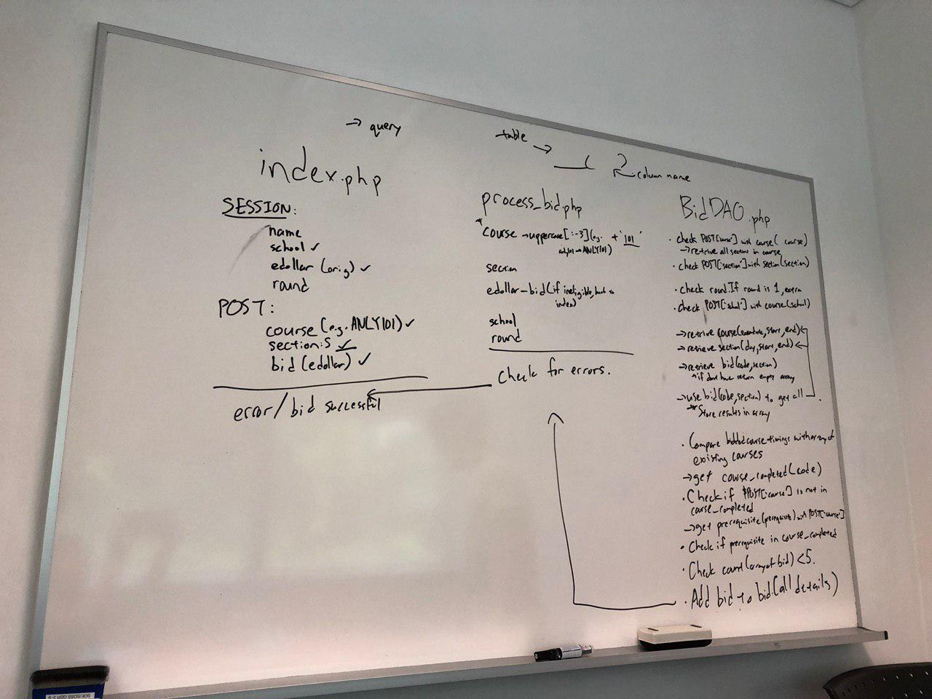

As of 6.09pm

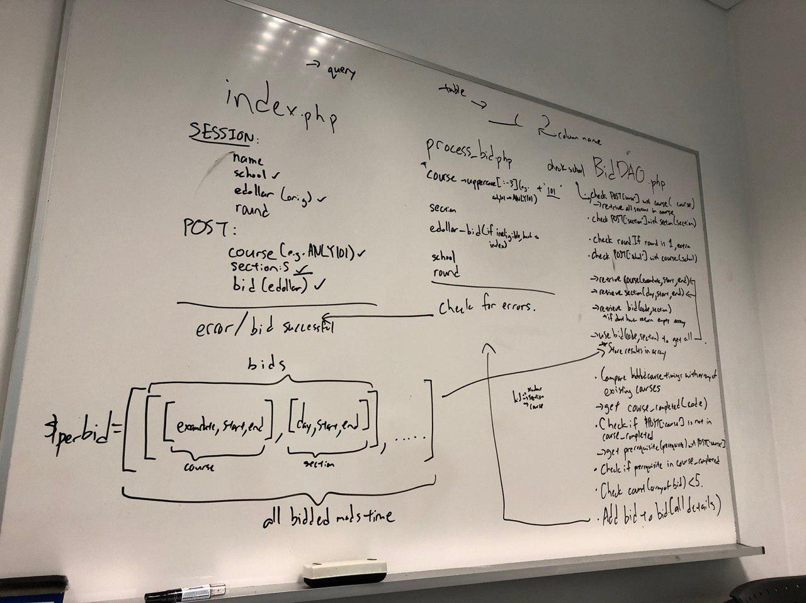

Prepared by,

Sonia and Jia Ying