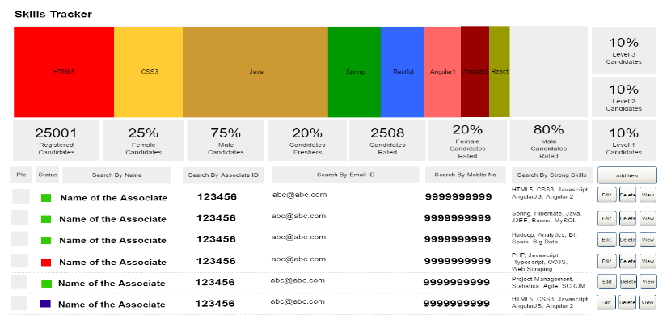  SINGLE PAGE APPLICATION ON SKILLS TRACKER  JAVA FSD 8 Hour Code Capsule | ABSTRACT  The Skills Tracker should be a Single Page Application (SPA) to perform operations like Managing Employee IT Skills and dashboard to search employees as per the required skills  Developer  JAVA Full Stack Developer

Contents
Important Instructions 2
Instructions 2
Assessment Deliverables 3
Business-Requirement: An Overview 3
System Personas 3
Technical Spec – Solution Development Environment 4
Front End Layer 4
Middle Tier Layer 4
Database & Integration Layer 4
Ancillary Layer 4
Deployment & Infrastructure 4
Editors 4
Wireframes 5
Dashboard and Search Associate by different criteria 5
Add New Employee Skills 6
Update Employee Skills 7
Add Skill Page 9
Database Tables 10
Methodology 10
Follow TDD 10
Load Testing 11
Continuous Integration 11
Software Requirements 11
Architecture 12
Architecture Diagram for JAVA Enterprise Full Stack 13
Assessment Deliverables 13

Important Instructions
- Adhere to the design specifications mentioned in the case study.
- Please make sure that your code does not have any compilation errors while submitting your case study solution.
- The final solution should be a zipped code having solution. Solution code will be used to perform Static code evaluation.
- Implement the code using best design standards.
- Use Internationalization for all the labels and messages in Rest API Development.
- Do not use System out statements or console.log for logging in Rest API and FrontEnd respectively. Use appropriate logging methods for logging statements/variable/return values.
- If you are using Spring Restful or Jersey JAX-RS to develop Rest API, then use Maven to build the project and create WAR file.
- If you are using Node and Express to develop Rest API, then use Grunt/Gulp/NPM to build/minify the project and create application for deployment.
- If you are using C#.Net/VB.Net, ASP.net, ASP.net MVC, WCF, Web API to build Rest API, then use relevant tools to build the project.
- Write web service which takes input and return required details from database.
- Use JSON format to transfer the results.

Instructions
- Adhere to the design specifications mentioned in the case study.
- Feel free to create front-end and back-end of single page application from scratch. You are free to use angular-cli commands at command prompt to create SPA (Single Page Application) template.
- Please make sure that your code does not have any compilation errors while submitting your case study solution.
- The final solution should consist of three parts:
  - Front-end built using HTML5, CSS3, Bootstrap and Angular JS as a SPA. Controllers written in Angular JS should consume restful API coded in business layer.
  - Business-layer built using Spring Restful/JAX-RS Jersey or Node.JS/Express.JS.
  - Database-layer built using MongDB or MySQL.

Assessment Deliverables
- For Front End – zipped application
- For Backend - Packaged code files (Source code and WAR).
- For SCM* – Project Code should be present in active GIT repository
- Few steps on how to run the solution

*SCM – Source Code Management

Business-Requirement: An Overview

System Personas


John Dempsey works in an IT company. He is an new age HR Academic Manager. Few of his roles and responsibilities includes:
- Keeping track of skill of individual Full Stack Engineers
- To use the single page solution (Skills Tracker) to keep track of employee skills.
The proposed solution (Skills Tracker) will try to provide the above-mentioned features.
The Skills Tracker should be a Single Page Application (SPA). Using this internal portal John Dempsey will be able perform following operations:
- Search Associate: John will be able to search associate with following criteria’s:
  - Search by associate name
  - Search by associate ID
  - Search by Email ID
  - Search By Mobile Number
  - Search By Strong Skills

- Add new Associate: John will be able to add new associate and its respective Full Stack Development Skills.
- Edit, Delete & View Associate: The associate which is searched can be updated, deleted and viewed.
- Add Skill: It will allow John to add new skills so that it can be used in “Add New Associate ” page.

Technical Spec – Solution Development Environment

Front End Layer
Framework(s)/SDK/Libraries | Version
AngularJS | 1.5 or above
Bootstrap | 3.0 or above
CSS | 3
HTML | 5
JavaScript | 1.8 or above
JQuery | 1.3

Middle Tier Layer
Technology | Framework(s)/SDK/Libraries | Version
Java Stack | Spring Boot | 1.5 or above
Java Stack | Spring MVC | 4.0 or above
Java Stack | JDK | 1.7 or above
Java Stack | Maven | 3.x or above

Database & Integration Layer
Technology | Framework(s)/SDK/Libraries | Version
Java Stack | Hibernate | 4.0 or above
Java Stack | JAX-RS Jersey/ Spring Restful
Java Stack | MySQL | 5.7.19
MongoDB | MongoDB | 3.4
MongoDB | NoSQL

Ancillary Layer
Technology | Framework(s)/SDK/Libraries | Version
Source Code Management Tool | GIT | 2.14.2
Build Tool/JAVA Stack | Maven | 3.x
Testing Tool/JAVA Stack | JUnit | 4.x
Testing Tool/JAVA Stack | Spring Test | 4.x

Deployment & Infrastructure
Technology | Framework(s)/SDK/Libraries | Version
Docker | -
Apache HTTP (XAMPP) | -
Node | -
Dependency Management Tool | NPM

Editors
Name | Version
Adobe Brackets
Sublime Text
Atom Editor

Wireframes

Dashboard and Search Associate by different criteria
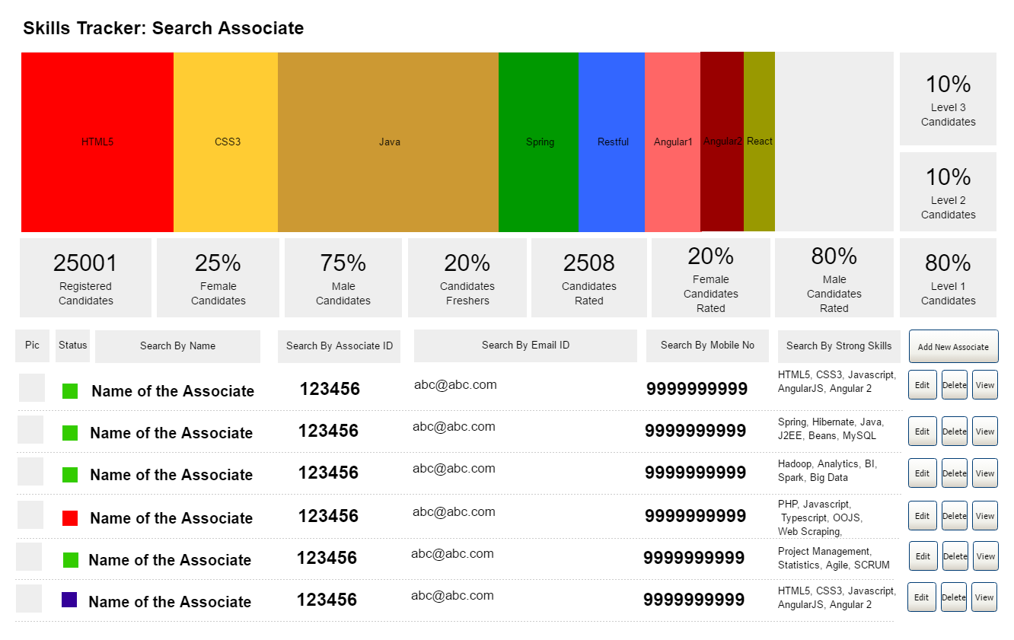Dashboard + Search by associate name, Search by associate ID, Search by Email ID, Search By Mobile Number, Search By Strong Skills.

Add New Employee Skills
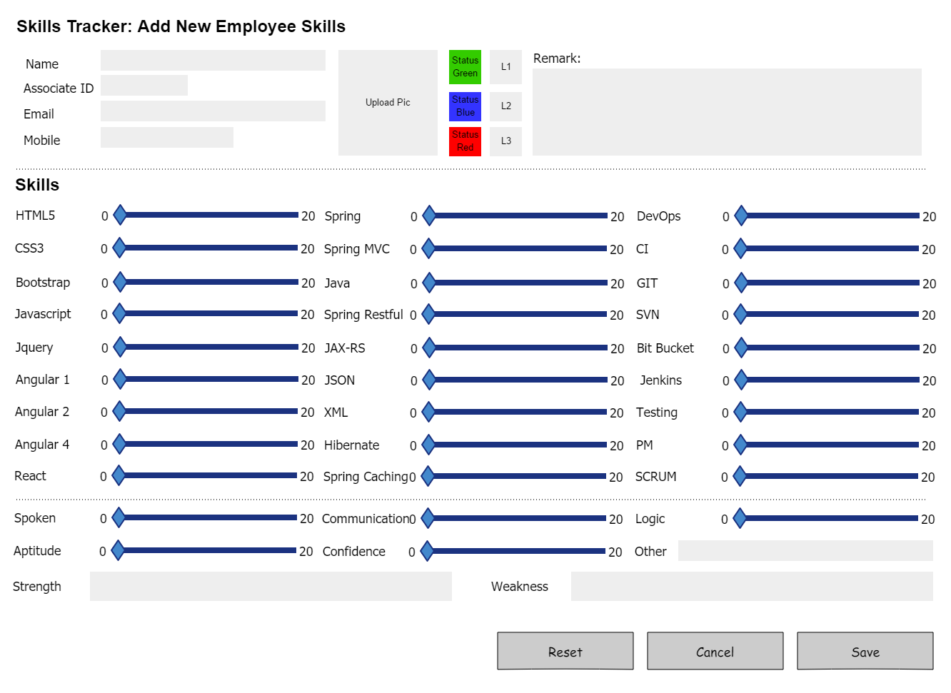
Add skills for the employee
- Each skill for the respective associate can be rated between 0 to 20
- Status selection criteria:
  - Status is green if associate is available to be allotted and tagged for the project.
  - Status is blue if associate is in process of being allocated and tagged to the project.
  - Status is red if associate is already allotted and tagged to the project.

- Level selection criteria:
- Level 1 i.e L1 will be the level for associates who are freshers and less than 1 year experience.
- Level 2 i.e L2 will be the level for associates who are carrying experience between 1 year to 5 year.
- Level 3 i.e L3 will be the level for associates who are carrying experience between 6 year to 8 year.

Update Employee Skills

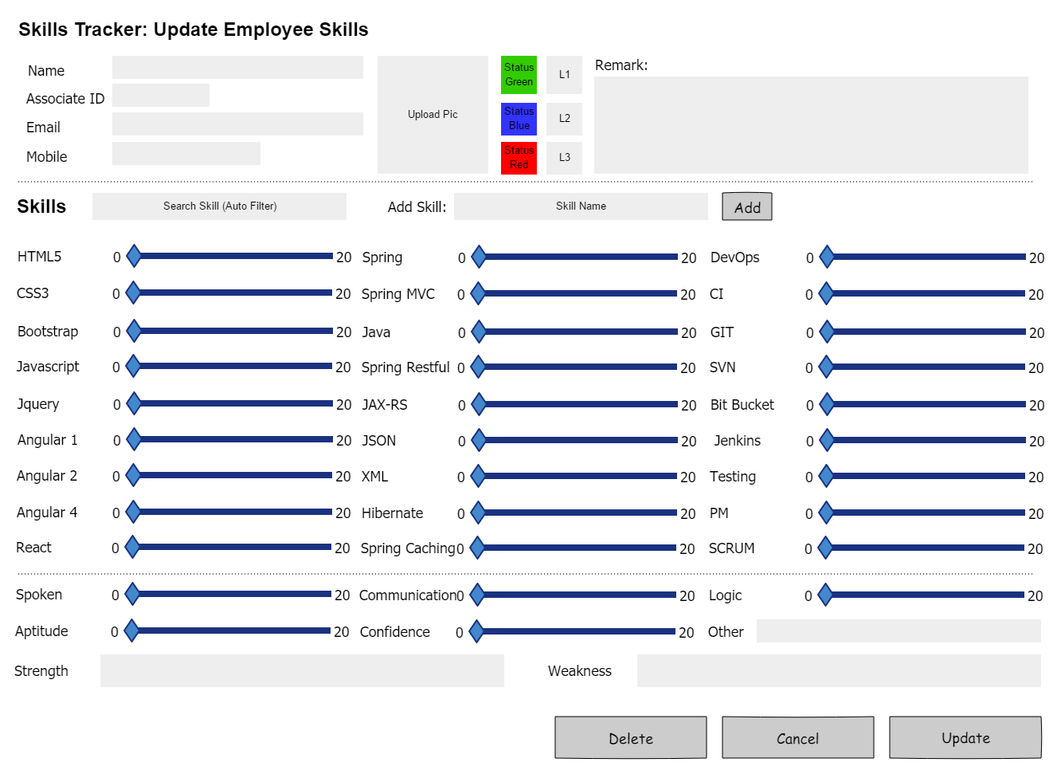
Update Associate Skills

Add Skill Page
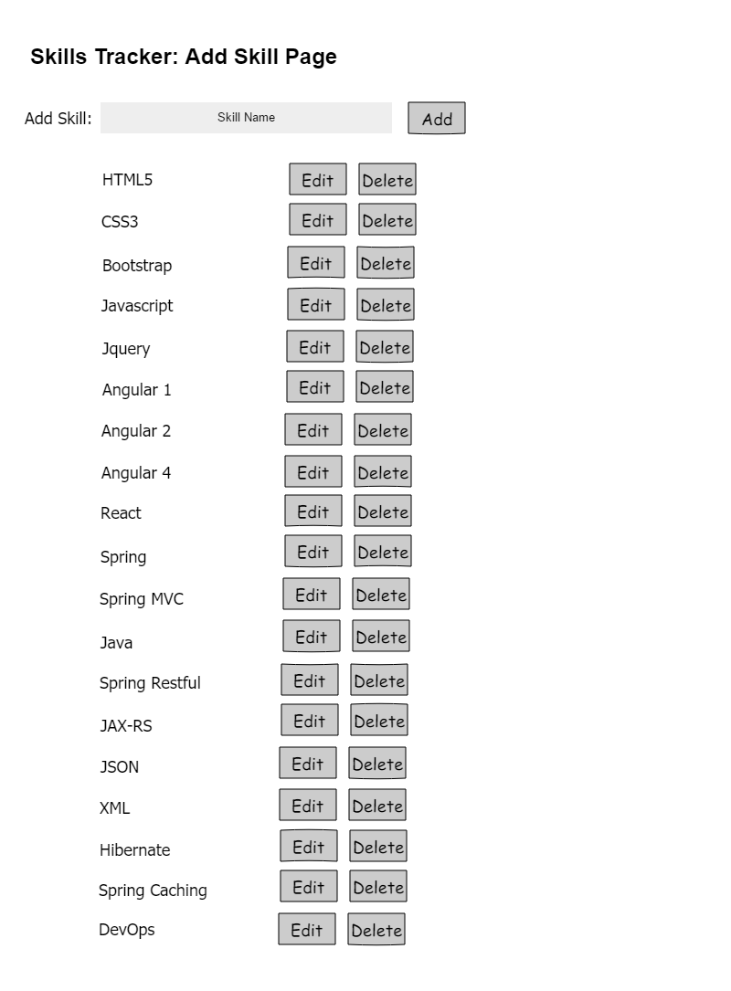
Add Skill Page

Database Tables
Associate Table |  | Associate Skills Table |  | Skills_Table
Associate_ID |  | Associate_ID |  | Skill_ID
Name |  | Skill_ID |  | Skill_Name
Email
Mobile
Pic
Status_Green
Status_Blue
Status_Red
Level_1
Level_2
Level_3
Remark
Strength
Weakness

Methodology

Follow TDD
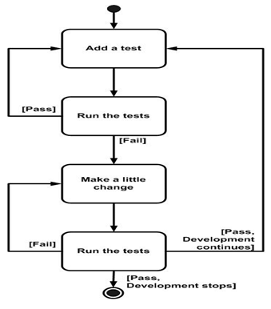
Development approach to follow
a. Use Jasmine to write your test cases
b. Use Emma Coverage (Istanbul and Karma) tool to measure the depth of your test cases - whether happy/unhappy scenarios are all covered in your testing.
c. Externalize your test data from your test code
d. The minimum acceptable Emma coverage statistic for methods - 85 %

Load Testing
One of the major improvement areas for associates is to write code that can sustain concurrent, multiple hits to the services written. To measure how scalable your code can be load testing should be incorporated as a part of development process rather than an effort conceived post delivery.
a. Set up JMeter in your environment
b. Load test your REST API’s
c. Simulate at least 500 concurrent threads and run the load test for at least 10 minutes
d. The findings of the report should be included as a part of final assessment deliverable.

Continuous Integration
a. Check in your code - ideally every day or at worst every 2 days or so.
b. Set up Travis CI/ or your favourite CI tool on the cloud and integrate with your Github code base.
c. Trigger build on every check in -the build should, apart from compiling, also run the test cases.
d. Save the build report’s as a part of final assessment deliverable - this will measure the regular check in code by associates as well as TDD nature of development

Software Requirements
This case study assumes knowledge of programming and hands-on with below mentioned skills.
The technologies included in Full Stack are not limited to following but may consist of:
- UI Layer (HTML5, CSS3, Bootstrap, JavaScript, Jquery, AngularJS, JSP)
- Middleware Restful API (Spring Restful, JAX-RS, Spring MVC)
- Database Persistence ( Hibernate)
- Database layer (MySQL, MongoDB)
- Ancillary skills (GIT, Docker, Maven) etc.
To complete this case study, you should be comfortable with basic single page web application concepts including REST and CRUD. The environment setup is built into virtual environment you are logged in to.
You may use angular-cli to create your template project.
Ref1: https://cli.angular.io/
Ref2: https://github.com/angular/angular-cli

Architecture
A physical architecture is an arrangement of physical elements, (system elements and physical interfaces) that provides the designed solution for a product, service, or enterprise. It is intended to satisfy logical architecture elements and system requirements. Workout Tracker follows a three layered architecture namely presentation layer, business logic layer and data access layer.
- Presentation Tier is the tier in which the users interact with an application. It is a single-page-application of responsive nature. Presentation Tier will consume restful API implemented in Business Tier to display content to the user.
- Business Tier is mainly working as the bridge between Data Tier and Presentation Tier. All the Data passes through the Business Tier before passing to the presentation Tier. Business Tier is the sum of Business Logic Layer, Data Access Layer and Value Object and other components used to add business logic. It exposes Rest API which can be called by Presentation Tier to display content to the user. It will also send the data from Presentation tier to Data Tier using Rest API.
- Data Tier is basically the server which stores all the application’s data. Data tier contents Database Tables, XML Files and other JAVAs of storing Application Data.

Architecture Diagram for Java Enterprise Full Stack
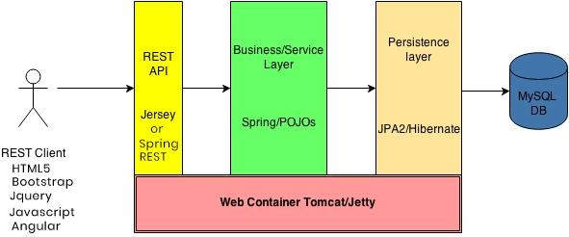
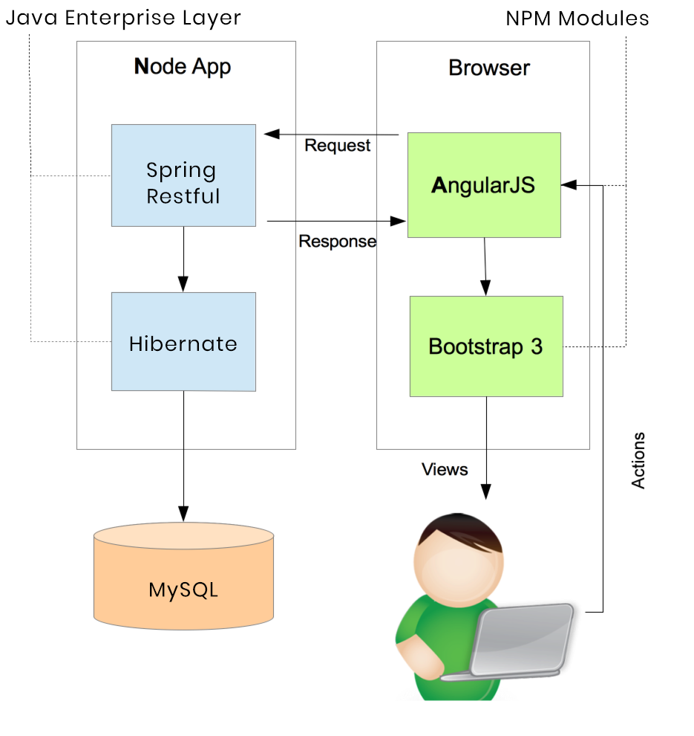

Important Instructions
- Adhere to the design specifications mentioned in the case study.
- Feel free to create front-end and back-end of single page application from scratch. You are free to use angular-cli commands at command prompt to create SPA (Single Page Application) template.
- Please make sure that your code does not have any compilation errors while submitting your case study solution.
- The final solution should consist of three parts:
  - Front-end built using HTML5, CSS3, Bootstrap and Angular as a SPA. Controllers written in Angular JS should consume restful API coded in business layer.
  - Business-layer built using Spring Restful/JAX-RS Jersey or Node.JS/Express.JS.
  - Database-layer built using MongDB or MySQL.

Assessment Deliverables
- For Front End – zipped application
- For Backend - Packaged code files (Source code and WAR).
- For SCM* – Project Code should be present in active GIT repository
- Few Steps on how to run the solution.
- Regular Build Reports from CI server
- Emma coverage reports
- Load test reports

*SCM – Source Code Management

