KapiMart Partner Handbook
  - Everything a new marketplace seller needs in the first ninety days
Edition 2026.3, published by the KapiMart Partner Team

1. Welcome to the marketplace
KapiMart connects independent food producers with more than two million active buyers across Europe. This handbook walks you through onboarding, the fee schedule and the support channels, and points to the Partner Portal for the day-to-day work.
Read it once from start to end; after that, each chapter stands on its own.

2. Getting started

2.1 Five steps to your first order
- Create your Seller Account in the Partner Portal and verify your business identity.
- Complete the business profile: legal name, VAT number and the address that appears on invoices.
- Upload your product catalogue with the bulk import template, or add products one at a time.
- Set your shipping zones, delivery promises and return policy.
- Connect a payout account and submit your first listing for review.

2.2 Account requirements
- A registered business in a supported country
- Food-safety certification for every product category you list
- A customer-service mailbox answered within one business day
- Product photographs of at least 1200 × 1200 pixels

3. Fees and payouts
Fees depend on the plan. The Starter plan carried a €19 monthly fee until June 2026; Starter is now free, and the transaction fee is unchanged.¹
Plan | Monthly fee | Transaction fee | Payout schedule
Starter | €0 | 8.0 % | Monthly
Growth | €49 | 6.5 % | Fortnightly
Scale | €199 | 5.0 % | Weekly
Enterprise | Custom | Custom | Daily
Payouts are made in euros to the account on file. Partners outside the euro area receive the amount converted at the European Central Bank reference rate on the payout date.
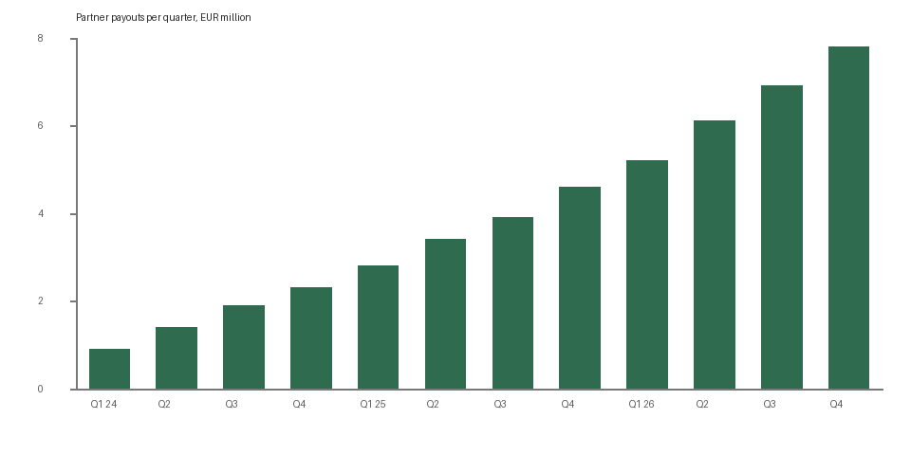
Figure 1. Quarterly partner payouts since the marketplace opened.
¹ Fees quoted exclude VAT; the Partner Agreement carries the full schedule.

4. Support
Partner Support is open Monday to Friday, 08:00 to 18:00 CET. Write to partners@kapimart.example.com or open a ticket from the Portal. Urgent order issues go to the on-call line printed on your dashboard.
Our best partners read this handbook twice: once before the first listing, and once after the first hundred orders.

