作业 #1
- Write a program that can output the following messages
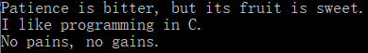

- Given the values of three variables a, b and c, write a program to compute and display the value of x, where
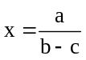
Using the following values for variables a, b and c, respectively.
- a=250, b=85, c=25
- a=300, b=70, c=70
- Enter three numbers for a, b, c

- Relationship between Celsius and Fahrenheit is governed by the formula
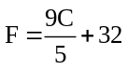
Write a program to convert the temperature.

- Area of a triangle is given by the formula
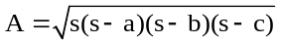
Where a, b and c are sides of the triangle and s=(a+b+c)/2. Write a program to compute the area of the triangle given the values a, b and c.

- Read in a 3-digit integer number, write a program that displays the number as follows:
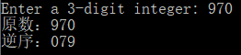

- [optional] Write an interactive program to demonstrate the process of multiplication. The program should ask the user to enter two two-digit integers and print the product of integers as shown below.
