作业 #3
- Compute and display the value of s, where
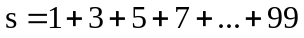

- Write a program to compute the sum of the digits of a given long integer number.
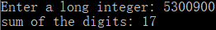

- Shown below is a Floyd’s triangle.
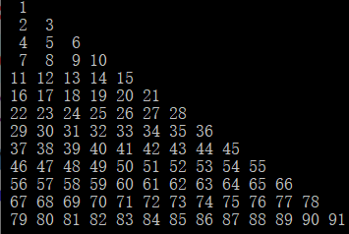
Write a program to print this triangle. (Tips: using %3d as print format)

- Write a program to determine whether a given integer is a prime number or not.
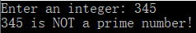
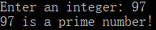

- Write a program to print the following output using for loops.
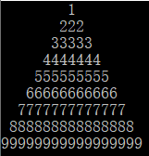 or 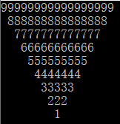

- [Optional] Compute and display the value of s, where

