# 要求

$$u_{o}＝2u_{i1}+3u_{i3}-5u_{i2}$$

## 设计电路如下

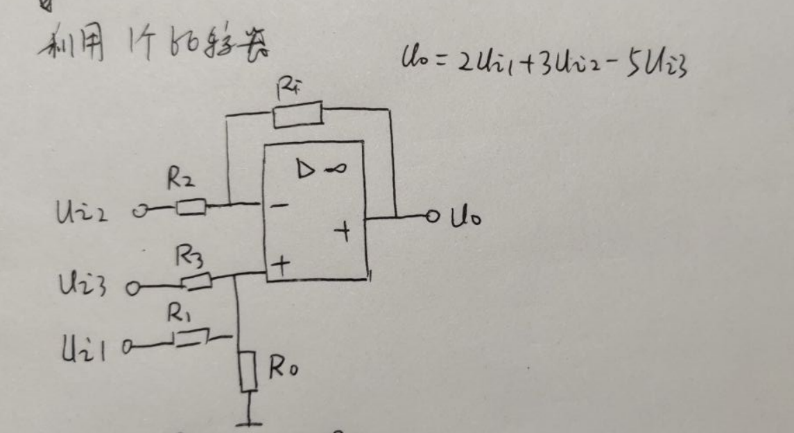

## 理论计算

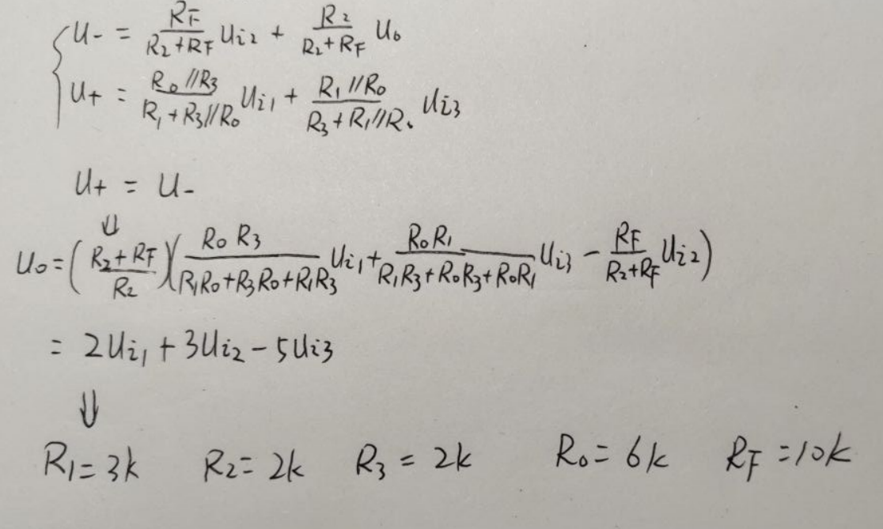

## 仿真

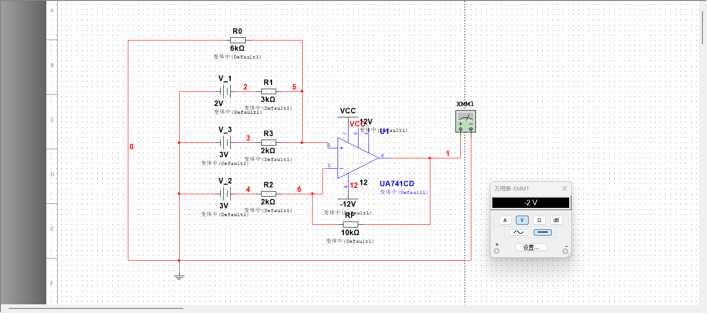

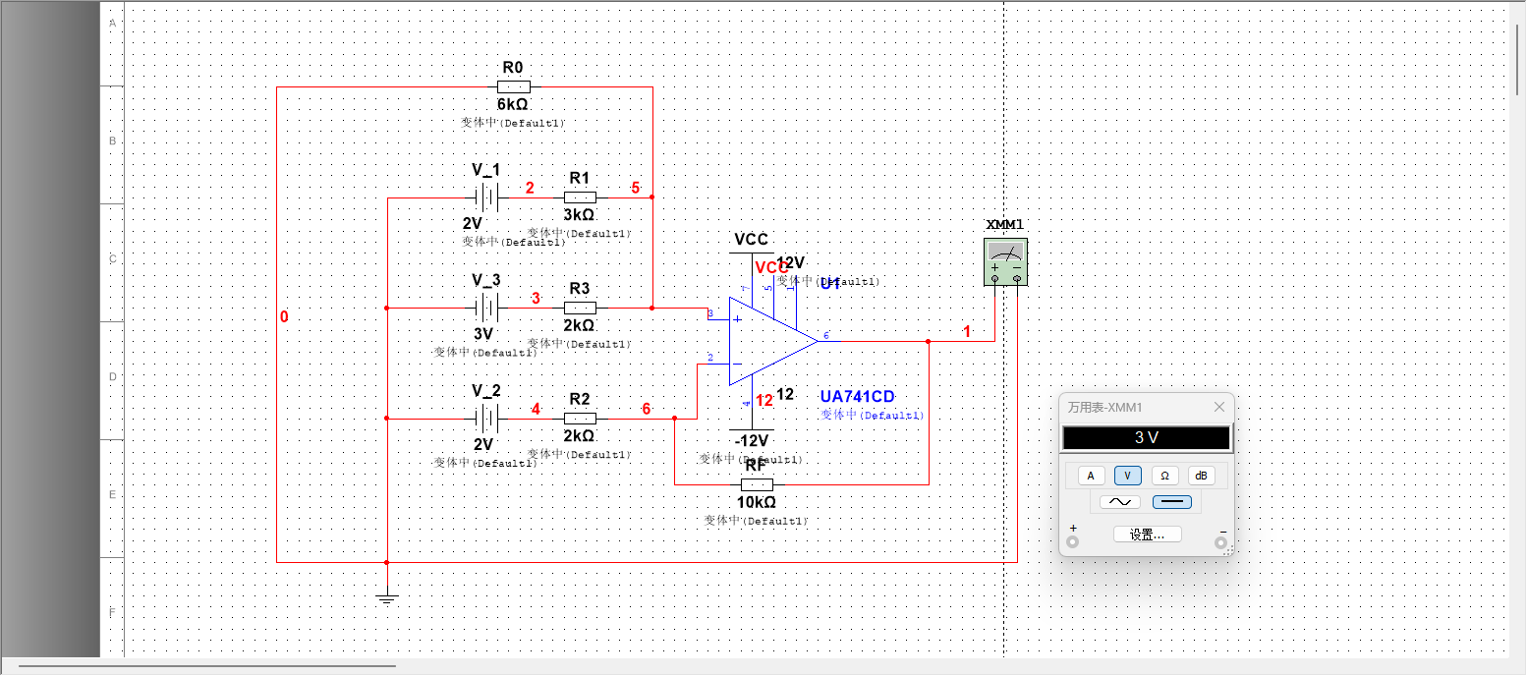

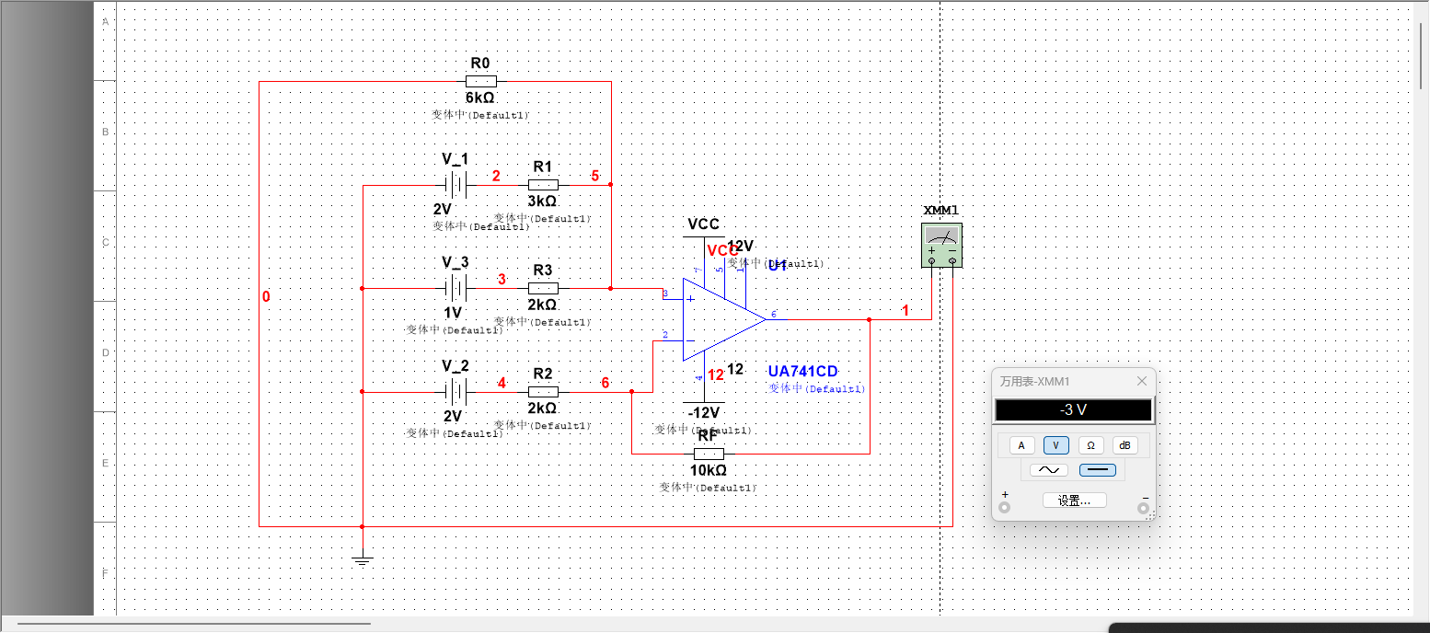

|  |  |  |  |
| --- | --- | --- | --- |
| $$V_{i1}$$ | $$V_{i2}$$ | $$V_{i3}$$ | $$U_{o}=2u_{i1}+3u_{i3}-5u_{i2}$$ |
| 2 | 3 | 3 | -2 |
| 2 | 2 | 3 | 3 |
| 2 | 2 | 1 | -3 |