Assignment 2
Due, Sunday, October 30, 2022 for 100% credit
Monday, October 31, 2022 for 90% credit
Tuesday, November 1, 2022 for 80% credit
Wednesday, November 2, 2022 for 70% credit

Assignment scope

This assignment is focused on writing JavaScript and will create an electronic version of a dice game Boggle.

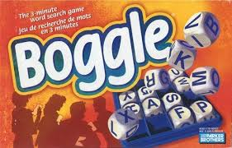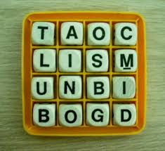

This project will require students to randomly generate a Boggle board. The player will have three minutes to find as many words as possible. Words are created with three letters or more. Words are formed from adjoining letters. Letters must join in the proper sequence to spell a word. Letters may join horizontally, vertically, or diagonally, to the left, right, up or down. No letter cube may be used more than once in a single word.

Resources

Three files have been provided as templates for this assignment
- boggle.html
- boggle.css
- boggle.js

Assignment submission

Create a single folder for all three files, the .html, .css and .js. Compress the folder and submit the compressed file (e.g. .zip)

Tasks
Activity
.html | - In the <head> link in the external boggle.css file  - In the <head> link in the external jquery-2.1.0.js library file  - In the <head> link in the external boggle.js file  - In the <body>  - For element <input type="button"…> add an onclick event to call JavaScript function addWord()
.css | - Modify the provided style settings  - background color for Boggle dice  - font color for Boggle dice  - background color for Enter button  - font color for Enter button  - background color for the page (i.e., body)
.js | - Declare the following global variables  - Array words initialized to an empty array  - Variable idx initialized to zero (i.e., 0)
.js | - Write function addWord to do the following  - Empty parameter list  - Set element idx of the words array equal to the value of HTML element id "js-word"  - Increment variable idx by one  - Update the value of HTML element id "js-word" to an empty string  - Call function displayWords, passing zero arguments
.js | - Write function displayWords to do the following  - Empty parameter list  - Initialize variable wordStr equal to HTML element <hr />  - Loop through the array words  - Append to variable wordStr the current element in array words concatenated with HTML element <br />  - Update the value of HTML element id "js-words-found" to variable wordStr
.js | - Inside the open/close curly braces jQuery $(document).ready(function() to the following  - Set constant boggle equal to an anonymous function  - Initialize constant container equal to HTML element id "js-boggle"  - Initialize array grid to an empty array (i.e. use let versus var to control variable scope throughout task 4.)  - Initialize variable isCustomGrid to false  - Declare variable customGrid  - Create global game settings, declare object settings, using the object initializer methodology, to add the following properties/values  - gridsize, value 4  - min, value 3  - max, value 6  - letters, value is in Figure 1 below  - Write function initializeGrid to do the following  - Parameter list includes one parameter, arg  - Initialize variable gridsize equal to zero (i.e. 0)  - Initialize variable setLength equal to zero (i.e. 0)  - If the typeof parameter arg is identical to 'number'  - Set property gridsize equal to parameter arg  - Else if Object.prototype.toString.call(arg) is identical to '[object Array]'  - Set variable isCustomGrid equal to true  - Set variable customGrid equal to parameter arg  - Error checking and exception handling code is provided, do not remove (!important)  - Set property gridsize equal to parameter arg's length property  - Error checking and exception handling code is provided, do not remove (!important)  - Referencing object settings, set property gridsize equal to variable gridsize  - Return object settings  - Write function setGrid to do the following  - Empty parameter list  - Initialize variable counter to property gridsize of object settings  - If variable isCustomGrid is true  - Append each letter to the Boggle board in all uppercase; code is provided, do not remove (!important)  - Return array grid  - Loop while variable counter is greater than 0  - Referencing array grid, call function push, pass as an argument function call setLetters()  - Decrement loop control variable counter by one  - Return array grid  - Write function setLetters to do the following  - Empty parameter list  - Initialize variable i to value 0  - Initialize variable len to property gridsize of object settings  - Declare variable randomLetter  - Initialize array letters to an empty array  - Loop len number of times  - Set variable randomLetter equal to object settings, property letter, randomly selecting one of the letters  - Add randomLetter to array letters  - Return array letters  - Write function renderGrid to do the following  - Initialize variable render to and empty string  - Reference array grid, call function .forEach()  - Function .forEach() receives one parameter, an anonymous function  - Anonymous function receives one parameter, row  - In the anonymous function, append to variable render explicit HTML code '<div class="row">'  - Reference parameter row, call function .forEach  - Function .forEach() receives one parameter, an anonymous function  - Anonymous function receives two parameters, (letter, i)  - In the anonymous function, append to variable render explicit HTML code `<span> ${letter} </span>`  - Append to variable render explicit HTML code '</div>'  - Set variable container, innerHTML, equal to variable render  - Write function init to do the following  - Empty parameter list  - If the typeof array arguments, index 0, is NOT identical to explicit text 'undefined'  - Call function initializeGrid, pass as an argument array arguments, index 0  - Call function setGrid  - Call function renderGrid  - Referencing object boggle, call function init, pass as an argument the value of 4 (i.e. this the size of the Boggle board)
Test Cases
Test Case 1 | Rendered HTML page looks similar to Figure 2
Test Case 2 | Player enters a word, Words Found updates to include entered word, similar to Figure 3

'AAAAAAAAABBCCDDDDDEEEEEEEEEEEEEFFGGGHHHHIIIIIIIIJKLLLLMMNNNNNOOOOOOOOPPQRRRRRRSSSSSTTTTTTTUUUUVVWWXYYZ'
Figure 1 Object settings, property letters value

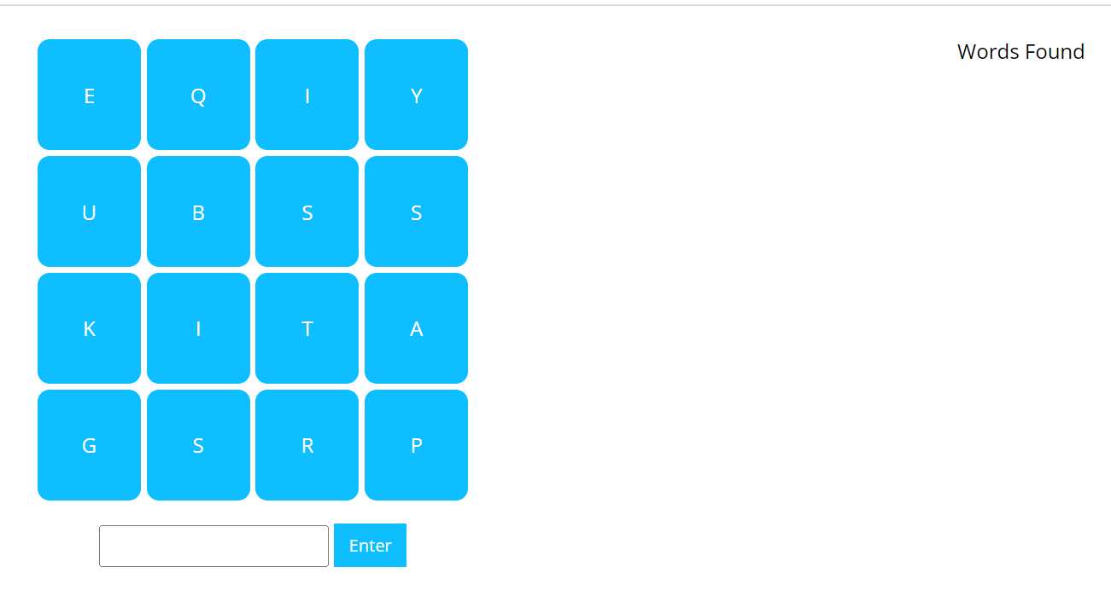
Figure 2 boggle.html

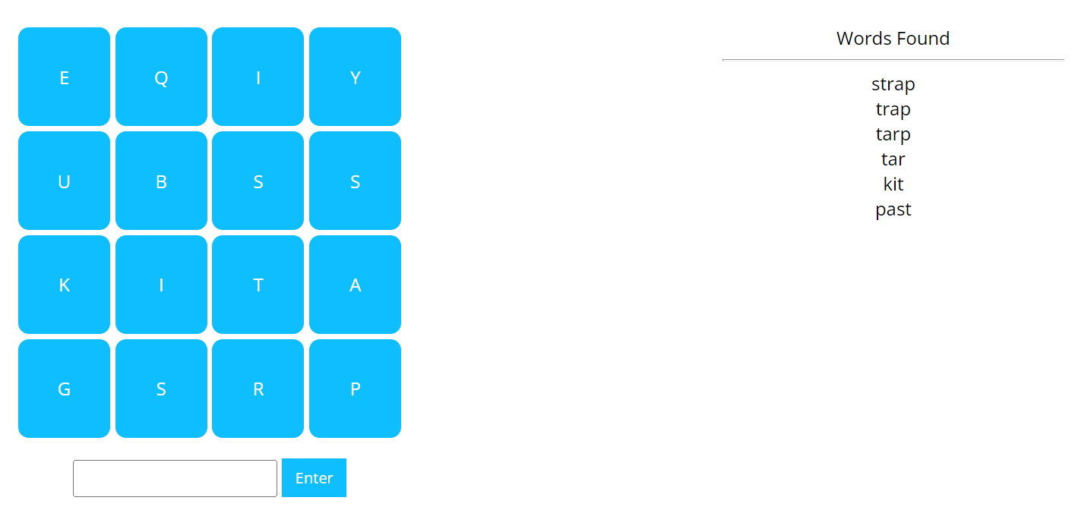
Figure 3 Words Found updated

