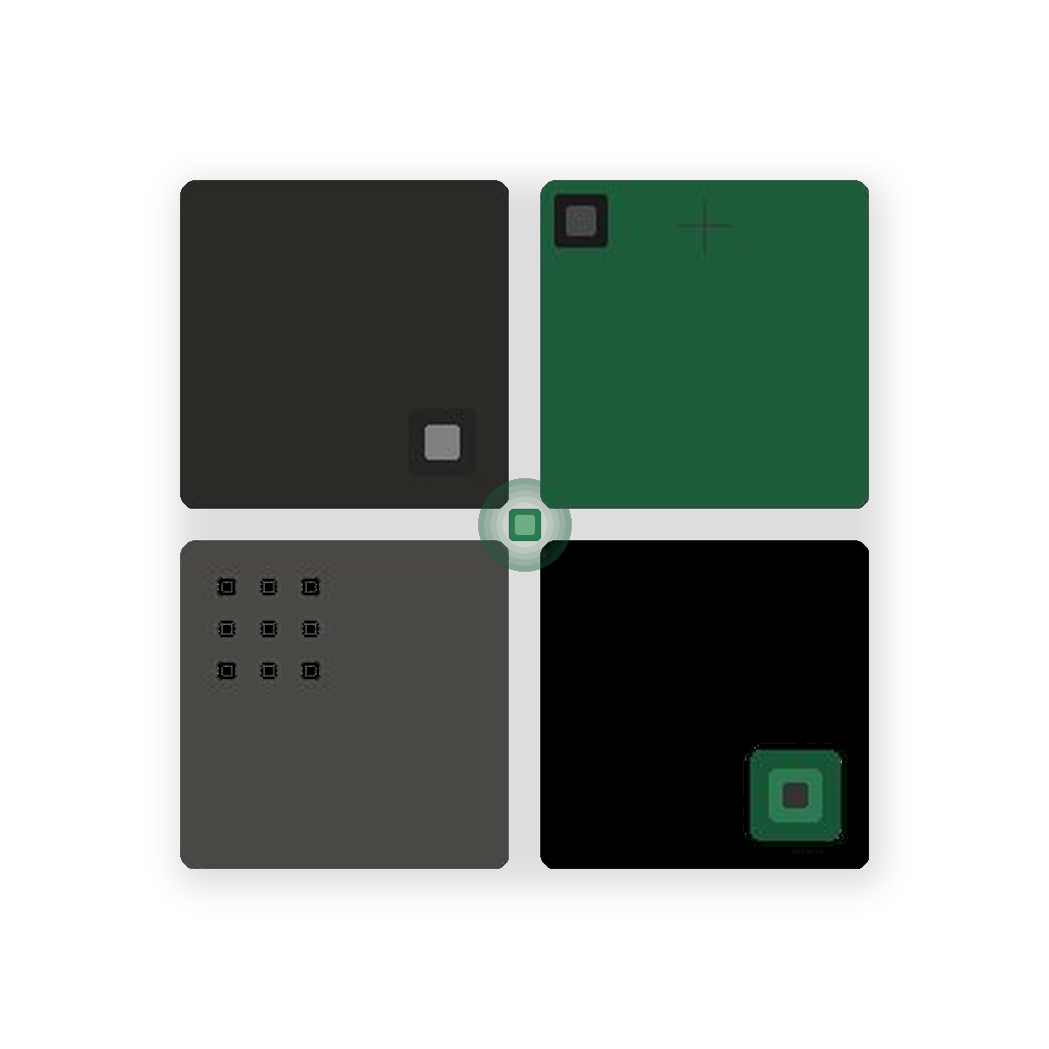  Oak & Pixel  PREMIUM DIGITAL STUDIO  — DIGITAL INFRASTRUCTURE  Designed  with  distinction.  Precision-crafted digital experiences for brands that refuse to compromise.  oakandpixel.co.za 2025 | — OUR STUDIO  We build digital  presence that  endures.  Oak & Pixel Studio is a boutique premium digital studio at the intersection of technology and taste. We design, build, and manage refined digital experiences for businesses that need their online presence to match the quality of their real-world service.  We work with a deliberately limited number of clients each year — because exceptional work demands genuine investment.  — Built to last. Designed to lead.  — WHAT WE DO  · Premium Websites · Booking Experiences  · Lead Capture Experiences · Client Onboarding Journeys  · CRM & Payment Integration · Client Portals  · Website Maintenance · Digital Presence Management  97% CLIENT RETENTION 12+ YEARS OF CRAFT 180+ ENGAGEMENTS | — SERVICE PLANS  Plan Setup Monthly  Signature R35,000 R7,500  Up to 5 pages · Booking · Lead capture · Domain, hosting & maintenance  Growth R60,000 R14,500  Everything in Signature · Up to 10 pages · Onboarding · CRM · Payments  Premium R95,000 R24,500  Everything in Growth · Bespoke experiences · Client portal · Advanced integrations  All prices exclude VAT. Setup fees are once-off. Monthly retainer billed at start of each month. 50% deposit required to commence. Proposals valid for 30 days.  — WHY OAK & PIXEL  · Precision-led design · High-touch execution  · Senior practitioners only · Technology with taste  — START A CONVERSATION  EMAIL info@oakandpixel.co.za PHONE +27 (75) 089 0614  WEB oakandpixel.co.za LOCATION Randburg · Gauteng  Ready to build something remarkable?

