The purpose of this document is to describe how to test for broadcast using UDP/IP communication.

IMPORTANT NOTE:
Script files and examples in this document assume vxworks-7 is installed in /media/jbabu/Windriver3/ directory in a Ubuntu 14.04.5 LTS machine. When installed in a different directory or OS, corresponding changes are to be made to scripts and commands.

Step:1

Open /media/jbabu/Windriver3/vxworks-7/host/x86-linux2/bin/vxsimnetd.conf in editor and append following lines to end of file.

SUBNET_START subnet2 {
SUBNET_EXTERNAL = no;
SUBNET_EXTPROMISC = no;
SUBNET_BROADCAST = yes;
SUBNET_ADDRESS = "192.168.1.0";
};
SUBNET_START subnet3 {
SUBNET_EXTERNAL = no;
SUBNET_EXTPROMISC = no;
SUBNET_BROADCAST = yes;
SUBNET_ADDRESS = "192.168.10.0";
};
SUBNET_START subnet4 {
SUBNET_EXTERNAL = no;
SUBNET_EXTPROMISC = no;
SUBNET_ADDRESS = "10.10.0.0";
SUBNET_MASK = "255.255.0.0";
};
SUBNET_START subnet5 {
SUBNET_EXTERNAL = no;
SUBNET_EXTPROMISC = no;
SUBNET_BROADCAST = yes;
SUBNET_ADDRESS = "192.168.20.0";
};

Before starting the test make sure that lansim is started .

Command used :sudo ./startlansim.sh

Script content is given below:

#!/bin/sh
/media/jbabu/Windriver3/vxworks-7/host/x86-linux2/bin/vxsimnetd -f /media/jbabu/Windriver3/vxworks-7/host/x86-linux2/bin/vxsimnetd.conf &
echo "LAN simulation started.."

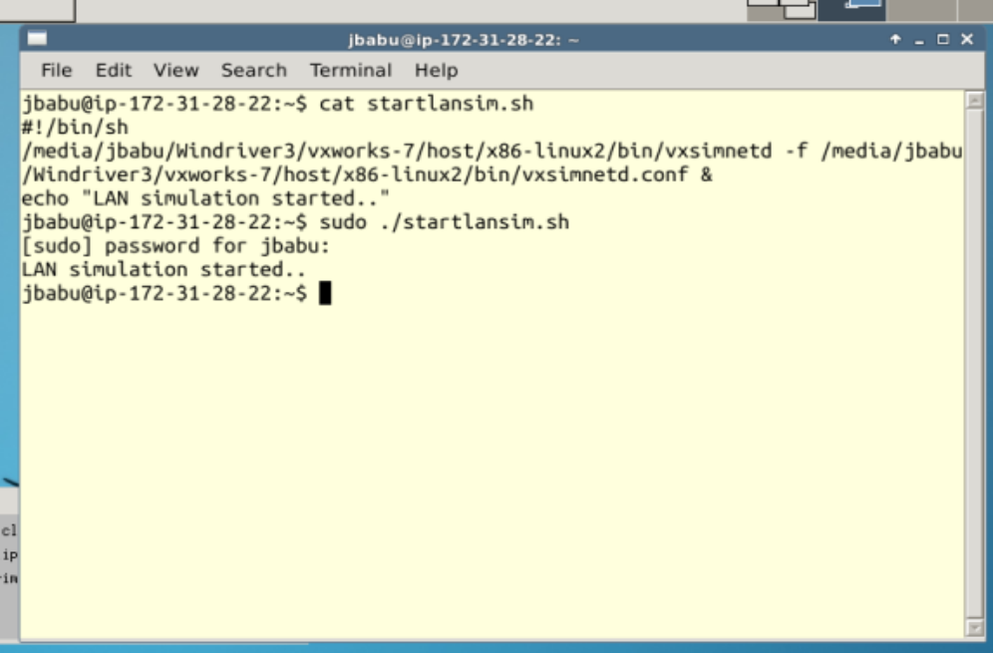

Step:2
From the Application menu select the “Terminal Emulator “
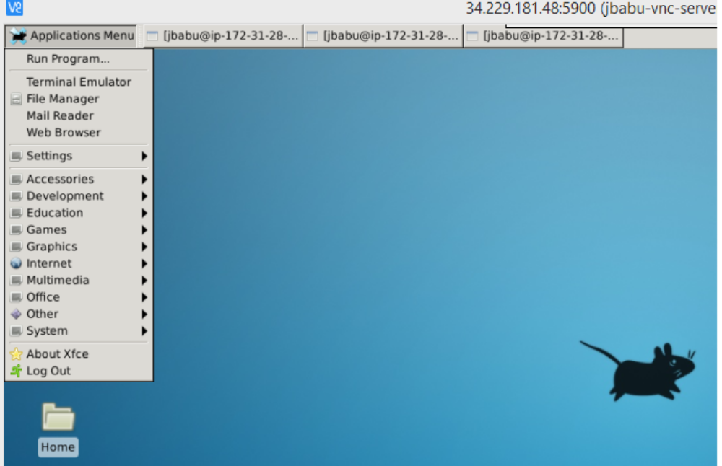
Step:3
In the console run the below script
./startdbgvxenv.sh
Script content is as below:

#!/bin/bash
cp /media/jbabu/Windriver3/workbench-4/workspace/t02/default/vxWorks /media/jbabu/Windriver3/deploy/
cp /media/jbabu/Windriver3/workbench-4/workspace/t02/default/vxWorks.sym /media/jbabu/Windriver3/deploy/
cp /media/jbabu/Windriver3/workbench-4/workspace/bc/vsb01_SIMLINUXgnu/bc/Debug/bc.out /media/jbabu/Windriver3/deploy/
cp /media/jbabu/Windriver3/workbench-4/workspace/bs/vsb01_SIMLINUXgnu/bs/Debug/bs.out /media/jbabu/Windriver3/deploy/
cd /media/jbabu/Windriver3/
source ./wrenv.sh -p vxworks-7

Above script will traverse to the project folder. eg,/media/jbabu/Windriver3

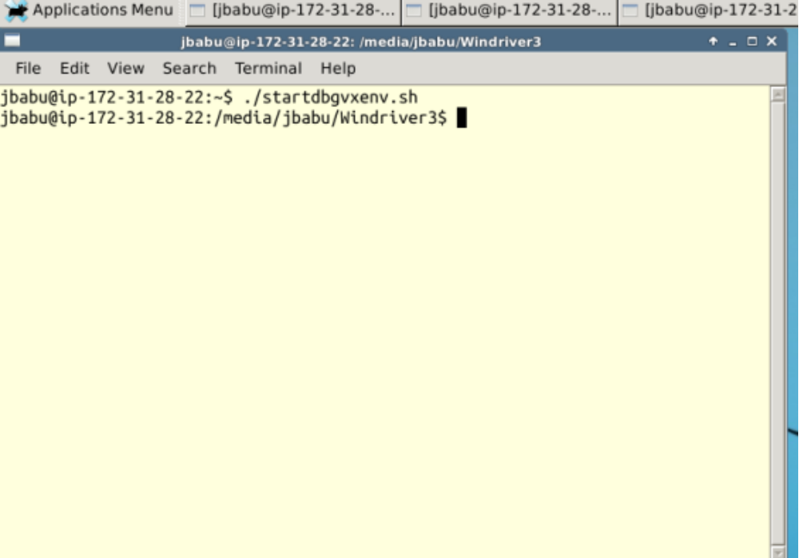
Step:4
change the directory eg, cd deploy

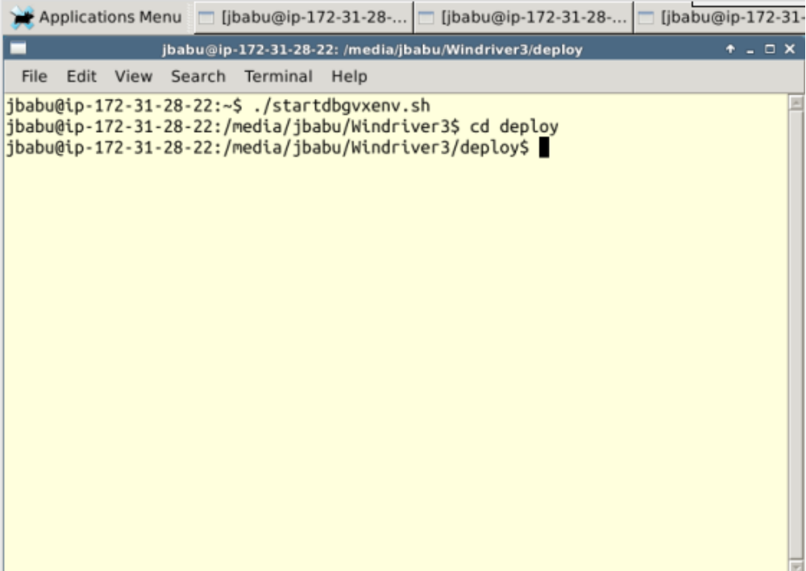

An example

1 | SCN01 | 1server, 1client | 1 interface per vxsim | 255.255.255.0
 |  | Client Configuration | Server Configuration | Network stack Action | Expected result
 | TC0101 | Simnet0:192.168.10.5 | Simnet0(192.168.10.6)  Listens to ADDR_ANY | Client sends broadcast on192.168.10.0 | server receive OK  pass

Commands used at Vxsimnet prompt:
Server console

- vxsim -d "simnet" -e "192.168.10.6" -p 2
- Try ifconfig to make sure that the enviroment is up and the simnet interfaces are up
- ld <bs.out
- bs ( Server Listens to ADDR_ANY)
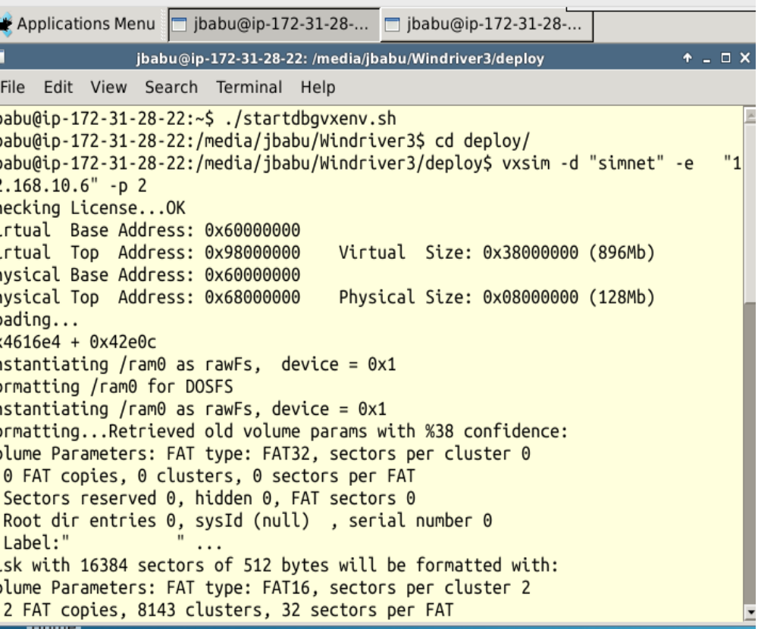
Screen shots is given below:

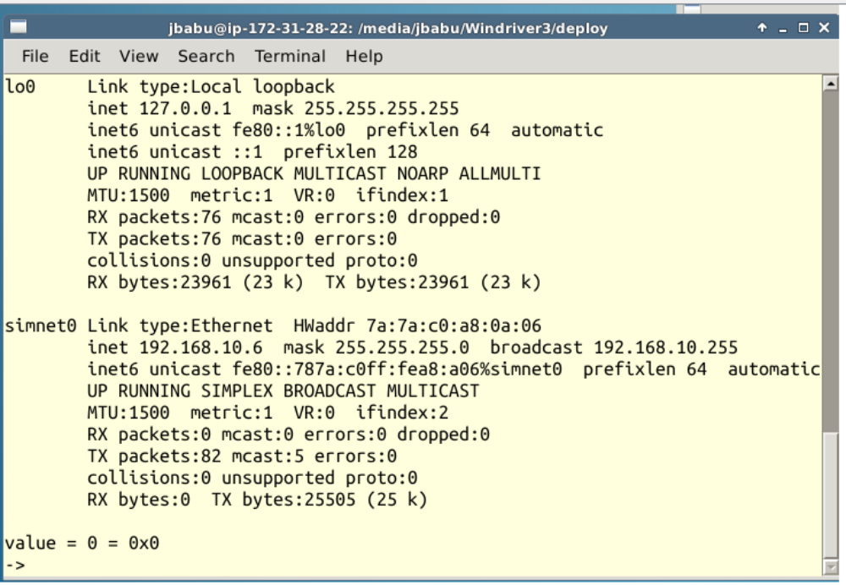
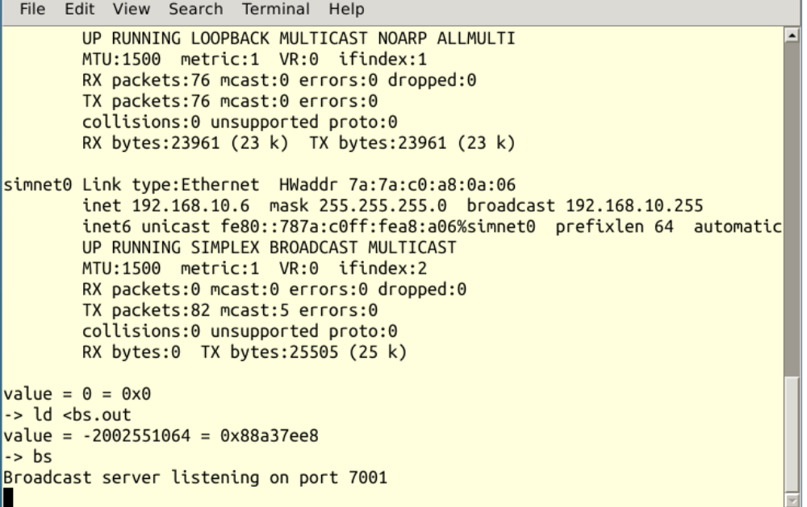
the above fig shows that the server is listening to BC port 7001

Server console o/p
Server console

jbabu@ip-172-31-28-22:~$ ./startdbgvxenv.sh
jbabu@ip-172-31-28-22:/media/jbabu/Windriver3$ cd deploy/
jbabu@ip-172-31-28-22:/media/jbabu/Windriver3/deploy$ vxsim -d "simnet" -e "192.168.10.6" -p 2
Checking License...OK
Virtual Base Address: 0x60000000
Virtual Top Address: 0x98000000 Virtual Size: 0x38000000 (896Mb)
Physical Base Address: 0x60000000
Physical Top Address: 0x68000000 Physical Size: 0x08000000 (128Mb)
Loading...
0x4616e4 + 0x42e0c
Instantiating /ram0 as rawFs, device = 0x1
Formatting /ram0 for DOSFS
Instantiating /ram0 as rawFs, device = 0x1
Formatting...Retrieved old volume params with %38 confidence:
Volume Parameters: FAT type: FAT32, sectors per cluster 0
0 FAT copies, 0 clusters, 0 sectors per FAT
Sectors reserved 0, hidden 0, FAT sectors 0
Root dir entries 0, sysId (null) , serial number 0
Label:" " ...
Disk with 16384 sectors of 512 bytes will be formatted with:
Volume Parameters: FAT type: FAT16, sectors per cluster 2
2 FAT copies, 8143 clusters, 32 sectors per FAT
Sectors reserved 1, hidden 0, FAT sectors 64
Root dir entries 512, sysId VXDOS16 , serial number 0
Label:" " ...
OK.
TUE AUG 01 04:17:09 2017: ipcom[88909000]: Warning: ipcom_shell_add_cmd() :: INCLUDE_SHELL or INCLUDE_IPCOM_SHELL_CMD component not included .
TUE AUG 01 04:17:09 2017: ipcom[88909000]: Warning: ipcom_shell_add_cmd() :: INCLUDE_SHELL or INCLUDE_IPCOM_SHELL_CMD component not included .

_________ _________
\77777777\ /77777777/
\77777777\ /77777777/
\77777777\ /77777777/
\77777777\ /77777777/
\77777777\ \7777777/
\77777777\ \77777/ VxWorks 7
\77777777\ \777/
\77777777\ \7/ Core Kernel version: 1.2.3.0
\77777777\ - Build date: Jul 20 2017 23:50:32
\77777777\
\7777777/ Copyright Wind River Systems, Inc.
\77777/ - 1984-2017
\777/ /7\
\7/ /777\
- -------

Board: SIMLINUX board
OS Memory Size: 124MB
ED&R Policy Mode: Deployed
Application Mode Agent: Started (always)
Stop Mode Agent: Started (always)

Loading symbol table from ip-172-31-28-22:/media/jbabu/Windriver3/deploy/vxWorks.sym ...done

TUE AUG 01 04:17:09 2017: ipcom[88909000]: Warning: ipcom_shell_add_cmd() :: INCLUDE_SHELL or INCLUDE_IPCOM_SHELL_CMD component not included .
-> ld <bs.out
value = -2002551064 = 0x88a37ee8
-> bs
Broadcast server listening on port 7001
<<< [192.168.10.5:55065]: msg001-test msg for tcno101
>>> [192.168.10.5:55065]: msg001-reply from bserver
Client

vxsim -d "simnet" -e "192.168.10.5" -p 6 ; bc("192.168.10.0",7001)
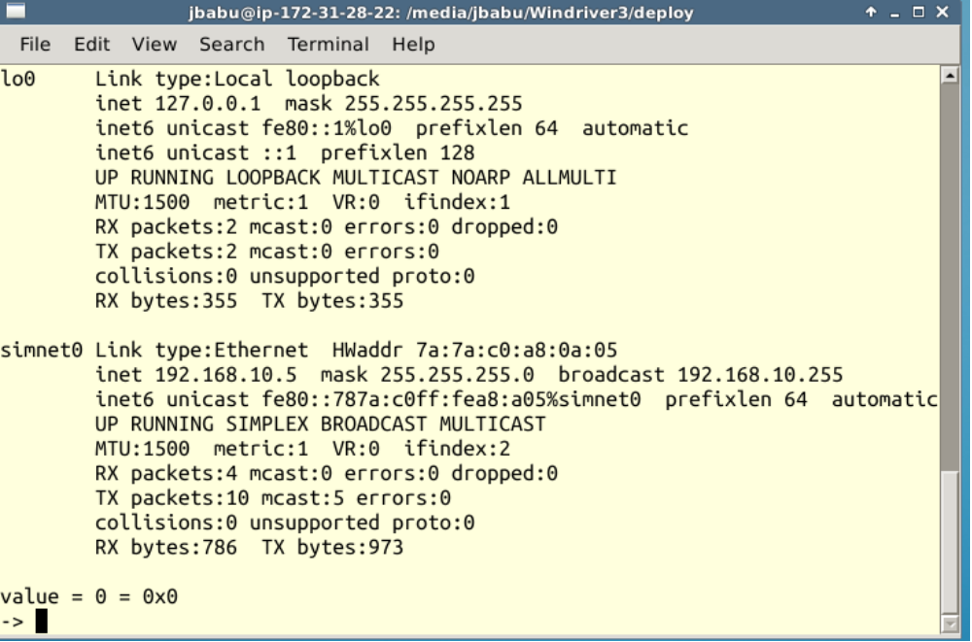
At Vxsimnet prompt,

->ld <bc.out

->bc(“192.168.10.0”,7001);

This communication is established; both the server and the client received the messages sent

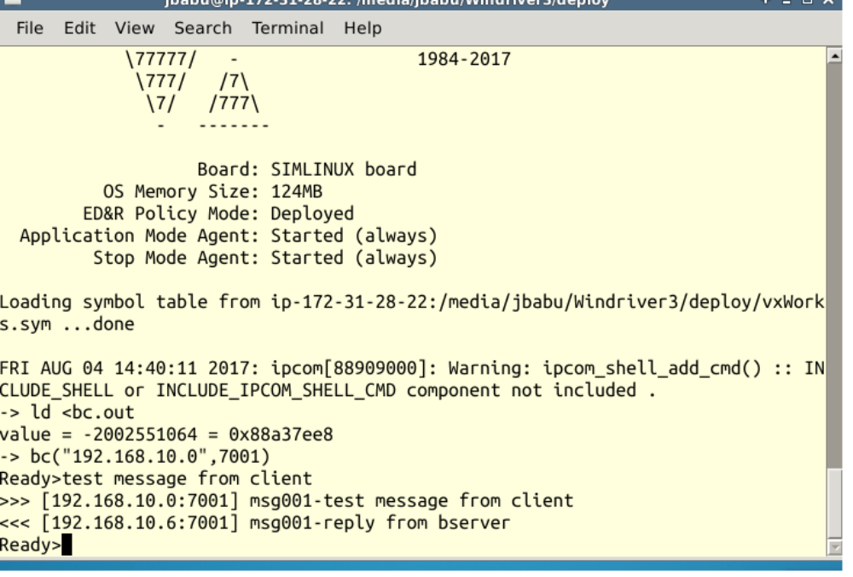
Server receives the client message and reply back
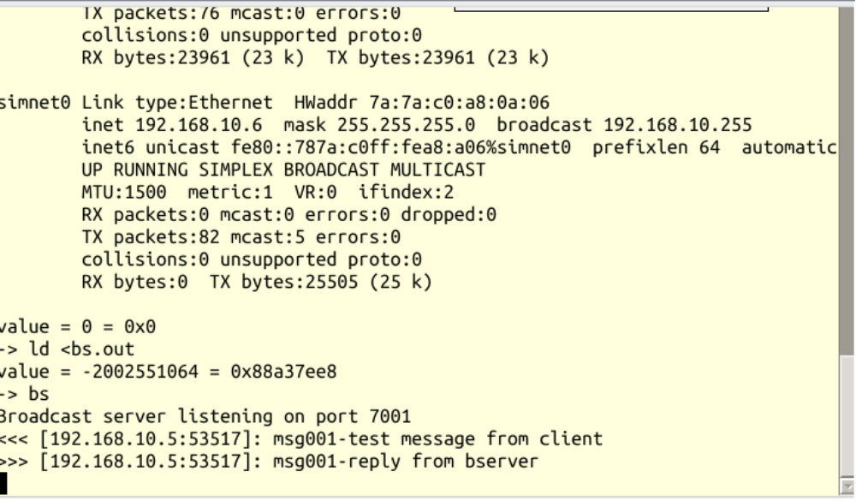
/EOD

