JPN_IWE14057: TEST SPECIFICATION
Step-by-step guide to test JPN_IWE14057 to Wind River VxWorks 6.2
22-Aug 15
Abiram Warrier

Contents
Development and Test Environment 3
1. Installation/build Instructions 3
4. Test Environment Setup & Execution Procedure 8
A. Test Preparation 8
B. Test Procedure 9
CASE: A01 DES-CBC3-MD5 9
CASE: A02 DES-CBC3-MD5 9
CASE: A03 RC4-MD5 10
CASE: A04 RC4-MD5 10
CASE: A05 DHE-RSA-AES256-SHA 11
CASE: A06 DHE-RSA-AES256-SHA 11
CASE: A07 EDH-RSA-DES-CBC-SHA 11
CASE: A08 EDH-RSA-DES-CBC-SHA 12
CASE: A09 ECDHE-RSA-AES256-SHA 12
CASE: A10 ECDHE-RSA-AES256-SHA 12
CASE: A11 ECDHE-ECDSA-AES256-SHA 13
CASE: A12 ECDHE-ECDSA-AES256-SHA 13
CASE: A13 ECDHE-RSA-DES-CBC3-SHA 14
CASE: A14 ECDHE-RSA-DES-CBC3-SHA 14
CASE : A15 DES-CBC3-SHA 14
CASE: A16 DES-CBC3-SHA 15
CASE: A17 DHE-RSA-AES128-SHA 15
CASE: A18 DHE-RSA-AES128-SHA 16
CASE: A19 ECDHE-RSA-RC4-SHA 16
CASE: A20 ECDHE-RSA-RC4-SHA 16
CASE: A21 ECDHE-ECDSA-RC4-SHA 17
CASE: A22 ECDHE-ECDSA-RC4-SHA 17
CASE: A23 RC4-SHA 18
CASE: A24 RC4-SHA 18
CASE: A25 DES-CBC-SHA 19
CASE: A26 DES-CBC-SHA 19
CASE: A27 DES-CBC3-SHA 19
CASE: A28 DES-CBC3-SHA 20
CASE: A29 AES256-SHA 20
CASE: A30 AES256-SHA 21
CASE: A31 ECDHE-RSA-RC4-SHA 21
CASE: A32 ECDHE-RSA-RC4-SHA 21
CASE: A33 ECDHE-RSA-DES-CBC3-SHA 22
CASE: A34 ECDHE-RSA-DES-CBC3-SHA 22
CASE: A35 ECDHE-RSA-AES256-SHA 23
CASE: A36 ECDHE-RSA-AES256-SHA 23
CASE: A37 ECDHE-ECDSA-RC4-SHA 23
CASE: A38 ECDHE-ECDSA-RC4-SHA 24
CASE: A39 ECDHE-ECDSA-DES-CBC3-SHA 24
CASE: A40 ECDHE-ECDSA-DES-CBC3-SHA 25
CASE: A41 ECDHE-ECDSA-AES256-SHA 25
CASE: A42 ECDHE-ECDSA-AES256-SHA 25
CASE: A43 DHE-RSA-AES256-SHA 26
CASE: A44 DHE-RSA-AES256-SHA 26
CASE: A45 AES256-SHA256 27
CASE: A46 AES256-SHA256 27
CASE: A47 ECDHE-ECDSA-AES256-SHA 27
CASE: A48 ECDHE-ECDSA-AES256-SHA 28

Development and Test Environment

Development and test environment for the JPN-IWE14057 project is as shown below.

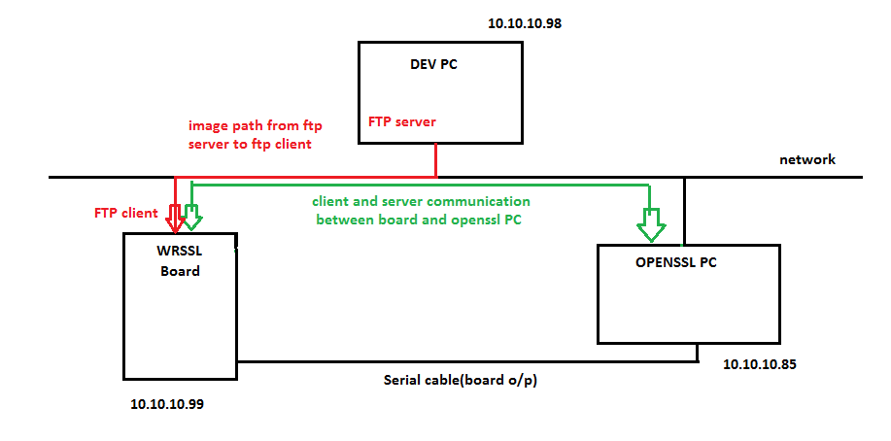
SSL Client-Server communication between VxWorks target board and OpenSSL PC
Image download via FTP
Target board running
VxWorks 6.2 + WR-SSL
PC running Ubuntu Linux + OpenSSL
PC running Win XP + Workbench
Ensure that required hardware and software are available to realize below setup before following instructions in this document.
Document also assumes that above setup is realized with required physical connections made as shown in above diagram.

Installation/build Instructions

On DEV PC:
- Install Wind River Workbench and vxWorks 6.2 and BSPs.
- Overwrite following directories
<WorkbenchInstallationDirectory>\VxWorks-6.2\target\src <WorkbenchInstallationDirectory>\VxWorks-6.2\target\h
<WorkbenchInstallationDirectory>\VxWorks-6.2\target\lib
with respective checked out folders from SVN repository.
https://github.com/neominds/JPN-IWE14057/trunk/src/target
On DEV-PC:
- Modify following files as described below
- File Location
<WorkbenchInstallationDirectory>\VxWorks-6.2\target\src\Makefile
Changes required:
-> Search for "COMMON_SUBDIRS" (where you will see wind,wrn,wvlisted)
-> Append "security" and "ssl" to the list of COMMON_SUBDIRS as shown in below fig.

- File Location
<WorkbenchInstallationDirectory>\VxWorks-6.2\target\config\all\usrConfig.c

Changes required:
-> define INCLUDE_USER_APPL macro by adding below line
#define INCLUDE_USER_APPL
->In the INCLUDE_USER_APPL block add below two lines to call those functions as shown in below fig.
secLibInit();
sslInit();
- File Location
<WorkbenchInstallationDirectory>\VxWorks-6.2\target\src\drv\wlan\management\Makefile
Changes required:
- search for "IS_DOT11SNMP" and comment that line as shown in below fig.
- File Location
<WorkbenchInstallationDirectory>\VxWorks-6.2\target\src\ppp\management\snmpAgent\Makefile
Changes required:
- search for "IS_SNMP_INSTALLED" and comment that line as shown in below fig.
- Build VxWorks-6.2 for specific CPU( for ex: PPC32,PENTIUM4) by following below steps:

- Open VXWorksDevlopmentShell(start->all programs->windriver->vxworks-6.2->vxworks development shell).
- Goto directory <WorkbenchInstallationDirectory>\VxWorks-6.2\target\src
- Build using 'make' command as make CPU=<cpu name> TOOL=<diab>
e.g :make CPU=PPC32 TOOL=diab

- Create Image Project Under WindRiver Workbench
- Open Workbench GUI(start->All programs->windriver->workbench 2.4).
- Create new VxWorksimage project from Workbench-2.4 menu(file->new->vxworks image project).
- Give project name and click on 'next' .
- Select BSP(Board Supporting Package) and tool chain and click on 'finish'. ( in our case we have selected wrsbcPowerQuiccII as BSP and diab as tool chain)
- Goto kernel configuration of the project from project window.
- In component tree, enable vxWorkscomponents INCLUDE_SSL and INCLUDE_SSL_APPS by including network security components under network components as shown in below fig.
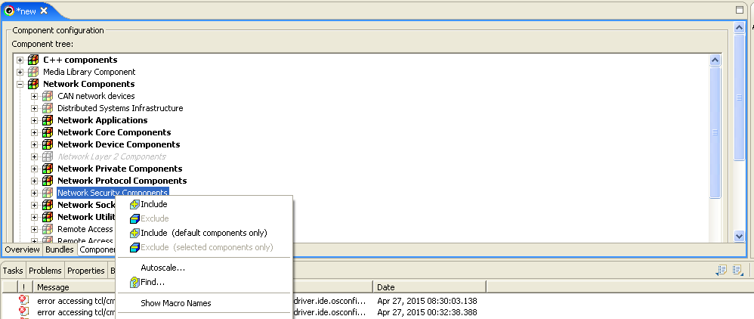

- Include Kernel shell ComponentsunderDevelopment Tools Components(select all)

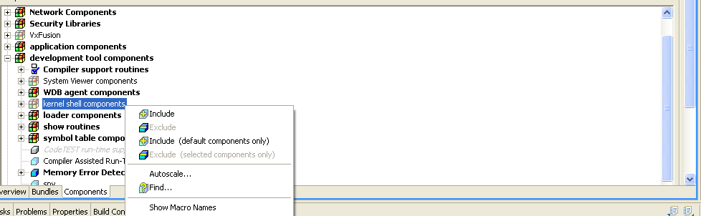

- Exclude “GNU compiler support routines” in “compiler support routines”
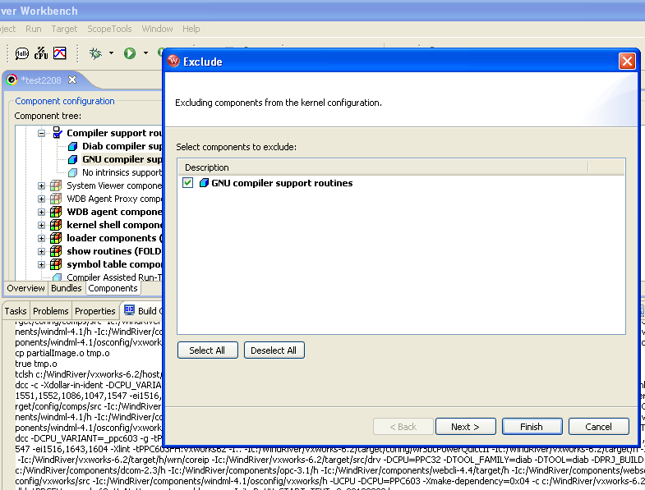
- Build/Rebuild Project.
- By default VxWorks image will be present in following directory.<WindRiverInstalledDirectory>\workspace\project_name\default\VxWorks

Bringing up Wind River Board

- Power on the WindRiver targetboard.
- Target board should be connected to OPENSSL PC using serial port.[use picocom for serial input/output or to see the console log of board. ].
i.e.picocom -b 9600 /dev/ttyS0
- Make a LAN connection between Target board and system in which ftp server is running, i.e., DEV PC.[FTP server is part of windriver package and available under start->all programs->windriver->vxworks-6.2->ftp server].
- Board and DEV PC should be on same network.
- Configure ftp server as below:
- Launch ftp server from start->all programs->windriver->vxworks-6.2->ftp server.
- Select security->user/rights. Pop up window as shown below fig will open.
- Select username( if no user available then create new by pressing 'new user') and set password and home directory for that user.(set the directory where vxworks images will be present as the home directory of ftp server).

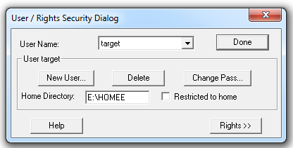

- Switch off and switch on the board and wait for ‘[VxWorks Boot]’command prompt.
- Configure board as below: ( press 'c' to get configure window)
- Select boot device( type 'help' to get the list of supported boot device).
- set appropriate IP address for board.
- host ip and gateway should be same as FTP server system's IP address.
- FTP user and password field should match with FTP server configuration.
- following fig. shows sample example

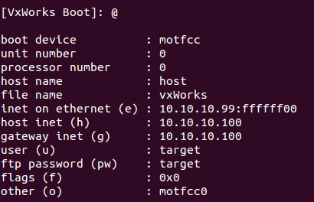

- Once board configuration is done, ‘[VxWorks Boot]’ prompt will be displayed again. You may use command ‘p’ to ensure that configuration is correct.
- Copy Vxworks images created to FTP home directory.

Test Environment Setup & Execution Procedure

Test Preparation

On OPENSSL-LINUX PC
      - download and install OPENSSL-1.0.1o from https://www.openssl.org/source/openssl-1.0.1o.tar.gz

      - Following certificates are to be generated and should be kept under respective folders.

md5WithRSAEncryption
$openssl genrsa -out md5rsakey.pem 2048
$openssl req -out md5rsa.csr -key md5rsakey.pem -new -md5
$openssl req -in md5rsa.csr -out md5rsa.pem -text

sha1WithRSAEncryption
$openssl genrsa -out sha1rsakey.pem 2048
$openssl req -out sha1rsa.csr -key sha1rsakey.pem -new -sha1
$openssl req -in sha1rsa.csr -out sha1rsa.pem -text

sha256WithRSAEncryption
$openssl genrsa -out sha256rsakey.pem 2048
$openssl req -out sha256rsa.csr -key sha256rsakey.pem -new -sha256
$openssl req -in sha256rsa.csr -out sha256rsa.pem -text

SHA1withECDSA
$openssl ecparam -name secp256k1 -genkey -out sha1ecdsakey.pem
$openssl req -new -x509 -key sha1ecdsakey.pem -out sha1ecdsa.pem -days 730
Note: You may verify the key and the certificate contents using
$openssl ecparam -in sha1ecdsakey.pem -text –noout
$openssl x509 -in sha1ecdsa.pem -text -noout

sha256withECDSA
$openssl ecparam -name secp256k1 -genkey -out sha256ecdsakey.pem
$openssl req -new -x509 -key sha256ecdsakey.pem -out sha256ecdsa.pem -days 730
Note: You may verify the key and the certificate contents using
$openssl ecparam -in sha256ecdsakey.pem -text -noout
$openssl x509 -in sha256ecdsa.pem -text -noout

      - Copy above generated certificate and key files to openssl-1.0.1o folder on OPENSSL-LINUX PC
      - Transfer above generated certificate and key files (via FTP or any other method) to home directory of FTP server on DEV-PC.

Test Procedure

CASE: A01 DES-CBC3-MD5

On WRSSL-Board and picocom on OPENSSL-PC
      - Run WRSSL as server using following command in WRSSL-PC picocom terminal.
-> nm_server "5","-cert", "md5rsa.pem", "-key", "md5rsakey.pem","-ssl2"
On OPENSSL-PC
      - Open terminal, change directory to openssl-1.0.1o and run openssl client as shown below
e.g.
$cd /home/user1/openssls/openssl-1.0.1o
$./apps/openssl s_client -ssl2 -cipher DES-CBC3-MD5 -connect <host>:4433

Expected result:
SSL connection should establish successfully. Verify by typing in a test message on the client terminal and seeing the same on server terminal and vice versa. Try to close connection from client. Connection should get closed without problems.

CASE: A02 DES-CBC3-MD5

On OPENSSL-LINUX -PC:

      - Open terminal, change directory to openssl-1.0.1o and run openssl server as shown below
e.g.
$cd /home/user1/openssls/openssl-1.0.1o
$./apps/openssl s_server -accept 4433 -cert md5rsa.pem –key md5rsakey.pem -ssl2 -msg

On WRSSL-Board and picocom on OPENSSL-PC
      - Run WRSSL as client using following command in WRSSL-PC picocom terminal.
-> nm_client "5","-ssl2","-cipher","DES-CBC3-MD5","-connect","<OPENSSL_PC_IPAddr>:4433"

Expected result:
SSL connection should establish successfully. Verify by typing in a test message on the client terminal and seeing the same on server terminal and vice versa. Try to close connection from client. Connection should get closed without problems.

CASE: A03 RC4-MD5

On WRSSL-Board and picocom on OPENSSL-PC:
      - Run WRSSL as server using following command in WRSSL-PC picocom terminal.
->nm_server "5","-cert", "md5rsa.pem", "-key", "md5rsakey.pem","-ssl2"
On OPENSSL-LINUX PC
      - Open terminal, change directory to openssl-1.0.1o and run OpenSSL client as shown below
$ cd /home/user1/openssls/openssl-1.0.1o
$./apps/openssl s_client -ssl2 -cipher RC4-MD5 -connect <host>:4433

Expected result:
SSL connection should establish successfully. Verify by typing in a test message on the client terminal and seeing the same on server terminal and vice versa. Try to close connection from client. Connection should get closed without problems.

CASE: A04 RC4-MD5

On OPENSSL-LINUX -PC:
      - Open terminal, change directory to openssl-1.0.1o and run openssl server as shown below
e.g.
$ cd /home/user1/openssls/openssl-1.0.1o
$ ./apps/openssl s_server -accept 4433 -cert md5rsa.pem -key md5rsakey.pem -ssl2 -msg

      - Run WRSSL as client using following command in WRSSL-PC picocom terminal.
-> nm_client "5","-ssl2","-cipher","RC4-MD5","-connect","<OPENSSL_PC_IPAddr>:4433"

Expected result:
SSL connection should establish successfully. Verify by typing in a test message on the client terminal and seeing the same on server terminal and vice versa. Try to close connection from client. Connection should get closed without problems.

CASE: A05 DHE-RSA-AES256-SHA
On WRSSL-Board and picocom on OPENSSL-PC:
      - Run WRSSL as server using following command in WRSSL-PC picocom terminal
-> nm_server "5","-cert", "sha1rsa.pem", "-key", "sha1rsakey.pem","-ssl3"

On OPENSSL-LINUX -PC:
      - Open terminal, change directory to openssl-1.0.1o and run openssl client as shown below
$cd /home/user1/openssls/openssl-1.0.1o
$./apps/openssl s_client -ssl3 -cipher DHE-RSA-AES256-SHA -connect <host>:4433

Expected result:
SSL connection should establish successfully. Verify by typing in a test message on the client terminal and seeing the same on server terminal and vice versa. Try to close connection from client. Connection should get closed without problems.

CASE: A06 DHE-RSA-AES256-SHA
On OPENSSL-LINUX -PC:
      - Open terminal, change directory to openssl-1.0.1o and run openssl server as shown below
e.g.
$ cd /home/user1/openssls/openssl-1.0.1o
$./apps/openssl s_server -accept 4433 -cert sha1rsa.pem -key sha1rsakey.pem -ssl3 -msg

On WRSSL-Board and picocom on OPENSSL-PC:
      - Run WRSSL as client using following command in WRSSL-PC picocom terminal.
->nm_client "5","-ssl3","-cipher","DHE-RSA-AES256-SHA","-connect","<OPENSSL_PC_IPAddr>:4433"

Expected result:
SSL connection should establish successfully. Verify by typing in a test message on the client terminal and seeing the same on server terminal and vice versa. Try to close connection from client. Connection should get closed without problems.

CASE: A07 EDH-RSA-DES-CBC-SHA
On WRSSL-Board and picocom on OPENSSL-PC:
      - Run WRSSL as server using following command in WRSSL-PC picocom terminal.
-> nm_server "5","-cert", "sha1rsa.pem", "-key", "sha1rsakey.pem","-ssl3"
On OPENSSL-LINUX -PC:
      - Open terminal, change directory to openssl-1.0.1o and run openssl client as shown below
$ cd /home/user1/openssls/openssl-1.0.1o
$./apps/openssl s_client -ssl3 -cipher EDH-RSA-DES-CBC-SHA -connect <host>:4433

Expected result:
SSL connection should establish successfully. Verify by typing in a test message on the client terminal and seeing the same on server terminal and vice versa. Try to close connection from client. Connection should get closed without problems.

CASE: A08 EDH-RSA-DES-CBC-SHA

On OPENSSL-LINUX -PC:
      - Open terminal, change directory to openssl-1.0.1o and run openssl server as shown below
e.g.
$cd /home/user1/openssls/openssl-1.0.1o
$./apps/openssl s_server -accept 4433 -cert sha1rsa.pem -key sha1rsakey.pem -ssl3 -msg

On WRSSL-Board and picocom on OPENSSL-PC:
      - Run WRSSL as client using following command in WRSSL-PC picocom terminal.
-> nm_client "5","-ssl3","-cipher","ECDHE-ECDSA-AES256-SHA","-connect","<OPENSSL_PC_IPAddr>:4433"

Expected result:
SSL connection should establish successfully. Verify by typing in a test message on the client terminal and seeing the same on server terminal and vice versa. Try to close connection from client. Connection should get closed without problems.

CASE: A09 ECDHE-RSA-AES256-SHA
On WRSSL-Board and picocom on OPENSSL-PC:
      - Run WRSSL as server using following command in WRSSL-PC picocom terminal.
-> nm_server "5","-cert", "sha1rsa.pem", "-key", "sha1rsakey.pem","-ssl3")

On OPENSSL-LINUX -PC:
      - Open terminal, change directory to openssl-1.0.1o and run openssl client as shown below
$ cd /home/user1/openssls/openssl-1.0.1o
$./apps/openssl s_client -ssl3 -cipher ECDHE-RSA-AES256-SHA -connect <host>:4433

Expected result:
SSL connection should establish successfully. Verify by typing in a test message on the client terminal and seeing the same on server terminal and vice versa. Try to close connection from client. Connection should get closed without problems.

CASE: A10 ECDHE-RSA-AES256-SHA

On OPENSSL-LINUX -PC:
      - Open terminal, change directory to openssl-1.0.1o and run openssl server as shown below
e.g.
$ cd /home/user1/openssls/openssl-1.0.1o
$./apps/openssl s_server -accept 4433 -cert sha1rsa.pem -key sha1rsakey.pem -ssl3 -msg

On WRSSL-Board and picocom on OPENSSL-PC:
      - Run WRSSL as client using following command in WRSSL PC picocom terminal.
-> nm_client "5","-ssl3","-cipher","ECDHE-RSA-AES256-SHA","-connect","<OPENSSL_PC_IPAddr>:4433"

Expected result:
SSL connection should establish successfully. Verify by typing in a test message on the client terminal and seeing the same on server terminal and vice versa. Try to close connection from client. Connection should get closed without problems.

CASE: A11 ECDHE-ECDSA-AES256-SHA

On WRSSL-Board and picocom on OPENSSL-PC:
1. Run WRSSL as server using following command in WRSSL-PC picocom terminal.
->nm_server "5","-cert", "sha1ecdsa.pem", "-key", "sha1ecdsakey.pem","-ssl3"

On OPENSSL-LINUX -PC:
- Open terminal, change directory to openssl-1.0.1o and run openssl client as shown below
$ cd /home/user1/openssls/openssl-1.0.1o
$./apps/openssl s_client -ssl3 -cipher ECDHE-ECDSA-AES256-SHA -connect <host>:4433

Expected result:
SSL connection should establish successfully. Verify by typing in a test message on the client terminal and seeing the same on server terminal and vice versa. Try to close connection from client. Connection should get closed without problems.

CASE: A12 ECDHE-ECDSA-AES256-SHA
On OPENSSL-LINUX -PC:
1. Open terminal, change directory to openssl-1.0.1o and run openssl server as shown below
e.g.
$ cd /home/user1/openssls/openssl-1.0.1o
$./apps/openssl s_server -accept 4433 -cert sha1ecdsa.pem -key sha1ecdsakey.pem -ssl3 -msg

On WRSSL-Board and picocom on OPENSSL-PC:
- Run WRSSL as client using following command in WRSSL-PC picocom terminal.
-> nm_client "5","-ssl3","-cipher","ECDHE-ECDSA-AES256-SHA","-connect","<OPENSSL_PC_IPAddr>:4433"

Expected result:
SSL connection should establish successfully. Verify by typing in a test message on the client terminal and seeing the same on server terminal and vice versa. Try to close connection from client. Connection should get closed without problems.

CASE: A13 ECDHE-RSA-DES-CBC3-SHA

On WRSSL-Board and picocom on OPENSSL-PC:
- Run WRSSL as server using following command in WRSSL-PC picocom terminal.
-> nm_server "5","-cert", "sha1rsa.pem", "-key", "sha1rsakey.pem","-ssl3"

On OPENSSL-LINUX -PC:
- Open terminal, change directory to openssl-1.0.1o and run openssl client as shown below
$cd /home/user1/openssls/openssl-1.0.1o
$./apps/openssl s_client -ssl3 -cipher ECDHE-RSA-DES-CBC3-SHA -connect <host>:4433

Expected result:
SSL connection should establish successfully. Verify by typing in a test message on the client terminal and seeing the same on server terminal and vice versa. Try to close connection from client. Connection should get closed without problems.

CASE: A14 ECDHE-RSA-DES-CBC3-SHA

On OPENSSL-LINUX -PC:
- Open terminal, change directory to openssl-1.0.1o and run openssl server as shown below
e.g.
$cd /home/user1/openssls/openssl-1.0.1o
$./apps/openssl s_server -accept 4433 -cert sha1rsa.pem -key sha1rsakey.pem -ssl3 -msg

On WRSSL-Board and picocom on OPENSSL-PC:
- Run WRSSL as client using following command in WRSSL-PC picocom terminal.
- nm_client "5","-ssl3","-cipher","ECDHE-RSA-DES-CBC3-SHA","-connect","<OPENSSL_PC_IPAddr>:4433"

Expected result:
SSL connection should establish successfully. Verify by typing in a test message on the client terminal and seeing the same on server terminal and vice versa. Try to close connection from client. Connection should get closed without problems.

CASE : A15 DES-CBC3-SHA

On WRSSL-Board and picocom on OPENSSL-PC:
- Run WRSSL as server using following command in WRSSL-PC picocom terminal.
->nm_server "5","-cert", "sha1rsa.pem", "-key", "sha1rsakey.pem","-ssl3")
On OPENSSL-LINUX -PC:
- Open terminal, change directory to openssl-1.0.1o and run openssl client as shown below
$cd /home/user1/openssls/openssl-1.0.1o
$./apps/openssl s_client -ssl3 -cipher DES-CBC3-SHA -connect <host>:4433

Expected result:
SSL connection should establish successfully. Verify by typing in a test message on the client terminal and seeing the same on server terminal and vice versa. Try to close connection from client. Connection should get closed without problems.

CASE: A16 DES-CBC3-SHA

On OPENSSL-LINUX -PC:
- Open terminal, change directory to openssl-1.0.1o and run openssl server as shown below
e.g.
$cd /home/user1/openssls/openssl-1.0.1o
$./apps/openssl s_server -accept 4433 -cert sha1rsa.pem -key sha1rsakey.pem -ssl3 -msg

On WRSSL-Board and picocom on OPENSSL-PC:
- Run WRSSL as client using following command in WRSSL-PC picocom terminal.
-> nm_client "5","-ssl3","-cipher","DES-CBC3-SHA","-connect","<OPENSSL_PC_IPAddr>:4433"

Expected result
SSL connection should establish successfully. Verify by typing in a test message on the client terminal and seeing the same on server terminal and vice versa. Try to close connection from client. Connection should get closed without problems.

CASE: A17 DHE-RSA-AES128-SHA

On WRSSL-Board and picocom on OPENSSL-PC:
- Run WRSSL as server using following command in WRSSL-PC picocom terminal.
-> nm_server "5","-cert", "sha1rsa.pem", "-key", "sha1rsakey.pem","-ssl3")

On OPENSSL-LINUX -PC:
- Open terminal, change directory to openssl-1.0.1o and run openssl client as shown below
$cd /home/user1/openssls/openssl-1.0.1o
$./apps/openssl s_client –ssl3 -cipher DHE-RSA-AES128-SHA -connect <host>:4433

Expected result:
SSL connection should establish successfully. Verify by typing in a test message on the client terminal and seeing the same on server terminal and vice versa. Try to close connection from client. Connection should get closed without problems.

CASE: A18 DHE-RSA-AES128-SHA

On OPENSSL-LINUX -PC:
- Open terminal, change directory to openssl-1.0.1o and run openssl server as shown below
e.g.
$cd /home/user1/openssls/openssl-1.0.1o
$./apps/openssl s_server -accept 4433 -cert sha1rsa.pem -key sha1rsakey.pem –ssl3 -msg

On WRSSL-Board and picocom on OPENSSL-PC:
- Run WRSSL as client using following command in WRSSL-PC picocom terminal.
-> nm_client "5","-ssl3","-cipher","DHE-RSA-AES128-SHA","-connect","<OPENSSL_PC_IPAddr>:4433"

Expected result:
SSL connection should establish successfully. Verify by typing in a test message on the client terminal and seeing the same on server terminal and vice versa. Try to close connection from client. Connection should get closed without problems.

CASE: A19 ECDHE-RSA-RC4-SHA

On WRSSL-Board and picocom on OPENSSL-PC:
- Run WRSSL as server using following command in WRSSL-PC picocom terminal.
-> nm_server "5","-cert", "sha1rsa.pem", "-key", " sha1rsakey.pem","-ssl3")

On OPENSSL-LINUX -PC:
- Open terminal, change directory to openssl-1.0.1o and run openssl client as shown below
$cd /home/user1/openssls/openssl-1.0.1o
$./apps/openssl s_client –ssl3 -cipher ECDHE-RSA-RC4-SHA -connect <host>:4433

Expected result:
SSL connection should establish successfully. Verify by typing in a test message on the client terminal and seeing the same on server terminal and vice versa. Try to close connection from client. Connection should get closed without problems.

CASE: A20 ECDHE-RSA-RC4-SHA

On OPENSSL-LINUX -PC:
- Open terminal, change directory to openssl-1.0.1o and run OpenSSL server as shown below
e.g.
$cd /home/user1/openssls/openssl-1.0.1o
$./apps/openssl s_server -accept 4433 -cert sha1rsa.pem -key sha1rsakey.pem –ssl3 -msg

On WRSSL-Board and picocom on OPENSSL-PC:
- Run WRSSL as client using following command in WRSSL-PC picocom terminal.
-> nm_client "5","-ssl3","-cipher","ECDHE-RSA-RC4-SHA","-connect","<OPENSSL_PC_IPAddr>:4433"

Expected result:
SSL connection should establish successfully. Verify by typing in a test message on the client terminal and seeing the same on server terminal and vice versa. Try to close connection from client. Connection should get closed without problems.

CASE: A21 ECDHE-ECDSA-RC4-SHA

On WRSSL-Board and picocom on OPENSSL-PC:
- Run WRSSL as server using following command in WRSSL-PC picocom terminal.
-> nm_server "5","-cert", "sha1ecdsa.pem", "-key", " sha1ecdsakey.pem","-ssl3"

On OPENSSL-LINUX -PC:
- Open terminal, change directory to openssl-1.0.1o and run OpenSSL client as shown below
$cd /home/user1/openssls/openssl-1.0.1o
$./apps/openssl s_client –ssl3 -cipher ECDHE-ECDSA-RC4-SHA -connect <host>:4433

Expected result:
SSL connection should establish successfully. Verify by typing in a test message on the client terminal and seeing the same on server terminal and vice versa. Try to close connection from client. Connection should get closed without problems.

CASE: A22 ECDHE-ECDSA-RC4-SHA

On OPENSSL-LINUX -PC:
- Open terminal, change directory to openssl-1.0.1o and run OpenSSL server as shown below
e.g.
$cd /home/user1/openssls/openssl-1.0.1o
$./apps/openssl s_server -accept 4433 -cert sha1ecdsa.pem -key sha1ecdsakey.pem –ssl3 -msg

On WRSSL-Board and picocom on OPENSSL-PC:
- Run WRSSL as client using following command in WRSSL-PC picocom terminal.
-> nm_client "5","-ssl3","-cipher","ECDHE-ECDSA-RC4-SHA","-connect","<OPENSSL_PC_IPAddr>:4433"

Expected result:
SSL connection should establish successfully. Verify by typing in a test message on the client terminal and seeing the same on server terminal and vice versa. Try to close connection from client. Connection should get closed without problems.

CASE: A23 RC4-SHA

On OPENSSL-LINUX -PC:
- Open terminal, change directory to openssl-1.0.1o and run OpenSSL server as shown below
e.g.
- Run WRSSL as server using following command in WRSSL-PC picocom terminal.
-> nm_server "5","-cert", "sha256rsa.pem", "-key", " sha256rsakey.pem","-tls1")

On WRSSL-Board and picocom on OPENSSL-PC:
- Open terminal, change directory to openssl-1.0.1o and run OpenSSL server as shown below
$cd /home/user1/openssls/openssl-1.0.1o
$./apps/openssl s_client -tls1 -cipher RC4-SHA -connect <host>:4433

Expected result:
SSL connection should establish successfully. Verify by typing in a test message on the client terminal and seeing the same on server terminal and vice versa. Try to close connection from client. Connection should get closed without problems.

CASE: A24 RC4-SHA

On OPENSSL-LINUX -PC:
- Open terminal, change directory to openssl-1.0.1o and run openssl server as shown below
e.g.
$cd /home/user1/openssls/openssl-1.0.1o
$./apps/openssl s_server -accept 4433 -cert sha256rsa.pem -key sha256rsakey.pem -tls1 -msg

On WRSSL-Board and picocom on OPENSSL-PC:
- Run WRSSL as client using following command in WRSSL-PC picocom terminal.
-> nm_client "5","-tls1","-cipher","RC4-SHA","-connect","<OPENSSL_PC_IPAddr>:4433"

Expected result:
SSL connection should establish successfully. Verify by typing in a test message on the client terminal and seeing the same on server terminal and vice versa. Try to close connection from client. Connection should get closed without problems.

CASE: A25 DES-CBC-SHA

On WRSSL-Board and picocom on OPENSSL-PC:
- Run WRSSL as server using following command in WRSSL-PC picocom terminal.
-> nm_server "5","-cert", "sha256rsa.pem", "-key", " sha256rsakey.pem","-tls1"

On OPENSSL-LINUX -PC:
- Open terminal, change directory to openssl-1.0.1o and run OpenSSL client as shown below
$cd /home/user1/openssls/openssl-1.0.1o
$./apps/openssl s_client -tls1 -cipher DES-CBC-SHA -connect <host>:4433

Expected result:
SSL connection should establish successfully. Verify by typing in a test message on the client terminal and seeing the same on server terminal and vice versa. Try to close connection from client. Connection should get closed without problems.

CASE: A26 DES-CBC-SHA

On OPENSSL-LINUX -PC:
- Open terminal, change directory to openssl-1.0.1o and run openssl server as shown below
e.g.
$cd /home/user1/openssls/openssl-1.0.1o
$./apps/openssl s_server -accept 4433 -cert sha256rsa.pem -key sha256rsakey.pem -tls1 -msg

On WRSSL-Board and picocom on OPENSSL-PC:
- Run WRSSL as client using following command in WRSSL-PC picocom terminal.
-> nm_client "5","-tls1","-cipher","DES-CBC-SHA","-connect","<OPENSSL_PC_IPAddr>:4433"

Expected result:
SSL connection should establish successfully. Verify by typing in a test message on the client terminal and seeing the same on server terminal and vice versa. Try to close connection from client. Connection should get closed without problems.

CASE: A27 DES-CBC3-SHA

On WRSSL-Board and picocom on OPENSSL-PC:

- Run WRSSL as server using following command in WRSSL-PC picocom terminal.
-> nm_server "5","-cert", "sha256rsa.pem", "-key", " sha256rsakey.pem","-tls1"
On OPENSSL-LINUX -PC:
- Open terminal, change directory to openssl-1.0.1o and run OpenSSL client as shown below
$cd /home/user1/openssls/openssl-1.0.1o
$./apps/openssl s_client -tls1 -cipher DES-CBC3-SHA -connect <host>:4433

Expected result:
SSL connection should establish successfully. Verify by typing in a test message on the client terminal and seeing the same on server terminal and vice versa. Try to close connection from client. Connection should get closed without problems.

CASE: A28 DES-CBC3-SHA

On OPENSSL-LINUX -PC:
- Open terminal, change directory to openssl-1.0.1o and run openssl server as shown below
e.g.
$cd /home/user1/openssls/openssl-1.0.1o
$./apps/openssl s_server -accept 4433 -cert sha256rsa.pem -key sha256rsakey.pem -tls1 -msg

On WRSSL-Board and picocom on OPENSSL-PC:
- Run WRSSL as client using following command in WRSSL-PC picocom terminal.
-> nm_client "5","-tls1","-cipher","DES-CBC3-SHA","-connect","<OPENSSL_PC_IPAddr>:4433"

Expected result:
SSL connection should establish successfully. Verify by typing in a test message on the client terminal and seeing the same on server terminal and vice versa. Try to close connection from client. Connection should get closed without problems.

CASE: A29 AES256-SHA

On WRSSL-Board and picocom on OPENSSL-PC:
- Run WRSSL as server using following command in WRSSL-PC picocom terminal.
-> nm_server "5","-cert", "sha256rsa.pem", "-key", " sha256rsakey.pem","-tls1"

On OPENSSL-LINUX -PC:
- Open terminal, change directory to openssl-1.0.1o and run openssl client as shown below
$cd /home/user1/openssls/openssl-1.0.1o
$./apps/openssl s_client -tls1 -cipher AES256-SHA -connect <host>:4433

Expected result:
SSL connection should establish successfully. Verify by typing in a test message on the client terminal and seeing the same on server terminal and vice versa. Try to close connection from client. Connection should get closed without problems.

CASE: A30 AES256-SHA

On OPENSSL-LINUX -PC:
- Open terminal, change directory to openssl-1.0.1o and run openssl server as shown below
e.g.
$cd /home/user1/openssls/openssl-1.0.1o
$./apps/openssl s_server -accept 4433 -cert sha256rsa.pem -key sha256rsakey.pem -tls1 -msg

On WRSSL-Board and picocom on OPENSSL-PC:
- Run WRSSL as client using following command in WRSSL-PC picocom terminal.
-> nm_client "5","-tls1","-cipher","AES256-SHA","-connect","<OPENSSL_PC_IPAddr>:4433"

Expected result:
SSL connection should establish successfully. Verify by typing in a test message on the client terminal and seeing the same on server terminal and vice versa. Try to close connection from client. Connection should get closed without problems.

CASE: A31 ECDHE-RSA-RC4-SHA

On WRSSL-Board and picocom on OPENSSL-PC:
- Run WRSSL as server using following command in WRSSL-PC picocom terminal.
-> nm_server "5","-cert", "sha256ecdsa.pem", "-key", "sha256ecdsakey.pem","-tls1"

On OPENSSL-LINUX -PC:
- Open terminal, change directory to openssl-1.0.1o and run openssl client as shown below
$cd /home/user1/openssls/openssl-1.0.1o
$./apps/openssl s_client -tls1 -cipher ECDHE-RSA-RC4-SHA -connect <host>:4433

Expected result:
SSL connection should establish successfully. Verify by typing in a test message on the client terminal and seeing the same on server terminal and vice versa. Try to close connection from client. Connection should get closed without problems.

CASE: A32 ECDHE-RSA-RC4-SHA

On OPENSSL-LINUX -PC:
- Open terminal, change directory to openssl-1.0.1o and run OpenSSL server as shown below
e.g.
$cd /home/user1/openssls/openssl-1.0.1o
$./apps/openssl s_server -accept 4433 -cert sha256ecdsa.pem -key sha256ecdsakey.pem -tls1 -msg

On WRSSL-Board and picocom on OPENSSL-PC:
- Run WRSSL as client using following command in WRSSL-PC picocom terminal.
-> nm_client "5","-tls1","-cipher","ECDHE-RSA-RC4-SHA","-connect","<OPENSSL_PC_IPAddr>:4433"

Expected result:
SSL connection should establish successfully. Verify by typing in a test message on the client terminal and seeing the same on server terminal and vice versa. Try to close connection from client. Connection should get closed without problems.

CASE: A33 ECDHE-RSA-DES-CBC3-SHA

On WRSSL-Board and picocom on OPENSSL-PC:
- Run WRSSL as server using following command in WRSSL-PC picocom terminal.
-> nm_server "5","-cert", "sha256rsa.pem", "-key", " sha256rsakey.pem","-tls1")

On OPENSSL-LINUX -PC:
- Open terminal, change directory to openssl-1.0.1o and run openssl client as shown below
$cd /home/user1/openssls/openssl-1.0.1o
$./apps/openssl s_client -tls1 -cipher ECDHE-RSA-DES-CBC3-SHA -connect <host>:4433

Expected result:
SSL connection should establish successfully. Verify by typing in a test message on the client terminal and seeing the same on server terminal and vice versa. Try to close connection from client. Connection should get closed without problems.

CASE: A34 ECDHE-RSA-DES-CBC3-SHA

On OPENSSL-LINUX -PC:
- Open terminal, change directory to openssl-1.0.1o and run OpenSSL server as shown below
e.g.
$cd /home/user1/openssls/openssl-1.0.1o
$./apps/openssl s_server -accept 4433 -cert sha256rsa.pem -key sha256rsakey.pem -tls1 -msg

On WRSSL-Board and picocom on OPENSSL-PC:
- Run WRSSL as client using following command in WRSSL-PC picocom terminal.
nm_client "5","-tls1","-cipher","ECDHE-RSA-DES-CBC3-SHA","-connect","<OPENSSL_PC_IPAddr>:4433"

Expected result:
SSL connection should establish successfully. Verify by typing in a test message on the client terminal and seeing the same on server terminal and vice versa. Try to close connection from client. Connection should get closed without problems.

CASE: A35 ECDHE-RSA-AES256-SHA

On WRSSL-Board and picocom on OPENSSL-PC:
- Run WRSSL as server using following command in WRSSL-PC picocom terminal.
-> nm_server "5","-cert", "sha256rsa.pem", "-key", " sha256rsakey.pem","-tls1"

On OPENSSL-LINUX -PC:
- Open terminal, change directory to openssl-1.0.1o and run OpenSSL client as shown below
$cd /home/user1/openssls/openssl-1.0.1o
$./apps/openssl s_client -tls1 -cipher ECDHE-RSA-AES256-SHA -connect <host>:4433

Expected result:
SSL connection should establish successfully. Verify by typing in a test message on the client terminal and seeing the same on server terminal and vice versa. Try to close connection from client. Connection should get closed without problems.

CASE: A36 ECDHE-RSA-AES256-SHA

On OPENSSL-LINUX -PC:
- Open terminal, change directory to openssl-1.0.1o and run openssl server as shown below
e.g.
$cd /home/user1/openssls/openssl-1.0.1o
$./apps/openssl s_server -accept 4433 -cert sha256ecdsa.pem -key sha256ecdsakey.pem -tls1 -msg

On WRSSL-Board and picocom on OPENSSL-PC:
- Run WRSSL as client using following command in WRSSL-PC picocom terminal.
-> nm_client "5","-tls1","-cipher","ECDHE-RSA-AES256-SHA","-connect","<OPENSSL_PC_IPAddr>:4433"

Expected result:
SSL connection should establish successfully. Verify by typing in a test message on the client terminal and seeing the same on server terminal and vice versa. Try to close connection from client. Connection should get closed without problems.

CASE: A37 ECDHE-ECDSA-RC4-SHA

On WRSSL-Board and picocom on OPENSSL-PC:
- Run WRSSL as server using following command in WRSSL-PC picocom terminal.
-> nm_server "5","-cert", "sha256ecdsa.pem", "-key", " sha256ecdsakey.pem","-tls1"

On OPENSSL-LINUX -PC:
- Open terminal, change directory to openssl-1.0.1o and run openssl client as shown below
$cd /home/user1/openssls/openssl-1.0.1o
$./apps/openssl s_client -tls1 -cipher ECDHE-ECDSA-RC4-SHA -connect <host>:4433

Expected result:
SSL connection should establish successfully. Verify by typing in a test message on the client terminal and seeing the same on server terminal and vice versa. Try to close connection from client. Connection should get closed without problems.

CASE: A38 ECDHE-ECDSA-RC4-SHA

On OPENSSL-LINUX -PC:
- Open terminal, change directory to openssl-1.0.1o and run OpenSSL server as shown below
e.g.
$cd /home/user1/openssls/openssl-1.0.1o
$./apps/openssl s_server -accept 4433 -cert sha256ecdsa.pem -key sha256ecdsakey.pem -tls1 –msg

On WRSSL-Board and picocom on OPENSSL-PC:
- Run WRSSL as client using following command in WRSSL-PC picocom terminal.
-> nm_client "5","-tls1","-cipher","ECDHE-ECDSA-RC4-SHA","-connect","<OPENSSL_PC_IPAddr>:4433"

Expected result:
SSL connection should establish successfully. Verify by typing in a test message on the client terminal and seeing the same on server terminal and vice versa. Try to close connection from client. Connection should get closed without problems.

CASE: A39 ECDHE-ECDSA-DES-CBC3-SHA

On WRSSL-Board and picocom on OPENSSL-PC:
- Run WRSSL as server using following command in WRSSL-PC picocom terminal.
-> nm_server "5","-cert", "sha256ecdsa.pem", "-key", " sha256ecdsakey.pem","-tls1"

On OPENSSL-LINUX -PC:
- Open terminal, change directory to openssl-1.0.1o and run OpenSSL client as shown below
$cd /home/user1/openssls/openssl-1.0.1o
$./apps/openssl s_client -tls1 -cipher ECDHE-ECDSA-DES-CBC3-SHA -connect <host>:4433

Expected result:
SSL connection should establish successfully. Verify by typing in a test message on the client terminal and seeing the same on server terminal and vice versa. Try to close connection from client. Connection should get closed without problems.

CASE: A40 ECDHE-ECDSA-DES-CBC3-SHA

On OPENSSL-LINUX -PC:
- Open terminal, change directory to openssl-1.0.1o and run OpenSSL server as shown below
e.g.
$cd /home/user1/openssls/openssl-1.0.1o
$./apps/openssl s_server -accept 4433 -cert sha256ecdsa.pem -key sha256ecdsakey.pem -tls1 -msg

On WRSSL-Board and picocom on OPENSSL-PC:
- Run WRSSL as client using following command in WRSSL-PC picocom terminal.
nm_client "5","-tls1","-cipher","ECDHE-ECDSA-DES-CBC3-SHA","-connect","<OPENSSL_PC_IPAddr>:4433"

Expected result:
SSL connection should establish successfully. Verify by typing in a test message on the client terminal and seeing the same on server terminal and vice versa. Try to close connection from client. Connection should get closed without problems.

CASE: A41 ECDHE-ECDSA-AES256-SHA

On OPENSSL-LINUX -PC:
- Run WRSSL as server using following command in WRSSL-PC picocom terminal.
-> nm_server "5","-cert", "sha256ecdsa.pem", "-key", " sha256ecdsakey.pem","-tls1_1")

On WRSSL-Board and picocom on OPENSSL-PC:
- Open terminal, change directory to openssl-1.0.1o and run openssl client as shown below
$cd /home/user1/openssls/openssl-1.0.1o
$./apps/openssl s_client -tls1_1 -cipher ECDHE-ECDSA-AES256-SHA -connect <host>:4433

Expected result:
SSL connection should establish successfully. Verify by typing in a test message on the client terminal and seeing the same on server terminal and vice versa. Try to close connection from client. Connection should get closed without problems.

CASE: A42 ECDHE-ECDSA-AES256-SHA

On OPENSSL-LINUX -PC:
- Open terminal, change directory to openssl-1.0.1o and run OpenSSL server as shown below
e.g.
$cd /home/user1/openssls/openssl-1.0.1o
$./apps/openssl s_server -accept 4433 -cert sha256ecdsa.pem -key sha256ecdsakey.pem -tls1_1 -msg

On WRSSL-Board and picocom on OPENSSL-PC:
- Run WRSSL as client using following command in WRSSL-PC picocom terminal.
-> nm_client"5","-tls1_1","-cipher","ECDHE-ECDSA-AES256-SHA","-connect","<OPENSSL_PC_IPAddr>:4433"

Expected result:
SSL connection should establish successfully. Verify by typing in a test message on the client terminal and seeing the same on server terminal and vice versa. Try to close connection from client. Connection should get closed without problems.

CASE: A43 DHE-RSA-AES256-SHA

On WRSSL-Board and picocom on OPENSSL-PC:
- Run WRSSL as server using following command in WRSSL-PC picocom terminal.
-> nm_server "5","-cert", "sha256rsa.pem", "-key", " sha256rsakey.pem","-tls1_1"

On OPENSSL-LINUX -PC:
- Open terminal, change directory to openssl-1.0.1o and run openssl client as shown below
$cd /home/user1/openssls/openssl-1.0.1o
$./apps/openssl s_client -tls1_1 -cipher DHE-RSA-AES256-SHA -connect <host>:4433

Expected result:
SSL connection should establish successfully. Verify by typing in a test message on the client terminal and seeing the same on server terminal and vice versa. Try to close connection from client. Connection should get closed without problems.

CASE: A44 DHE-RSA-AES256-SHA

On OPENSSL-LINUX -PC:
- Open terminal, change directory to openssl-1.0.1o and run OpenSSL server as shown below
e.g.
$cd /home/user1/openssls/openssl-1.0.1o
$./apps/openssl s_server -accept 4433 -cert sha256rsa.pem -key sha256rsakey.pem -tls1_1 -msg

On WRSSL-Board and picocom on OPENSSL-PC:
- Run WRSSL as client using following command in WRSSL-PC picocom terminal.
nm_client "5","-tls1_1","-cipher","DHE-RSA-AES256-SHA","-connect","<OPENSSL_PC_IPAddr>:4433"

Expected result:
SSL connection should establish successfully. Verify by typing in a test message on the client terminal and seeing the same on server terminal and vice versa. Try to close connection from client. Connection should get closed without problems.

CASE: A45 AES256-SHA256

On WRSSL-Board and picocom on OPENSSL-PC:
- Run WRSSL as server using following command in WRSSL-PC picocom terminal.
-> nm_server "5","-cert", "sha256rsa.pem", "-key", " sha256rsakey.pem","-tls1_2"

On OPENSSL-LINUX -PC:
- Open terminal, change directory to openssl-1.0.1o and run openssl client as shown below
$cd /home/user1/openssls/openssl-1.0.1o
$./apps/openssl s_client -tls1 -cipher AES256-SHA256 -connect <host>:4433

Expected result:
SSL connection should establish successfully. Verify by typing in a test message on the client terminal and seeing the same on server terminal and vice versa. Try to close connection from client. Connection should get closed without problems.

CASE: A46 AES256-SHA256

On OPENSSL-LINUX -PC:
- Open terminal, change directory to openssl-1.0.1o and run openssl server as shown below
e.g.
$cd /home/user1/openssls/openssl-1.0.1o
$./apps/openssl s_server -accept 4433 -cert sha256rsa.pem -key sha256rsakey.pem -tls1_2 –msg

On WRSSL-Board and picocom on OPENSSL-PC:
- Run WRSSL as client using following command in WRSSL-PC picocom terminal.
-> nm_client "5","-tls1_2","-cipher","AES256-SHA256","-connect","<OPENSSL_PC_IPAddr>:4433"

Expected result:
SSL connection should establish successfully. Verify by typing in a test message on the client terminal and seeing the same on server terminal and vice versa. Try to close connection from client. Connection should get closed without problems.

CASE: A47 ECDHE-ECDSA-AES256-SHA

On WRSSL-Board and picocom on OPENSSL-PC:
- Run WRSSL as server using following command in WRSSL-PC picocom terminal.
-> nm_server "5","-cert", "sha256ecdsa.pem", "-key", " sha256ecdsakey.pem","-tls1_2"

On OPENSSL-LINUX -PC:
- Open terminal, change directory to openssl-1.0.1o and run openssl client as shown below
$cd /home/user1/openssls/openssl-1.0.1o
$./apps/openssl s_client -tls1_2 -cipher ECDHE-ECDSA-AES256-SHA -connect <host>:4433

Expected result:
SSL connection should establish successfully. Verify by typing in a test message on the client terminal and seeing the same on server terminal and vice versa. Try to close connection from client. Connection should get closed without problems.

CASE: A48 ECDHE-ECDSA-AES256-SHA

On OPENSSL-LINUX -PC:
- Open terminal, change directory to openssl-1.0.1o and run openssl server as shown below
e.g.
$cd /home/user1/openssls/openssl-1.0.1o
$./apps/openssl s_server -accept 4433 -cert sha256ecdsa.pem -key sha256ecdsakey.pem -tls1_2 -msg

On WRSSL-Board and picocom on OPENSSL-PC:
- Run WRSSL as client using following command in WRSSL-PC picocom terminal.
-> nm_client "5","-tls1","-cipher","ECDHE-ECDSA-AES256-SHA","-connect","<OPENSSL_PC_IPAddr>:4433"

Expected result:
SSL connection should establish successfully. Verify by typing in a test message on the client terminal and seeing the same on server terminal and vice versa. Try to close connection from client. Connection should get closed without problems.

/EOD

