JPN_RIC13351-2: RELEASE NOTES and HOW TO
Step-by-step guide to install, build and test JPN_RIC13351-2 patch to Wind River VxWorks 6.1
23 Apr 2015
Ver 0.01

INSTALLATION INSTRUCTIONS

- Install Wind River workbench and vxWorks 6.1 and BSPs as listed in setup.log attached.
- Checkout ~/release/ folder of SVN repository. [ https://github.com/neominds/ric13351/tree/master/release ] .
- Unzip the source zip file ric13351-2_src.zip in the checked out directory.
- Apply JPN_RIC13351-2 patch to VxWorks Source Code as described below:.
1. Open VxWorks Development Shell.
2. Go to checked out directory. Make sure JPN_RIC13351-2.bat file is present in this location.
3. Execute command as below to install patch:
JPN_RIC13351-2.bat <WindRiverInstalledDirectory>
e.g. C:\bhargav\work\ric13351>JPN_RIC13351-2.bat C:\WindRiver
OR
JPN_RIC13351-2.bat <WindRiverInstalledDirectory> <withtest>(To get code changes with test programs)
e.g. C:\bhargav\work\ric13351>JPN_RIC13351-2.bat C:\WindRiver withtest

4. How to enable Features
- By Default JPN_RIC13351-2 is Disabled.

- To Enable JPN_RIC13351-2 , please follow steps below:

- Edit file ~\< WorkbenchInstallationDirectory> \vxWorks-6.1\target\h\openssl\asn1.h
- Define JPN_RIC13351-2 as a #define JPN_RIC13351-2

BUILD INSTRUCTIONS

- Modify following files as described below (If you have already followed document RIC13351 RELEASE NOTES and HOW TO than skip this step)
- File Location
<WorkbenchInstallationDirectory>\VxWorks-6.1\target\src\Makefile
Changes required:
-> Search for "COMMON_SUBDIRS" (where you will see wind,wrn,wvlisted)
-> Append "security" and "ssl" to the list of COMMON_SUBDIRS as shown in below fig.
- File Location
<WorkbenchInstallationDirectory>\VxWorks-6.1\config\target\all\usrConfig.c

Changes required:
-> In the INCLUDE_USER_APPL block add a call to secLibinit() and sslInit() as shown in below fig.
- File Location
<WorkbenchInstallationDirectory>\VxWorks-6.1\target\src\drv\wlan\management\Makefile
Changes required:
- search for "IS_DOT11SNMP" and comment that 802.11 SNMP parameter as shown in below fig.
- File Location
<WorkbenchInstallationDirectory>\VxWorks-6.1\target\src\ppp\management\snmpAgent\Makefile
Changes required:
- search for "IS_SNMP_INSTALLED" and comment that line as shown in below fig.
- Build VxWorks-6.1 for specific CPU( for ex: PPC603, PENTUIM3, PENTIUM4) by following below steps:

- Open VXWorksDevlopment Shell(start->all programs->windriver->vxworks-6.1->vxworks development shell).
- Goto directory <WorkbenchInstallationDirectory>\VxWorks-6.1\target\src
- Build using ' make' command
e.g : make CPU=PPC603 TOOL=diab

- Create Image Project Under WindRiver Workbench
- Open Workbench GUI(start->All programs-> windriver windriver->workbench 2.3).
- Create new VxWorks image project from Workbench-2.3 menu(file->new->vxworks image project).
- Give project name and click on 'next' .
- Select BSP(Board Supporting Package) and tool chain and click on 'finish'. ( for ex. we have selected wrsbcPowerQuiccII as BSP and diab as tool chain)
- Go to kernel configuration of the project from project window.
- In component tree, enable vxWorks components INCLUDE_SSL and INCLUDE_SSL_APPS by including network security components under network components as shown in below fig.
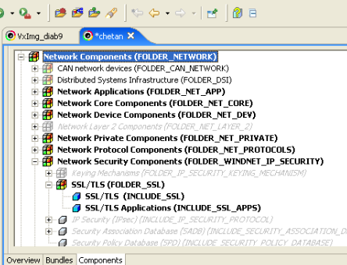
- Include Kernel shell Components under Development Tools Components
- Build/Rebuild Project.

3. Load VxWorks Image to the board using ftp server(for loading procedure see below section).

BRINGING UP WINDRIVER BOARD

- Power on the WindRiver target board.
- Target board should be connected to PC using serial port. [ use picocom for serial input/output. i.e picocom -b 9600 /dev/ttyS0 ].
- Make a LAN connection between Target board and system in which ftp server is running.[ftp server is coming with windriver packageand available under start->all programs->windriver->vxworks-6.1->ftp server].
- Board and system should be on same network( suggestion is to use 10.10.10.x network).
- Configure ftp server as below:
- launch ftp server from start->all programs->windriver->vxworks-6.1->ftp server.
- select security->user/rights.so, pop up window as shown below fig will open.
- select username( if no user available than create new by pressing 'new user') and set password and home directory for that user.(set the directory where vxworks image and required certificate and key files are present as the home directory of ftpserver).
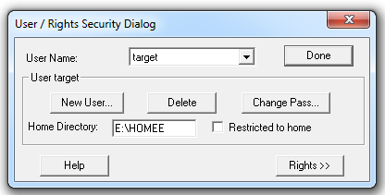

- Configure board as below: ( press 'c' to get configure window)
- Select boot device ( type 'help' to get the list of supported boot device).
- set appropriate ip address for board.
- host ip and gateway should be same as ftp server system's ip.
- ftp user and password field should match with ftp server configuration.
- once board configueration is done, press '@' to start booting process.

TEST ENVIRONMENT SETUP & EXECUTION PROCEDURE

- Common Openssl Procedure for all CVE

- To Build Openssl, follow below steps:
- Download openssl source tar file
- extract tar file ( cmd: tar -xvzf tar file name)
- ./config
- make

- Generate Diffrent Type of Self-Signed Certificate

- Create self signed CA file(Which will act as root certificate to other certs)
- ./apps/openssl genrsa -out ca-key.pem 1024
- ./apps/openssl req -new -key ca-key.pem -out ca.pem

- Create RSA certificate
- ./apps/openssl genrsa -out rsakey.pem 1024
- ./apps/openssl req -new -key rsakey.pem -out rsa.csr(common name should be different than CA certificate)
- ./apps/ openssl x509 -req -days 365 -in rsa.csr -signkey rsakey.pem -CA ca.pem CAkey ca-key.pem -out rsa.pem

- Create DSA certificate
- ./apps/ openssl dsaparam -genkey 1024 -out dsakey.pem
- ./apps/openssl req -new -key dsakey.pem -out dsa.csr
- ./apps/openssl x509 -req -days 365 -in dsa.csr -signkey dsakey.pem -out dsa.pem

- Create ECDH certificate
- ./apps/openssl ecparam -genkey -out ecdhkey.pem-name prime256v1
- ./apps/openssl req -x509 -new -key ecdhkey.pem -out ecdhcert.pem

- Create DH certificate (must use openssl-1.0.2 for this)
- ./apps/openssl dhparam -out dhparam.pem 1024
- ./apps/openssl genpkey -paramfile dhparam.pem -out dhkey.pem
- ./apps/openssl pkey -in dhkey.pem -pubout -out dhpubkey.pem
- ./apps/openssl genrsa -out rsa_key.pem 1024
- ./apps/openssl req -new -key rss_key.pem -out rsa.csr
- ./apps/openssl x509 -req -in rsa.csr -CAkey ca-key.pem -CA ca.pem -force_pubkey dhpubkey.pem -out dhcert.pem -CAcreateserial
(Note: use same CA certificate and key files in all commands)
Note: All openssl commands need to be executed from the directory where OpenSSL was built.

- CVE-2014-3572:

Test Requirements

- Target board running Wind River VxWorks with SSL built as per instructions in section 2.
- Desktop PC running Ubuntu 14.04 LTS with openssl-0.9.8zc , openssl-0.9.8zd & openssl-1.0.1k
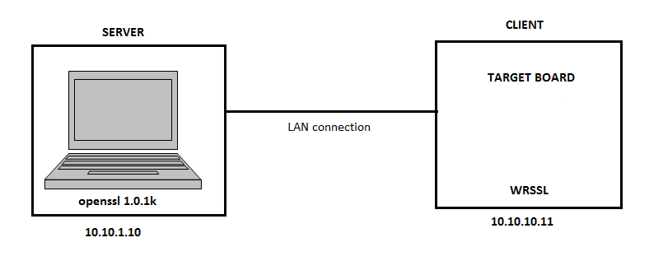

Test Preparation

1. Generate RSA as well ECDHE certificate and key file under openssl-1.0.1k
2. Get two Vxworks image one with fix and other one is without fix(To get vxworks image see above section of this document).
3. Modify openssl-1.0.1k as below.So, it will skip serverkeyexchange packet during handshake.
- ssl3_send_server_key_exchange function in file ssl/s3_srvr.c, line 2053
- return (ssl3_do_write(s,SSL#_RT_HANDSHAKE));
+ return 1;

- ssl3_get_client_key_exchange function in file ssl/s3_srvr.c, line 2627
- tkey=s->s3->tmp.ecdh;
+ tkey=s->cert->pkeys[SSL_PKEY_ECC].privatekey->pkey.ecc

-> build openssl by using command make.

Test Procedure

TEST_SR_01
-> goto openssl-1.0.1k and run openssl server by following command
./apps/openssl s_server -cert <ec_cert> -key <ec_key> -accept 4433 -ssl3 -msg

-> In other terminal goto openssl-0.9.8zc , run client by following command;
./apps/openssl s_client -ssl3 -cipher ECDHE-ECDSA-AES256-SHA -msg

-> expected result is, connection should establish.

NOTE :You need to provide exactly the same key file which is used to generate the certificate you provided.
TEST_SR_02
-> As Mentioned under TEST_SR_01 run openssl-1.0.1k server
-> In Other terminal goto openssl-0.9.8zd and run client using same command as TEST_SR_01.
-> expected result is, client should reject the connection with error message.

TEST_SR_03
-> Run openssl-1.0.1k as a server using following command
./apps/openssl s_server -accept 4433 -cert <rsa_cert> -key <rsa_key>
-> Run WRSSL(Before Applying Patch) using following command
nm_client_main("4","-connect","<host_ip:host_port>","-cipher","DHE-RSA-AES128-SHA")
-> Expected result is, WRSSL client rejects connection because unsuported DH.

TEST_SR_04
-> Run openssl-1.0.1k as a server as mentioned in TEST_SR_03 by following same procedure
-> Run WRSSL(After Patch) by following same command as TEST_SR_03.
-> Expected result is, WRSSL rejects connection because after patch it is not vulnerable.

TEST_SR_05
-> Undo changes from openssl-1.0.1k mentioned under TEST_SR_01 and rebuild it.
-> Run openssl-1.0.1k as a server using following command
./apps/openssl s_server -accept 4433 -cert <rsa_cert> -key <rsa_key>
-> Run WRSSL(Afteer Patch) client as below:
nm_client_main("4","-connect","<host_ip>:<host_port>","-cipher","DHE-RSA-AES128-SHA")
-> As openssl is genuine server WRSSL client accept connection.

- CVE-2015-0204:

Test Requirements

- Target board running Wind River VxWorks with SSL built as per instructions in section 2.
- Two vxwork image one with fix and other one is without.
- Desktop PC running Ubuntu 14.04 LTS with openssl-0.9.8zc , openssl-0.9.8zd.

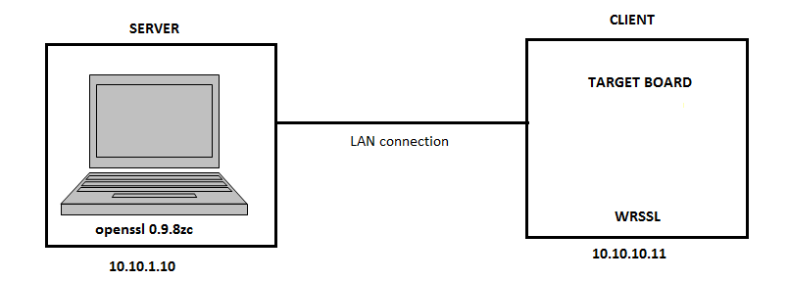

Test Preparation

            - Generate RSA certificate and key file under openssl-0.9.8zc
            - Modify openssl-0.9.8zc for test as below:

ssl3_accept function in ss/s3_srvr.c , line 369
- s->s3_tmp.use_rsa_tmp=0;
+ s->s3_tmp.use_rsa_tmp=1;

- Rebuild Openssl-0.9.8zc using make command.

Test Procedure

TEST_SR_01
-> Run openssl-0.9.8zc as a server using following command
./apps/openssl s_server -cert <rsa_cert> -key <rsa_key> -cipher NULL-SHA -msg -tls1

-> In other terminal goto openssl-0.9.8zc , run client by following command;
./apps/openssl s_client -cipher NULL-SHA -msg -tls1
-> expected result is, connection should establish.

TEST_SR_02
-> As Mentioned under TEST_SR_01 run openssl-0.9.8zc server
-> In Other terminal goto openssl-0.9.8zd and run client same as TEST_SR_01 .
-> expected result is, client should reject the connection with error message.

TEST_SR_03
-> As per TEST_SR_01 run openssl-0.9.8zc server.
-> Load before fix vxworks image to board.
-> Run WRSSL usinng following command
nm_client_main("6","-connect","<host_ip>:<host_port>","-cipher","NULL-SHA","-tls1","-msg")
-> Expected result is, WRSSL client accept server .

TEST_SR_04
-> Run openssl server as mentioned in TEST_SR_01 by following same command
-> Load after fix vxworks image to the windriver board.
-> Run WRSSL by following same command as TEST_SR_03.
-> Expected result is, WRSSL rejects connection because after patch it is not vulnerable.

- CVE-2015-0205:

Test Requirements

- Target board running Wind River VxWorks with SSL built as per instructions in section 2.
- Two vxwork image one with fix and other one is without.
- Desktop PC running Ubuntu 14.04 LTS with openssl-1.0.1j , openssl-1.0.1k and openssl-1.0.2.

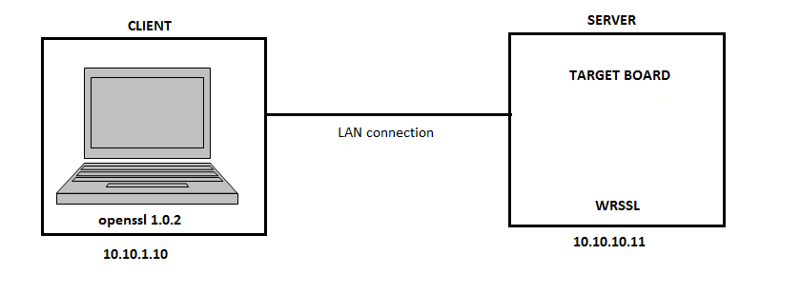

Test Preparation

            - Generate DH key and certificate as described above under openssl-1.0.2
            - Generate 2 seprate pair of rsa certificate and key file.
            - Modify 1.0.2 for test as below :

ssl3_accept function in ssl/s3_clnt.c , line 439, comment following snipt

ret=ssl3_send_client_verify(s);
if(ret<=0)
goto end;

- Rebuild Openssl-1.0.2 using make command.

Test Procedure

TEST_SR_01
-> Run openssl-1.0.1j as a server using following command
./apps/openssl s_server -accept 4433 -cert <rsa_cert> -key <rsa_key> -CAfile ca.pem -Verify 2 -cipher DHE-RSA-AES128-SHA -msg
-> In other terminal goto openssl-1.0.2 , run client by following command;
./apps/openssl s_client -connect 127.0.0.1:4433 -cipher DHE-RSA-AES128-SHA -cert <dh_cert> -key <dh_key> -CAfile ca.pem -ssl3 -msg
-> expected result is, connection should establish.

TEST_SR_02
-> As Mentioned under TEST_SR_01 run openssl-1.0.1k server
-> In Other terminal goto openssl-1.0.2 and run client same as TEST_SR_01 .
-> expected result is, client should reject the connection with error message.
TEST_SR_03
-> Load before fix vxworks image to target board.
-> Run WRSSL server using following command
nm_server_main("9","-cert","<rsa_cert>","-key","<rsa_key>","-CAfile","ca.pem","-Verify","2","-ssl3")
-> Run openssl-1.0.2 as client in other terminal using following command
./apps/openssl s_client -connect <host_ip>:<host_port> -cert <dhcert> -key <dh_key> -CAfile ca.pem -ssl3
-> Expected result is, WRSSL server rejects connection .

TEST_SR_04
-> Load after fix vxworks image to target board.
-> Run WRSSL server by following same command as TEST_SR_03.
-> Run openssl-1.0.2 as a client in other terminal by following below command
./apps/openssl s_client -connect <host_ip>:<host_port> -cert <rsa_cert> -key <rsa_key> -CAfile ca.pem
-> Expected result is, WRSSL rejects connection because after patch it is not vulnerable.

- CVE-2014-8275:

Test Requirements

- Target board running Wind River VxWorks with SSL built as per instructions in section 2.
- Two vxwork image one with fix and other one is without.
- Desktop PC running Ubuntu 14.04 LTS with openssl-0.9.8zd.

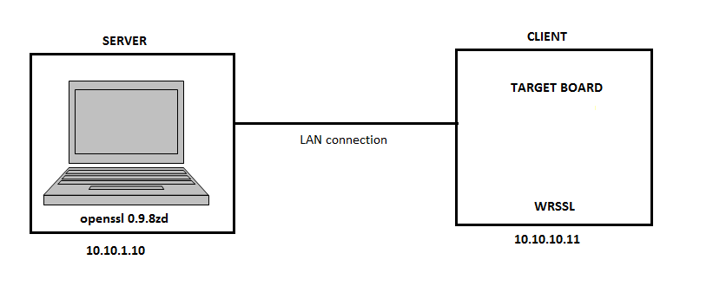

Test Preparation

            - Generate RSA key and certificate files.

Test Procedure

TEST_SR_01

-> Modify openssl-0.9.8zd as below:
ssl3_add_cert_to_buf function in file ssl/s3_both.c, line 316
+ buf->data[502]=0x04;
-> Rebuild openssl-0.9.8zd
-> Run openssl-0.9.8zd as a server using following command
./apps/openssl s_server -cert <rsa_cert> -key <rsa_key> -accept 4433
-> Load after fix image to windriver target board.
-> run wrssl as a client using following command
nm_client_main("4","-connect","<host_ip>:<host_port>","-CAfile","<CA_file>")
-> expected result is, though WRSSL get error notification it will ignore that and establish connection.

TEST_SR_02
-> undo TEST_SR_01 changes in openssl-0.9.8zd.
-> modify openssl-0.9.8zd as mentioned below
ssl3_add_cert_to_buf function in file ssl/s3_both.c, line 316
+buf->data[489]=0x08
+buf->data[490]=0x08
+buf->data[491]=0x08
+buf->data[492]=0x08
+buf->data[493]=0x08
+buf->data[494]=0x08

-> Rebuild openssl-0.9.8zd.
-> Run openssl-0.9.8zd as a server
./apps/openssl s_server -cert <rsa_cert> -key <rsa_key> -accept 4433
-> Run WRSSL(After Fix) as a client using following command
nm_client_main("4","-connect","<host_ip>:<host_port>","-CAfile","<CA_file>")
-> expected result is, though WRSSL get error notification it will ignore that and establish connection.

