JPN_RIC13351-2: RELEASE NOTES and HOW TO
Step-by-step guide to install, build and test JPN_RIC13351-2 patch to Wind River VxWorks 6.1
30 Apr 2015
Ver 0.05

Contents
1. Development and Test Environment 2
2. Installation Instructions 2
3. Build Instructions 4
3. Bringing up Wind River Board 8
4. Test Environment Setup & Execution Procedure 9
➢ CVE-2014-3572: 9
1. Test Preparation 9
2. Test Procedure 10
➢ CVE-2015-0204: 12
1. Test Preparation 12
2. Test Procedure 12
➢ CVE-2015-0205: 14
1. Test Preparation 14
2. Test Procedure 15
➢ CVE-2014-8275: 17
1. Test Preparation 17
2. Test Procedure 17
➢ Cleanup 19

Development and Test Environment

Development and test environment for the JPN_RIC13351- 2 project is as shown below.

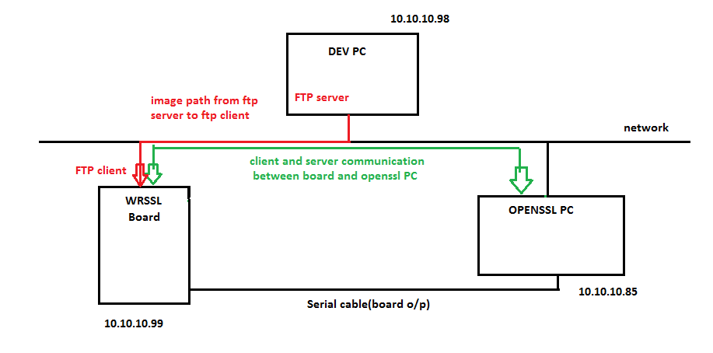
SSL Client-Server communication between VxWorks target board and OpenSSL PC
Image download via FTP
Target board running
VxWorks 6.1 + WR-SSL
PC running Ubuntu Linux + OpenSSL
PC running Win XP + Workbench
Ensure that required hardware and software are available to realize below setup before following instructions in this document.
Document also assumes that above setup is realized with required physical connections made as shown in above diagram.

Installation Instructions

On DEV PC:
- Install Wind River Workbench and vxWorks 6.1 and BSPs as listed in setup.log in Appendix 1.
- Do SVN checkout https://github.com/neominds/JPN_RIC13351-2/trunk/releases/430 to a local working folder [ e.g. C:\user1\work)
- Change directory to checked out directory (e.g. cd c:\user1\work\430\)
- Unzip ric13351_2_asis_430.zip file.
- Apply JPN_RIC13351-2 patch to VxWorks Source Code as described below:
- Open VxWorks Development Shell (start->all programs->windriver->vxworks-6.1->vxworks development shell).
2. Go to checked out directory (e.g. c:\user1\work\430\). Make sure JPN_RIC13351-2.bat file is present in this location.
3. Execute command as below to install patch
1) JPN_RIC13351-2.bat <WindRiverInstalledDirectory> withtest
e.g. C:\user1\work\430>JPN_RIC13351-2.bat C:\WindRiver withtest
Note: if you intend to only install patch and NOT perform tests after applying patch, additional option “withtest” is NOT required. See command and example below.
JPN_RIC13351-2.bat <WindRiverInstalledDirectory>
e.g. C:\user1\work\430>JPN_RIC13351-2.bat C:\WindRiver
4. How to enable Features
- By default JPN_RIC13351-2 is Disabled.

- To enable JPN_RIC13351-2 , please follow steps below:

- Edit file
~\<WorkbenchInstallationDirectory> \vxWorks-6.1\target\h\openssl\asn1.h
- Define JPN_RIC13351-2 by adding below line
#define JPN_RIC13351-2
- Edit file
~\<WorkbenchInstallationDirectory> \vxWorks-6.1\target\h\openssl\x509.h
- Define JPN_RIC13351-2 by adding below line
#define JPN_RIC13351-2
On OPENSSL PC:
        - Download and extract following OpenSSL versions from https://www.openssl.org/source/ to a local directory. (e.g /home/user1/openssls/)
OpenSSL 0.9.8zc
OpenSSL 0.9.8zd
OpenSSL 1.0.1k
OpenSSL 1.0.2
[Note: when .tar.gz files are extracted, a directory will be created for each of above versions, e.g. /home/user1/openssls/openssl-0.9.8zf/]
        - Build each of above versions as shown in example below.
$ cd /home/user1/openssls/openssl-0.9.8zc
$ ./config
$ make
$ cd /home/user1/openssls/openssl-0.9.8zd
$ ./config
$ make
$ cd /home/user1/openssls/openssl-1.0.1k
$ ./config
$ make
$ cd /home/user1/openssls/openssl-1.0.2
$ ./config
$ make

Make sure there are no build failures.

        - Do SVN checkout https://github.com/neominds/JPN_RIC13351-2/trunk/releases/430 to a local working folder [ e.g. /home/user1/work)
- Change directory to checked out directory (e.g. cd /home/user1/work)
- Unzip ric13351_2_asis_430.zip file.
- Copy all files from <local_working_folder>/430/test_src/certificates directory to each openSSL folder created in step 1.
e. g.
$cd /home/user1/work/430/test_src/certificates/
$cp * /home/user1/openssls/openssl-0.9.8zc/
$cp * /home/user1/openssls/openssl-0.9.8zd/
$cp * /home/user1/openssls/openssl-1.0.1k/
$cp * /home/user1/openssls/openssl-1.0.2/

Build Instructions

On DEV-PC:
- Modify following files as described below
- File Location
<WorkbenchInstallationDirectory>\VxWorks-6.1\target\src\Makefile
Changes required:
-> Search for "COMMON_SUBDIRS" (where you will see wind,wrn,wvlisted)
-> Append "security" and "ssl" to the list of COMMON_SUBDIRS as shown in below fig.

- File Location
<WorkbenchInstallationDirectory>\VxWorks-6.1\target\config\all\usrConfig.c

Changes required:
-> define INCLUDE_USER_APPL macro by adding below line
#define INCLUDE_USER_APPL
->In the INCLUDE_USER_APPL block add below two lines to call those functions as shown in below fig.
secLibInit();
sslInit();
- File Location
<WorkbenchInstallationDirectory>\VxWorks-6.1\target\src\drv\wlan\management\Makefile
Changes required:
- search for "IS_DOT11SNMP" and comment that line as shown in below fig.
- File Location
<WorkbenchInstallationDirectory>\VxWorks-6.1\target\src\ppp\management\snmpAgent\Makefile
Changes required:
- search for "IS_SNMP_INSTALLED" and comment that line as shown in below fig.
- Build VxWorks-6.1 for specific CPU( for ex: PPC603, PENTUIM3, PENTIUM4) by following below steps:

- Open VXWorksDevlopmentShell (start->all programs->windriver->vxworks-6.1->vxworks development shell).
- Goto directory <WorkbenchInstallationDirectory>\VxWorks-6.1\target\src
- Build using 'make' command as make CPU=<cpu name> TOOL=<diab>
e.g : make CPU=PPC603 TOOL=diab

- Create Image Project Under WindRiver Workbench
- Open Workbench GUI(start->All programs->windriver->workbench 2.3).
- Create new VxWorksimage project from Workbench-2.3menu(file->new->vxworks image project).
- Give project name and click on 'next' .
- Select BSP(Board Supporting Package) and tool chain and click on 'finish'. ( in our case we have selected wrsbcPowerQuiccII as BSP and diab as tool chain)
- Goto kernel configuration of the project from project window.
- In component tree, enable vxWorks componentsINCLUDE_SSL and INCLUDE_SSL_APPS by including network security components under network components as shown in below fig.
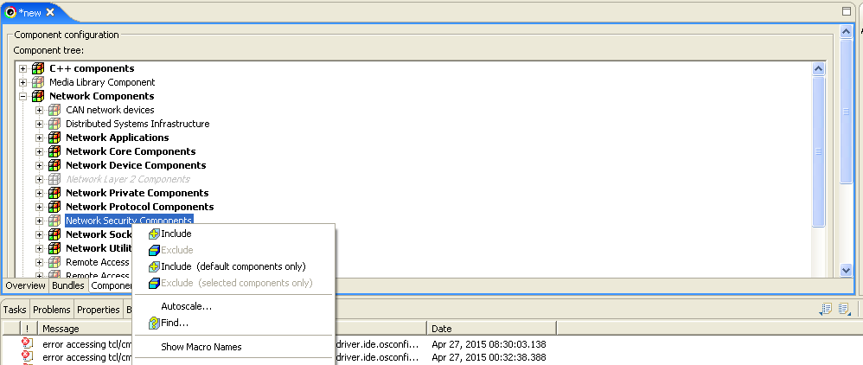

- Include Kernel shell Components under Development Tools Components(select all)

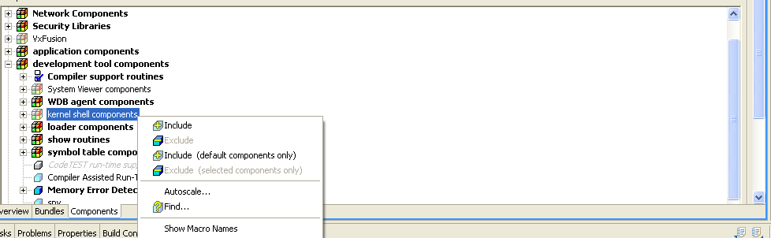

- Build/Rebuild Project.
- By default VxWorks image will be present in following directory. <WindRiverInstalledDirectory>\workspace\project_name\default\VxWorks
This is image with fix. Rename this image as "Vxworks_withfix"
- Generate VxWorks image without fix, following below steps.
- > Edit file ~\<WorkbenchInstallationDirectory>\vxWorks-6.1\target\h\openssl\asn1.h
-> comment below line
#define JPN_RIC13351-2
-> Edit file ~\<WorkbenchInstallationDirectory>\vxWorks6.1\target\h\openssl\x509.h
-> comment below line
#define JPN_RIC13351-2
- In workbench IDE, perform clean, refresh and build the project. Image without fix will be created. Rename this as "Vxworks_withoutfix"

Bringing up Wind River Board

- Power on the WindRiver target board.
- Target board should be connected to OPENSSL PC using serial port. [use picocom for serial input/output or to see the console log of board. ].
i. e. picocom -b 9600 /dev/ttyS0
- Make a LAN connection between Target board and system in which ftp server is running, i.e., DEV PC. [FTP server is part of windriver package and available under start->all programs->windriver->vxworks-6.1->ftp server].
- Board and DEV PC should be on same network (suggestion is to use 10.10.10.x network (or) refer setup diagram in section 1).
- Configure ftp server as below:
- Launch ftp server from start->all programs->windriver->vxworks-6.1->ftp server.
- Select security->user/rights. Pop up window as shown below fig will open.
- Select username( if no user available then create new by pressing 'new user') and set password and home directory for that user.(set the directory where vxworks images will be present as the home directory of ftpserver).

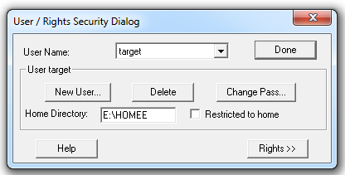

- Switch off and switch on the board and wait for ‘[VxWorks Boot]’ command prompt.
- Configure board as below: ( press 'c' to get configure window)
- Select boot device( type 'help' to get the list of supported boot device).
- set appropriate IP address for board.
- hostip and gateway should be same as FTP server system's IP address.
- FTP user and password field should match with FTP server configuration.
- following fig. shows sample example

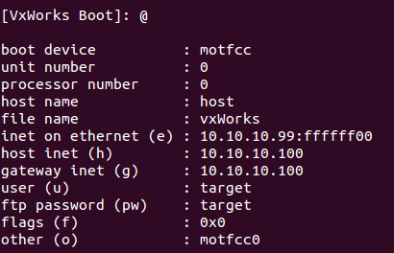

- Once board configuration is done, ‘[VxWorks Boot]’ prompt will be displayed again. You may use command ‘p’ to ensure that configuration is correct.
- Copy Vxworks images created in Section 2, VxWorks_withfix and Vxworks_withoutfix to FTP home directory.
- On DEV-PC,
Copy all files from <local_working_folder>\430\test_src\certificates directory to FTP home directory (e.g. E:\HOMEE)
e. g.
C:\home\user1\work\430\>cd test_src\certificates
C:\home\user1\work\430\test_src\certificates>copy *.* E:\HOMEE\

Test Environment Setup & Execution Procedure

CVE-2014-3572:

Test Preparation

On OPENSSL-PC:
- Change directory to openssl-1.0.1k (directory created in Section 2, steps for OPENSSL-PC).
e.g.
$cd /home/user1/openssls/openssl-1.0.1k
- Create a backup copy of original ssl/s3_srvr.c file
e.g.
$cp /home/user1/openssls/openssl-1.0.1k/ssl/s3_srvr.c /home/user1/openssls/openssl-1.0.1k/ssl/s3_srvr.c_orig
- Replace ssl/s3_srvr.c with 430/test_src/OpenSSL/CVE-2014-3572/s3_srvr.c under SVN checked out folder
E.g.
$cp /home/user1/work/430/test_src/OpenSSL/CVE-2014-3572/s3_srvr.c /home/user1/openssls/openssl-1.0.1k/ssl/s3_srvr.c
- Re-build openssl 1.0.1k
E.g
$cd /home/user1/openssls/openssl-1.0.1k
$make

Test Procedure

TEST_SR_01
On OPENSSL-PC:
- Open terminal, change directory to openssl-1.0.1k and run openssl server as shown below
e.g.
$cd /home/user1/openssls/openssl-1.0.1k
$./apps/openssl s_server -cert ecdh.pem -key ecdhkey.pem –accept 4433 -ssl3 –msg
$
- Open another terminal, , change directory to openssl-0.9.8zc and run openssl client as shown below
e.g.
$cd /home/user1/openssls/openssl-0.9.8zc
$./apps/openssl s_client -ssl3 -cipher ECDHE-ECDSA-AES256-SHA -msg

Expected Result
SSL connection should establish successfully. Verify by typing in a test message on the client terminal and seeing the same on server terminal and vice versa.
TEST_SR_02
On OPENSSL-PC:
- Open terminal, change directory to openssl-1.0.1k and run openssl server as shown below
e.g.
$cd /home/user1/openssls/openssl-1.0.1k
$./apps/openssl s_server -cert ecdh.pem -key ecdhkey.pem –accept 4433 -ssl3 –msg
$
- Open another terminal, , change directory to openssl-0.9.8zd and run openssl client as shown below
e.g.
$cd /home/user1/openssls/openssl-0.9.8zd
$./apps/openssl s_client -ssl3 -cipher ECDHE-ECDSA-AES256-SHA -msg
Expected Result
SSL client should fail to establish connection with error message.
TEST_SR_03
On OPENSSL-PC:
- Open terminal, change directory to openssl-1.0.1k and run openssl server as shown below
e.g.
$cd /home/user1/openssls/openssl-1.0.1k
$./apps/openssl s_server -accept 4433 -cert rsa.pem -key rsakey.pem
$
On DEV-PC:
- Change to FTP home directory, copy file Vxworks_withoutfix to VxWorks
e.g.
C:\>cd E:\ HOMEE
C:\>E:
E:\HOMEE>copy Vxworks_withoutfix VxWorks
On WRSSL-Board and picocom on OPENSSL-PC:
- Restart the board. Wait till VxWorks image is downloaded via FTP and VxWorks prompt is displayed on picocom terminal. [Enter ‘@’ at VxWorks boot prompt in picocom terminal to boot VxWorks]
- Run WRSSL client using following command in OPENSSL-PC picocom terminal.
->nm_client_main("4","-connect","<OPENSSL_PC_IPAddr>:4433","-cipher","DHE-RSA-AES128-SHA")
Expected Result
WR-SSL client should fail to establish connection because of unsupported DH.
TEST_SR_04
On OPENSSL-PC:
- Open terminal, change directory to openssl-1.0.1k and run openssl server as shown below
e.g.
$cd /home/user1/openssls/openssl-1.0.1k
$./apps/openssl s_server -accept 4433 -cert rsa.pem -key rsakey.pem
$
On DEV-PC:
- Change to FTP home directory, copy file Vxworks_withfix to VxWorks
e.g.
C:\>cd E:\ HOMEE
C:\>E:
E:\HOMEE>copy Vxworks_withfix VxWorks
On WRSSL-Board and picocom on OPENSSL-PC:
- Restart the board. Wait till VxWorks image is downloaded via FTP and VxWorks prompt is displayed on picocom terminal. [Enter ‘@’ at VxWorks boot prompt in picocom terminal to boot VxWorks]
- Run WRSSL client using following command in OPENSSL-PC picocom terminal.
->nm_client_main("4","-connect","<OPENSSL_PC_IPAddr>:4433","-cipher","DHE-RSA-AES128-SHA")
Expected Result
WR-SSL client should fail to establish connection because after patch it is not vulnerable.
TEST_SR_05
On OPENSSL-PC:
- In opensl-1.0.1k directory, restore ssl/s3_srvr.c file from backup copy
e.g.
$cp /home/user1/openssls/openssl-1.0.1k/ssl/s3_srvr.c_orig /home/user1/openssls/openssl-1.0.1k/ssl/s3_srvr.c
- Re-build openssl 1.0.1k
E.g
$cd /home/user1/openssls/openssl-1.0.1k
$make
- Open terminal, change directory to openssl-1.0.1k and run OpenSSL server as shown below
e.g.
$cd /home/user1/openssls/openssl-1.0.1k
$./apps/openssl s_server -accept 4433 -cert rsa.pem -key rsakey.pem
On WRSSL-Board and picocom on OPENSSL-PC:
- Restart the board. Wait till VxWorks image is downloaded via FTP and VxWorks prompt is displayed on picocom terminal. [Enter ‘@’ at VxWorks boot prompt in picocom terminal to boot VxWorks]
Note: Ensure that VxWorks image in FTP home directory of DEV-PC is same as Vxworks_withfix

- Run WRSSL client using following command in OPENSSL-PC picocom terminal.
->nm_client_main("4","-connect","<OPENSSL_PC_IPAddr>:4433","-cipher","DHE-RSA-AES128-SHA")
Expected Result
WR-SSL client should establish successful connection.

CVE-2015-0204:

Test Preparation

On OPENSSL-PC:
- Change directory to openssl-0.9.8zc (directory created in Section 2, steps for OPENSSL-PC).
e.g.
$cd /home/user1/openssls/openssl-0.9.8zc
- Create a backup copy of original ssl/s3_srvr.c file
e.g.
$cp /home/user1/openssls/openssl-0.9.8zc/ssl/s3_srvr.c /home/user1/openssls/openssl-0.9.8zc/ssl/s3_srvr.c_orig
- Replace ssl/s3_srvr.c with 430/test_src/OpenSSL/CVE-2015-0204/s3_srvr.c under SVN checked out folder
E.g.
$cp /home/user1/work/430/test_src/OpenSSL/CVE-2015-0204/s3_srvr.c /home/user1/openssls/openssl-0.9.8zc/ssl/s3_srvr.c
- Re-build openssl-0.9.8zc
E.g
$cd /home/user1/openssls/openssl-0.9.8zc
$make

Test Procedure

TEST_SR_01
On OPENSSL-PC:
- Open terminal, change directory to openssl-0.9.8zc and run OpenSSL server as shown below
e.g.
$cd /home/user1/openssls/openssl-0.9.8zc
$./apps/openssl s_server -cert rsa.pem -key rsakey.pem -cipher NULL-SHA -msg -tls1

- Open another terminal, , change directory to openssl-0.9.8zc and run OpenSSL client as shown below
e.g.
$cd /home/user1/openssls/openssl-0.9.8zc
$./apps/openssl s_client -cipher NULL-SHA -msg -tls1
Expected Result
SSL connection should establish successfully. Verify by typing in a test message on the client terminal and seeing the same on server terminal and vice versa.
TEST_SR_02
On OPENSSL-PC:
- Open terminal, change directory to openssl-0.9.8zc and run OpenSSL server as shown below
e.g.
$cd /home/user1/openssls/openssl-0.9.8zc
$./apps/openssl s_server -cert rsa.pem -key rsakey.pem -cipher NULL-SHA -msg -tls1

- Open another terminal, , change directory to openssl-0.9.8zd and run OpenSSL client as shown below
e.g.
$cd /home/user1/openssls/openssl-0.9.8zd
$./apps/openssl s_client -cipher NULL-SHA -msg -tls1
Expected Result
SSL client should fail to establish connection with error message.
TEST_SR_03
On OPENSSL-PC:
- Open terminal, change directory to openssl-0.9.8zc and run OpenSSL server as shown below
e.g.
$cd /home/user1/openssls/openssl-0.9.8zc
$./apps/openssl s_server -cert rsa.pem -key rsakey.pem -cipher NULL-SHA -msg -tls1
On DEV-PC:
- Change to FTP home directory, copy file Vxworks_withoutfix to VxWorks
e.g.
C:\>cd E:\ HOMEE
C:\>E:
E:\HOMEE>copy Vxworks_withoutfix VxWorks
On WRSSL-Board and picocom on OPENSSL-PC:
- Restart the board. Wait till VxWorks image is downloaded via FTP and VxWorks prompt is displayed on picocom terminal. [Enter ‘@’ at VxWorks boot prompt in picocom terminal to boot VxWorks]
- Run WRSSL client using following command in OPENSSL-PC picocom terminal.
->nm_client_main("6","-connect","<OPENSSL_PC_IPAddr>:4433","-cipher","NULL-SHA","-tls1","-msg")
Expected Result
SSL connection should establish successfully. Verify by typing in a test message on the client terminal and seeing the same on server terminal and vice versa.
TEST_SR_04
On OPENSSL-PC:
- Open terminal, change directory to openssl-0.9.8zc and run OpenSSL server as shown below
e.g.
$cd /home/user1/openssls/openssl-0.9.8zc
$./apps/openssl s_server -cert rsa.pem -key rsakey.pem -cipher NULL-SHA -msg -tls1
On DEV-PC:
- Change to FTP home directory, copy file Vxworks_withfix to VxWorks
e.g.
C:\>cd E:\ HOMEE
C:\>E:
E:\HOMEE>copy Vxworks_withfix VxWorks
On WRSSL-Board and picocom on OPENSSL-PC:
- Restart the board. Wait till VxWorks image is downloaded via FTP and VxWorks prompt is displayed on picocom terminal. [Enter ‘@’ at VxWorks boot prompt in picocom terminal to boot VxWorks]
- Run WRSSL client using following command in OPENSSL-PC picocom terminal.
->nm_client_main("6","-connect","<OPENSSL_PC_IPAddr>:4433","-cipher","NULL-SHA","-tls1","-msg")
Expected Result
SSL client should fail to establish connection successfully because after patch it is not vulnerable.

CVE-2015-0205:

Test Preparation

On OPENSSL-PC:
- Change directory to openssl-1.0.2 (directory created in Section 2, steps for OPENSSL-PC).
e.g.
$cd /home/user1/openssls/openssl-1.0.2
- Create a backup copy of original ssl/ s3_clnt.c file
e.g.
$cp /home/user1/openssls/openssl-1.0.2/ssl/s3_clnt.c /home/user1/openssls/openssl-1.0.2/ssl/s3_clnt.c_orig
- Replace ssl/s3_clnt.c with 430/test_src/OpenSSL/CVE-2015-0205/s3_clnt.c under SVN checked out folder
E.g.
$cp /home/user1/work/430/test_src/OpenSSL/CVE-2015-0205/s3_clnt.c /home/user1/openssls/openssl-1.0.2/ssl/s3_clnt.c
- Re-build openssl-1.0.2
E.g
$cd /home/user1/openssls/openssl-1.0.2
$make

Test Procedure

TEST_SR_01
On OPENSSL-PC:
- Open terminal, change directory to openssl-1.0.1j and run OpenSSL server as shown below
e. g.
$cd /home/user1/openssls/openssl-1.0.1j
$./apps/openssl s_server -accept 4433 -cert rsa.pem -key rsakey.pem -CAfile ca_dh.pem -Verify 2 -cipher DHE-RSA-AES128-SHA –msg

- Open another terminal, , change directory to openssl-1.0.2 and run OpenSSL client as shown below
e.g.
$cd /home/user1/openssls/openssl-1.0.2
$./apps/openssl s_client -connect 127.0.0.1:4433 -cipher DHE-RSA-AES128-SHA -cert dh.pem -key dhkey.pem -CAfile ca_dh.pem -ssl3 -msg
Expected Result
SSL connection should establish successfully. Verify by typing in a test message on the client terminal and seeing the same on server terminal and vice versa.
TEST_SR_02
On OPENSSL-PC:
- Open terminal, change directory to openssl-1.0.1k and run OpenSSL server as shown below
e. g.
$cd /home/user1/openssls/openssl-1.0.1k
$./apps/openssl s_server -accept 4433 -cert rsa.pem -key rsakey.pem -CAfile ca_dh.pem -Verify 2 -cipher DHE-RSA-AES128-SHA –msg

- Open another terminal, , change directory to openssl-1.0.2 and run OpenSSL client as shown below
e.g.
$cd /home/user1/openssls/openssl-1.0.2
$./apps/openssl s_client -connect 127.0.0.1:4433 -cipher DHE-RSA-AES128-SHA -cert dh.pem -key dhkey.pem -CAfile ca_dh.pem -ssl3 -msg
Expected Result
SSL client should fail to establish connection with error message.
TEST_SR_03
On DEV-PC:
- Change to FTP home directory, copy file Vxworks_withoutfix to VxWorks
e. g.
C:\>cd E:\ HOMEE
C:\>E:
E:\HOMEE>copy Vxworks_withoutfix VxWorks
On WRSSL-Board and picocom on OPENSSL-PC:
- Restart the board. Wait till VxWorks image is downloaded via FTP and VxWorks prompt is displayed on picocom terminal. [Enter ‘@’ at VxWorks boot prompt in picocom terminal to boot VxWorks]
- Run WRSSL server using following command in OPENSSL-PC picocom terminal.
->nm_server_main("9","-cert", "rsa.pem", "-key", "rsakey.pem",
"-CAfile","ca_dh.pem","-Verify","2","-ssl3")
On OPENSSL-PC:
- Open terminal, , change directory to openssl-1.0.2 and run OpenSSL client as shown below
e.g.
$cd /home/user1/openssls/openssl-1.0.2
$./apps/openssl s_client -connect <TARGET_BOARD_IP>:4433 -cert dh.pem -key dhkey.pem -CAfile ca_dh.pem -ssl3
Expected Result
SSL client should fail to establish connection with error message.
TEST_SR_04
On DEV-PC:
- Change to FTP home directory, copy file Vxworks_withfix to VxWorks
e. g.
C:\>cd E:\ HOMEE
C:\>E:
E:\HOMEE>copy Vxworks_withfix VxWorks
On WRSSL-Board and picocom on OPENSSL-PC:
- Restart the board. Wait till VxWorks image is downloaded via FTP and VxWorks prompt is displayed on picocom terminal. [Enter ‘@’ at VxWorks boot prompt in picocom terminal to boot VxWorks]
- Run WRSSL server using following command in OPENSSL-PC picocom terminal.
->nm_server_main("9","-cert", "rsa.pem", "-key", "rsakey.pem",
"-CAfile","ca_dh.pem","-Verify","2","-ssl3")
On OPENSSL-PC:
- Open terminal, , change directory to openssl-1.0.2 and run OpenSSL client as shown below
e.g.
$cd /home/user1/openssls/openssl-1.0.2
$./apps/openssl s_client -connect <TARGET_BOARD_IP>:4433 -cert dh.pem -key dhkey.pem -CAfile ca_dh.pem -ssl3
Expected Result
WR-SSL server should fail to establish connection because after patch it is not vulnerable.

CVE-2014-8275:

Test Preparation

None

Test Procedure

TEST_SR_01
On OPENSSL-PC:
- Change directory to openssl-0.9.8zd (directory created in Section 2, steps for OPENSSL-PC).
e.g.
$cd /home/user1/openssls/openssl-0.9.8zd
- Create a backup copy of original ssl/s3_both.c file
e.g.
$cp /home/user1/openssls/openssl-0.9.8zd/ssl/s3_both.c /home/user1/openssls/openssl-0.9.8zd/ssl/s3_both.c_orig
- Replace ssl/s3_both.c with 430/test_src/OpenSSL/CVE-2014-8275/case1/s3_both.c under SVN checked out folder
E.g.
$cp /home/user1/work/430/test_src/OpenSSL/CVE-2014-8275/case1/s3_both.c /home/user1/openssls/openssl-0.9.8zd/ssl/s3_both.c
- Re-build openssl-0.9.8zd
E.g
$cd /home/user1/openssls/openssl-0.9.8zd
$make
- Open terminal, change directory to openssl-0.9.8zd and run OpenSSL server as shown below
e. g.
$cd /home/user1/openssls/openssl-0.9.8zd
$./apps/openssl s_server -cert rsa.pem -key rsakey.pem -accept 4433
On DEV-PC:
- Change to FTP home directory, copy file Vxworks_withfix to VxWorks
e. g.
C:\>cd E:\ HOMEE
C:\>E:
E:\HOMEE>copy Vxworks_withfix VxWorks
On WRSSL-Board and picocom on OPENSSL-PC:
- Restart the board. Wait till VxWorks image is downloaded via FTP and VxWorks prompt is displayed on picocom terminal. [Enter ‘@’ at VxWorks boot prompt in picocom terminal to boot VxWorks]
- Run WRSSL client using following command in OPENSSL-PC picocom terminal.
-> nm_client_main("4","-connect","<OPENSSL_PC_IP>:4433",
"-CAfile","ca_rsa.pem")
Expected Result
Though WRSSL client display error notification it will ignore that and establish connection successfully.

TEST_SR_02
On OPENSSL-PC:
- Change directory to openssl-0.9.8zd (directory created in Section 2, steps for OPENSSL-PC).
e.g.
$cd /home/user1/openssls/openssl-0.9.8zd
- [Note: Skip this step if performed as part of TEST_SR_01]
Create a backup copy of original ssl/s3_both.c file
e.g.
$cp /home/user1/openssls/openssl-0.9.8zd/ssl/s3_both.c /home/user1/openssls/openssl-0.9.8zd/ssl/s3_both.c_orig
- Replace ssl/s3_both.c with 430/test_src/OpenSSL/CVE-2014-8275/case2/s3_both.c under SVN checked out folder
E.g.
$cp /home/user1/work/430/test_src/OpenSSL/CVE-2014-8275/case2/s3_both.c /home/user1/openssls/openssl-0.9.8zd/ssl/s3_both.c
- Re-build openssl-0.9.8zd
E.g
$cd /home/user1/openssls/openssl-0.9.8zd
$make
- Open terminal, change directory to openssl-0.9.8zd and run OpenSSL server as shown below
e. g.
$cd /home/user1/openssls/openssl-0.9.8zd
$./apps/openssl s_server -cert rsa.pem -key rsakey.pem -accept 4433
On DEV-PC:
- Change to FTP home directory, copy file Vxworks_withfix to VxWorks
e. g.
C:\>cd E:\ HOMEE
C:\>E:
E:\HOMEE>copy Vxworks_withfix VxWorks
On WRSSL-Board and picocom on OPENSSL-PC:
- Restart the board. Wait till VxWorks image is downloaded via FTP and VxWorks prompt is displayed on picocom terminal. [Enter ‘@’ at VxWorks boot prompt in picocom terminal to boot VxWorks]
- Run WRSSL client using following command in OPENSSL-PC picocom terminal.
-> nm_client_main("4","-connect","<OPENSSL_PC_IP>:4433",
"-CAfile","ca_rsa.pem")
Expected Result
Though WRSSL client display error notification it will ignore that and establish connection successfully.
TEST_SR_03
On OPENSSL-PC:
- Change directory to openssl-0.9.8zd (directory created in Section 2, steps for OPENSSL-PC).
e.g.
$cd /home/user1/openssls/openssl-0.9.8zd
- Create a backup copy of original crypto/dsa/dsa_asn1.c file
e.g.
$cp /home/user1/openssls/openssl-0.9.8zd/crypto/dsa/dsa_asn1.c /home/user1/openssls/openssl-0.9.8zd/crypto/dsa/dsa_asn1.c_orig
- Replace crypto/dsa/dsa_asn1.c with 430/test_src/OpenSSL/CVE-2014-8275/case3/dsa_asn1.c under SVN checked out folder
E.g.
$cp /home/user1/work/430/test_src/OpenSSL/CVE-2014-8275/case3/dsa_asn1.c /home/user1/openssls/openssl-0.9.8zd/crypto/dsa/dsa_asn1.c
- Re-build openssl-0.9.8zd
E.g
$cd /home/user1/openssls/openssl-0.9.8zd
$make
On DEV-PC:
- Change to FTP home directory, copy file Vxworks_withfix to VxWorks
e. g.
C:\>cd E:\ HOMEE
C:\>E:
E:\HOMEE>copy Vxworks_withfix VxWorks
On WRSSL-Board and picocom on OPENSSL-PC:
- Restart the board. Wait till VxWorks image is downloaded via FTP and VxWorks prompt is displayed on picocom terminal. [Enter ‘@’ at VxWorks boot prompt in picocom terminal to boot VxWorks]
- Run WRSSL server using following command in OPENSSL-PC picocom terminal.
-> nm_server_main("8","-accept","4433","-cert","dsa.pem",
"-key","dsakey.pem","-Verify","2")
On OPENSSL-PC:
- Open terminal, change directory to openssl-0.9.8zd and run OpenSSL client as shown below
e. g.
$cd /home/user1/openssls/openssl-0.9.8zd
$./apps/openssls_client -connect <TARGET_BOARD_IP>:4433 -cert dsa.pem -key dsakey.pem
Expected Result
Though WRSSL client display error notification it will ignore that and establish connection successfully.

Cleanup

On OPENSSL-PC:
Perform following commands to restore backed up files.
$cp /home/user1/openssls/openssl-1.0.1k/ssl/s3_srvr.c_orig /home/user1/openssls/openssl-1.0.1k/ssl/s3_srvr.c
$cp /home/user1/openssls/openssl-0.9.8zc/ssl/s3_srvr.c_orig /home/user1/openssls/openssl-0.9.8zc/ssl/s3_srvr.c
$cp /home/user1/openssls/openssl-1.0.2/ssl/s3_clnt.c_orig /home/user1/openssls/openssl-1.0.2/ssl/s3_clnt.c
$cp /home/user1/openssls/openssl-0.9.8zd/ssl/s3_both.c_orig /home/user1/openssls/openssl-0.9.8zd/ssl/s3_both.c
$cp /home/user1/openssls/openssl-0.9.8zd/crypto/dsa_asn1.c_orig /home/user1/openssls/openssl-0.9.8zd/crypto/dsa_asn1.c

APPENDIX 1: Setup.log file for VxWorks 6.1 Installation
TBD

/EOD

