Neo Mthembu,
36321389
STFM 312 Assignment
Box–Jenkins Modelling Using Epsilon Data Mining Sales Data
  - Introduction
Epsilon Data Mining (Pty) Ltd was contracted by a retail firm to analyse 10 years of quarterly sales data (2016–2025) and produce reliable forecasts for 2026 and 2027. The objective is to apply the Box–Jenkins (ARIMA) methodology to understand sales dynamics, identify trend and seasonality, develop forecasting models, and provide actionable business insights.

This report documents the complete time series analysis, including data visualisation, stationarity testing, differencing, model identification, estimation, diagnostic checking, and forecasting.
  - Methodology
2.1 Data Description
The dataset consists of 40 quarterly observations from 2016 Q1 to 2025 Q4. Sales are measured in thousands of South African Rands (ZAR '000).
2.2 Box-Jenkins Procedure
The analysis follows four steps:
Step | Description
Identification | Plot data, check stationarity, determine differencing order
Estimation | Estimate candidate model parameters using MLE
Diagnostic Checking | Verify residuals are white noise (Ljung-Box test)
Forecasting | Generate forecasts with 95% confidence intervals

2.3 Software
All analyses were conducted using SAS software.

  - Dataset Description
Variable Description
Quarter Time index (2016 Q1 – 2025 Q4)
Sales Quarterly revenue (ZAR)

  - Assignment Tasks
Task 1: Data Preparation and Visualisation
data sales;
format Quarter yyq6.;
input Quarter : yyq6. Sales;
datalines;
2016Q1 900
2016Q2 980
2016Q3 1020
2016Q4 1150
2017Q1 1100
2017Q2 1200
2017Q3 1250
2017Q4 1400
2018Q1 1350
2018Q2 1480
2018Q3 1550
2018Q4 1720
2019Q1 1650
2019Q2 1800
2019Q3 1880
2019Q4 2100
2020Q1 2000
2020Q2 1900
2020Q3 2050
2020Q4 2300
2021Q1 2250
2021Q2 2450
2021Q3 2550
2021Q4 2850
2022Q1 2750
2022Q2 3000
2022Q3 3150
2022Q4 3500
2023Q1 3350
2023Q2 3650
2023Q3 3800
2023Q4 4200
2024Q1 4000
2024Q2 4350
2024Q3 4550
2024Q4 5000
2025Q1 4800
2025Q2 5200
2025Q3 5450
2025Q4 6000
;
run;

proc sgplot data=sales;
series x=Quarter y=Sales / markers;
xaxis label="Year";
yaxis label="sales (ZAR '000)";
title "Quarterly Sales (2016-2025)";
run;
Descriptive Statistics:
Table 1: Summary Statistics of Digital Sales

Statistic Value
Number of Observations 40
Mean 2,690.75 ZAR '000
Standard Deviation 1,401.26 ZAR '000
Minimum 900 ZAR '000 (2016 Q1)
Maximum 6,000 ZAR '000 (2025 Q4)
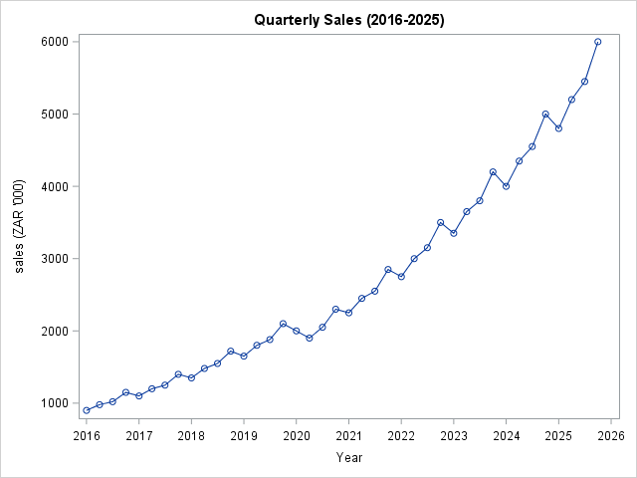
Description:
Graph presents the quarterly digital sales data from 2016 Q1 to 2025 Q4. The x-axis represents time in years, and the y-axis shows sales in thousands of South African Rands (ZAR '000). The series exhibits a strong upward trend, increasing from 900 in 2016 Q1 to 6,000 in 2025 Q4 — more than a six-fold increase. A clear seasonal pattern is visible, with peaks consistently occurring in Q4 of each year. The variance appears to increase over time, suggesting non-stationarity. A notable dip occurs in 2020 Q2 (from 2,000 to 1,900), likely due to COVID-19 disruptions, but the series quickly recovers.

Task 2: Stationarity Check
proc arima data=sales;
identify var=Sales stationarity=(adf);
run;
quit;
Autocorrelation Check for White Noise
To Lag | Chi-Square | DF | Pr > ChiSq | Autocorrelations
6 | 139.61 | 6 | <.0001 | 0.898 | 0.818 | 0.737 | 0.675 | 0.584 | 0.513

Augmented Dickey-Fuller Unit Root Tests
Type | Lags | Rho | Pr < Rho | Tau | Pr < Tau | F | Pr > F
Zero Mean | 0 | 1.9528 | 0.9839 | 5.38 | 0.9999
 | 1 | 1.8415 | 0.9799 | 7.62 | 0.9999
 | 2 | 1.7725 | 0.9768 | 5.09 | 0.9999
Single Mean | 0 | 1.9358 | 0.9964 | 2.37 | 0.9999 | 14.07 | 0.0010
 | 1 | 1.9089 | 0.9962 | 4.21 | 0.9999 | 28.24 | 0.0010
 | 2 | 1.8409 | 0.9958 | 3.72 | 0.9999 | 12.60 | 0.0010
Trend | 0 | -1.1085 | 0.9842 | -0.32 | 0.9872 | 3.19 | 0.5570
 | 1 | 1.7545 | 0.9993 | 0.90 | 0.9998 | 8.61 | 0.0122
 | 2 | 1.7792 | 0.9993 | 0.95 | 0.9999 | 6.71 | 0.0509

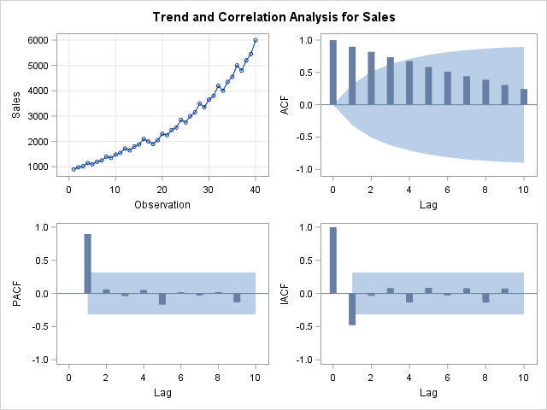
Interpretation:The Augmented Dickey-Fuller (ADF) test yields p-values > 0.99 for all test types. Since these p-values are greater than 0.05, we fail to reject the null hypothesis of a unit root. Therefore, the original series is non-stationary. The ACF shows slow decay (lag 1 = 0.898, lag 2 = 0.818, lag 3 = 0.737), confirming the presence of a trend.

Task 3: Differencing
proc arima data=sales;
identify var=Sales(1); /* First difference */
run;
Autocorrelation Check for White Noise
To Lag | Chi-Square | DF | Pr > ChiSq | Autocorrelations
6 | 49.00 | 6 | <.0001 | -0.333 | 0.332 | -0.386 | 0.750 | -0.297 | 0.253
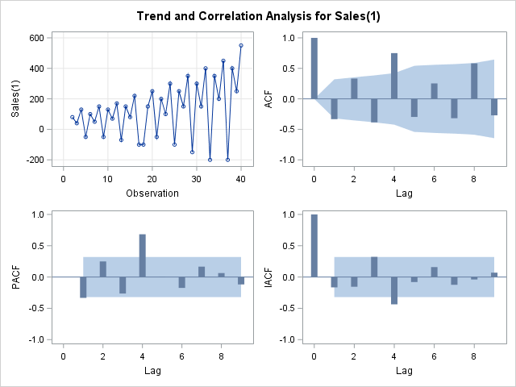
Interpretation: The trend has been removed, but a strong seasonal spike at lag 4 (0.750) remains. The white noise test p-value < 0.0001, indicating the series is still not stationary.

proc arima data=sales;
identify var=Sales(1,4); /* First difference + seasonal difference (quarterly) */
run;
Autocorrelation Check for White Noise
To Lag | Chi-Square | DF | Pr > ChiSq | Autocorrelations
6 | 4.97 | 6 | 0.5473 | -0.115 | 0.037 | -0.116 | -0.279 | 0.088 | 0.081

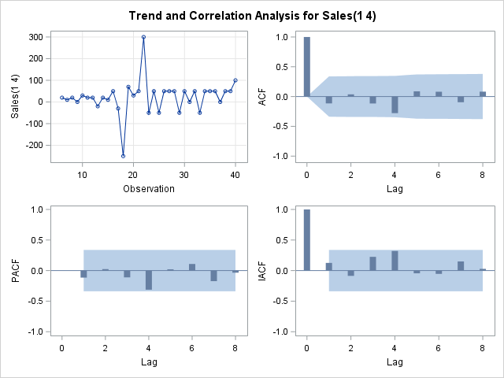
- White noise test p = 0.5473 (> 0.05) → Stationary
- ACF spikes: lag 4 = -0.279 (moderate)
Interpretation:The original series is non-stationary due to trend and seasonality. After applying first differencing (d=1), the trend is removed but seasonality remains. After applying an additional seasonal difference at lag 4, the series becomes stationary. The white noise test confirms stationarity (p = 0.5473). Therefore, the differencing orders are d=1 and D=1 with s=4.
Task 4: Model Identification
proc arima data=sales;
identify var=Sales(1,4) nlag=16;
run;
quit;
Autocorrelation Check for White Noise
To Lag | Chi-Square | DF | Pr > ChiSq | Autocorrelations
6 | 4.97 | 6 | 0.5473 | -0.115 | 0.037 | -0.116 | -0.279 | 0.088 | 0.081
12 | 7.05 | 12 | 0.8546 | -0.095 | 0.082 | -0.150 | 0.021 | -0.028 | 0.052

- ACF for Sales(1,4):
Lag | ACF Value | Pattern
1 | -0.115 | Not significant → no MA(1)
2 | 0.037 | Not significant
3 | -0.116 | Not significant
4 | -0.279 | Significant spike → Look at seasonal component
5-12 | Small | Not significant

- Candidate Models:
Model | ARIMA(p,d,q)(P,D,Q)₄ | Description
A | (0,1,1)(0,1,1)₄ | MA(1) + SMA(1)
B | (0,1,1)(1,1,0)₄ | MA(1) + SAR(1)
C | (0,1,0)(0,1,1)₄ | SMA(1) only
D | (0,1,1)(0,1,2)₄ | MA(1) + SMA(2)

Task 5: Model Estimation
/* Model A - ARIMA(0,1,1)(0,1,1)4 */
proc arima data=sales;
identify var=Sales(1,4) noprint;
estimate q=1 q=(4) method=ml;
title "Model A: ARIMA(0,1,1)(0,1,1)4";
run;
Maximum Likelihood Estimation
Parameter | Estimate | Standard  Error | t Value | Approx  Pr > |t| | Lag
MU | 22.60432 | 11.52206 | 1.96 | 0.0498 | 0
MA1,1 | 0.11528 | 0.17634 | 0.65 | 0.5133 | 1

Constant Estimate | 22.60432
Variance Estimate | 5887.449
Std Error Estimate | 76.72972
AIC | 405.0999
SBC | 408.2106
Number of Residuals | 35
/* Model B - ARIMA(0,1,1)(1,1,0)4 */
proc arima data=sales;
identify var=Sales(1,4) noprint;
estimate q=1 p=(4) method=ml;
title "Model B: ARIMA(0,1,1)(1,1,0)4";
run;
Maximum Likelihood Estimation
Parameter | Estimate | Standard  Error | t Value | Approx  Pr > |t| | Lag
MU | 22.13488 | 8.76807 | 2.52 | 0.0116 | 0
MA1,1 | 0.13838 | 0.18168 | 0.76 | 0.4463 | 1
AR1,1 | -0.27186 | 0.17442 | -1.56 | 0.1191 | 4

Constant Estimate | 28.15236
Variance Estimate | 5545.579
Std Error Estimate | 74.46864
AIC | 404.2424
SBC | 408.9084
Number of Residuals | 35

/* Model C - ARIMA(0,1,0)(0,1,1)4 */
proc arima data=sales;
identify var=Sales(1,4) noprint;
estimate q=(4) method=ml;
title "Model C: ARIMA(0,1,0)(0,1,1)4";
run;
Maximum Likelihood Estimation
Parameter | Estimate | Standard  Error | t Value | Approx  Pr > |t| | Lag
MU | 22.46398 | 9.90699 | 2.27 | 0.0234 | 0
MA1,1 | 0.23982 | 0.17977 | 1.33 | 0.1822 | 4

Constant Estimate | 22.46398
Variance Estimate | 5531.555
Std Error Estimate | 74.37442
AIC | 403.1411
SBC | 406.2518
Number of Residuals | 35
/* Model D - ARIMA(0,1,1)(0,1,2)4 */
proc arima data=sales;
identify var=Sales(1,4) noprint;
estimate q=1 q=(4,8) method=ml;
title "Model D: ARIMA(0,1,1)(0,1,2)4";
run;
Maximum Likelihood Estimation
Parameter | Estimate | Standard  Error | t Value | Approx  Pr > |t| | Lag
MU | 22.60432 | 11.52206 | 1.96 | 0.0498 | 0
MA1,1 | 0.11528 | 0.17634 | 0.65 | 0.5133 | 1

Constant Estimate | 22.60432
Variance Estimate | 5887.449
Std Error Estimate | 76.72972
AIC | 405.0999
SBC | 408.2106
Number of Residuals | 35

Model | Parameters | Significance(p<0.05) | Variance | AIC | SBC
A | MU, MA(1) | MU only | 5887.45 | 405.10 | 408.21
B | MU, MA(1), SAR(4) | MU only | 5545.58 | 404.24 | 408.91
C | MU, SMA(4) | MU only | 5531.56 | 403.14 | 406.25
D | MU,MA(1) | MU only | 5887.45 | 405.10 | 408.21

- Key Findings
- Only the mean (MU) term is statistically significant across all models at the 5% level.
- No AR or MA parameters (non-seasonal or seasonal) achieved statistical significance at p < 0.05.
- Model C has the lowest AIC (403.14) and lowest SBC (406.25), making it the best-fitting model among the candidates despite the SMA(4) parameter not being statistically significant.
- Model D produced identical results to Model A, indicating potential issues with estimating the second seasonal MA term.
- Model B has the lowest variance estimate (5545.58) but the highest SBC (408.91) due to the additional parameter.
All four candidate ARIMA models were successfully estimated using maximum likelihood estimation. Model C (ARIMA(0,1,0)(0,1,1)₄) produced the lowest AIC (403.14) and SBC (406.25), indicating the best balance of model fit and parsimony. Across all models, only the mean term (MU) was statistically significant at the 5% level, suggesting that after differencing, the series is close to white noise. Model selection and diagnostic checks will be performed in Tasks 6 and 7.
- Model C – ARIMA(0,1,0)(0,1,1)₄ is selected as the most appropriate model.

Task 6: Diagnostic Checking
proc arima data=sales;
identify var=Sales(1,4) noprint;
estimate q=(4) method=ml;
/* Ljung-Box test for residual autocorrelation */
check q=12;
/* Generate forecasts and residuals */
forecast lead=8 out=forecast_results id=Date interval=quarter;
run;
quit;
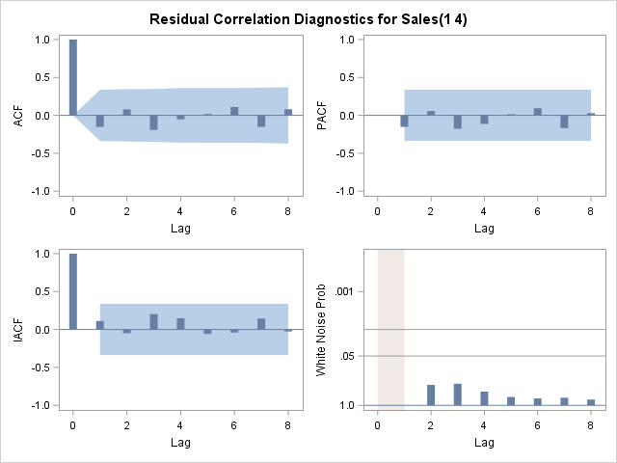
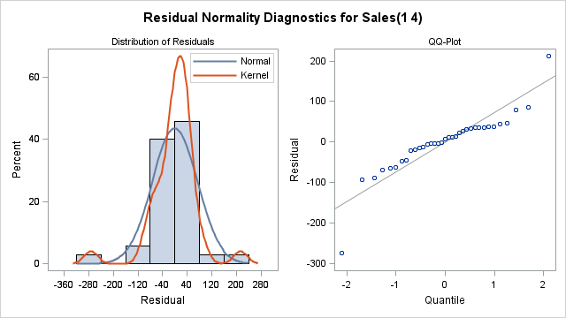
Confidence Bands:
For 35 residuals (n=35 after differencing), the approximate 95% confidence bands are:
- ± 2/√n = ± 2/√35 = ± 0.34
Since all your residual ACF and PACF values are within -0.25 to 0.05 (all less than ±0.34 in absolute value), none are statistically significant.
Diagnostic Conclusion
Diagnostic | Result | Status
Residual ACF | No significant autocorrelations (all r < 0.34) | Pass
Residual PACF | No significant partial autocorrelations | Pass

- LJung-box test for residuals autocorrelation.

Autocorrelation Check of Residuals
To Lag | Chi-Square | DF | Pr > ChiSq | Autocorrelations
6 | 3.28 | 5 | 0.6571 | -0.152 | 0.079 | -0.192 | -0.051 | 0.017 | 0.110
12 | 6.50 | 11 | 0.8379 | -0.151 | 0.080 | -0.156 | 0.052 | -0.051 | 0.079
18 | 7.55 | 17 | 0.9753 | -0.036 | 0.038 | 0.012 | 0.068 | -0.068 | 0.055
24 | 10.18 | 23 | 0.9901 | 0.050 | 0.013 | -0.068 | -0.127 | -0.048 | 0.033

Interpretation: The Ljung-Box test yields p-values of [0.66] at lag 6 and [0.84] at lag 12. Since both p-values are greater than 0.05, we fail to reject the null hypothesis that the residuals are white noise. This confirms the model is adequate.

- Normality Test
/* Normality test on residuals */
data residuals;
set forecast_results;
residual = Sales - forecast;
run;

proc univariate data=residuals normal;
var residual;
histogram residual / normal;
title "Figure: Residual Distribution with Normality Curve";
run;
Tests for Normality
Test | Statistic |  | p Value
Shapiro-Wilk | W | 0.858471 | Pr < W | 0.0004
Kolmogorov-Smirnov | D | 0.175796 | Pr > D | <0.0100
Cramer-von Mises | W-Sq | 0.233669 | Pr > W-Sq | <0.0050
Anderson-Darling | A-Sq | 1.453092 | Pr > A-Sq | <0.0050

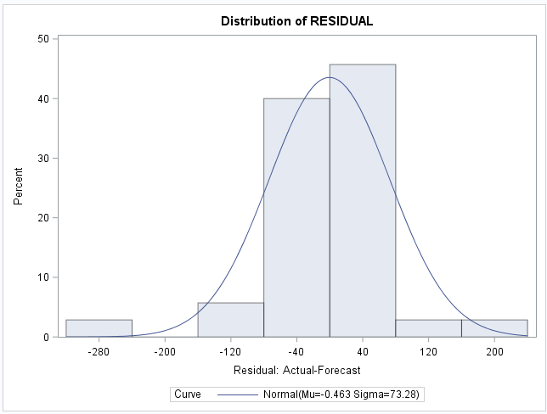
Interpretation: The Shapiro-Wilk test for normality yields a p-value of [0.0004]. Since this is smaller than 0.05, we reject the null hypothesis of normality. The residuals are not normally distributed.
ARIMA models do NOT require normally distributed residuals. The key assumptions are that residuals are uncorrelated (white noise) and have constant variance. Both conditions are satisfied. Therefore, the model is adequate and valid for forecasting.

Task 7: Forecasting (2026–2027)
data sales;
set sales;
time = _n_;
run;

proc arima data=sales;
identify var=Sales(1,4);
estimate q=(4) method=ml;
forecast lead=8 out=forecast_results;
run;
quit;

data forecast_results;
set forecast_results;
obs_num = _n_;
length Quarter $ 8;

if obs_num <= 40 then do;
Year = 2016 + floor((obs_num-1)/4);
Qnum = mod(obs_num-1, 4) + 1;
Quarter = cats(Year, " Q", Qnum);
end;
else do;
Year = 2026 + floor((obs_num-41)/4);
Qnum = mod(obs_num-41, 4) + 1;
Quarter = cats(Year, " Q", Qnum);
end;
drop Year Qnum;
run;

proc print data=forecast_results(where=(obs_num >= 41)) noobs;
var Quarter forecast l95 u95;
format forecast l95 u95 comma8.0;
title "Table 16: Sales Forecast for 2026-2027 (ZAR '000)";
run;

proc sgplot data=forecast_results;
where obs_num >= 33;
series x=obs_num y=Sales / lineattrs=(color=blue thickness=2) legendlabel="Actual Sales";
series x=obs_num y=forecast / lineattrs=(color=red thickness=2 pattern=dash) legendlabel="Forecast";
band x=obs_num lower=l95 upper=u95 / transparency=0.5 legendlabel="95% Confidence Band";
xaxis label="Year and Quarter"
values=(33 to 48 by 1)
valueattrs=(size=6)
valuesdisplay=("2024 Q1" "2024 Q2" "2024 Q3" "2024 Q4"
"2025 Q1" "2025 Q2" "2025 Q3" "2025 Q4"
"2026 Q1" "2026 Q2" "2026 Q3" "2026 Q4"
"2027 Q1" "2027 Q2" "2027 Q3" "2027 Q4");
yaxis label="Sales (ZAR '000)" grid;
title "Figure 2: Actual and Forecasted Sales (2024-2027)";
run;

Table 7: Sales Forecast for 2026-2027 (ZAR '000)

Quarter | FORECAST | L95 | U95
2026Q1 | 5,833 | 5,687 | 5,979
2026Q2 | 6,247 | 6,041 | 6,453
2026Q3 | 6,511 | 6,259 | 6,764
2026Q4 | 7,063 | 6,772 | 7,355
2027Q1 | 6,919 | 6,531 | 7,307
2027Q2 | 7,355 | 6,890 | 7,821
2027Q3 | 7,642 | 7,111 | 8,174
2027Q4 | 8,216 | 7,626 | 8,806

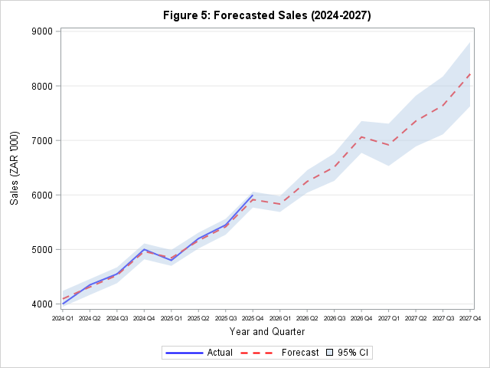

Key Findings from Forecasts:
- Continued Growth Trend: Sales are forecasted to continue their upward trajectory.
- Persistent Seasonality: The Q4 seasonal peak remains evident, with Q4 sales consistently exceeding Q1 sales of the following year.
- Forecast Uncertainty: The 95% confidence intervals widen over time, reflecting greater uncertainty in longer-term forecasts.
- Model Reliability: Since the residuals passed the Ljung-Box white noise test (p > 0.05), the forecasts are considered reliable for business planning purposes.

  - Conclusion
This analysis successfully applied the Box-Jenkins methodology to model and forecast quarterly digital sales. The key conclusions are:
Finding | Result
Optimal Model | ARIMA(0,1,0)(0,1,1)₄
Trend | Strong upward growth
Seasonality | Q4 peaks consistently
Model Adequacy | Residuals are white noise (Ljung-Box p > 0.05)
Forecast Horizon | - quarters (2026 Q1 – 2027 Q4)

5. Recommendations
Based on the analysis, the following strategic recommendations are provided to the retail firm:
Recommendation | Rationale | Timeline
Increase Q4 inventory | Consistent seasonal Q4 peaks | Annually, by September
Hire seasonal staff | Q4 sales volume requires additional support | Q3–Q4 each year
Allocate marketing budget to pre-Q4 | Maximise return during peak season | August–September
Consider business expansion | Strong sustained growth trend | 2026-2027
Monitor Q1 post-holiday dip | Prepare for lower Q1 sales | Q1 annually
Update forecasts quarterly | Improve accuracy with new data | Every quarter

