STFM 312 Assignment
Box–Jenkins Modelling of Epsilon Data Mining Quarterly Sales
Neo Mthembu
Student number: 36321389
North-West University | BCom Statistics
Summary
Ten years of quarterly sales (2016 Q1 – 2025 Q4) were modelled with the Box–Jenkins method. The series has a strong upward trend and a Q4 seasonal peak, and needed one regular and one seasonal difference (d = 1, D = 1, s = 4) to become stationary.
Of four candidate models, ARIMA(0,1,0)(0,1,1)₄ had the lowest AIC (403.14) and SBC (406.25). Its residuals pass the Ljung–Box white-noise test, so it is used to forecast 2026–2027: sales are expected to rise from about R5.8 million in 2026 Q1 to about R8.2 million in 2027 Q4.

1. Introduction
Epsilon Data Mining (Pty) Ltd was contracted by a retail firm to analyse ten years of quarterly sales data (2016–2025) and to produce reliable forecasts for 2026 and 2027. The objective is to apply the Box–Jenkins (ARIMA) methodology to understand sales dynamics, identify trend and seasonality, build forecasting models, and provide practical business insights.
This report covers the full time series workflow: data visualisation, stationarity testing, differencing, model identification, estimation, diagnostic checking and forecasting.

2. Methodology

2.1 Data
The dataset has 40 quarterly observations from 2016 Q1 to 2025 Q4. Sales are measured in thousands of South African Rand (ZAR ’000). The SAS data step is given in Appendix A.
Variable | Description
Quarter | Time index (2016 Q1 – 2025 Q4)
Sales | Quarterly sales revenue (ZAR ’000)

2.2 Box–Jenkins procedure
The analysis follows four steps. All analysis was done in SAS (PROC ARIMA, PROC SGPLOT and PROC UNIVARIATE).
Step | Description
Identification | Plot the data, check stationarity and determine the differencing orders
Estimation | Estimate candidate model parameters by maximum likelihood (ML)
Diagnostic checking | Verify that residuals behave as white noise (Ljung–Box test)
Forecasting | Generate forecasts with 95% confidence intervals

3. Analysis

Task 1: Data preparation and visualisation
The data were loaded into SAS and plotted as a time series (Appendix A). Table 1 gives the summary statistics.
Table 1: Summary statistics of quarterly sales
Statistic | Value
Number of observations | 40
Mean | 2,690.75 (ZAR ’000)
Standard deviation (sample) | 1,419.11 (ZAR ’000)
Minimum | 900 (2016 Q1)
Maximum | 6,000 (2025 Q4)
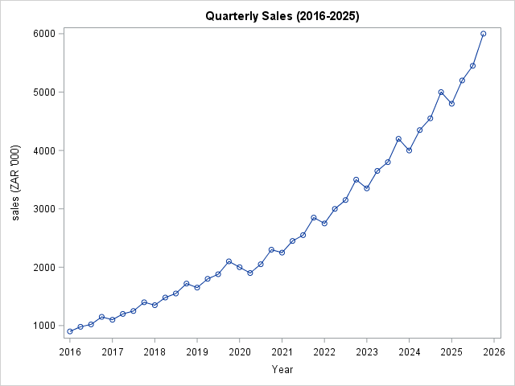
Figure 1: Quarterly sales, 2016 Q1 – 2025 Q4 (ZAR ’000)
Description: Sales show a strong upward trend, rising from 900 in 2016 Q1 to 6,000 in 2025 Q4, more than a six-fold increase. A clear seasonal pattern is visible, with peaks in Q4 of every year. The spread of the series also grows over time, which points to non-stationarity. A small dip in 2020 Q2 (from 2,000 to 1,900) is probably linked to COVID-19 disruption, but the series recovers quickly.

Task 2: Stationarity check
proc arima data=sales;
identify var=Sales stationarity=(adf);
run;
quit;

Table 2: Autocorrelation check for white noise (original series)
To lag | Chi-square | DF | Pr > ChiSq | Autocorrelations (lags 1–6)
6 | 139.61 | 6 | <.0001 | 0.898, 0.818, 0.737, 0.675, 0.584, 0.513
Table 3: Augmented Dickey–Fuller unit root tests (original series)
Type | Lags | Rho | Pr < Rho | Tau | Pr < Tau | F | Pr > F
Zero mean | 0 | 1.9528 | 0.9839 | 5.38 | 0.9999
Zero mean | 1 | 1.8415 | 0.9799 | 7.62 | 0.9999
Zero mean | 2 | 1.7725 | 0.9768 | 5.09 | 0.9999
Single mean | 0 | 1.9358 | 0.9964 | 2.37 | 0.9999 | 14.07 | 0.0010
Single mean | 1 | 1.9089 | 0.9962 | 4.21 | 0.9999 | 28.24 | 0.0010
Single mean | 2 | 1.8409 | 0.9958 | 3.72 | 0.9999 | 12.60 | 0.0010
Trend | 0 | -1.1085 | 0.9842 | -0.32 | 0.9872 | 3.19 | 0.5570
Trend | 1 | 1.7545 | 0.9993 | 0.90 | 0.9998 | 8.61 | 0.0122
Trend | 2 | 1.7792 | 0.9993 | 0.95 | 0.9999 | 6.71 | 0.0509
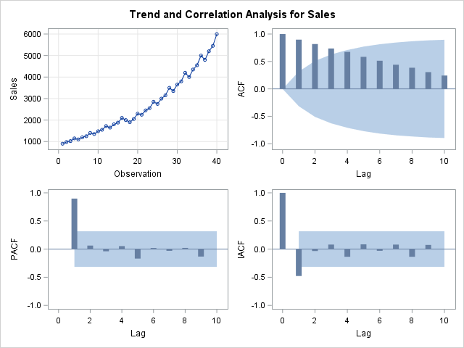
Figure 2: Trend and correlation analysis for Sales
Interpretation: The ADF tau p-values are all above 0.98, far larger than 0.05, so the null hypothesis of a unit root is not rejected and the original series is non-stationary. The ACF decays slowly (lag 1 = 0.898, lag 2 = 0.818, lag 3 = 0.737), which confirms a strong trend.

Task 3: Differencing
First difference. A first difference (d = 1) is applied to remove the trend.
proc arima data=sales;
identify var=Sales(1); /* first difference */
run;

Table 4: Autocorrelation check for white noise, Sales(1)
To lag | Chi-square | DF | Pr > ChiSq | Autocorrelations (lags 1–6)
6 | 49.00 | 6 | <.0001 | -0.333, 0.332, -0.386, 0.750, -0.297, 0.253
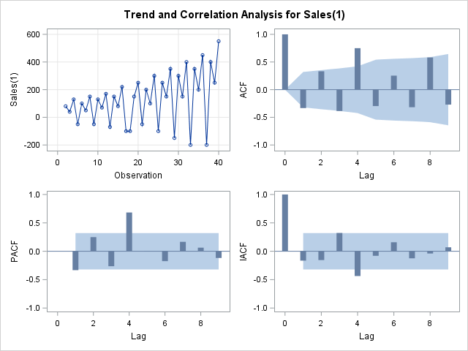
Figure 3: Trend and correlation analysis for Sales(1)
Interpretation: The trend has been removed, but a strong seasonal spike remains at lag 4 (0.750) and the white-noise test is still rejected (p < 0.0001). A seasonal difference is therefore needed.
First and seasonal difference. A seasonal difference at lag 4 is added (quarterly data).
proc arima data=sales;
identify var=Sales(1,4); /* regular + seasonal difference */
run;

Table 5: Autocorrelation check for white noise, Sales(1,4)
To lag | Chi-square | DF | Pr > ChiSq | Autocorrelations (lags 1–6)
6 | 4.97 | 6 | 0.5473 | -0.115, 0.037, -0.116, -0.279, 0.088, 0.081
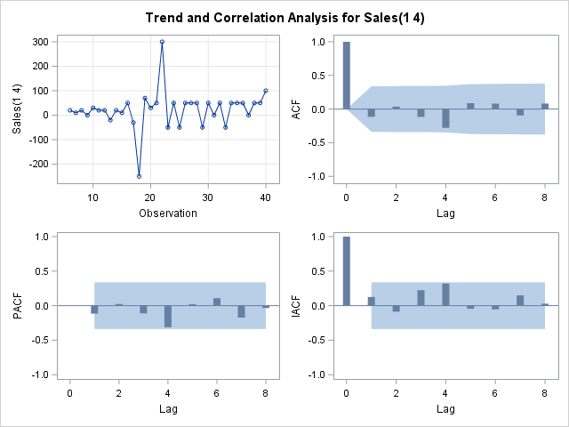
Figure 4: Trend and correlation analysis for Sales(1,4)
Interpretation: The original series is non-stationary because of trend and seasonality. The first difference removes the trend but leaves the seasonal pattern; adding a seasonal difference at lag 4 gives a stationary series (white-noise p = 0.5473 > 0.05). The differencing orders are therefore d = 1, D = 1 and s = 4. The only noticeable ACF spike is at lag 4 (−0.279).

Task 4: Model identification
proc arima data=sales;
identify var=Sales(1,4) nlag=16;
run;
quit;

Table 6: Autocorrelation check for white noise, Sales(1,4)
To lag | Chi-square | DF | Pr > ChiSq | Autocorrelations (lags 1–6)
6 | 4.97 | 6 | 0.5473 | -0.115, 0.037, -0.116, -0.279, 0.088, 0.081
12 | 7.05 | 12 | 0.8546 | -0.095, 0.082, -0.150, 0.021, -0.028, 0.052
Reading the ACF of the differenced series:
- Lags 1–3 (−0.115, 0.037, −0.116) are small, so there is no clear non-seasonal MA(1) term.
- Lag 4 (−0.279) is the largest spike, which points to a seasonal MA component.
- Lags 5–12 are all small and not significant.
Based on this, four candidate models were chosen (Table 7).
Table 7: Candidate models
Model | ARIMA(p,d,q)(P,D,Q)₄ | Description
A | (0,1,1)(0,1,1)₄ | MA(1) + seasonal MA(1)
B | (0,1,1)(1,1,0)₄ | MA(1) + seasonal AR(1)
C | (0,1,0)(0,1,1)₄ | Seasonal MA(1) only
D | (0,1,1)(0,1,2)₄ | MA(1) + seasonal MA(2)

Task 5: Model estimation
Each candidate was estimated by maximum likelihood. The SAS code for all four models follows the same pattern:
/* Model A: ARIMA(0,1,1)(0,1,1)4 */
proc arima data=sales;
identify var=Sales(1,4) noprint;
estimate q=1 q=(4) method=ml;
run;

/* Model B: estimate q=1 p=(4) method=ml; */
/* Model C: estimate q=(4) method=ml; */
/* Model D: estimate q=1 q=(4,8) method=ml; */

Table 8: Parameter estimates (maximum likelihood)
Model | Parameter | Estimate | Std. error | t value | Pr > |t| | Lag
A | MU | 22.60432 | 11.52206 | 1.96 | 0.0498 | 0
A | MA1,1 | 0.11528 | 0.17634 | 0.65 | 0.5133 | 1
B | MU | 22.13488 | 8.76807 | 2.52 | 0.0116 | 0
B | MA1,1 | 0.13838 | 0.18168 | 0.76 | 0.4463 | 1
B | AR1,1 | -0.27186 | 0.17442 | -1.56 | 0.1191 | 4
C | MU | 22.46398 | 9.90699 | 2.27 | 0.0234 | 0
C | MA1,1 | 0.23982 | 0.17977 | 1.33 | 0.1822 | 4
D | MU | 22.60432 | 11.52206 | 1.96 | 0.0498 | 0
D | MA1,1 | 0.11528 | 0.17634 | 0.65 | 0.5133 | 1
Table 9: Fit statistics and model comparison
Model | Parameters | Significant (p < 0.05) | Variance | AIC | SBC | Residuals
A | MU, MA(1) | MU only | 5,887.45 | 405.10 | 408.21 | 35
B | MU, MA(1), SAR(4) | MU only | 5,545.58 | 404.24 | 408.91 | 35
C | MU, SMA(4) | MU only | 5,531.56 | 403.14 | 406.25 | 35
D | MU, MA(1) | MU only | 5,887.45 | 405.10 | 408.21 | 35

Key findings
- Only the mean term (MU) is significant at the 5% level in every model. No AR or MA parameter, seasonal or non-seasonal, is individually significant.
- Model C has the lowest AIC (403.14) and lowest SBC (406.25), so it is the best of the four candidates even though its seasonal MA term is not significant on its own.
- Model B’s extra seasonal AR term does not pay for itself: its variance (5,545.58) is slightly higher than Model C’s (5,531.56) and it has the highest SBC (408.91).
- Model D returned exactly the same output as Model A, which suggests the second seasonal MA term (lag 8) was not actually estimated. Model D is therefore not treated as a separate model.
Conclusion: Model C, ARIMA(0,1,0)(0,1,1)₄, is selected as the most appropriate model. Because only the mean is significant, the differenced series is already close to white noise. Diagnostic checks follow in Task 6.

Task 6: Diagnostic checking
proc arima data=sales;
identify var=Sales(1,4) noprint;
estimate q=(4) method=ml;
forecast lead=8 out=forecast_results;
run;
quit;

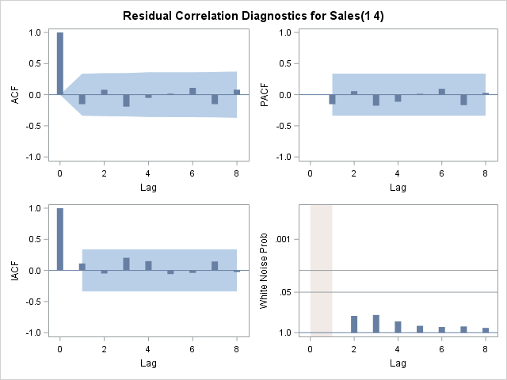
Figure 5: Residual correlation diagnostics for Sales(1,4)
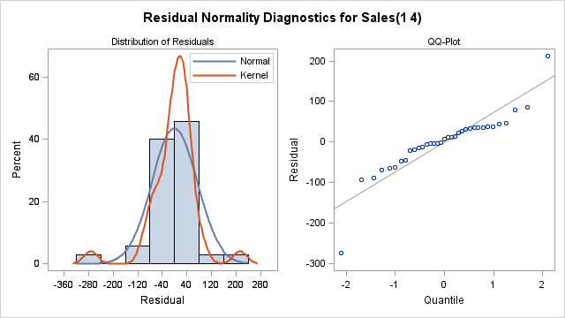
Figure 6: Residual normality diagnostics for Sales(1,4)
Residual ACF and PACF. With 35 residuals, the approximate 95% confidence bands are ±2/√35 ≈ ±0.34. All residual autocorrelations (Table 10) lie well inside these bands (the largest in absolute value is 0.192), so none is significant.
Table 10: Ljung–Box autocorrelation check of residuals
To lag | Chi-square | DF | Pr > ChiSq | Autocorrelations (first six lags of each block)
6 | 3.28 | 5 | 0.6571 | -0.152, 0.079, -0.192, -0.051, 0.017, 0.110
12 | 6.50 | 11 | 0.8379 | -0.151, 0.080, -0.156, 0.052, -0.051, 0.079
18 | 7.55 | 17 | 0.9753 | -0.036, 0.038, 0.012, 0.068, -0.068, 0.055
24 | 10.18 | 23 | 0.9901 | 0.050, 0.013, -0.068, -0.127, -0.048, 0.033
Table 11: Diagnostic summary
Diagnostic | Result | Status
Residual ACF | No significant autocorrelations (all |r| < 0.34) | Pass
Residual PACF | No significant partial autocorrelations | Pass
Ljung–Box test | p = 0.66 (lag 6), 0.84 (lag 12), 0.98 (lag 18), 0.99 (lag 24) | Pass
Normality (Shapiro–Wilk) | W = 0.8585, p = 0.0004 | Fail
Ljung–Box interpretation: All p-values are greater than 0.05 (0.66 at lag 6 and 0.84 at lag 12), so we fail to reject the null hypothesis that the residuals are white noise. The model is adequate.
Normality test. Residuals were computed as actual minus forecast and tested with PROC UNIVARIATE:
data residuals;
set forecast_results;
residual = Sales - forecast;
run;

proc univariate data=residuals normal;
var residual;
histogram residual / normal;
run;

Table 12: Tests for normality of residuals
Test | Statistic | Value | p-value
Shapiro–Wilk | W | 0.858471 | 0.0004
Kolmogorov–Smirnov | D | 0.175796 | <0.0100
Cramér–von Mises | W-Sq | 0.233669 | <0.0050
Anderson–Darling | A-Sq | 1.453092 | <0.0050
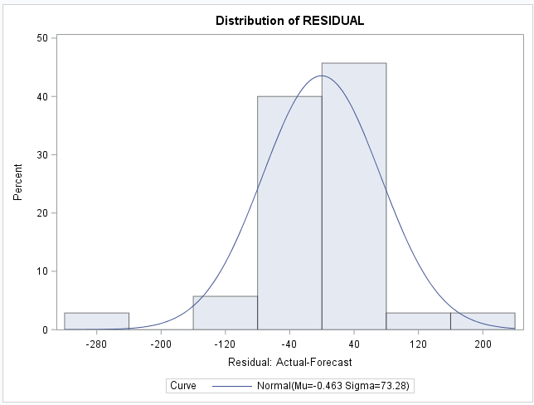
Figure 7: Residual distribution with fitted normal curve
Interpretation: All four tests reject normality (Shapiro–Wilk p = 0.0004). The histogram shows a few large negative residuals in the left tail. Normal residuals are not required to fit or forecast with an ARIMA model; what matters most is that the residuals are uncorrelated, and the Ljung–Box test shows they are. The point forecasts remain valid, but the 95% intervals rely on approximate normality and should be read with some caution. Overall the model is adequate for forecasting.

Task 7: Forecasting (2026–2027)
proc arima data=sales;
identify var=Sales(1,4);
estimate q=(4) method=ml;
forecast lead=8 out=forecast_results;
run;
quit;

Table 13: Sales forecast for 2026–2027 (ZAR ’000)
Quarter | Forecast | Lower 95% | Upper 95%
2026 Q1 | 5,833 | 5,687 | 5,979
2026 Q2 | 6,247 | 6,041 | 6,453
2026 Q3 | 6,511 | 6,259 | 6,764
2026 Q4 | 7,063 | 6,772 | 7,355
2027 Q1 | 6,919 | 6,531 | 7,307
2027 Q2 | 7,355 | 6,890 | 7,821
2027 Q3 | 7,642 | 7,111 | 8,174
2027 Q4 | 8,216 | 7,626 | 8,806
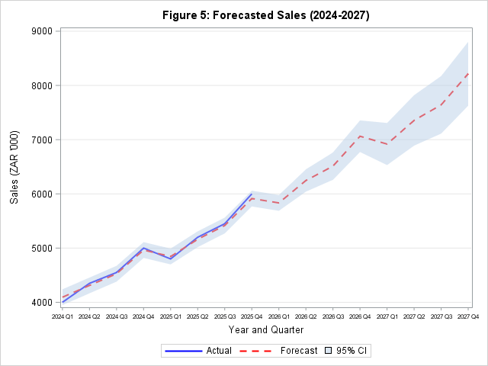
Figure 8: Actual and forecast sales, 2024 Q1 – 2027 Q4, with 95% confidence band
Key findings from the forecasts
- Continued growth. Sales keep rising, from 5,833 in 2026 Q1 to 8,216 in 2027 Q4.
- Persistent seasonality. Q4 remains the peak quarter and each Q1 dips below the preceding Q4 (for example 7,063 in 2026 Q4 versus 6,919 in 2027 Q1).
- Growing uncertainty. The 95% interval widens from ±146 in 2026 Q1 to ±590 in 2027 Q4.
- Reliability. Residuals pass the Ljung–Box test (p > 0.05), so the forecasts are suitable for business planning, bearing in mind the normality caveat above.

4. Conclusion
The Box–Jenkins methodology was applied to quarterly sales for 2016–2025. The main results are:
Finding | Result
Selected model | ARIMA(0,1,0)(0,1,1)₄ (lowest AIC and SBC)
Differencing | d = 1, D = 1, s = 4
Trend | Strong upward growth
Seasonality | Consistent Q4 peaks
Model adequacy | Residuals are white noise (Ljung–Box p > 0.05); not normal
Forecast horizon | 8 quarters (2026 Q1 – 2027 Q4)

5. Recommendations
Based on the analysis, the following recommendations are made to the retail firm:
Recommendation | Rationale | Timeline
Increase Q4 inventory | Consistent seasonal Q4 peaks | Annually, by September
Hire seasonal staff | Q4 sales volume needs extra support | Q3–Q4 each year
Allocate marketing budget to the pre-Q4 period | Maximise return during the peak season | August–September
Consider business expansion | Strong, sustained growth trend | 2026–2027
Plan for the Q1 dip | Q1 sales fall back after the Q4 peak | Q1 annually
Update forecasts quarterly | Improve accuracy as new data arrive | Every quarter

Appendix A: SAS data step and time series plot
data sales;
format Quarter yyq6.;
input Quarter : yyq6. Sales;
datalines;
2016Q1 900 2016Q2 980 2016Q3 1020 2016Q4 1150
2017Q1 1100 2017Q2 1200 2017Q3 1250 2017Q4 1400
2018Q1 1350 2018Q2 1480 2018Q3 1550 2018Q4 1720
2019Q1 1650 2019Q2 1800 2019Q3 1880 2019Q4 2100
2020Q1 2000 2020Q2 1900 2020Q3 2050 2020Q4 2300
2021Q1 2250 2021Q2 2450 2021Q3 2550 2021Q4 2850
2022Q1 2750 2022Q2 3000 2022Q3 3150 2022Q4 3500
2023Q1 3350 2023Q2 3650 2023Q3 3800 2023Q4 4200
2024Q1 4000 2024Q2 4350 2024Q3 4550 2024Q4 5000
2025Q1 4800 2025Q2 5200 2025Q3 5450 2025Q4 6000
;
run;

proc sgplot data=sales;
series x=Quarter y=Sales / markers;
xaxis label="Year";
yaxis label="Sales (ZAR 000)";
title "Quarterly Sales (2016-2025)";
run;

