Vector2.MoveTowards()

Makes the object move towards the target position as specified in the parameter of *Vector2.MoveTowards()* parameters. Useful in moving an object through a series of waypoints having their own respective position in the scene.

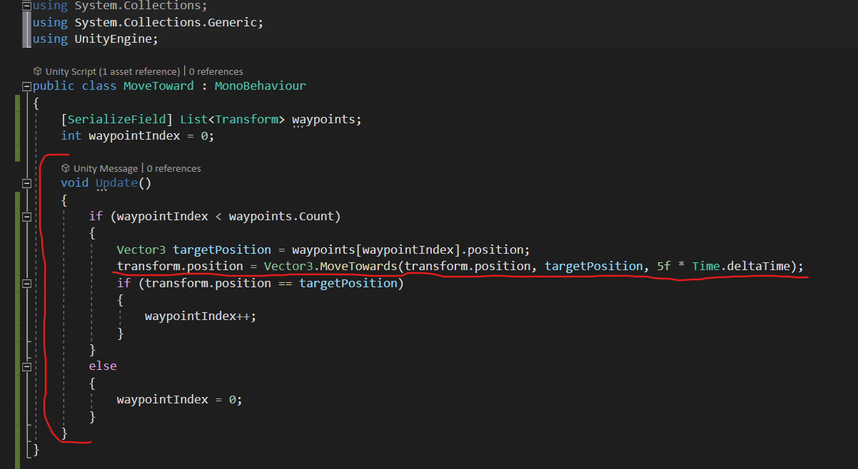

List of type Transform for waypoints is created and as per the requirement in which object travels the desired **path** followed by different **waypoints** placed in the scene.