BEVUE Lazy Array
Processing EEG data in the web browser is a little more complex than expected. Each channel needs to be loaded and filtered, but you do not want to do everything at once before the application even loads, because you will wait for a long time. Instead, you want to load the data from the HDF5 file, and cache it to avoid reading it again when the view changes slightly. Similarly, if you want to display filtered data, you should cache the filtered data while you use the same filter parameters.
And trust me, you want the data to be loaded fast. While the user is waiting for the application to load, Figure 1 is displayed to the user. The more time the application spends loading data, the longer this cursed image appears on screen.
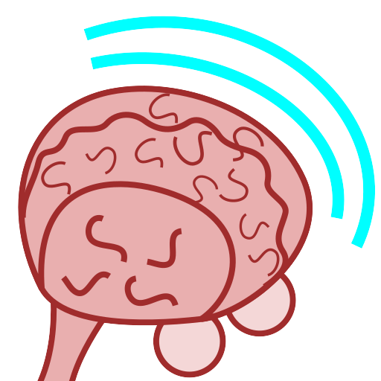Figure 1: Loading image

The problem is channel-independent
Each channel is processed independently, so there is no need to keep all channels in the same instance of a data structure, but we can still reuse the code for each channel.

The problem is the same for raw data and filtered data
If you can store bits of raw channel data, you can use the same data structure to store bits of filtered data. The difference is that you need more raw data for some amount of filtered data, because the convolution filter needs margin before and after the part of the data that you want to filter.

The data structure
The data structure is defined as an alternating linked list of empty and full sections. The full sections contain known data, and the empty sections are just placeholders. They are alternating, because in a non-empty chain of sections, the first and the last sections always have data, and no two sections of the same type are next to each other. Each section is linked to its previous section with the before property, and with the next section with the after property.
A section consists of an array of values, if it is a full section, a starting index and a length. The lazy array itself just knows the first section and the last section.
The special JavaScript null value indicates that the link is not set. For a lazy array, if the first or the last section is null, then it means that there are no sections in the array. In fact, if either of them is null, then both must be null. For a section, if its before (respectively, after) property is null, then it just means that this is the first (respectively, the last) section of the array.
The code is shipped with a test that demonstrates a little scenario where some bits of data are put to the array. At the end of the 7th step, the data structure is laid out in a way that is explained in Figure 2. There are three full sections of the array, each of them having exactly one value. Between these full sections, two empty sections are present. They do not occupy any memory for the actual data. Each section is linked to its previous and next sections, except for the first section and the last section. They are not linked to any further sections.
Figure 2: Test scenario after the 7th step

Using the code
The code is provided to you as a NPM package. You can install it like any other Neonatool dependency of BEVUE, by setting up your local NPM installation to be able to pull from the NPM registry provided by plmlab. See the plmlab page for the project at:
https://plmlab.math.cnrs.fr/neonatool/lazy-array
The default module exports just one class as a default, that we will name LazyArray.

Constructor
The class constructor does not expect any argument. It always creates an empty array.

Async method: slice (start, length, fetcher)
This method asynchronously returns a Float64Array of length that contains the whole data starting at start. If there are empty sections, or if the lazy array is yet empty, the missing data are loaded in new full sections by calling the asynchronous fetcher. This function receives as a number the index of the next data span to load, and as a second number, the number of floats to load.
If there are multiple empty sections that need to be filled for the request to be satisfied, the fetcher may be called multiple times.

Non-async method: forget (start, length)
Invalidate the length numbers starting at start. If you request them again by calling the slice method, then they will be loaded again. Does not return anything, does not throw exceptions.

