

|  |
| --- |
| Business Template  **Subject areas** |
| **Logo / Image** |

Contents

1 Business Description 3

1.1 Business background 3

1.2 Problems. Current Situation 3

1.3 The benefits of implementing a database. Project Vision 3

2 Model description 3

2.1 Definitions & Acronyms 3

2.2 Logical Scheme 3

2.3 Objects 3

# 

# Business Description

## Business background

## This section outlines the significance of mountaineering for the club and emphasizes the necessity for a structured database to systematically record information about climbs, climbers, and mountains.

## Problems. Current Situation

## Describes the operational challenges faced by the club in the absence of a database, such as difficulties in tracking climber achievements, managing detailed records of climbs, and maintaining up-to-date safety information.

## the Benefits of implementing a database. Project Vision

## Highlights how the introduction of a database will solve existing problems, enhance club operations, improve safety protocols, and provide valuable insights into climbing activities.

# Model description

## Definitions & Acronyms

## Highlights how the introduction of a database will solve existing problems, enhance club operations, improve safety protocols, and provide valuable insights into climbing activities.

## Logical Scheme

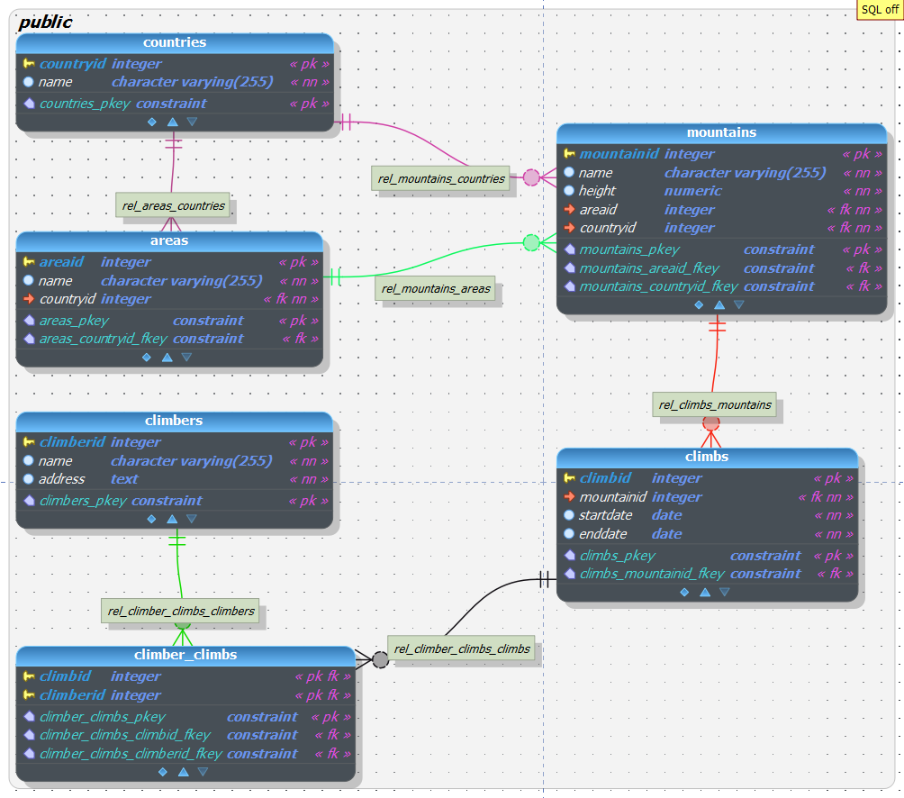

## Objects

## This part offers a comprehensive description of each entity (table) in the database, including the table name, field names, their descriptions, data types, and any noteworthy comments regarding table relationships or constraintsThe ClimberID field is used as a foreign key in the Climber_Climbs table to establish a many-to-many relationship between Climbers and Climbs, indicating which climbers have participated in which climbs..

## Table Description

## Table Name: Climbers

## Description: This table stores information about each climber who is a member of the mountaineering club or participates in club activities. It includes personal details such as names and addresses.

|  |  |  |  |
| --- | --- | --- | --- |
| Table Name | Field name | Field Description | Data Type |
| Climbers | ClimberID | Unique identifier for each climber, PK/FK | Int |
| Filed Name Name | Full name of the climber | Text |

Example with data

|  |  |  |  |
| --- | --- | --- | --- |
| Field Name 1 | Field name 2 | Field name 3 | Field name N |
| 1 | aaa | 123 | 1234 |