Back To The Basics - Python Exception Handling Best Practices
Errors and exceptions are inevitable in programming, often arising from invalid user input, unavailable resources, or coding mistakes. Without proper handling, these issues can cause your programs to crash or behave unpredictably. Effective error and exception handling ensures that your programs respond to unexpected situations gracefully, maintaining stability and providing informative feedback to users.

What Exactly Are Python Exceptions?
Exceptions are events that disrupt the normal flow of a program's execution. When an exception occurs, Python generates an object representing the error and halts the program. All exceptions in Python inherit from the BaseException class, forming a hierarchy of error types. Python provides many built-in exceptions, such as TypeError, ValueError, and ZeroDivisionError, which cover common error scenarios. You can also create custom exceptions by subclassing the Exception class, allowing you to define errors specific to your application. This approach ensures compatibility across Python versions and prevents conflicts with built-in exceptions.
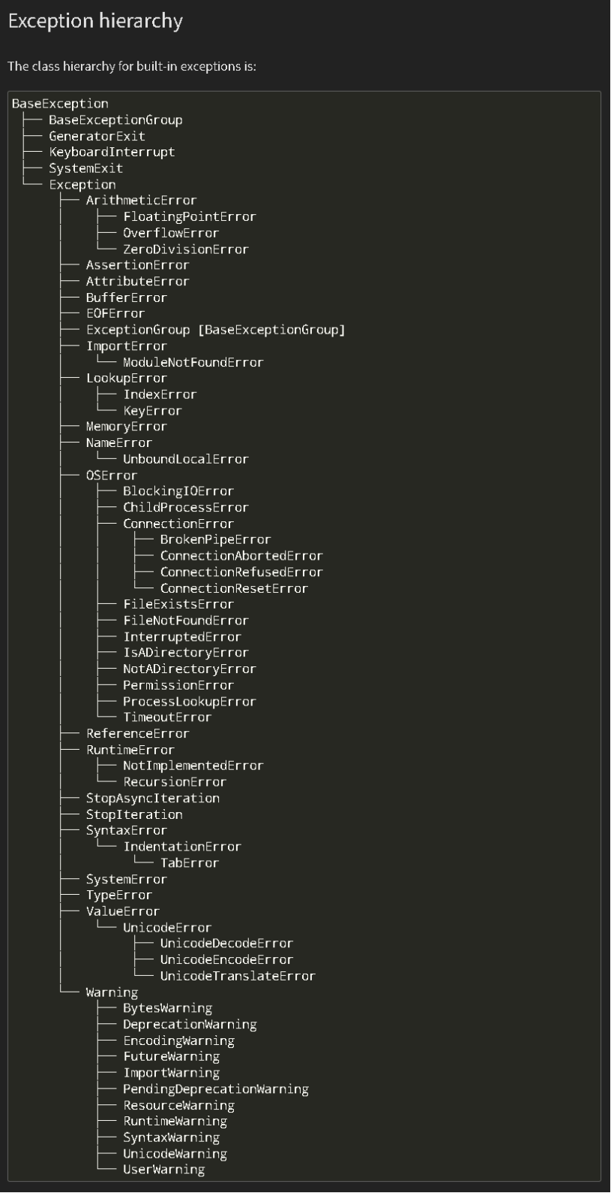
Don’t be overwhelmed with the vast number of exceptions; with time, you’ll become familiar with the ones most relevant to your work. Visual aids like the exception hierarchy (https://docs.python.org/3/library/exceptions.html#exception-hierarchy) found in the python docs (https://docs.python.org) can serve as helpful reference.

Python Exception Handling Techniques

Using Python's try, except, and finally Blocks for Exception Handling
The try, except, and finally blocks are a common pattern in Python for managing errors. The try block(1) contains code that may raise an exception, while the except block(2) handles specific exceptions that occur during the execution of the try block. The finally(3) block is always executed, regardless of whether an exception was raised, making it ideal for cleanup tasks like closing files or releasing resources. This structure ensures that your program can gracefully recover from errors and maintain stability.
```python

expected_value = float(768.9)

try: # 1
result = _function()
if not result == expected_value:
raise ValueError('The result is invalid.')
return result
except ValueError as err: # 2
print(err)
return
finally:

```

Catching All Exceptions (But Be Careful!)

While you can catch all exceptions using a generic except block, this should be done cautiously to avoid masking unexpected errors that can hide bugs and make debugging difficult. It's generally better to catch specific exceptions to handle expected errors appropriately, ensuring other issues are noticed and fixed. Here's an example of how not to handle exceptions:

```python

try:
# Code that might raise an exception
except:
# This catches all exceptions, but can lead to hidden bugs
pass
```

Using try-except Blocks

A try-except block allows you to catch and handle exceptions effectively. By specifying different except blocks for different exceptions, you can tailor your program's response based on the specific error that occurred. This approach offers flexibility in managing various error conditions.

python

try:
# Code that might raise an exception
except ValueError:
# Handle ValueError specifically
except ZeroDivisionError:
# Handle division by zero specifically

Utilizing else and finally Clauses

The try-except-else-finally structure is a powerful tool for error handling. The try block contains code that might raise an exception, while the except blocks catch and handle the exception. If no exceptions are raised, the else block executes. The finally block runs regardless of whether an exception occurred, making it ideal for cleanup tasks like closing files or releasing resources.

python

try:
# Code that might raise an exception
except Exception as e:
# Handle the exception
else:
# Code that runs if no exception occurred
finally:
# Code that runs no matter what, typically cleanup tasks

Handling Specific Scenarios
Division by Zero

Dividing by zero raises Python's ZeroDivisionError. To handle this, you can catch the exception and provide a fallback response, such as an error message or a prompt for valid input, ensuring the program doesn’t crash and can recover gracefully.

python

try:
result = 10 / 0
except ZeroDivisionError:
print("You can't divide by zero!")

Handling Multiple Exceptions

Python allows handling multiple exceptions by specifying multiple except blocks. This enables you to manage different error conditions separately, making your code more robust.

```python

try:
number = int(input("Enter a number: "))
result = 10 / number
except ValueError:
print("That's not a number!")
except ZeroDivisionError:
print("You can't divide by zero!")
```

Creating Custom Exceptions

Custom exceptions can be created by subclassing the built-in Exception class. This allows you to define errors specific to your application, making debugging more efficient and your code more readable.

python

class MyCustomError(Exception):
pass

try:
raise MyCustomError("Something went wrong!")
except MyCustomError as e:
print(e)

Logging Exceptions

Logging exceptions is crucial for debugging and maintaining code. Python’s built-in logging module makes it easy to set up logging in your applications, providing a record of errors that helps diagnose and fix issues.

```python

import logging

logging.basicConfig(level=logging.ERROR)

try:
result = 10 / 0
except ZeroDivisionError as e:
logging.error(f"Error occurred: {e}")
```

Best Practices for Exception Handling in Python

Catch Specific Exceptions: Always catch specific exceptions to improve code readability and maintainability.
Avoid Silent Failures: Avoid using bare except clauses that catch all exceptions without proper handling.
Use else and finally Clauses: The else clause is useful for code that should run if no exceptions occur, and finally is ideal for cleanup tasks.
Create Custom Exceptions: Custom exceptions help you handle errors specific to your application, making debugging easier.
Log Exceptions: Logging exceptions provides a record of errors that aids in diagnosing and resolving issues.

Example of Exception Handling

Here’s a basic example of exception handling in Python:

python

try:
number = int(input("Enter a number: "))
result = 10 / number
except ValueError:
print("That's not a valid number!")
except ZeroDivisionError:
print("You can't divide by zero!")
finally:
print("End of the program.")

Conclusion

This article has explored various methods for handling exceptions in Python, from managing invalid input and division by zero to creating custom exceptions and logging errors. By following these best practices, you can write robust and maintainable Python code that gracefully handles errors and provides a better user experience.

This version enhances the original text with more detailed explanations and better structure while maintaining the core message.
You said:
Can I have a paragraph on how try, except and finally blocks are typically used for error handling and can I have a paragraph on raising an exception intentionally to catch and handle specific errors ?

example:

python

try:
result = some_function()
if not result.some_attribute:
raise ValueError('The attribute is invalid!')
return result
except ValueError as err:
print(err)
return

Intentionally Raising Exceptions to Handle Specific Errors

In some cases, you may need to raise an exception intentionally to signal a specific error condition that your program should handle. For example, after performing an operation, you might check a condition and raise a ValueError if it’s not met. This allows you to catch the exception in an except block and handle it appropriately, such as logging the error or providing user feedback. This technique is useful for enforcing business rules or ensuring data integrity within your application.

Example:

python

try:
result = some_function()
if not result.some_attribute:
raise ValueError('The attribute is invalid!')
return result
except ValueError as err:
print(err)
return

