PDFwriter for Mac
How to install
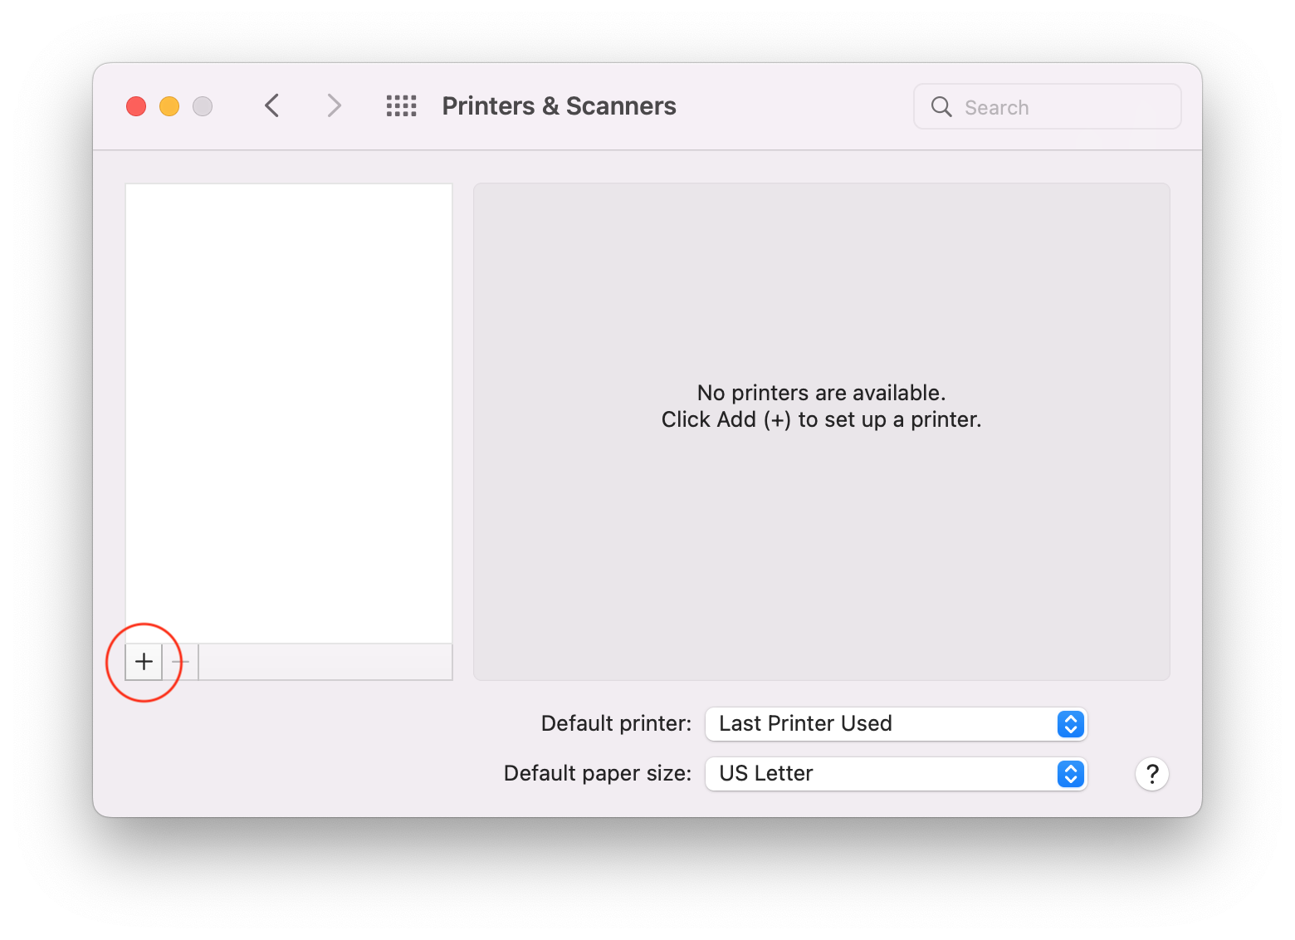
Open the .dmg file that you have downloaded and double click on the Lisanet PDFwriter.pkg file to install the PDFwriter print driver.
After Installation has been completed, open the macOS System Preferences application and click on the Printers & Scanners icon. In the Printers & Scanners panel, click on the + button (circled in red in the screen snapshot to the right).
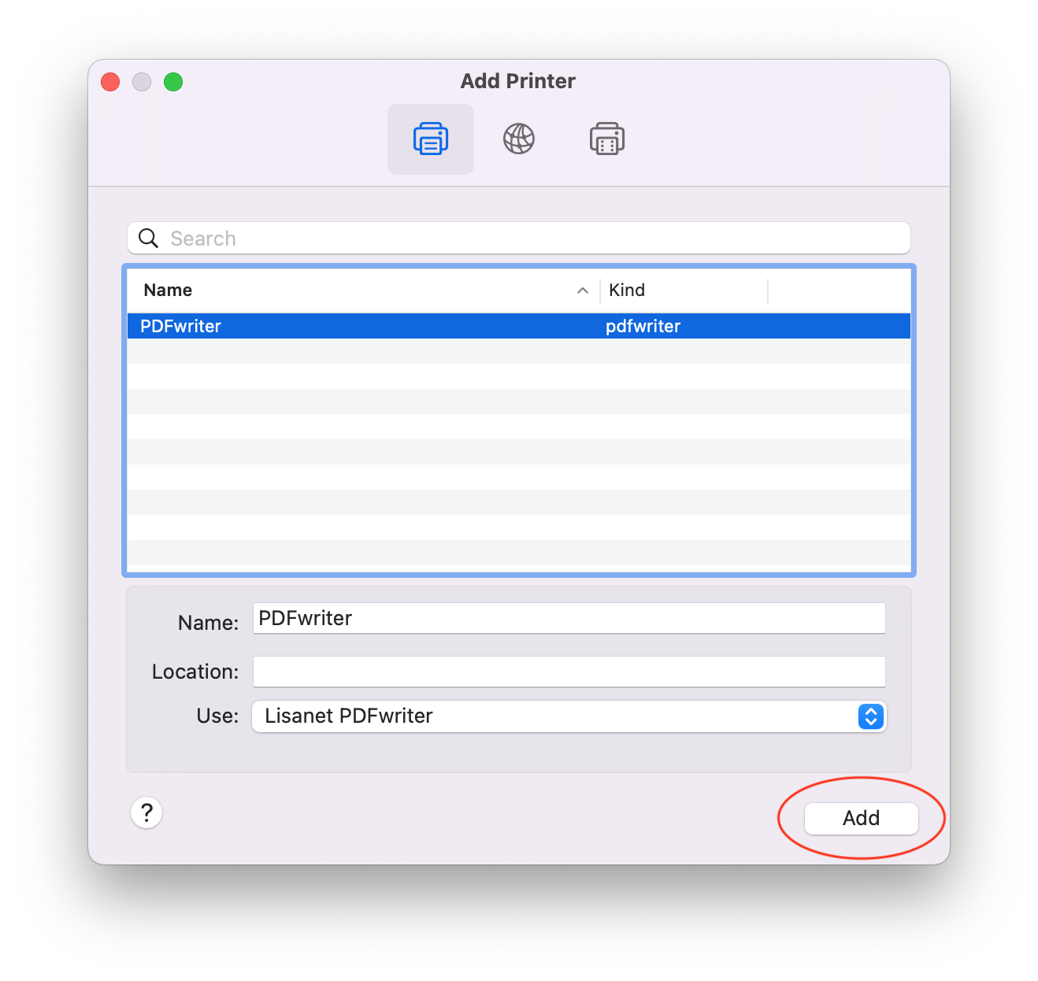
The Add Printer dialog should appear. Within 30 seconds or so, the PDFwriter driver should appear in the list of drivers.
Select the PDFwriter driver and the Use list box should change to Lisanet PDFwriter like in the screen snapshot to the right. Press the Add button (circled in red in the screen snapshot to the right) and PDFWriter should now be in the list of printers in the Printers & Scanners panel.

Usage
Simply print your documents to the PDFwriter printer just like any other printer. When you print using the PDFwriter printer, the PDFwriter driver will save a PDF file in the /Users/Shared/PDFwriter/<your macOS username> folder.

How to uninstall
If you want to completely uninstall PDFwriter from your machine, open the Terminal application and execute the following command:
sudo /Library/Printers/Lisanet/PDFwriter/Contents/Resources/uninstall.sh

History
PDFwriter for Mac is heavily based on CUPS-PDF but does not use Ghostscript to generate PDF files. Instead, it uses native macOS internal PDF processing.

Copyright
PDFwriter for Mac is copyrighted 2010, 2011, and 2022 by Simone Karin Lehmann and other contributors under the terms of the GNU GPL version 2 or later.
Source code can be downloaded from the GitHub pdfwriterformac project page.

