**Class Đăng Ký:**

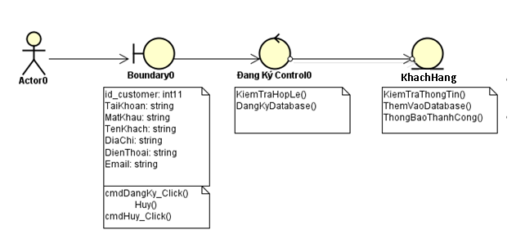

**Class Dang Nhap:**

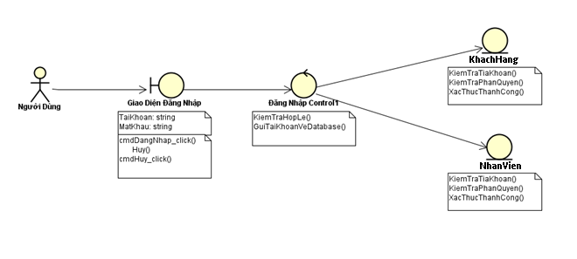

**Class quen mat khau:**

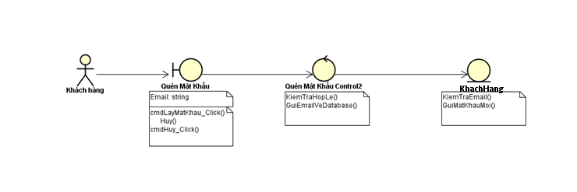

**Class quan li thong tin khach hang:**

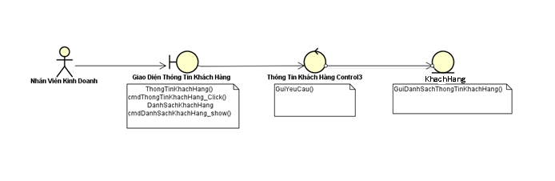

**Class them san pham**

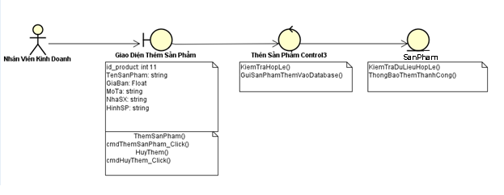

**Class tra cuu thong tin san pham**

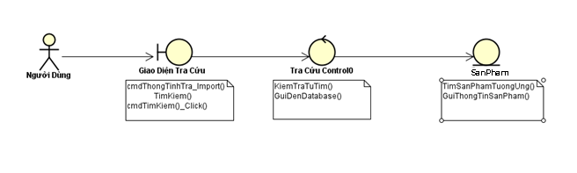

**Class Mua Hang**

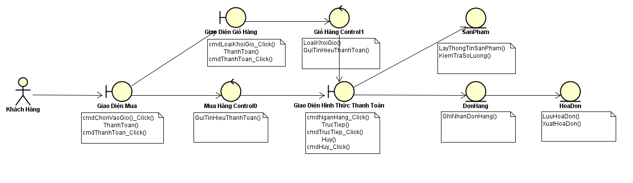

**Class Bao Hanh, Sua Chua**

