**Hibernate**

Contents

**Exercise 1** 2

**Exercise-2** 2

## Exercise 1

Create a Movie Entity and map it to a table HQL_Movie in H2 Database and perform the CRUD operation using Hibernate

**Movie :**

* **MovieId**
* **MovieName**
* **Language**
* **releasedIn**
* **revenueInDollars**

**Sample Data**

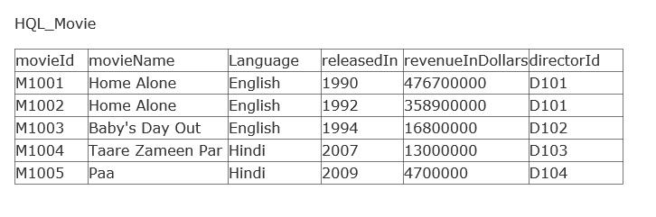

## Exercise-2

A director can direct more than one Movie.

Create the table to implement the above scenario

Director Details:

* directorID
* directorName
* bornIn

Movie Details:

* MovieId
* MovieName
* Language
* releasedIn
* revenueInDollars

a.Insert sample Data as below

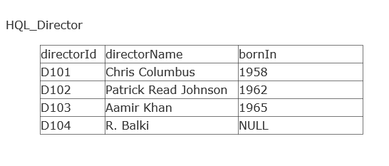



b.Write HQL queries to implement the below usecases

