DORCA3 API

Contents

1 SPI MODE 3

2 RSA 3

2.1 Definition of Module 3

2.2 Block Diagram 3

3 AES/ARIA 4

3.1 Module Definition 4

3.2 Block Diagram 5

3.3 API 5

3.4 Block Cipher Modes of Operation 6

4 Cipher Memory 12

4.1 Module Definition 12

4.2 Block Diagram 12

4.3 API 13

5 ECDH 14

5.1 Module Definition 14

5.2 Block Diagram 14

5.3 API 15

6 PUF&TRNG 16

6.1 Module Definition 16

6.2 블록도 설명 16

6.3 API 16

7 SHA 17

7.1 Module Definition 17

7.2 블록도 설명 17

7.3 API 17

8 ECDSA 18

8.1 Module Definition 18

8.2 Block Diagram 18

8.3 API 18

9 UUP: User Unique Password 19

9.1 19

9.1 Module Definition 19

9.2 Block Diagram 19

9.3 API 20

10 Key Generation and Modification 20

10.1 Module Definition 20

10.2 Block Diagram 21

10.3 API 21

11 Setup procedure 22

12 Permission 22

12.1 Module Definition 22

12.2 Block Diagram 22

12.3 API 22

13 Configuration Domain 23

13.1 Module Definition 23

13.2 Block Diagram 23

13.3 API 28

Reference

SPI comm. definition

<https://en.wikipedia.org/wiki/Serial_Peripheral_Interface>

1. SPI MODE

CORE 1 manages the asymmetric code, and CORE 0 manages the symmetric code. The SPI_MODE needs to be set as follows:

**CORE 0: Symmetric Key, Cipher memory, AES/ARIA etc.**

CPOL = 0, CPHA = 0, Clock idle low, data is clocked in on rising edge, output data (change) on falling edge

**CORE 1: Asymmetric Key, ECDSA, RSA, ECDH etc.**

CPOL = 0, CPHA = 1, Clock idle low, data is clocked in on falling edge, output data (change) on rising edge

Reference

Public-key cryptography

<https://en.wikipedia.org/wiki/Public-key_cryptography>

Symmetric vs. Asymmetric Encryption – What are differences?

https://www.ssl2buy.com/wiki/symmetric-vs-asymmetric-encryption-what-are-differences

RSA (cryptosystem)

<https://en.wikipedia.org/wiki/RSA_(cryptosystem)>

1. RSA
   1. Definition of Module

RSA 2048 Encryption and Decryption

* 1. Block Diagram



The private key decodes the text encoded with the public key.

API

**Module Name: RsaPubEnc2048**

**Description: performs RSA encryption**

**Parameter:**

* unsigned char * pub_key_n [in] RSA Modulus
* unsigned char * pub_key_e [in] RSA PublicExponent
* unsigned char * out [out] output data
* unsigned char *in [in] input data
* size_t len [in] data length set to 512
* int padding [in] not used

**Function Name: RsaPubDec2048**

**Description: performs RSA Decryption**

**Parameter:**

* unsigned char * priv_key [in] RSA Private key
* unsigned char * pub_key_n [in] RSA Modulus_n
* unsigned char * out [out] output data
* unsigned char *in [in] input data
* size_t len [in] data length set to 512
* int padding [in] not used

Reference

Symmetric-key algorithm

<https://en.wikipedia.org/wiki/Symmetric-key_algorithm>

1. AES/ARIA
   1. Module Definition

AES128/AES256/ ARIA128/ ARIA256

* 1. Block Diagram



The keys used for encoding and decoding are the same using the symmetric key algorithm

* 1. API

**Module Name: Dorca3CipherDecipher**

**Description: Performs AES encryption and decryption**

**Parameter:**

* int mode [in] 0: encryption 1: decryption
* int arg_type [in] 1: AES 2: ARIA
* unsigned char* key [in] key for encryption and decryption

If the key value is NULL, maintain the original key value

* int key_length [in] key length
* unsigned char* iv [in] Initialization Vector
* unsigned char* out [out] output buffer
* unsigned char* in [in] input buffer
* size_t len [in] length of buffer 16 or 32
* int type [in] operation mode type {

MODE_ECB = 0,

MODE_CBC = 1,

MODE_OFB = 2,

MODE_CTR = 3,

MODE_CFB = 4

* int LAST [in] indicator to end of sequence 0: on going 1: end

**Module Name: Dorca3CipherDecipherGivenIdx**

**Description: Performs encryption and decryption with key value set previously. Key is saved once encryption and decryption have taken place.**

**Parameter:**

* int key_idx [in] key index
* int mode [in] 0: encryption 1: decryption
* int arg_type [in] 1: AES 2: ARIA
* unsigned char* key [in] not used
* int key_length [in] key length
* unsigned char* iv [in] Initialization Vector
* unsigned char* out [out] output buffer
* unsigned char* in [in] input buffer
* size_t len [in] length of buffer 16 or 32
* int type [in] operation mode type {

MODE_ECB = 0,

MODE_CBC = 1,

MODE_OFB = 2,

MODE_CTR = 3,

MODE_CFB = 4

* int LAST [in] indicator to end of sequence 0: on going 1: end

Reference

Advanced Encryption Standard

https://en.wikipedia.org/wiki/Advanced_Encryption_Standard

Block cipher mode of operation

https://en.wikipedia.org/wiki/Block_cipher_mode_of_operation

3. 4. Block Cipher Modes of Operation

In the study of cryptography, block cipher modes of operation is the process of operating under block cipher repetitively and safely using a single key. Because block cipher operates under specific length, it is important to first divide any length of data into unit blocks and then to decide how to encode them. This is when the cipher modes are determined by the modes of operation.

**Modes of Operation**

To improve the weakness in security of ECB, the basic method of block cipher, different modes of operation are used. Block cipher modes of operation utilize Initialization Vector (IV) and the results of encryption and decryption of the previous block to cause effect on the encryption and decryption of the present block, therefore enhancing the security of the entire process. The most well-known modes include ECB, CBC, OFB, CFB, and CTR, and their reliability and transmission rate between the blocks are different.

1. ECB (Electronic Code Book) Mode

ECB As it could be seen in the figure below (fig. 1.1), the encryption of the ECB mode encrypts each block of data independently. If the length of the snippet of the data isn’t a factor of the length of the data, the snippet will undergo padding to obtain the desired length. The keys used during encryption and decryption are the same. The downside of ECB mode is that after the key value has been set, encryption/decryption of any plaintext/ciphertext will result in the same ciphertext/plaintext, therefore encryption/decryption of one block will grant permission to proceeding blocks.

Because each block is independently encrypted, an error in one block won’t affect the operation of another block.

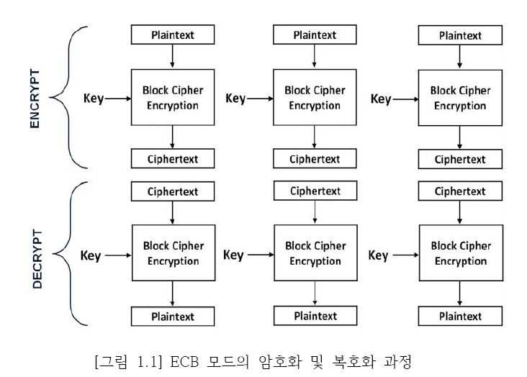

1. CBC (Cipher Block Chaining) Mode

As it could be seen in the figure below (fig. 1.2), the encryption of the CBC mode ciphers each block consecutively depending on the encryption of the previous block which is done with XOR. In the first block, the primitive vector (IV) is utilized. Because encryption requires feedback from the previous block, it is impossible to cipher the entire data parallelly, but in the case of decryption, the results from the previous block are XORed after deciphering has completed, parallel computation is possible. CBC mode has high security thanks to its reliance on the result of the previous block, which means that many different versions of ciphers could be produced from a single piece of data. Therefore, this mode is used mostly when handling personal or confidential information.

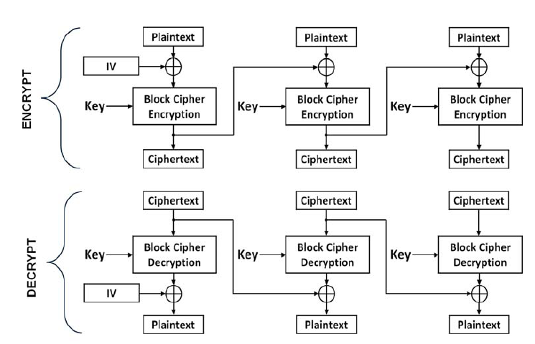

1. OFB (Output Feedback) Mode

As it could be seen in the figure below (fig. 1.3), the encryption of the OFB mode cyphers the plaintext by XORing it with block cypher encryption, which outputs the ciphertext. As for the first block, the initialization is done with the primitive vector, and for the succeeding blocks, the cipher block sends signals to do so. In terms of processing, it is the same for both encryption and decryption.

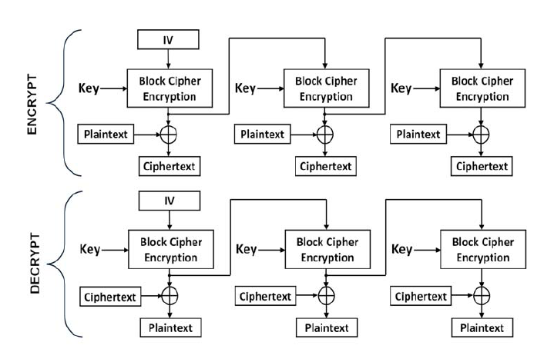

1. CFB (Cipher Feedback) Mode

As it could be seen in the figure below (figure 1.4), the encryption of the CFB mode is done the same as the CBC mode and the ciphertext is obtained by XORing the plaintext and the encryption in the given block. The decryption is performed by XORing the previous ciphertext with the block encryption and therefore producing the plaintext. For both encryption and decryption, the first block encrypts the primitive text, which is XORed with the plaintext(ciphertext), which outputs a ciphertext(plaintext). In both encryption and decryption procedure, only the encryption of the block cipher is used, and as in the case of CBC mode, encryption is a serial process while decryption could be performed in a parallel manner.

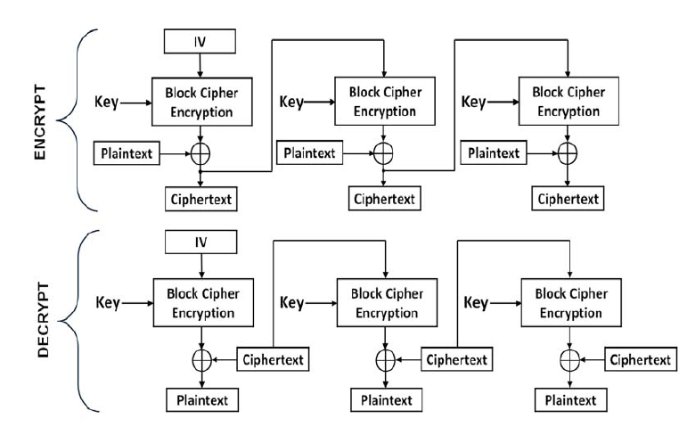

1. CTR (counter) Mode

As it could be seen in the figure below (fig. 1.5), the encryption of the CTR mode increments the value of initial vector by 1, which is XORed with the ciphertext with the plaintext to produce the ciphertext. Encryption and decryption process are performed in the same manner, and cryptic algorithm is used. The process don’t rely on one another, therefore it could be processed parallelly which makes it suitable for high-speed encryption/decryption.

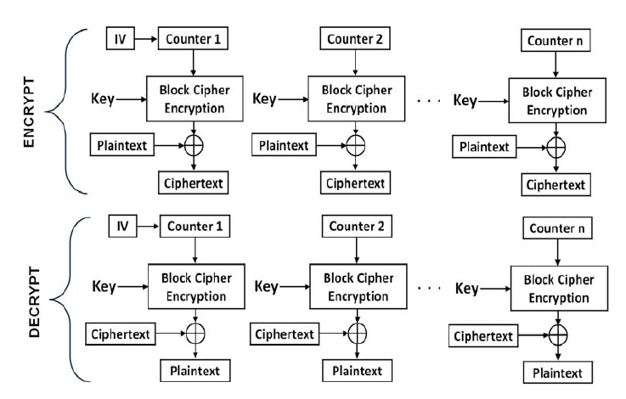

1. Cipher Memory
   1. Module Definition

3840 byte cipher memory

* 1. Block Diagram



This module is used to save or read from non-volatile memory eeprom, and when the user attempts to send data with a designated key, DORCA3 ciphers and saves the data with that key. When EepromWrite is used to write a Cipher text the Dorca3 ciphers it and saves it. When EepromRead is used to read data, Dorca3 again ciphers it and returns the data.

Eeprom could be distinguished as Page, Sub Page, and Sub Frame as shown in the chart below.

|  |  |  |
| --- | --- | --- |
|  | SUBFRAME | 3'h0 : [127:0] of selected page 3'h1 : [255:128] of selected page 3'h2 : [383:256] of selected page 3'h3 : [511:384] of selected page |
|  | SUBPAGE | 3'h0 : subpage 0 (0x00 ~ 0x3F) 3'h1 : subpage 1 (0x40 ~ 0x7F) 3'h2 : subpage 2 (0x80 ~ 0xBF) 3'h3 : subpage 3 (0xC0 ~ 0xFF) |
|  | PAGE | 4'h1 : EE_USER_ZONE_M01 (0xF100 ~ 0xF1FF) … 4'hF : EE_USER_ZONE_M15 (0xFF00 ~ 0xFFFF) |

* 1. API

**Function name: EepromWrite**

**Description: write encrypted data into eeprom using a designated key**

**Parameter:**

* Unsigned char * Key[in] Key value used for encryption
* Setting key value to NULL keeps the original value of the key.
* int SubFrame[in] SubFramenumber
* int SubPage[in] SubPageNumber
* int Page,[in] PageNumber
* int Algorithm[in] AES128 3,AES256 1,ARIA128 2,ARIA256 0
* unsigned char *CT[in] Ciphertext to be saved

**Function Name: EepromRead**

**Description: Outputs a common key from private and public keys inputed**

**Parameter:**

* Unsigned char * Key[in] Key value that will be used for decryption
* Setting key value to NULL keeps the original value of the key.
* int SubFrame[in] SubFramenumber
* int SubPage[in] SubPageNumber
* int Page,[in] PageNumber
* int Algorithm[in] AES128 3,AES256 1,ARIA128 2,ARIA256 0
* unsigned char *CT[out] Ciphertext to be read

Reference

ECC : Elliptic-curve cryptography

https://en.wikipedia.org/wiki/Elliptic-curve_cryptography

Elliptic-curve Diffie–Hellman

https://en.wikipedia.org/wiki/Elliptic-curve_Diffie%E2%80%93Hellman

1. ECDH
   1. Module Definition

ECDH P256

* 1. Block Diagram



This module is used to create secure and common keys between two users. As it could be seen in the diagram above, USER A creates his/her own private key DA, and by perforing DA * G, HA is created which is passed to USER B. USER B also creates his/her own pivate key DB which will create HB by doing DB * G, and pass that to USER A. Finally, both USER A and USER B creates a common key called S by S = DAHB = DADBG for USER A and S = DBHA = DADBG for USER B.

* 1. API

**Function name: EcdhGenPubKey**

**Description: Receives public key by inputting secure key.**

**Parameter:**

uint8_t* sk[in] Private Key length: 32

struct _point* p1[out] Public KEy struct _point {

uint8_t x[32];

uint8_t y[32];

}

**Function Name: EcdhGenPubKeyPuf**

**Description: Generates a random value, makes it into a secure key, and uses it to create a public key.**

**Parameter:**

struct _point* p1[out] Public Key struct _point {

uint8_t x[32];

uint8_t y[32];

}

**Function Name: EcdhGenSessionKey**

**Description: Creates the final common key using the secure key from input.**

**Parameter:**

uint8_t* sk[in] Secret Key length: 32

struct _point* p1[out] Public Key struct _point {

uint8_t x[32];

uint8_t y[32];

}

**Function Name: EcdhGenSessionKeyPuf**

**Description: Uses the secret key that was created before to create the final final common key. Ecdh_gen_pub_key_puff must be called before to create the secure key.**

**Parameter:**

struct _point* p1[out] Public Key struct _point {

uint8_t x[32];

uint8_t y[32];

}

**Function Name: KeyFromEcdh**

**Description: Places the key obtained from ECDH into AES_X0**

**Parameter:**

None

Reference

TRNG making:

<https://www.google.co.kr/search?q=TRNG+AES+feedback+LFSR&safe=active&source=lnms&tbm=isch&sa=X&ved=0ahUKEwi2qpjUiNrdAhUBebwKHeBtDPkQ_AUICigB&biw=1466&bih=817#imgrc=U4iYFEIm2O1QVM>:

1. PUF&TRNG
   1. Module Definition

Generates random value.

* 1. 블록도 설명

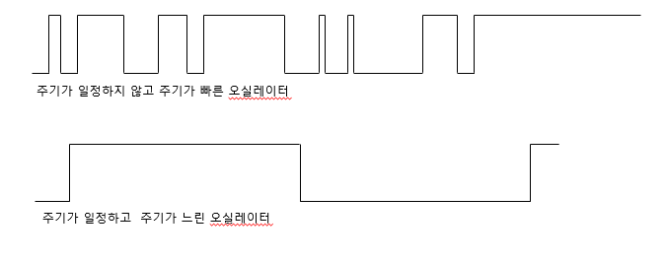

By using an oscillator which has a low and even frequency to count the frequency of an oscillator which has high and uneven frequency, different counts could be obtained every time the count is performed. Using this, random number could be generated.

* 1. API

**Function name: rand_pseudorand**

**Description: random number is generated**

**Parameter:**

* char *out Output 16 byte

Reference

Hash

<https://en.wikipedia.org/wiki/Hash>

SHA-2

https://en.wikipedia.org/wiki/SHA-2

1. SHA
   1. Module Definition

Creates HASH table

* 1. 블록도 설명
  2. API

**Function name: StandardShaMode**

**Description: creates HASH values**

**Parameter:**

* unsigned char *txdata [in]
* unsigned char *rxdata [out]
* long long ByteNo [in]

Reference

Elliptic Curve Digital Signature Algorithm

<https://en.wikipedia.org/wiki/Elliptic_Curve_Digital_Signature_Algorithm>

1. ECDSA



6. 1. Module Definition

Elliptic Curve Cryptography

* 1. Block Diagram



ECDSA is an algorithm that sends message with digital cryptography, and when it receives the message with digital cryptography, it checks for any errors and/or illegal changes.

User A performs HASH(SHA256) on the message to create digest, which is used(signed) as the secret key as R and S data. User B performs HASH(SHA256) on the received message to create digest, and uses the received values R and S to verify that the message hasn’t been forged.

* 1. API

Function Name: EcdsaGenSignature

Description: generates digital signature

Parameter:

* uint8_t* d length: 32 secret key [in]
* uint8_t* k length: 32 secret key [in]
* uint8_t* r length: 32 sign [out]
* uint8_t* s length: 32 sign [out]
* uint8_t* h length: 32 sha-256 hash[in]

**Function Name: EcdsaVerifySignature**

**Description: verifies the digital signature**

**Parameter:**

* point *public_key typedef struct _point

{

uint8_t x[32];

uint8_t y[32];

}point;

* uint8_t* r length: 32 sign [in]
* uint8_t* s length: 32 sign [in]
* uint8_t* h length: 32 sha-256 hash[in]

**Function Name: EcdsaGenPublicKey**

**Description: Creates Public Key**

**Parameter:**

* unsigned char *private_key length:32 Private Key[out]
* point *public_key typedef struct _point

{

uint8_t x[32];

uint8_t y[32];

}point;

* uint8_t* r length: 32 sign [in]
* uint8_t* s length: 32 sign [in]
* uint8_t* h length: 32 sha-256 hash[in]

1. UUP: User Unique Password

   2. Module Definition

Description of User Unique Password, which is the only method of distinguishing one chip from another. This module was originally called Root Serial, but due to possible misinterpretation of the name which could lead to possible concerns regarding backdooring, the name has been changed to user unique password. In fact, this module does create a unique password that the user sets.

* 1. Block Diagram

Saves 4 Serials, and when reading a Serial, reads the result from SHA.

Once UID permission is obtained, the first and third serials can be obtained.

* 1. API

**Function Name: RSCreate01**

**Description: Algorithm of NeoWine that tags each device its own serial 0,1.**

**Parameter:**

None

**Function Name: RSCreate23**

**Description: With a value that user inputs, serial 2, 3 is created.**

**Parameter:**

* unsigned char *pUservalue32A 32bit user value for serial2[in]
* unsigned char *pUservalue32B 32bit user value for serial3[in]

**Function Name: RSSSHAReadIdx**

**Description: reads serial by performing SHA**

**Parameter:**

* Int index : 읽어올 serial index (0,1,2,3)
* Unsigned char* out: serial 값

**Function name: RSDirectRead13**

**Description: Reads the actual serial number 1 and 3 by inputting UID and PASSWORD**

**Parameter:**

* unsigned char *pRS: output [out]
* int index: index값 1또는 3 [in]
* unsigned char *UID_PW_PT: 16바이트 UID 비밀번호 포인터[in]

1. Key Generation and Modification
   1. Module Definition

Generates or mFasodifies the key value that is used for encryption and decryption

* 1. Block Diagram



The key hierarchy is as follows: SEED_KEY, AES_KEY_0, AES_KEY_1, AES_KEY_2, AES_KEY_3. SEED_KEY is written when it is first created, with it AES_KEY0 is made. With AES_KEY1, AES_KEY2 is created, and with AES_KEY 2 AES_KEY3 is created.

In the sample program, AES_KEY_1 is used for permission get operation, and AES_KEY0 is designated for encryption and decryption

* 1. API

In the sample program, AES_KEY_1 is used for permission get operation, and AES_KEY0 is designated for encryption and decryption

**Function name: KeyCreatXn**

**Description: Generates and modifies key**

**Parameter:**

* int index: Key index[in]
* int mode: MODE256 or MODE128[in]
* unsigned char *prevKey: Key value of the key from previous hierarchy[in]
* unsigned char *key: Key value previously in]

1. Setup procedure



The Seed Key is written during the initiation sage. After that, the Seed Key is used to make the AES KEY. ROOT SERIAL is created after AES KEY is made. When the download file is executed, writing is executed.

1. Permission
   1. Module Definition

With permission, the user is capable of performing a specific function and reading data.

Permission is comprised of SUPER, DETOUR, DESTROY0, DESTROY1, EEPROM, and UID.

* 1. Block Diagram

Omitted

* 1. API

**Function Name: GetPermission**

**Description: Receives permission**

**Parameter:**

* int iType [in]

RG_PERM_SUPER_PASS = 5,

RG_PERM_DETOUR_PASS = 4,

RG_PERM_DESTORY0_PASS = 3,

RG_PERM_DESTORY1_PASS= 2,

RG_PERM_EEPROM_PASS= 1,

RG_PERM_UID_PASS = 0

* unsigned char *pchPW Password for Permission[in]
* int index Key used to obtain permission index[in]

**Function Name: ReleasePermission**

**Description: Releases permission**

**Parameter:**

none

1. Configuration Domain
   1. Module Definition

Domain used to set up the chip. More explanation later.

* 1. Block Diagram

Configuration memory could be distinguished as the following types. Each type has following characteristics.

-EE_CONFIC_UID

With the permission of EE_UID_PW, it can be modified with API.

-EE_SEED_KEY

Refer to the description of Key Memory.

With permission of EE_SUPER_PW, it can be modified with API.

-EE_CONFIG_LOCK

With permission of EE_SUPER_PW, it can be modified with API.

EE_UZx0_WR_LOCK ~ EE_UZxF_WR_LOCK

EE_SEED_KEY_LOCK

EE_KEY_AES_LOCK

|  |  |  |  |  |
| --- | --- | --- | --- | --- |
| |  | | --- | | EE_CONFIG_UID  0xEBC0 | | | | | |  |  | EE_CONFIG_UID Value set by user input.  If in lock status by EE_CONFIG_LOCK:EE_CONFIG_UID_LOCK, write is restricted. |
| EE_UID | 4 | Lowest Byte Address is EE_UID[0] byte. …. Highest Byte Address is EE_UID[3] byte. 0x4444_4444 |
| EE_MANUFACTID | 2 | EE_MANUFACTID[0] EE_MANUFACTID[1] 0x2222 |
| EE_REV_CTRL_USR | 4 | Reserved Revision Control for user use. Limited access to EE_UID_PW.  0x4444_4444 |
| EE_CONFIG_USER_CTRL1 | 1 | [7:2] Reserved [1] EE_CLKXTAL_EN 0 : CLKXTAL can toggle high and low. (default) 1 : CLKXTAL maintains high state.  [0] EE_OSC_5M_20M 0 : 20 MHz (default) 1 : 5 MHz |

|  |  |  |  |
| --- | --- | --- | --- |
| EE_SEED  0xEC00 | EE_SEED_KEY | 32 | User(E-MCU) can receive UID_PW permission to read and write from this domain in administrative mode(EE_CONFIG_LOCK:EE_SEED_KEY_LOCK is in unlock status).  If EE_CONFIG_LOCK:EE_SEED_KEY_LOCK is in Lock status, the user(E-MCU) may not read nor write EE_SEED_KEY even if the user has the UID_PW permission. 0x0001_0203_0405_0607_0809_0A0B_0C0D_0E0F_1011_1213_1415_1617_1819_1A1B_1C1D_1E1F |

|  |  |  |  |
| --- | --- | --- | --- |
| EE_CONFIG_USER  0xEC40 | EE_CONFIG_USER_CTRL0 | 1 | In ST0_EE_CFG state, E-MCU can’t write anything in this page In ST0_EE_CFG state, E-MCU may freely read from this page.  [7:3] Reserved [2] EE_RS_x2_FLAG  0 : Before EE_RS_x2 is made 1 : EE_RX_x2 is made [1:0] :RESERVED |

|  |  |  |  |
| --- | --- | --- | --- |
| EE_CONFIG_LOCK  0xEC80 | EE_UZx0_WR_LOCK ~  EE_UZxF_WR_LOCK | 16 | Setting bit (0->1) is only possible with EE_UID_PW permission. It is a OTP(One Time Programmable) Domain. The user (E-MCU) may change the value 0 from each bit to 1, but changing the value 1 to 0 is impossible. EE_USER_ZONE_M00 ~ EE_USER_ZONE_M15 Out of 16 domains, matched to 1  EE_UZx0_WR_LOCK -> EE_USER_ZONE_M11 matched to 1 Write is prohibited when status is Lock. 0x00 : EE_UZxN domain is in Unlock status. 0x01~0xFF : EE_UZxN domain is in Lock status. Changes can’t be made. |
| EE_SEED_KEY_LOCK | 1 | Setting bit (0->1) is only possible with EE_UID_PW permission. It is a OTP(One Time Programmable) Domain. The user (E-MCU) may change the value 0 from each bit to 1, but changing the value 1 to 0 is impossible.  0x00 : EE_SEED_KEY domain is in Unlock status.  0x01~0xFF : EE_SEED_KEY domain is in Lock status. No changes can be made. |
| EE_RS_x0 LOCK | 1 | Setting bit (0->1) is only possible with EE_UID_PW permission. It is a OTP(One Time Programmable) Domain. The user (E-MCU) may change the value 0 from each bit to 1, but changing the value 1 to 0 is impossible.  0x00 : EE_RS_x0 domain is in Unlock status. E-MCU may read the values in EE_RS_x0 domain. 0x01~0xFF : EE_RS_x0 domain is in Lock status. E-MCU may not read the values in EE_RS_x0 domain. |
| EE_KEY_AES_LOCK | 1 | Setting bit (0->1) is only possible with EE_UID_PW permission. It is a OTP(One Time Programmable) Domain.  The user (E-MCU) may change the value 0 from each bit to 1, but changing the value 1 to 0 is impossible. 0x00 : EE_KEY_AES_xN domain is in Unlock status. E-MCU may read the values in EE_KEY_AES_xN domain. 0x01~0xFF : EE_KEY_AES_xN domain is in Lock status. E-MCU may not read the values in EE_AES_xN domain. |

* 1. API

Function Name: SetConfigArea

Parameter:

* int permType Permission type [in]

G_PERM_SUPER_PASS = 5,

RG_PERM_DETOUR_PASS = 4,

RG_PERM_DESTORY0_PASS = 3,

RG_PERM_DESTORY1_PASS= 2,

RG_PERM_EEPROM_PASS= 1,

RG_PERM_UID_PASS = 0

* int CfgName Configuration Domain Name [in]

A_EE_CONFIG_NW =0,

A_EE_CONFIG_FAC =1,

A_EE_CONFIG_UID =2,

A_EE_SEED_KEY = 3,

A_EE_CONFIG_USER = 4,

A_EE_CONFIG_LOCK = 5,

A_EE_MEM_TEST = 6,

A_EE_MIDR = 7

* unsigned char *pPW_PT Password of Permission[in] 16byte
* unsigned char *pBuffer Buffer to be read
* int length set to length 64

Function Name: GetconfigArea

Parameter:

* int permType Permission type [in]

G_PERM_SUPER_PASS = 5,

RG_PERM_DETOUR_PASS = 4,

RG_PERM_DESTORY0_PASS = 3,

RG_PERM_DESTORY1_PASS= 2,

RG_PERM_EEPROM_PASS= 1,

RG_PERM_UID_PASS = 0

* int CfgName Configuration Domain name [in]

A_EE_CONFIG_NW =0,

A_EE_CONFIG_FAC =1,

A_EE_CONFIG_UID =2,

A_EE_SEED_KEY = 3,

A_EE_CONFIG_USER = 4,

A_EE_CONFIG_LOCK = 5,

A_EE_MEM_TEST = 6,

A_EE_MIDR = 7

* unsigned char *pPW_PT Password of Permission[in] 16byte
* unsigned char *pBuffer Buffer to be read
* int length length of data to be read in bytes