Homework 1 1
Homogeneous Transformation Matrices 1
Composite Transformation 1
Plotting the robot 3
bonus 3
Functions 4

Homework 1
clc; clear; close all;

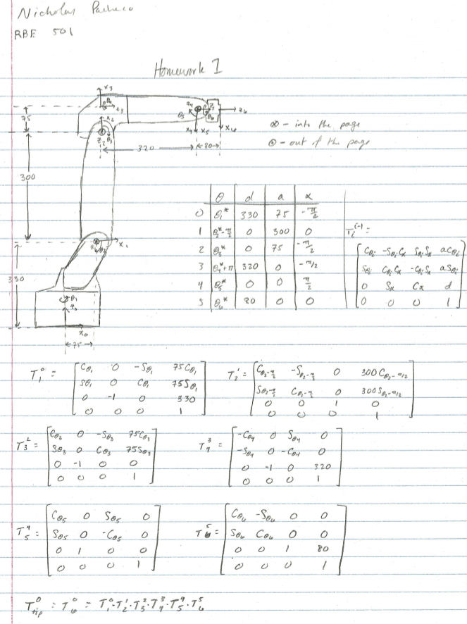

Homogeneous Transformation Matrices
syms t1 t2 t3 t4 t5 t6
DH_table = [t1 330 75 -sym(pi)/2;
t2-sym(pi)/2 0 300 0;
t3 0 75 -pi/2;
t4+sym(pi) 320 0 -sym(pi)/2;
t5 0 0 sym(pi)/2;
t6 80 0 0];
T01 = tdh(DH_table(1,:));
T12 = tdh(DH_table(2,:));
T23 = tdh(DH_table(3,:));
T34 = tdh(DH_table(4,:));
T45 = tdh(DH_table(5,:));
T56 = tdh(DH_table(6,:));

Composite Transformation
T0_6 = T01*T12*T23*T34*T45*T56;
T0_6 = simplify(T0_6,'Steps', 100);
pretty(T0_6)
input = deg2rad([0,75,30,135,-45,60]);
T0_6_val = subs(T0_6, [t1,t2,t3,t4,t5,t6],input);
T0_6_val = vpa(T0_6_val,4)
[[sin(t6) #4 - cos(t6) #2, cos(t6) #4 + sin(t6) #2,
cos(t2 + t3) cos(t1) cos(t5) - sin(t5)
(sin(t1) sin(t4) + cos(t1) cos(t2) cos(t4) sin(t3) + cos(t1) cos(t3)
cos(t4) sin(t2)), 75 cos(t1) + 300 cos(t1) sin(t2) - 320
cos(t1) sin(t2) sin(t3) - 80 sin(t1) sin(t4) sin(t5) + 320
cos(t1) cos(t2) cos(t3) + 75 cos(t1) cos(t2) sin(t3) + 75
cos(t1) cos(t3) sin(t2) + 80 cos(t1) cos(t2) cos(t3) cos(t5) - 80
cos(t1) cos(t5) sin(t2) sin(t3) - 80
cos(t1) cos(t2) cos(t4) sin(t3) sin(t5) - 80
cos(t1) cos(t3) cos(t4) sin(t2) sin(t5)],
[sin(t6) #3 - cos(t6) #1, cos(t6) #3 + sin(t6) #1,
cos(t2 + t3) cos(t5) sin(t1) - sin(t5)
(cos(t2) cos(t4) sin(t1) sin(t3) - cos(t1) sin(t4) + cos(t3) cos(t4)
sin(t1) sin(t2)), 75 sin(t1) + 300 sin(t1) sin(t2) + 75
cos(t2) sin(t1) sin(t3) + 75 cos(t3) sin(t1) sin(t2) + 80
cos(t1) sin(t4) sin(t5) - 320 sin(t1) sin(t2) sin(t3) + 320
cos(t2) cos(t3) sin(t1) + 80 cos(t2) cos(t3) cos(t5) sin(t1) - 80
cos(t5) sin(t1) sin(t2) sin(t3) - 80
cos(t2) cos(t4) sin(t1) sin(t3) sin(t5) - 80
cos(t3) cos(t4) sin(t1) sin(t2) sin(t5)],
[cos(t6) #5 + cos(t2 + t3) sin(t4) sin(t6),
cos(t2 + t3) cos(t6) sin(t4) - sin(t6) #5,
- sin(t2 + t3) cos(t5) - cos(t2 + t3) cos(t4) sin(t5),
300 cos(t2) + 75 cos(t2) cos(t3) - 320 cos(t2) sin(t3) - 320
cos(t3) sin(t2) - 75 sin(t2) sin(t3) - 80 cos(t2) cos(t5) sin(t3) - 80
cos(t3) cos(t5) sin(t2) - 80 cos(t2) cos(t3) cos(t4) sin(t5) + 80
cos(t4) sin(t2) sin(t3) sin(t5) + 330],
[0, 0, 0, 1]]
where
#1 == cos(t2 + t3) sin(t1) sin(t5) - cos(t1) cos(t5) sin(t4) + cos(t2)
cos(t4) cos(t5) sin(t1) sin(t3) + cos(t3) cos(t4) cos(t5) sin(t1)
sin(t2)
#2 == cos(t5) sin(t1) sin(t4) + cos(t2
+ t3) cos(t1) sin(t5) + cos(t1) cos(t2) cos(t4) cos(t5)
sin(t3) + cos(t1) cos(t3) cos(t4) cos(t5) sin(t2)
#3 == cos(t1) cos(t4) + cos(t2) sin(t1) sin(t3) sin(t4) + cos(t3)
sin(t1) sin(t2) sin(t4)
#4 == cos(t1) cos(t2) sin(t3) sin(t4) - cos(t4) sin(t1) + cos(t1)
cos(t3) sin(t2) sin(t4)
#5 == sin(t2 + t3) sin(t5) - cos(t2 + t3) cos(t4) cos(t5)
T0_6_val =
[ 0.7415, 0.08174, -0.666, 301.1]
[ -0.3624, -0.7866, -0.5, -40.0]
[ -0.5647, 0.6121, -0.5536, 34.85]
[ 0, 0, 0, 1.0]

Plotting the robot
plot_robot([0,75,30,135,-45,60]);
title('Position of robot at given input')
xlabel('x');
ylabel('y');
zlabel('z');
snapnow

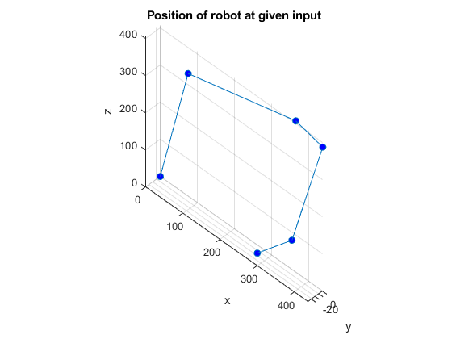

bonus
fanimator(@(t)animator(t));
title('Animated Plot Moving to Position')
xlabel('x');
ylabel('y');
zlabel('z');
view([45,45])
axis equal
grid on
playAnimation;
snapnow
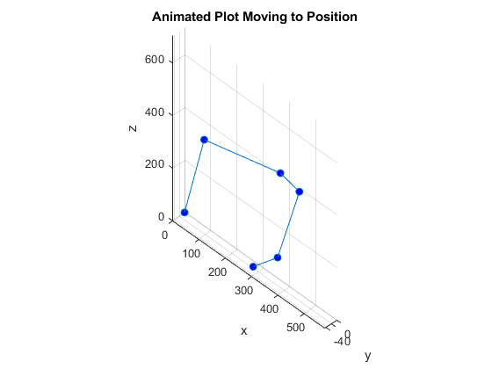

Functions
function p = plot_robot(q)
% assumes q is in degrees
q = deg2rad(q);
t1 = q(1); t2 = q(2); t3 = q(3); t4 = q(4); t5 = q(5); t6 = q(6);
DH_table = [t1 330 75 -pi/2;
t2-pi/2 0 300 0;
t3 0 75 -pi/2;
t4+pi 320 0 -pi/2;
t5 0 0 pi/2;
t6 80 0 0];
T01 = tdh(DH_table(1,:));
T12 = tdh(DH_table(2,:));
T23 = tdh(DH_table(3,:));
T34 = tdh(DH_table(4,:));
T45 = tdh(DH_table(5,:));
T56 = tdh(DH_table(6,:));
T02 = T01*T12;
T03 = T01*T12*T23;
T04 = T01*T12*T23*T34;
T05 = T01*T12*T23*T34*T45;
T0_tip = T01*T12*T23*T34*T45*T56;
x = [0 T01(1,4) T02(1,4) T03(1,4) T04(1,4) T05(1,4) T0_tip(1,4)];
y = [0 T01(2,4) T02(2,4) T03(2,4) T04(2,4) T05(2,4) T0_tip(2,4)];
z = [0 T01(3,4) T02(3,4) T03(3,4) T04(3,4) T05(3,4) T0_tip(3,4)];
p = plot3(x,y,z, '-o','MarkerFaceColor', 'b');
view([45,45])
axis equal
grid on
end
function p = animator(t)
initial_pos = zeros(1,6);
increment = [0,75,30,135,-45,60]./10;
q = initial_pos+increment*t;
p = plot_robot(q);
end

Published with MATLAB® R2019b

