Mid term for RBE 501 1
2) DH Table 2
3) Generating Homogeneous transformation matrix 3
4) Calculating position of end effector in home position 4
5) Showing a vector in end effector frame relative to body 5
6) Inverse Kinematics 5
finding possible solutions only fixing joint 2 6
7) Jacobian 7
Determining Singularities 8
find where x velcoties will be equal to 0 9
find where y velocities will be equal to 0 10
Inverse Velocity 11
functions 13

Mid term for RBE 501
clc;clear;close all

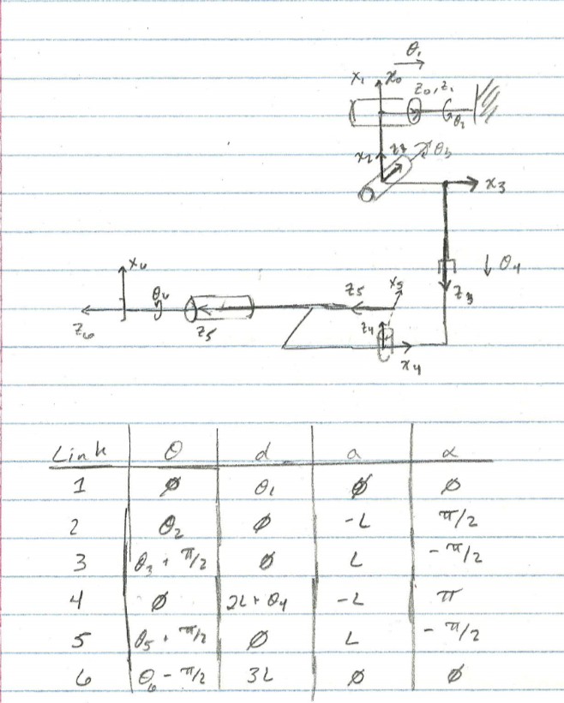

2) DH Table
syms t1 t2 t3 t4 t5 t6 L real
dh_table = [0 t1 0 0;
t2 0 -L sym(pi)/2;
t3+sym(pi)/2 0 L -sym(pi)/2;
0 2*L+t4 -L sym(pi);
t5+sym(pi)/2 0 L -sym(pi)/2;
t6-sym(pi)/2 3*L 0 0];
dh_table_var = @(t1, t2, t3, t4, t5, t6)...
[0 t1 0 0;
t2 0 -100 pi/2;
t3+pi/2 0 100 -pi/2;
0 2*100+t4 -100 pi;
t5+pi/2 0 100 -pi/2;
t6-pi/2 3*100 0 0];

3) Generating Homogeneous transformation matrix
T01 = tdh(dh_table(1,:));
T12 = tdh(dh_table(2,:));
T23 = tdh(dh_table(3,:));
T34 = tdh(dh_table(4,:));
T45 = tdh(dh_table(5,:));
T56 = tdh(dh_table(6,:));
T06 = simplify(T01*T12*T23*T34*T45*T56,'Steps',20);
pretty(T06)
T_total = get_fwdkin(dh_table,true);
T_tip = T06;
[[cos(t5) sin(t2) sin(t6) + cos(t2) cos(t3) cos(t6) + cos(t2) sin(t3)
sin(t5) sin(t6),
cos(t5) cos(t6) sin(t2) - cos(t2) cos(t3) sin(t6) + cos(t2) cos(t6)
sin(t3) sin(t5), cos(t2) cos(t5) sin(t3) - sin(t2) sin(t5),
L cos(t5) sin(t2) - 2 L cos(t2) cos(t3) - L cos(t2) - 3 L
sin(t2) sin(t5) - t4 cos(t2) cos(t3) + 3 L cos(t2) cos(t5) sin(t3) + L
cos(t2) sin(t3) sin(t5)],
[cos(t3) cos(t6) sin(t2) - cos(t2) cos(t5) sin(t6) + sin(t2) sin(t3)
sin(t5) sin(t6),
cos(t6) sin(t2) sin(t3) sin(t5) - cos(t2) cos(t5) cos(t6) - cos(t3)
sin(t2) sin(t6), cos(t2) sin(t5) + cos(t5) sin(t2) sin(t3),
3 L cos(t2) sin(t5) - L cos(t2) cos(t5) - 2 L cos(t3) sin(t2) - L
sin(t2) - t4 cos(t3) sin(t2) + 3 L cos(t5) sin(t2) sin(t3) + L
sin(t2) sin(t3) sin(t5)],
[cos(t6) sin(t3) - cos(t3) sin(t5) sin(t6),
- sin(t3) sin(t6) - cos(t3) cos(t6) sin(t5), -cos(t3) cos(t5),
t1 - 2 L sin(t3) - t4 sin(t3) - 3 L cos(t3) cos(t5) - L cos(t3) sin(t5)],
[0, 0, 0, 1]]

4) Calculating position of end effector in home position
Home = subs(T_tip,[t1 t2 t3 t4 t5 t6,L],[zeros(1,6),100])
dh_table_home = subs(dh_table,[t1 t2 t3 t4 t5 t6,L],[zeros(1,6),100]);
plot_robot(dh_table_home);
view(-45,-45)
Home =
[ 1, 0, 0, -300]
[ 0, -1, 0, -100]
[ 0, 0, -1, -300]
[ 0, 0, 0, 1]
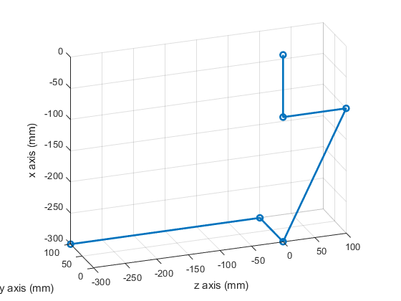

5) Showing a vector in end effector frame relative to body
ee_vector = [10;10;10];
ee_vector_bframe = Home(1:3,1:3)*ee_vector
ee_vector_bframe =
10
-10
-10

6) Inverse Kinematics
desired_point = [-350; 50; -350];
% Finding possible solutions if we fix joint 2 and joint 3
pos = subs(T_tip(1:3,4),[L t2 t3],[100 0 0])
eqn1 = pos(1) == desired_point(1);
eqn2 = pos(2) == desired_point(2);
eqn3 = pos(3) == desired_point(3);
solution_ikin = solve([eqn1 eqn2 eqn3],[t1 t4 t5]);
t1_vals = real(vpa(solution_ikin.t1));
t4_vals = real(vpa(solution_ikin.t4));
t5_vals = real(vpa(solution_ikin.t5));
point1 = [t1_vals(1) 0 0 t4_vals(1) t5_vals(1) 0]'
point2 = [t1_vals(2) 0 0 t4_vals(2) t5_vals(2) 0]'
result_pos1 = vpa(subs(pos,[t1 t2 t3 t4 t5 t6]',point1),4)
result_pos2 = vpa(subs(pos,[t1 t2 t3 t4 t5 t6]',point2),4)
pos =
- t4 - 300
300*sin(t5) - 100*cos(t5)
t1 - 300*cos(t5) - 100*sin(t5)
point1 =
-662.24989991991991029234465604699
0
0
50.0
-2.9786223138389117253083476554077
0
point2 =
-37.75010008008008970765534395301
0
0
50.0
0.48053076904240287364851350084553
0
result_pos1 =
-350.0
50.0
-350.0
result_pos2 =
-350.0
50.0
-350.0

finding possible solutions only fixing joint 2
pos = simplify(subs(T_tip(1:3,4),[L t2],[100 0]),'Steps',40)
eqn1 = pos(1) == desired_point(1)
eqn2 = pos(2) == desired_point(2)
eqn3 = pos(3) == desired_point(3)
% From these equations t5 == -2.9786, pi+2.9786, 0.4805, pi-0.4805
% if we pick t5 = 0.4805;
eqn1 = subs(eqn1,t5,0.4805)
eqn3 = subs(eqn3,t5,0.4806)
% We are still left with 2 equations with 3 unknowns.
% By selecting a value for t4 we can solve for t3. T4 is only bounded by
% its own joint limitations and even if it weren't, there are an infinite
% amount of numberse to choose between 0 and 1 meaning there are an
% infinite number of choices for t4.
% But then whatever we select for t3 and t4, t1 will be used to compensate
% to make sure the equation is still valid in the z position. If we were
% to unlock t2 and no longer have it fixed like we did to start this
% approach, there would then be even more solutions. This means
% there are an infinite number of solutions to the inverse kinematics
% problem at this point based on the first 5 joints. Unless specific joints
% are determined before hand, there will be an infinite number of solutions
% based on the position equations for the robot.
% By nature, theta 6 does not affect the position of the end effector and
% so there will always be an infinite number of solutions to the any valid
% inverse kinematics problem when considering all 6 joints.
pos =
300*cos(t5)*sin(t3) - 200*cos(t3) + 100*sin(t3)*sin(t5) - t4*cos(t3) - 100
300*sin(t5) - 100*cos(t5)
t1 - 200*sin(t3) - 300*cos(t3)*cos(t5) - 100*cos(t3)*sin(t5) - t4*sin(t3)
eqn1 =
300*cos(t5)*sin(t3) - 200*cos(t3) + 100*sin(t3)*sin(t5) - t4*cos(t3) - 100 == -350
eqn2 =
300*sin(t5) - 100*cos(t5) == 50
eqn3 =
t1 - 200*sin(t3) - 300*cos(t3)*cos(t5) - 100*cos(t3)*sin(t5) - t4*sin(t3) == -350
After constraining joint 5
eqn1 =
300*cos(961/2000)*sin(t3) - 200*cos(t3) - t4*cos(t3) + 100*sin(961/2000)*sin(t3) - 100 == -350
eqn3 =
t1 - 200*sin(t3) - 300*cos(2403/5000)*cos(t3) - 100*sin(2403/5000)*cos(t3) - t4*sin(t3) == -350

7) Jacobian
z0 = [0;0;1]; p0 = [0;0;0];
z1 = T_total(1:3,3,1); p1 = T_total(1:3,4,1);
z2 = T_total(1:3,3,2); p2 = T_total(1:3,4,2);
z3 = T_total(1:3,3,3); p3 = T_total(1:3,4,3);
z4 = T_total(1:3,3,4); p4 = T_total(1:3,4,4);
z5 = T_total(1:3,3,5); p5 = T_total(1:3,4,5);
pe = T_total(1:3,4,6);
Jv = simplify([z0 cross(z1,pe-p1) cross(z2,pe-p2)...
z3 cross(z4,pe-p4) cross(z5,pe-p5)],'Steps', 10);
Jw = simplify([zeros(3,1) z1 z2 zeros(3,1) z4 z5], 'Steps', 10);
J = simplify([Jv; Jw],'Steps',10);
pretty(J);
[[0, L sin(t2) - 3 L (#5 + #4) + L cos(t2) cos(t5) + 2 L
cos(t3) sin(t2) + t4 cos(t3) sin(t2) - L sin(t2) sin(t3) sin(t5),
cos(t2) #1, -#7, -L (3 cos(t5) sin(t2) + #3
+ 3 cos(t2) sin(t3) sin(t5) - #2), 0],
[0, L cos(t5) sin(t2) - L cos(t2) - 2 L cos(t2) cos(t3) - 3 L (#3 - #2)
- t4 cos(t2) cos(t3) + L cos(t2) sin(t3) sin(t5), sin(t2) #1, -#6,
L (3 cos(t2) cos(t5) + #5 + #4 - 3 sin(t2) sin(t3) sin(t5)), 0],
[1, 0, 3 L cos(t5) sin(t3) - t4 cos(t3) - 2 L cos(t3) + L
sin(t3) sin(t5), -sin(t3), -L cos(t3) (cos(t5) - 3 sin(t5)), 0],
[0, 0, sin(t2), 0, #7, #2 - #3], [0, 0, -cos(t2), 0, #6, #5 + #4],
[0, 1, 0, 0, sin(t3), -cos(t3) cos(t5)]]
where
#1 == 2 L sin(t3) + t4 sin(t3) + 3 L cos(t3) cos(t5) + L cos(t3) sin(t5)
#2 == cos(t2) cos(t5) sin(t3)
#3 == sin(t2) sin(t5)
#4 == cos(t5) sin(t2) sin(t3)
#5 == cos(t2) sin(t5)
#6 == cos(t3) sin(t2)
#7 == cos(t2) cos(t3)

Determining Singularities
Only care about positional singularities
Jv = simplify(subs(Jv,L,100),'Steps',20);
% velocity jacobian
det_Jv = simplify(det(Jv*Jv'),'Steps',20);
pretty(det_Jv)
% t2 and t1 do not affect singularity as the are not in the determinant of Jv*Jv'
% Therefore we will set t2 = 0, t1 = 0
Jv1 = simplify(subs(Jv,t2,0));
pretty(Jv1);
See end of document for determinant of Jv*Jv’
Jv1 = [[0, 100 cos(t5) - 300 sin(t5), 200 sin(t3) + 300 cos(t3) cos(t5) + 100
cos(t3) sin(t5) + t4 sin(t3), -cos(t3), sin(t3) #1 100, 0],
[0, #3 - 200 cos(t3) + #2 - t4 cos(t3) - 100, 0,
0, 300 cos(t5) + 100 sin(t5), 0],
[1, 0, #3 - 200 cos(t3) + #2 - t4 cos(t3), -sin(t3), -cos(t3) #1 100, 0]]
where
#1 == cos(t5) - 3 sin(t5)
#2 == 100 sin(t3) sin(t5)
#3 == 300 cos(t5) sin(t3)

find where x velocities will be equal to 0
end effector point is directly in line with joint 2 and 3
Jvx = Jv1(1,2:5) == zeros(1,4)
% therefore t3 == +- pi/2
th3 = -pi/2;
% therefore (100*cos(t5)-300sin(t5) == 0
th5 = atan(1/3);
% therefore (t4 + 200) == 0
th4 = -200;
rank_typ1_ex1 = rank(vpa(subs(Jv,[t1 t2 t3 t4 t5 t6],[0 0 th3 th4 th5 0]),4))
% alternate th3
th3 = pi/2
rank_typ1_ex2 = rank(vpa(subs(Jv,[t1 t2 t3 t4 t5 t6],[0 0 th3 th4 th5 0]),4))
dh_table_sing_ex1 = subs(dh_table,[t1 t2 t3 t4 t5 t6,L],[0 0 -pi/2 -200 th5 0,100]);
plot_robot(dh_table_sing_ex1);
Jvx =
[ 100*cos(t5) - 300*sin(t5) == 0, 200*sin(t3) + 300*cos(t3)*cos(t5) + 100*cos(t3)*sin(t5) + t4*sin(t3) == 0, -cos(t3) == 0, 100*sin(t3)*(cos(t5) - 3*sin(t5)) == 0]
rank_typ1_ex1 =
2
th3 =
1.5708
rank_typ1_ex2 =
2
This means that there are only two singularities that cause the velocity to be 0 in the x direction. [t3 = +/- pi/2, t4 = -200, t5 = atan(1/3)]
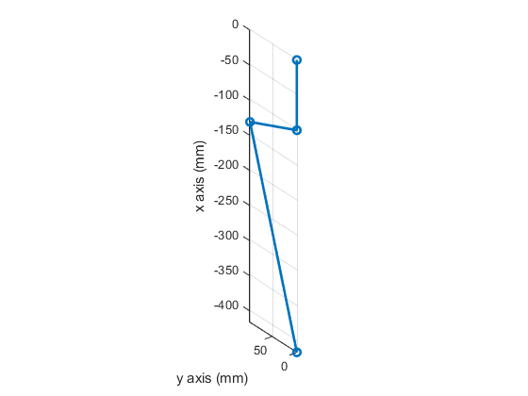

find where y velocities will be equal to 0
This means the end effector is in line with joint 2 and in the y and z axis only
Jvy = Jv1(2,2:5) == zeros(1,4)
% therefore 300cos(t5) + 100sin(t5) == 0
th5 = atan(-3);
% This means that -cos(t3)(t4 + 200) == 100 and there are infinite
% solutions to this equation
%one example
th3 = acos(-1/2.5); th4 = 50;
rank_typ2_ex1 = rank(vpa(subs(Jv,[t1 t2 t3 t4 t5 t6],[0 0 th3 th4 th5 0]),4))
% another example
th3 = 2*pi/3; th4 = 0;
rank_typ2_ex2 =rank(vpa(subs(Jv,[t1 t2 t3 t4 t5 t6],[0 0 th3 th4 th5 0]),4))
dh_table_sing_ex2 = subs(dh_table,[t1 t2 t3 t4 t5 t6,L],[0 0 2*pi/3 0 th5 0,100]);
plot_robot(dh_table_sing_ex2);
Jvy =
[ 300*cos(t5)*sin(t3) - 200*cos(t3) + 100*sin(t3)*sin(t5) - t4*cos(t3) - 100 == 0, 0 == 0, 0 == 0, 300*cos(t5) + 100*sin(t5) == 0]
rank_typ2_ex1 =
2
rank_typ2_ex2 =
2
Joint 1 and Joint 2 do not affect singular configurations. The equations that governs singularities that cause the velocity to be 0 in the y direction are
300cos(t5) + 100sin(t5) == 0
-cos(t3)(t4 + 200) == 100
This means there are an infinite number of solutions that can produce a singular configuration in which the end effector is in line with joint 2 and the line created between joint 2 and the end effector is perpendicular to the link extending below link 2.
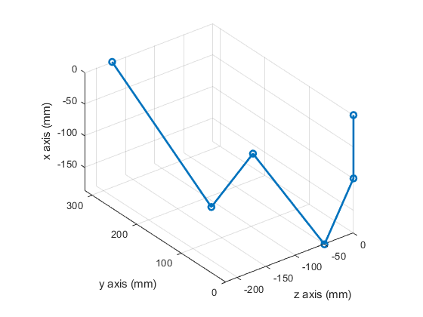

Inverse Velocity
tip_vel = [10;0;10];
Jv_val = subs(Jv,[L t1 t2 t3 t4 t5 t6],[100 zeros(1,6)])
joint_vel = vpa(pinv(Jv_val)*tip_vel,4)
rank_Jv_val = rank(Jv_val)
% Becauses the rank of Jv = 3 (full rank) at the home position and there
% are 5 columns, there are an infinite number of possible solutions to the
% inverse velocity problem. The pinv solution finds an answer that
% minimizes the norm of joint velocities, but is only one possible answer.
% By moving only joint 1, 3, and 4 for example, there are an infinite
% combination of joint velocities that would produce a tip velocity of
% [10;0;10].
Jv_val =
[ 0, 100, 300, -1, 0, 0]
[ 0, -300, 0, 0, 300, 0]
[ 1, 0, -200, 0, -100, 0]
joint_vel =
0.03191
-0.4986
0.1995
-0.02194
-0.4986
0
Another solution based on written work below
Joint_vel = [10;0;0;-10;0;0]
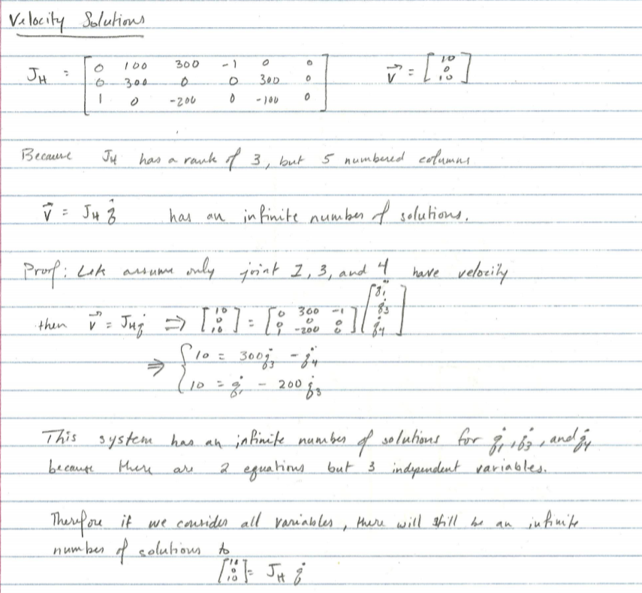

functions
function T = get_fwdkin(dh_table,is_sym)
rows = size(dh_table,1);
if is_sym
T = sym('T',[4,4,rows]);
else
T = zeros(4,4,rows);
end
for i = 1:rows
if i == 1
T(:,:,i) = tdh(dh_table(i,:));
else
T(:,:,i) = simplify(T(:,:,i-1)*tdh(dh_table(i,:)),'Steps',10);
end
end
end
function p = plot_robot(dh_table)
T = get_fwdkin(dh_table,false);
num_transforms = size(T,3);
pos = [0;0;0];
for i = 1:num_transforms
pos = [pos T(1:3,4,i)];
end
% p = plot3(pos(3,:),-pos(2,:),pos(1,:),'Marker','o');
p = plot3(pos(3,:),-pos(2,:),pos(1,:),'Marker','o','LineWidth',2);
xlabel('z axis (mm)')
ylabel('y axis (mm)')
zlabel('x axis (mm)')
axis equal
grid on
end
Published with MATLAB® R2019b

Determinant of Jv*Jv’
24000000 t4 + sin(2 t5) 24004200000000 + 9600000000 cos(t3) + 100000000 t4
2 2 3
cos(t3) + 240000 t4 cos(t3) - 35999800 t4 cos(t3)
3 4 2
+ 400 t4 cos(t3) - 43999600 t4 cos(t3) + 128000000 t4 cos(t5)
+ t4 sin(2 t5) 48000000 - 4800000000 cos(t5) sin(t3) + 2399980000
2 3
sin(t3) sin(t5) + 6200030000 cos(t3) - 3999960000 cos(t3)
4 2 4
- 1999970000 cos(t3) + 28011200000000 cos(t5) - 28000000000000 cos(t5)
2 2 2 3 3 2
+ 570000 t4 cos(t3) - 120000 t4 cos(t3) + 1600 t4 cos(t3)
2 4 2 2 3 3
- 269999 t4 cos(t3) + 320000 t4 cos(t5) - 200 t4 cos(t3)
4 2 3 4 4 4
+ 2 t4 cos(t3) - 800 t4 cos(t3) - t4 cos(t3) - 12800000000
2 2 3
cos(t3) cos(t5) + t4 sin(2 t5) 120000 - 96000000000000 cos(t5)
3
sin(t5) - 3999980000 sin(t3) sin(t5) + 80000000 t4 cos(t3) - 19999840000
2 2 3 2 2
cos(t3) cos(t5) + 12800000000 cos(t3) cos(t5) + 5600000000 cos(t3)
4 4 2 4 4
cos(t5) + 19999920000 cos(t3) cos(t5) - 5600000000 cos(t3) cos(t5)
2 2 3
+ 60000 t4 + 20000 t4 sin(t3) sin(t5) - 24000000 t4 sin(t3)
2
sin(t5) - 2000000000 cos(t3) sin(t3) sin(t5) - 320000000 t4 cos(t3)
2 3 2 4 2
cos(t5) + 64000000 t4 cos(t3) cos(t5) + 224000000 t4 cos(t3) cos(t5)
2 3
+ 9599940000 cos(t3) cos(t5) sin(t3) + 14400000000 cos(t3) cos(t5)
3 2
sin(t3) + 10799880000 cos(t3) cos(t5) sin(t3) - 20399880000 cos(t3)
3
cos(t5) sin(t5) + 9600000000 cos(t3) cos(t5) sin(t5) + 20399940000
4 2 3
cos(t3) cos(t5) sin(t5) - 60000 t4 sin(t3) sin(t5) + 5999960000
3 2
cos(t3) sin(t3) sin(t5) - 48000000 t4 cos(t5) sin(t3) - 800000 t4
2 2 2 4 2
cos(t3) cos(t5) + 560000 t4 cos(t3) cos(t5) + 8000000 t4
2 3
sin(t3) sin(t5) - 7200000000 cos(t3) cos(t5) sin(t3) - 21600000000
3 3 2 3
cos(t3) cos(t5) sin(t3) + 19200000000 cos(t3) cos(t5)
4 3
sin(t5) - 19200000000 cos(t3) cos(t5) sin(t5) - 64000000 t4
2 2
cos(t3) cos(t5) - 120000 t4 cos(t5) sin(t3) - 1200000000
2
cos(t3) cos(t5) sin(t3) - 9600000000 cos(t3) cos(t5) sin(t5) + 180000 t4
2 2 3
cos(t3) cos(t5) sin(t3) + 720000 t4 cos(t3)
3 3 2
cos(t5) sin(t3) - 108000000 t4 cos(t3) cos(t5) sin(t3) - 600000 t4
2 3 3 2
cos(t3) cos(t5) sin(t5) + 1200 t4 cos(t3) cos(t5) sin(t3) + 420000 t4
4 2 3 3
cos(t3) cos(t5) sin(t5) + 240000 t4 cos(t3) sin(t3) sin(t5) + 400 t4
3 2
cos(t3) sin(t3) sin(t5) + 20800000000 cos(t3) cos(t5)
sin(t3) sin(t5) - 102000000 t4 cos(t3) cos(t5) sin(t3) - 48000000 t4
cos(t3) cos(t5) sin(t5) - 42000000 t4
2 2
cos(t3) sin(t3) sin(t5) - 10400000000 cos(t3) cos(t5)
3 2
sin(t3) sin(t5) - 31200000000 cos(t3) cos(t5)
2 2
sin(t3) sin(t5) + 72000000 t4 cos(t3) cos(t5) sin(t3) - 720000 t4
3
cos(t3) cos(t5) sin(t3) + 72000000 t4 cos(t3) cos(t5)
3 3
sin(t3) + 149999400 t4 cos(t3) cos(t5) sin(t3) - 1200 t4
2
cos(t3) cos(t5) sin(t3) - 240000000 t4 cos(t3)
3
cos(t5) sin(t5) + 48000000 t4 cos(t3) cos(t5) sin(t5) + 168000000 t4
4 2
cos(t3) cos(t5) sin(t5) - 240000 t4 cos(t3) sin(t3) sin(t5) + 61999800
3 3
t4 cos(t3) sin(t3) sin(t5) - 400 t4 cos(t3) sin(t3) sin(t5) - 156000000
3 2 2
t4 cos(t3) cos(t5) sin(t3) sin(t5) + 104000000 t4 cos(t3) cos(t5)
sin(t3) sin(t5) + 9004200000000

