Immersion of Achilles tendon in phosphate buffered saline influences T₁ and T₂* relaxation times: an ex vivo study

M. Krämer^{1,*}, M. R. Kollert^{2,3}, N. M. Brisson², M. B. Maggioni¹,
G. N. Duda^{2,3}, J. R. Reichenbach¹

¹ Medical Physics Group, Institute of Diagnostic and Interventional Radiology, Jena University Hospital, Friedrich Schiller University Jena, Germany
² Julius Wolff Institute and Center for Musculoskeletal Surgery, Charité – Universitätsmedizin Berlin, Germany
³ Berlin-Brandenburg Center and School for Regenerative Therapies, Charité – Universitätsmedizin Berlin, Germany

Corresponding Author:
Dr. rer. nat. Martin Krämer
Medical Physics Group, IDIR, Jena University Hospital
Philosophenweg 3, D-07443 Jena, Germany
Phone: +49 3641 9 390731
Fax: +49 3641 9 390728
E-Mail: martinkraemer84@gmail.com

Authors’ Names, Degrees, and E-Mails:
- Martin Krämer, Dr. rer. nat.: martinkraemer84@gmail.com
- Matthias R. Kollert, M.Sc.: matthias.kollert@charite.de
- Nicholas M. Brisson, Ph.D.: nicholas.brisson@charite.de
- Marta B. Maggioni, M.Sc.: marta.maggioni@uni-jena.de
- Georg N. Duda, Dr.-Ing.: georg.duda@charite.de
- Jürgen R. Reichenbach, Dr. rer. nat.: Juergen.Reichenbach@med.uni-jena.de

Keywords: ultra-short echo-time; UTE; phosphate buffered saline; PBS; tissue swelling; Achilles tendon; ex vivo; relaxation time constants

Submitted to NMR in Biomedicine
This manuscript or parts of this manuscript have not been
and will not be submitted elsewhere for publication

Abstract
Robust relaxation parameter mapping in ex vivo tissue requires hydration to be closely controlled to ensure tissue integrity and consistent measurement conditions over long durations. One way to maintain the hydration of ex vivo tendon tissue is immersing samples in a buffer solution. To this end, various buffer solutions have been proposed; however, many appear to influence the tissue relaxation times, especially over prolonged exposure. In this work, we investigated the effect of immersing ovine Achilles tendon tissue in phosphate buffered saline (PBS) on T₁ and T₂* relaxation times. Ex vivo samples were measured at 0 h (baseline), 30 h and 67 h after immersion in PBS. Ultra-short echo-time (UTE) imaging was performed using variable flip angle and echo-train shifted multi-echo imaging for T₁ and T₂* estimation, respectively. Compared to baseline, both T₁ and T₂* relaxation times increased significantly after 30 h of immersion in PBS. T₂* continued to show a significant increase between 30 h and 67 h. Both T₁ and T₂* tended to approach saturation at 67 h. These findings demonstrate the importance of applying stringently controlled tissue preparation and preservation techniques, both before and during MRI experiments, as an experimental step as basic as immersing tissue samples in PBS can strongly influence relaxation parameter measurements.
Introduction
Tendons are crucial structures of the musculoskeletal system, as their primary mechanical role is to transmit muscle forces to bones, thereby allowing locomotion and enhancing joint stability [1]. Knowledge of basic structural and mechanical functions of healthy tendons is essential to understanding and treating injured or pathological tendons. Nonetheless, tendons have thus far been understudied with magnetic resonance imaging (MRI), likely due to challenges that arise with parameter quantification, notably, rapid signal decay caused by ultra-short T₂* relaxation times ranging between 0.5 ms and 2.5 ms [2, 3, 4]. Direct imaging of tendons by means of MRI requires the application of ultra-short echo-time (UTE) imaging sequences, which utilize two-dimensional half radiofrequency (rf) pulses [5, 6] or non-selective short rectangular rf pulses [7, 8, 9], which are not readily available on most clinical MRI systems. UTE imaging sequences can achieve echo-times (TE) below 1 ms, thus enabling direct imaging of tendons and parameter quantification simultaneously.
Being a non-invasive method, MRI has the advantage of yielding detailed examinations of ex vivo tissue while preserving its structural and mechanical properties. This not only enables longitudinal analysis but also direct comparison to histological or biomechanical measurements. Importantly, tissue parameters quantified in such samples could aid in linking structural or biomechanical properties from ex vivo experiments to disease-related changes observed in in vivo measurements. However, imaging of ex vivo tissue samples can be challenging for several reasons. First, air-tissue boundaries can cause unwanted susceptibility artifacts that can be reduced by immersing the samples in fluids that closely match susceptibility differences. Second, to achieve high spatial resolutions or to quantify tissue parameters of interest, the samples (which are typically small) must often be measured over a longer period of time: from several hours to more than a day. During such prolonged periods, sample integrity and hydration must be controlled as dehydration is known to strongly affect structure and mechanical properties of tendon tissue [10, 11]. For this reason, many experiments are performed after having stored the samples in water-free substances such as perfluoropolyether (Fomblin), with or without additional formalin fixation [12, 13]. Nevertheless, such approaches can influence tissue structural and mechanical properties, as well as quantitative MRI parameters [14, 15, 16]. To address these potential complications, an alternative method is to immerse the samples in saline or phosphate-buffered saline (PBS) solutions. These mimic the physiological osmolarity of interstitial fluid, for the measurement duration, especially when imaging fresh and unfixed samples.
Currently, a paucity of literature is available on the influence of buffer solutions on the quantification of MRI relaxation parameters in tendons. Chang et al. investigated the influence of immersing ex vivo human Achilles tendons in different fluids (saline solution, Fomblin and perfluorooctyl bromide) and found no influence on T₂ and T₂* values [17]. However, their results were based on six tendon samples obtained from tissue banks, which had high inter-donor variability [17]. Moreover, those tendon samples underwent a deep-freeze-thaw cycle before being measured, which could have affected tissue swelling behavior. Pownder et al. reported that exposing fresh tendon tissue to such a freeze-thaw cycle decreases T₂* [18]. Furthermore, Safa et al. described that exposing tendon tissue to a buffer solution such as PBS influences tissue hydration and mechanics, and leads to solute diffusion into the tissue [19]. Accordingly, these swelling effects may alter MRI relaxation parameters and confound data interpretation. Yet, it remains unclear how exposure of fresh tendon tissue to PBS affects T₁ and T₂* measurements.
In this work, we investigated the effect of immersing ex vivo tendon tissue in PBS on MRI relaxation parameters. Variable flip angle [20] and multi-echo [21] 3D-UTE imaging was applied to quantify T₁ and T₂*, respectively. Soleus portions of fresh ovine Achilles tendons were immersed in PBS for 67 h, and relaxation parameters were estimated after 0 h (baseline), 30 h and 67 h.

Material and methods

Sample preparation
Fresh Achilles tendons from eight healthy sheep (Merino, female, 4+ years old) were excised after euthanasia in a different research project in compliance with the ethical guidelines of legal, local animal rights protection authorities (Landesamt für Gesundheit und Soziales Berlin). The tendons were excised close to the calcaneus and before the onset of the calf muscle, and thus contained a mid-tendon portion along with adjoining fibrocartilaginous enthesis tissue. The samples were enveloped in plastic wrap and stored for 4 days at 4°C in a moist environment to avoid dehydration. The moist environment was achieved by placing the samples in individual sealed 50 ml polypropylene centrifuge tubes with moistened cotton gauze at the conical tip of the tubes. On the fourth day, any remaining surrounding tissues were removed, and the denuded soleus portions of the Achilles tendons were enveloped in plastic wrap and stored for 3 additional days at 4°C in a moist environment. For the MRI experiments, the samples were removed from the plastic wrap and transferred from the centrifuge tubes to similar tubes filled with PBS (Dulbecco's Phosphate-Buffered Saline, Sigma-Aldrich, Taufkirchen, Germany), and immediately (within 10 minutes) positioned in the MRI scanner for imaging.

Relaxation parameter mapping
To estimate T₁, a single-echo 3D-UTE acquisition with TE of 0.15 ms was repeated using a variation of the flip angle (VFA) [22] of 34°, 26°, 19°, 14°, 11°, and 5°. To calculate T₁ relaxation time maps from the six data sets with different flip angles, a two-parameter fit of the signal equation for fast low-angle shot (FLASH) gradient-echo MRI sequences was applied [20].
To estimate T₂*, an echo-train shifted [23, 24] multi-echo 3D-UTE imaging sequence [20] was used with TE of 0.15 ms, 0.35 ms, 0.60 ms, 1.77 ms, 1.97 ms, and 2.22 ms. The multi-echo acquisition during one readout train was carried out in a monopolar fashion using re-phasing gradients between echoes. To map T₂* from the 6 echoes acquired, a voxel-wise squared exponential fit to the corresponding power images was computed from the reconstructed magnitude data, including an additional offset parameter to account for potential noise bias [25, 26].

MRI protocol
All tendon samples were measured simultaneously with the laboratory tubes positioned next to one another and wrapped between the two elements of a 16-channel NORAS Variety flex measurement coil (NORAS MRI products GmbH, Höchberg, Germany). Measurements were performed with a clinical 3 T whole-body MRI scanner (Magnetom PRISMA, Siemens Healthineers, Erlangen, Germany). For 3D-UTE imaging, non-selective hard pulse excitation and spikey-ball trajectories were used [27]. Echo-train shifted multi-echo and VFA acquisition were performed with the same orientation and gradient parameters described above, using a 192 x 148 x 58 acquisition matrix size and a 180 x 139 x 55 mm³ field of view that resulted in an isotropic spatial resolution of 0.95 x 0.95 x 0.95 mm³. Furthermore, the echo-train shifted multi-echo acquisition used a flip angle of 15° and a repetition time (TR) of 5.5 ms, whereas the VFA acquisition used a longer TR of 9.4 ms to allow the use of larger flip angles without violating the limits of the specific absorption rate. Three blocks of VFA and echo-train shifted multi-echo data acquisition, each 65 minutes in duration, were collected at baseline, 30 h and 67 h after filling the laboratory tubes with PBS.
Images were reconstructed offline in MATLAB (The MathWorks, Inc., Natick, Massachusetts, United States of America) using re-gridding with iterative sampling density compensation and an optimized kernel [28]. Data analysis and non-linear curve fitting were also performed in MATLAB. After calculation of relaxation parameter maps, regions-of- interest (ROI) were drawn manually in mid-tendon and enthesis regions of all samples. To this end, transverse slices in the middle of the tendon and close to the enthesis end were used to define the respective mid-tendon and enthesis positions. The extracted T₁ and T₂* relaxation parameters of all voxels were averaged for each ROI. To test the significance of changes in T₁ and T₂* between 0 h (baseline), 30 h and 67 h of immersion in PBS, a two-sided Wilcoxon rank-sum test was performed in MATLAB. Statistical significance was set at p<0.05.

Results
Typical FLASH signal curves were observed for the VFA acquisitions (Figure 1), with a peak between flip angles of 5° and 15° followed by a fall-off for larger flip angles. Since the individual peak positions change along the x-axis, the curves qualitatively indicate different T₁ relaxation times between mid-tendon (Figure 1, left) and enthesis (Figure 1, right) regions, and between different immersion durations. After fitting the data to the FLASH signal model, the comparison of the extracted T₁ relaxation times averaged over all samples (Figure 2) demonstrated a significant increase from baseline to 30 h for both the mid-tendon (p = 0.004) and enthesis (p = 0.002) region. Changes in T₁ relaxation times from 30 h to 67 h were not significant for both regions (p>0.05). The change of T₁ over the entire immersion duration was significantly greater (p = 0.004) in the enthesis (ΔT₁ = 231 ± 44 ms) compared to the mid-tendon region (ΔT₁ = 110 ± 20 ms).
Signals plotted over the six acquired echoes displayed rapid decays for both the mid-tendon (Figure 3, left) and enthesis (Figure 3, right) regions. Qualitatively, the signal in the enthesis region decayed more slowly. Quantitatively, the T₂* relaxation times averaged over all samples (Figure 4) increased significantly between baseline and 30 h (p = 0.002) and between 30 h and 67 h (p = 0.004) for the mid-tendon region. Furthermore, a significant increase was found for the enthesis region from baseline to 30 h (p = 0.002) and from 30 h to 67 h (p = 0.002). The total change in T₂* over the entire immersion duration was significantly higher (p = 0.001) in the enthesis (ΔT₂* = 0.31 ± 0.03 ms) compared to mid-tendon region (ΔT₂* s = 0.18 ± 0.02 ms).

Discussion
In this study, significant increases in T₁ and T₂* were observed after immersing ovine Achilles tendon samples in PBS. This finding is in contrast to that from Chang et al. [17], who reported no increase in T₂* for ex vivo human Achilles tendon following immersion in PBS. The latter study, however, investigated samples that were deep-frozen and thawed. This process could disrupt the microstructure of the extracellular matrix and change water binding properties within the tendon [18, 29], thereby altering its ability to interact with PBS. In addition, it appears that T₁ and T₂* came close to saturation after 67 h of tendon immersion in PBS. However, confirmation of a true saturation behavior (i.e., to extract saturation time constants for the increases in T₁ and T₂* following tendon immersion in PBS) requires more than three time points for reliable fitting of corresponding data. The underlying mechanism causing the increases in relaxation parameters in the mid-tendon and enthesis regions is likely related to an increase in weakly bound water, or free water, in the extracellular matrix through tissue swelling. Furthermore, solute molecules may diffuse into the tissue [19] and interact with its structure, which could also affect MRI measurements.
A comparison of T₁ and T₂* relaxation times from the current study to those reported in the literature is challenging because there are currently no known data for ovine Achilles tendons. For human tendons, T₂* relaxation times of 2.4 ms [30] and 0.9 ms [31] have been reported for ex vivo, and 1.5 ms [3] and 0.4 ms [32] for in vivo studies. With baseline T₂* relaxation times of 0.2 ms and 0.5 ms for the mid-tendon and enthesis regions, respectively, our results fall within the lower range of values reported for human tissue at 3T. Furthermore, increased T₂* values have been reported for the enthesis compared to the mid-tendon region [31, 32], consistent with our findings. Nevertheless, a comparison of the current results with data from human studies is not straightforward. For instance, tendons from animals and humans exhibit molecular differences and are exposed to distinct mechanical loading patterns and magnitudes due to the bipedal vs. quadrupedal nature of locomotion [33]. Moreover, discrepancies across studies may be due to magic angle effect [34, 35], which is known to have a strong influence on T₂*. In the present study, the samples were fully excised from surrounding tissue, thus allowing parallel alignment with the scanner’s main magnetic field. With larger samples, still containing surrounding tissue, alignment of the tendons with the magnetic field may be more difficult and possibly imprecise. Consequently, T₂* values reported in the literature may vary due to orientation issues.
Reference values for T₁ relaxation times in human Achilles mid-tendons have been reported to range between 610 ms and 640 ms, both in in vivo [3, 4] and ex vivo studies [30, 31]; lower values (i.e., 530 ms) were found for an ex vivo rabbit Achilles tendon [36]. In humans, one study found a higher T₁ value in the enthesis compared to the mid-tendon [31], while another study found no T₁ difference between these regions [3]. In the current study, the observed baseline T₁ values of 390 ± 38 ms for the mid-tendon and 600 ± 64 ms for the enthesis are lower than those indicated above. In addition to the above-mentioned differences between human and animal tendons, B₁ inhomogeneities [37, 32], different tissue sample sizes and temperature effects [38] are another possible source of variation, especially when comparing values obtained from small excised tendons, intact cadaveric limbs and in vivo studies. In our experiments, temperature effects were deemed negligible as the samples were placed in a temperature-controlled MRI system with an ambient temperature of 23°C for the entire duration of the 67 h measurement.
In conclusion, we have shown that an experimental step as fundamental as immersing tendon samples in PBS for measurement or preservation can have significant effects on both T₁ and T₂* relaxation parameters. The strong effect of swelling of tendon tissue in PBS on the measured relaxation times underscores the importance of closely controlling the handling and hydration of samples not only before, but also during the MRI of ex vivo tissue experiments to yield valid and reliable results. More studies are needed to obtain reproducible and robust relaxation parameters through improved protocols for ex vivo tendon imaging. Ultimately, such methodological refinements will improve the effectiveness of combining MRI relaxation parameter mapping of ex vivo tendon with other methods of tissue analysis, such as histology and biomechanics, and may lead to improved interpretation of in vivo measurements.

Acknowledgments
This work was supported by the German Research Foundation (DFG, DU 298/25-1, RE 1123/22-1) and the Interdisciplinary Center for Clinical Research (IZKF, J64) in Jena, Germany. The authors have no relevant financial conflicts to disclose regarding this study. We acknowledge technical assistance with tissue harvesting from Svenja Kasselmann and Dr. Katja Reiter (Charité – Universitätsmedizin Berlin).

References
[1] Wang JHC. Mechanobiology of tendon. Journal of Biomechanics 2006;39(9):1563–1582. ISSN 0021-9290.
[2] Jerban S, Nazaran A, Cheng X, Carl M, Szeverenyi N, Du J, Chang EY. Ultrashort echo time T2* values decrease in tendons with application of static tensile loads. Journal of Biomechanics 2017;61:160–167. ISSN 00219290. http://linkinghub.elsevier.com/retrieve/pii/S0021929017303779.
[3] Grosse U, Springer F, Hein T, Grözinger G, Schabel C, Martirosian P, Schick F, Syha R. Influence of physical activity on T1 and T2* relaxation times of healthy achilles tendons at 3T. Journal of Magnetic Resonance Imaging 2015;41(1):193–201. ISSN 10531807. http://doi.wiley.com/10.1002/jmri.24525.
[4] Grosse U, Syha R, Hein T, Gatidis S, Grözinger G, Schabel C, Martirosian P, Schick F, Springer F. Diagnostic value of T₁ and T₂* relaxation times and off-resonance saturation effects in the evaluation of achilles tendinopathy by MRI at 3T: MR Evaluation of Achilles Tendinopathy. Journal of Magnetic Resonance Imaging 2015;41(4):964–973. ISSN 10531807. http://doi.wiley.com/10.1002/jmri.24657.
[5] Robson MD, Gatehouse PD. Consequences of T2 relaxation during half-pulse slice selection for ultrashort TE imaging. Magnetic Resonance in Medicine 2010;64(2):610–615. ISSN 07403194, 15222594. http://doi.wiley.com/10.1002/mrm.22323.
[6] Josan S, Pauly JM, Daniel BL, Pauly KB. Double half RF pulses for reduced sensitivity to eddy currents in UTE imaging. Magnetic Resonance in Medicine 2009;61(5):1083–1089. ISSN 07403194, 15222594. http://doi.wiley.com/10.1002/mrm.21879.
[7] Rahmer J, Börnert P, Groen J, Bos C. Three-dimensional radial ultrashort echo-time imaging with T2 adapted sampling. Magnetic Resonance in Medicine 2006;55(5):1075–1082. ISSN 0740-3194, 1522-2594. http://doi.wiley.com/10.1002/mrm.20868.
[8] Rahmer J, Blume U, Börnert P. Selective 3D ultrashort TE imaging: comparison of dual-echo acquisition and magnetization preparation for improving short-T2 contrast. Magnetic Resonance Materials in Physics, Biology and Medicine 2007;20(2):83–92. ISSN 0968-5243, 1352-8661. http://link.springer.com/10.1007/s10334-007-0070-6.
[9] Krämer M, Motaal AG, Herrmann KH, Löffler B, Reichenbach JR, Strijkers GJ, Hoerr V. Cardiac 4D phase-contrast CMR at 9.4 T using self-gated ultra-short echo time (UTE) imaging. Journal of Cardiovascular Magnetic Resonance 2017;19(1). ISSN 1532-429X. http://jcmr-online.biomedcentral.com/articles/10.1186/s12968-017-0351-9.
[10] Masic A, Bertinetti L, Schuetz R, Chang SW, Metzger TH, Buehler MJ, Fratzl P. Osmotic pressure induced tensile forces in tendon collagen. Nature Communications 2015;6:5942. ISSN 2041-1723.
[11] Lozano PF, Scholze M, Babian C, Scheidt H, Vielmuth F, Waschke J, Ondruschka B, Hammer N. Water-content related alterations in macro and micro scale tendon biomechanics. Scientific Reports 2019;9(1):7887. ISSN 2045-2322.
[12] Strijkers GJ, Bouts A, Blankesteijn WM, Peeters THJM, Vilanova A, van Prooijen MC, Sanders HMHF, Heijman E, Nicolay K. Diffusion tensor imaging of left ventricular remodeling in response to myocardial infarction in the mouse. NMR in biomedicine 2009;22(2):182–190. ISSN 0952-3480.
[13] Helander KG. Kinetic studies of formaldehyde binding in tissue. Biotechnic & Histochemistry: Official Publication of the Biological Stain Commission 1994;69(3):177–179. ISSN 1052-0295.
[14] Fishbein KW, Canuto HC, Bajaj P, Camacho NP, Spencer RG. Optimal methods for the preservation of cartilage samples in MRI and correlative biochemical studies. Magnetic Resonance in Medicine 2007;57(5):866–873. ISSN 0740-3194.
[15] Hales PW, Burton RAB, Bollensdorff C, Mason F, Bishop M, Gavaghan D, Kohl P, Schneider JE. Progressive changes in T₁, T₂ and left-ventricular histo-architecture in the fixed and embedded rat heart. NMR in Biomedicine 2011;24(7):836–843. ISSN 1099-1492.
[16] Zheng S, Xia Y. Changes in Proton Dynamics in Articular Cartilage Caused by Phosphate Salts and Fixation Solutions. Cartilage 2010;1(1):55–64. ISSN 1947-6035.
[17] Chang EY, Du J, Bae WC, Statum S, Chung CB. Effects of achilles tendon immersion in saline and perfluorochemicals on T2 and T2*. Journal of Magnetic Resonance Imaging 2014;40(2):496–500. ISSN 10531807. http://doi.wiley.com/10.1002/jmri.24360.
[18] Pownder SL, Shah PH, Potter HG, Koff MF. The effect of freeze-thawing on magnetic resonance imaging T2* of freshly harvested bovine patellar tendon. Quantitative Imaging in Medicine and Surgery 2015;5(3):368–373. ISSN 2223-4292.
[19] Safa BN, Meadows KD, Szczesny SE, Elliott DM. Exposure to buffer solution alters tendon hydration and mechanics. Journal of Biomechanics 2017;61:18–25. ISSN 1873-2380.
[20] Krämer M, Maggioni MB, Brisson NM, Zachow S, Teichgräber U, Duda GN, Reichenbach JR. T1 and T2* mapping of the human quadriceps and patellar tendons using ultra-short echo-time (UTE) imaging and bivariate relaxation parameter-based volumetric visualization. Magnetic Resonance Imaging 2019;63:29–36. ISSN 1873-5894.
[21] Krämer M, Herzau B, Reichenbach JR. Segmentation and visualization of the human cranial bone by T2* approximation using ultra-short echo time (UTE) magnetic resonance imaging. Zeitschrift fur Medizinische Physik 2019; doi: 10.1016/j.zemedi.2019.06.003. [Epub ahead of print]. ISSN 1876-4436.
[22] Fram EK, Herfkens RJ, Johnson G, Glover GH, Karis JP, Shimakawa A, Perkins TG, Pelc NJ. Rapid calculation of T1 using variable flip angle gradient refocused imaging. Magnetic Resonance Imaging 1987;5(3):201–208. ISSN 0730725X. http://linkinghub.elsevier.com/retrieve/pii/0730725X8790021X.
[23] Feinberg DA, Oshio K. Gradient-echo shifting in fast MRI techniques (ERASE imaging) for correction of field inhomogeneity errors and chemical shift. Journal of Magnetic Resonance (1969) 1992;97(1):177 – 183. ISSN 0022-2364. http://www.sciencedirect.com/science/article/pii/0022236492902464.
[24] Heiler PM, Schmitter S, Schad LR. Artifact free T2*-weighted imaging at high spatial resolution using segmented EPI sequences. Zeitschrift für Medizinische Physik 2010;20(3):166–174. ISSN 09393889. https://linkinghub.elsevier.com/retrieve/pii/S0939388910000334.
[25] Henkelman RM. Measurement of signal intensities in the presence of noise in MR images: Technical Reports: Signal intensities in MR image noise. Medical Physics 1985;12(2):232–233. ISSN 00942405. http://doi.wiley.com/10.1118/1.595711.
[26] Miller AJ, Joseph PM. The use of power images to perform quantitative analysis on low SNR MR images. Magnetic Resonance Imaging 1993;11(7):1051–1056. ISSN 0730725X. https://linkinghub.elsevier.com/retrieve/pii/0730725X93902253.
[27] Herrmann KH, Krämer M, Reichenbach JR. Time Efficient 3D Radial UTE Sampling with Fully Automatic Delay Compensation on a Clinical 3T MR Scanner. PLOS ONE 2016;11(3):e0150371. ISSN 1932-6203. http://dx.plos.org/10.1371/journal.pone.0150371.
[28] Zwart NR, Johnson KO, Pipe JG. Efficient sample density estimation by combining gridding and an optimized kernel. Magnetic Resonance in Medicine 2012;67(3):701–710. ISSN 07403194. http://doi.wiley.com/10.1002/mrm.23041.
[29] Ma YJ, Chang EY, Bydder GM, Du J. Can ultrashort-TE (UTE) MRI sequences on a 3-T clinical scanner detect signal directly from collagen protons: freeze-dry and D2 O exchange studies of cortical bone and Achilles tendon specimens. NMR in biomedicine 2016;29(7):912–917. ISSN 1099-1492.
[30] Filho GH, Du J, Pak BC, Statum S, Znamorowski R, Haghighi P, Bydder G, Chung CB. Quantitative Characterization of the Achilles Tendon in Cadaveric Specimens: T1 and T2 * Measurements Using Ultrashort-TE MRI at 3 T. American Journal of Roentgenology 2009;192(3):W117–W124. ISSN 0361-803X, 1546-3141. http://www.ajronline.org/doi/10.2214/AJR.07.3990.
[31] Chen B, Cheng X, Dorthe EW, Zhao Y, D’Lima D, Bydder GM, Liu S, Du J, Ma YJ. Evaluation of normal cadaveric Achilles tendon and enthesis with ultrashort echo time (UTE) magnetic resonance imaging and indentation testing. NMR in Biomedicine 2019;32(1):e4034. ISSN 09523480. http://doi.wiley.com/10.1002/nbm.4034.
[32] Ma YJ, Zhu Y, Lu X, Carl M, Chang EY, Du J. Short T ₂ imaging using a 3D double adiabatic inversion recovery prepared ultrashort echo time cones (3D DIR-UTE-Cones) sequence: 3D DIR-UTE-Cones Short T ₂ Imaging. Magnetic Resonance in Medicine 2018;79(5):2555–2563. ISSN 07403194. http://doi.wiley.com/10.1002/mrm.26908.
[33] Hast MW, Zuskov A, Soslowsky LJ. The role of animal models in tendon research. Bone & Joint Research 2014;3(6):193–202. ISSN 2046-3758.
[34] Du J, Chiang AJT, Chung CB, Statum S, Znamirowski R, Takahashi A, Bydder GM. Orientational analysis of the Achilles tendon and enthesis using an ultrashort echo time spectroscopic imaging sequence. Magnetic Resonance Imaging 2010;28(2):178–184. ISSN 0730725X. https://linkinghub.elsevier.com/retrieve/pii/S0730725X09001787.
[35] Fullerton GD, Rahal A. Collagen structure: The molecular source of the tendon magic angle effect. Journal of Magnetic Resonance Imaging 2007;25(2):345–361. ISSN 10531807, 15222586. http://doi.wiley.com/10.1002/jmri.20808.
[36] Wellen J, Helmer KG, Grigg P, Sotak CH. Spatial characterization of T1 and T2 relaxation times and the water apparent diffusion coefficient in rabbit Achilles tendon subjected to tensile loading. Magnetic Resonance in Medicine 2005;53(3):535–544. ISSN 0740-3194, 1522-2594. http://doi.wiley.com/10.1002/mrm.20361.
[37] Ma YJ, Lu X, Carl M, Zhu Y, Szeverenyi NM, Bydder GM, Chang EY, Du J. Accurate T ₁ mapping of short T ₂ tissues using a three-dimensional ultrashort echo time cones actual flip angle imaging-variable repetition time (3D UTE-Cones AFI-VTR) method. Magnetic Resonance in Medicine 2018;80(2):598–608. ISSN 07403194. http://doi.wiley.com/10.1002/mrm.27066.
[38] Birkl C, Langkammer C, Haybaeck J, Ernst C, Stollberger R, Fazekas F, Ropele S. Temperature Dependency of T1 Relaxation Time in Unfixed and Fixed Human Brain Tissue. Biomedizinische Technik Biomedical Engineering 2013;58 Suppl 1. ISSN 1862-278X.

Figure legends

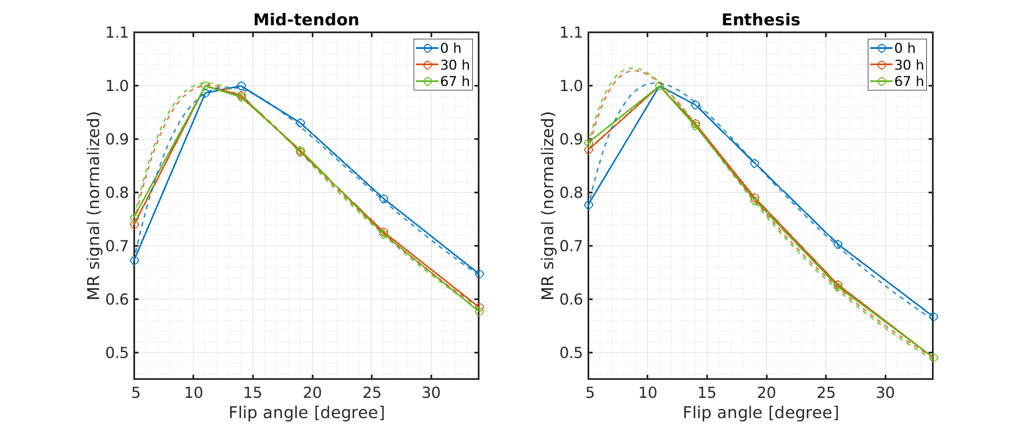
Figure 1: Dependence of the MR signal on the flip angle and the curve-fitting results (dashed lines) used to estimate the T₁ relaxation time. Results are shown for one sample at baseline (blue) and after 30 h (red) and 67 h (yellow) of immersion in PBS. To simplify data visualization, the signals were normalized to the individual maximum of the curves.

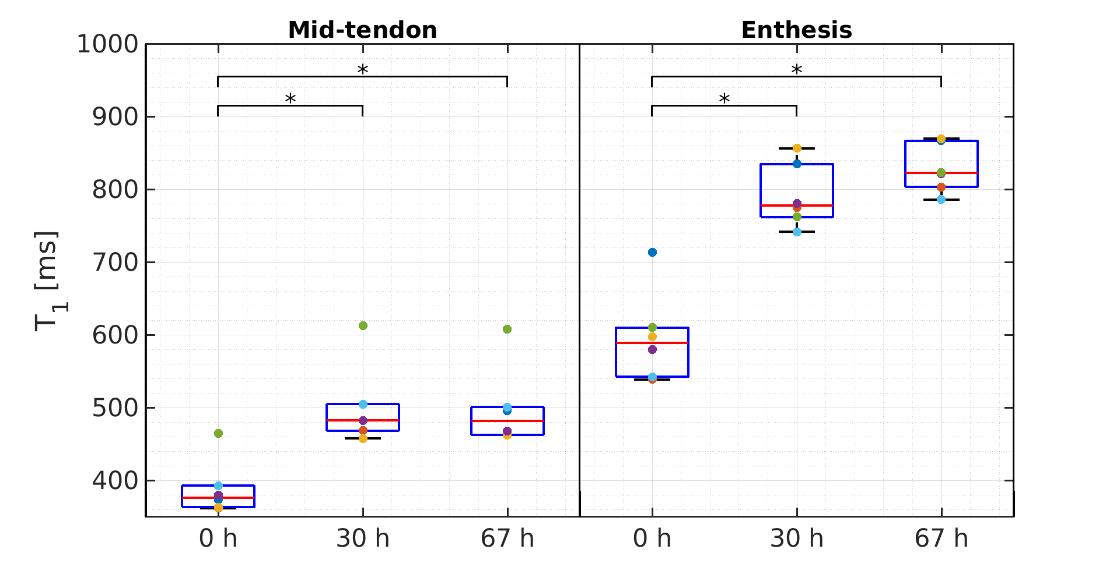
Figure 2: Box plots showing the estimated T₁ relaxation times for a region-of-interest in the mid-tendon (left) and enthesis (right) at baseline, 30 h and 67 h after immersion in PBS. Statistically significant differences (p<0.05) are denoted by *.

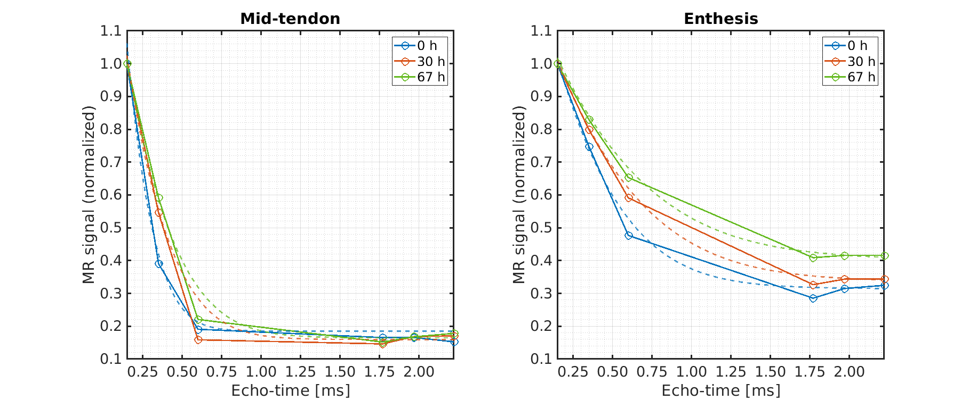
Figure 3: Decays of the transverse magnetization and T₂* curve fitting results (dashed lines) for the mid-tendon and enthesis regions, respectively, for one tendon sample at baseline (blue) and after 30 h (red) and 67 h (yellow) immersion in PBS. To simplify data visualization, the signals were normalized to the individual maximums of the decay curves.

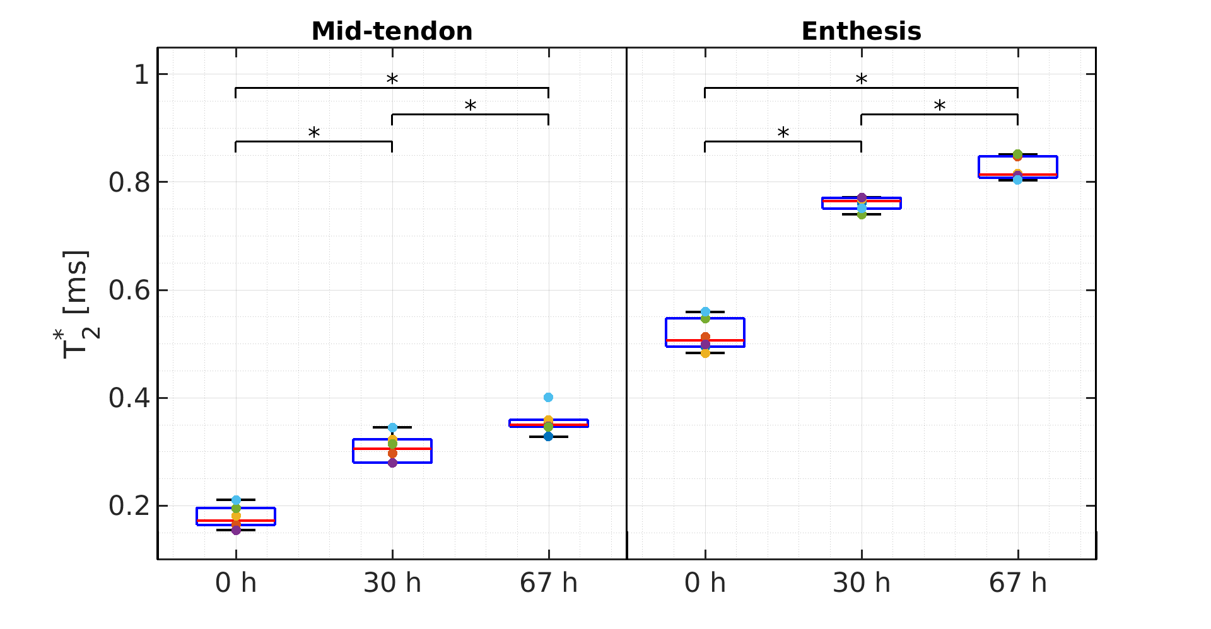
Figure 4: Box plots showing the estimated T₂* relaxation times for a region-of-interest in the mid-tendon (left) and enthesis (right) at baseline, 30 h and 67 h after immersion in PBS. Statistically significant differences (p<0.05) are denoted by *.

