Development of a Semi-Automated Segmentation Pipeline for Dynamic MRI Analysis of Knee Joint Kinematics
Aayush Nepal,¹ Martin Krämer¹ and Jürgen R. Reichenbach¹
1 Medical Physics Group, Institute of Diagnostic and Interventional Radiology, Jena University Hospital, Friedrich Schiller University Jena, Jena, Germany.
* Contact communicating author

Synopsis: Accurate segmentation of the femur and tibia from dynamic MRI scans of the knee during flexion-extension cycles can provide detailed kinematic insights. Developing a semi-automated segmentation pipeline enables efficient tibiofemoral kinematic analysis, offering potential advancements in clinical and research applications.

Introduction
The study of tibiofemoral kinematics often employs three-dimensional datasets to accurately capture the complex motion patterns of the knee joint [1]. Typically, these studies require a combination of static and dynamic scans, alongside sophisticated modelling techniques and algorithms to extract kinematic parameters [2-4]. Although these methods provide detailed insights, their extensive resource requirements often limit their broader applicability.
Nonetheless, effective kinematic analysis can also be achieved with 2D dynamic MRI scans. This study introduces a semi-automated pipeline specifically designed to segment the tibia and femur during knee flexion-extension cycles from single slice CINE images in the sagittal view. By bypassing the need for high-resolution static scans and complex computational approaches like machine learning, this streamlined process offers a practical, less resource-intensive alternative for conducting detailed kinematic assessments. Following segmentation, a couple of kinematic parameters are extracted to demonstrate the application of this algorithm.

Methods
Dynamic MRI scans were conducted on five healthy volunteers (ages 28-39) using a Siemens 3T Prisma scanner. Volunteers underwent scans of the left leg through controlled extension-flexion cycles, guided by a 60-bpm metronome, under both loaded and unloaded conditions.
MRI data was captured using a 2D radial golden-angle gradient echo FLASH sequence with echo time of 2.51 ms, flip angle of 8 degrees and repetition time of 5.8 ms. 276 spokes were acquired per k-space, with each spoke consisting of 352 data points. Each scan session lasted 160 seconds, during which volunteers performed multiple extension-flexion cycles, with a total of 100 k-space repetitions being acquired.
The semi-automated segmentation process was executed in five main steps: first, the Canny edge detector was used to identify edges in the image for the tibia and femur. Next, connected-component labeling technique was used to pick out the relevant edges. Key reference points were then established on the binary edge outputs facilitating frame-to-frame transformations using greedy nearest neighbor sorting and cubic spline interpolation. Transformation matrices, that map the position of the bone edge from one frame to the next were determined through optimization of a cost function. This function quantified the alignment error between subsequent frames by calculating the minimal distances between transformed and target coordinates. Optimization of this function was conducted by using the nonlinear least squares approach to obtain the optimal set of translation and rotation parameters. Finally, these matrices were applied to the boundaries of tibia and femur segments in the first frame, automating segmentation across the remaining frames in the motion cycle.
Post-segmentation, kinematic analysis focused on the angle between the long axes of the femur and tibia, derived from principal component analysis, and the Euclidean distance between key anatomical landmarks (distal and proximal points of femur and tibia), providing insights into orientation and spatial relationship of the bones.

Results
The segmentation algorithm consistently achieved a precision of less than 0.4 mm in tracking bone edges. Fig 1 illustrates the automatic segmentation of tibia and femur (green) achieved for one of the datasets across the movement cycle. The results of kinematic parameter tracking are given in Figures 2 and 3.
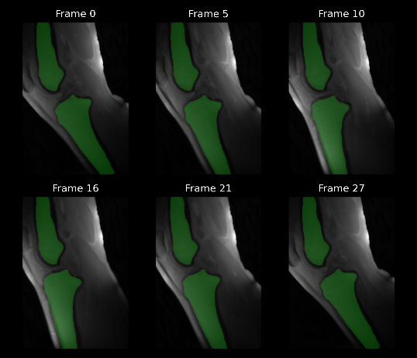
Fig. 1: The result of automatic segmentation of the tibia and femur (shown in green) for one of the datasets at various time points during the extension-flexion cycle.
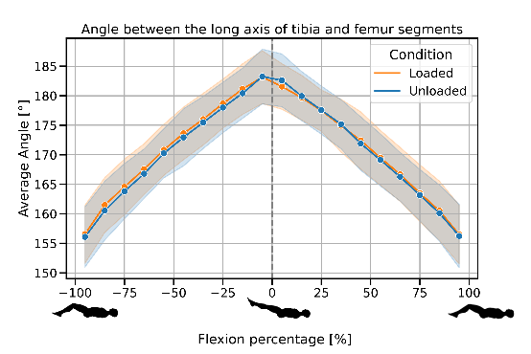
Fig. 2: Average angle between the long axes of the bone segments throughout the motion cycle under loaded and unloaded conditions. The shaded regions represent one standard deviation uncertainty across all datasets
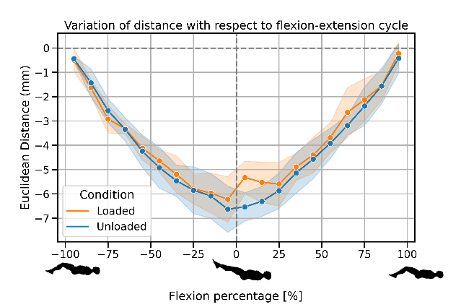
Fig. 3: Plot showing the variation of the Euclidean distance between anatomical landmarks on the femur and tibia with respect to time in the motion cycle. The shaded region represents one standard deviation uncertainty across all datasets for each condition.

Discussion
This study presents a semi-automated approach to tibiofemoral kinematic analysis using dynamic 2D MRI scans, demonstrating that detailed kinematic assessments can be effectively conducted without the extensive resources required for 3D imaging. Key to this approach is the efficient automation of segmentation of tibia and femur for all frames after the initial one, which significantly reduces the manual labor and time involved in the analysis process. This method not only proves comparable in precision to traditional techniques but also enhances accessibility and practicality for clinical and research settings.
A limitation encountered in the study was the occasional difficulty in restricting leg movement to a single plane, which may affect the precision of the kinematic data. Addressing this, future research could refine the mechanical setup or explore the applicability of this segmentation technique to other joint analyses, such as patellofemoral kinematics. The clear segmentation of the patella offers promising avenues for extending this methodology, potentially improving both the scope and the accuracy of kinematic assessments.

Conclusion
Through the development and application of a novel semi-automated algorithm, this study not only facilitates efficient kinematic analysis using 2D dynamic MRI but also expands the potential for detailed, resource-efficient kinematic studies in clinical and research environments.

References
1. Hull. Coordinate system requirements to determine motions of the tibiofemoral joint free from kinematic crosstalk errors. Journal of Biomechanics. 2020.
2. Conconi, Michele, et al. “In-Vivo Quantification of Knee Deep-Flexion in Physiological Loading Condition through Dynamic MRI”. Applied Sciences 13.1: 629, 2023.
3. d’Entremont, Agnes G.et al. “Do dynamic-based MR knee kinematics methods produce the same results as static methods?” Magnetic Resonance in Medicine 69.6: 1634–1644. 2013.
4. Mazzoli, Valentina, Schoormans, et al. “Accelerated 4D self-gated MRI of tibiofemoral kinematics”. NMR in Biomedicine 30.11: e3791. 2017.

