Semi-Automated Segmentation Pipeline for Dynamic MRI Analysis of Knee Joint Kinematics
Aayush Nepal^{1*}, Nicholas M. Brisson^{2,3}, Georg N. Duda^{2,3}, Jürgen R. Reichenbach¹ and Martin Krämer¹
¹Medical Physics Group, Institute of Diagnostic and Interventional Radiology, Jena University Hospital, Friedrich Schiller University Jena, Germany
2Julius Wolff Institute, Berlin Institute of Health at Charité – Universitätsmedizin Berlin, Germany
3Berlin Movement Diagnostics (BeMoveD), Center for Musculoskeletal Surgery, Charité – Universitätsmedizin Berlin, Germany
* Corresponding author

Synopsis: Accurate segmentation of the tibia and femur from dynamic MRI scans during knee flexion-extension can provide detailed insights into joint kinematics. Developing a semi-automated segmentation pipeline enables a streamlined approach to tibiofemoral kinematic analysis, offering potential advancements in clinical and research applications.

Introduction
The study of tibiofemoral kinematics often employs three-dimensional MRI datasets to accurately capture the complex motion patterns of the knee joint [1]. Typically, these studies require a combination of static and dynamic scans, alongside sophisticated modelling techniques and algorithms to extract kinematic parameters [2]. While this approach is comprehensive, it is time intensive; other alternatives may simplify and hasten the acquisition and analysis.
This study introduces a semi-automated pipeline designed to segment the tibia and femur during knee flexion-extension cycles from single slice CINE images in the sagittal view, and to track kinematic parameters from these segments. By bypassing the need for high-resolution static scans and complex computational approaches like machine learning, this streamlined process offers a practical, less resource-intensive alternative for conducting kinematic assessments.

Methods
Dynamic MRI scans were acquired for five healthy volunteers (28-39 years old) using a Siemens 3T Prisma scanner. Volunteers underwent scans of the left leg as they actively completed repetitive, open chain knee flexion- extension cycles to the beat of a metronome (6 cycles/min), under both loaded (12 kg added weight) and unloaded conditions using a special MRI safe device for guided knee motion [3].
MRI was captured using a 2D radial golden-angle gradient echo FLASH sequence with echo time of 2.51 ms, flip angle of 8° and repetition time of 5.8 ms. The acquisition matrix size was 176 x 176 x 1. Each scan lasted 160 s, with a total of 100 k-space repetitions acquired. Cine images were reconstructed, with each frame representing a 2° interval of knee motion using iterative and non-Cartesian reconstruction techniques.
The semi-automated segmentation process was executed in five main steps: (1) Canny edge detection was used to identify edges in the image for the tibia and femur; (2) connected-component labeling technique was used to pick out edges of the interior boundary of the cortical bone; (3) key reference points were established on the binary edge outputs, facilitating frame-to-frame transformations using greedy nearest neighbor sorting and cubic spline interpolation; (4) transformation matrices that map the position of the bone edge from one frame to the next were determined through optimization of a cost function. This function quantified the alignment error between subsequent frames by calculating the minimal distances between transformed and target coordinates. Optimization of this function was conducted by using the nonlinear least squares approach to obtain the optimal set of translation and rotation parameters; and (5) these matrices were applied to the boundaries of the tibia and femur segments in the first frame, automating segmentation across the remaining frames in the motion cycle.

After segmentation, the angle between the long axes of the tibia and femur was derived using principal component analysis, and the Euclidean distance between anatomical landmarks at the distal and proximal points of these bones was measured.

Results
The segmentation algorithm consistently achieved a point-to-point alignment error of less than 0.40 ± 0.02 mm in tracking bone edges. Fig. 1 illustrates the semi-automatic segmentation of the tibia and femur (green) achieved for one of the datasets across the knee flexion-extension movement cycle. As shown in Fig. 2 and Fig. 3, the angle between the bones were similar between loaded and unloaded conditions, whereas the distance between anatomical landmarks showed some deviations during the initial stages of flexion.
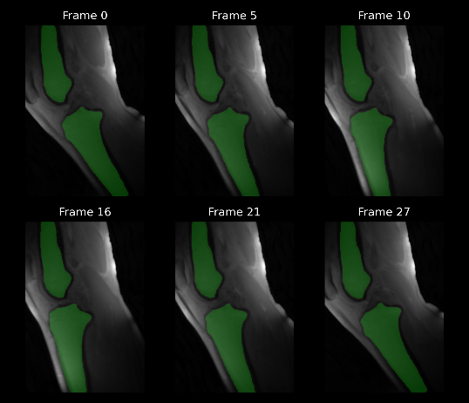
Fig. 1: Example segmentation: the tibia and femur (green) were segmented from one dataset at different points during the knee motion cycle.
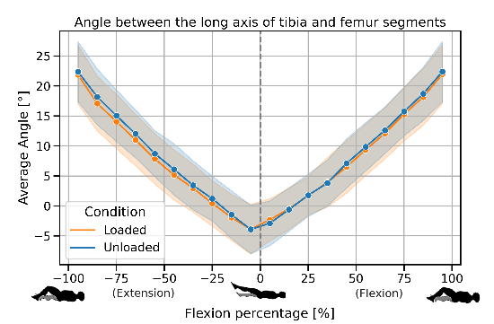
Fig. 2: Average angle between the long axes of the tibia and femur throughout the motion cycle under loaded (12 kg) and unloaded conditions. The shaded regions represent one standard deviation of uncertainty across all datasets.

Discussion
This study presents a semi-automated approach to tibiofemoral kinematic analysis, demonstrating that kinematic assessments can be effectively conducted by solely using dynamic 2D CINE images. Central to this approach is the automated segmentation of the tibia and femur across all frames, which significantly reduces the manual labor and time involved in the analysis process.
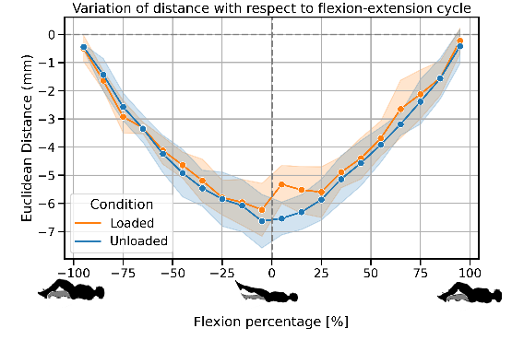
Fig. 3: Plot showing the variation of the Euclidean distance between anatomical landmarks on the tibia and femur with respect to time in the motion cycle. The shaded region represents one standard deviation of uncertainty across all datasets.
Notably, this method was able to capture differences in kinematic parameters such as the distance between anatomical landmarks, under different knee loading conditions, highlighting its practical application.
A study limitation was the occasional difficulty of restricting leg movement to a single plane, which may have affected the precision of the kinematic data. Future research could address this challenge by refining the mechanical setup. Furthermore, the application of this segmentation technique to other joints could be of interest, for instance, to analyze patellofemoral kinematics.

Conclusion
Through the development and application of a novel semi-automated algorithm, our proposed technique not only facilitates kinematic analysis using 2D dynamic MRI but also supports the potential for resource-efficient kinematic studies in clinical and research environments.

References
1. Hull ML. Coordinate system requirements to determine motions of the tibiofemoral joint free from kinematic crosstalk errors. Journal of Biomechanics. 2020.
2. d’Entremont AG et al. Do dynamic-based MR knee kinematics methods produce the same results as static methods? Magnetic Resonance in Medicine 69.6: 1634–1644. 2013.
3. Brisson NM et al. A novel multipurpose device for guided knee motion and loading during dynamic magnetic resonance imaging. Zeitschrift für Medizinische Physik 32:4 2022.

